GPOS Provantis Quick Start Guide
Standard Operating Guide for Store Staff & Cashiers
This manual provides step-by-step instructions for operating the GPOS Provantis terminal during daily store operations. Follow this guide to manage transactions, handle payments, apply discounts, and close shifts efficiently.
1. Dashboard Layout & Overview
When you log into the terminal, you will see the main point-of-sale dashboard interface.
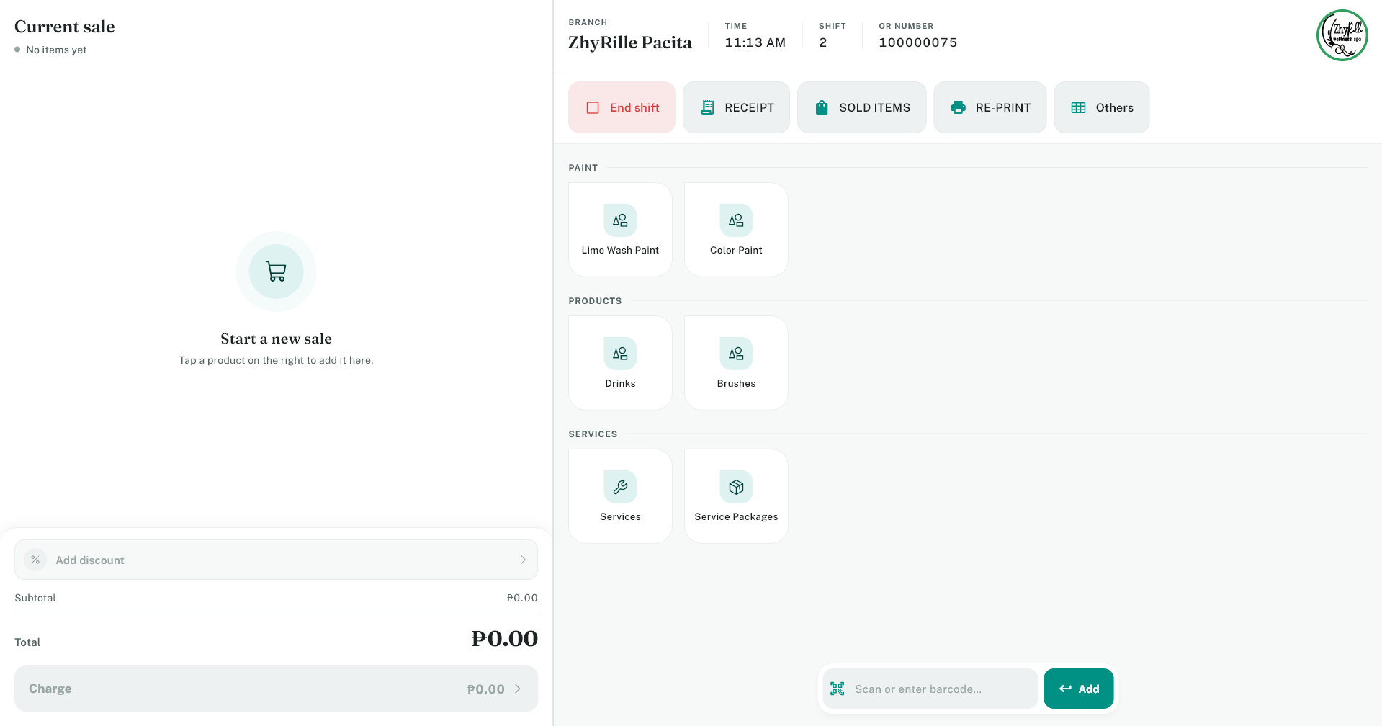

Key areas of the interface include:
- Product area: Displays item categories and searchable inventory.
- Barcode field: Input field for hardware barcode scanning or manual code entry.
- Cart view: List of all selected items, itemized quantities, and line totals.
- Discount button: Applies promotional, staff, or manual discounts.
- Total area: Shows subtotal, tax breakdown, discounts, and final amount due.
- Charge button: Proceeds to the payment processing screen.
- Shift button: Opens or closes active store operational shifts.
- Others button: Accesses auxiliary functions (reports, cash drops, printer setup).
2. Starting Your Shift
You must open your shift before processing any sales to ensure accurate cash tracking.
1. Navigate to the main dashboard.
2. Tap the Start Shift button.
3. When prompted, count and enter your starting opening cash amount.
4. Tap Confirm to open the register.
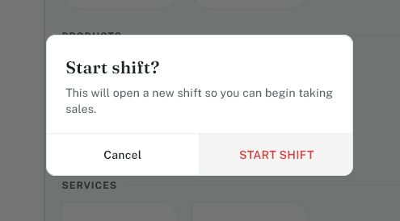

CRITICAL REQUIREMENT: Never process sales before opening a shift. Always verify physical drawer cash before confirming start.

3. Adding Items to the Sale
Items can be added to the customer cart using two methods:
Option A: Scan a Barcode
1. Scan the barcode label using the scanner or type the barcode into the input box.
2. Press Enter or tap Add.
3. Confirm the item appears in the cart view.
Option B: Select from Product List
1. Locate the product on the screen grid.
2. Tap the product icon to add 1 unit to the cart.
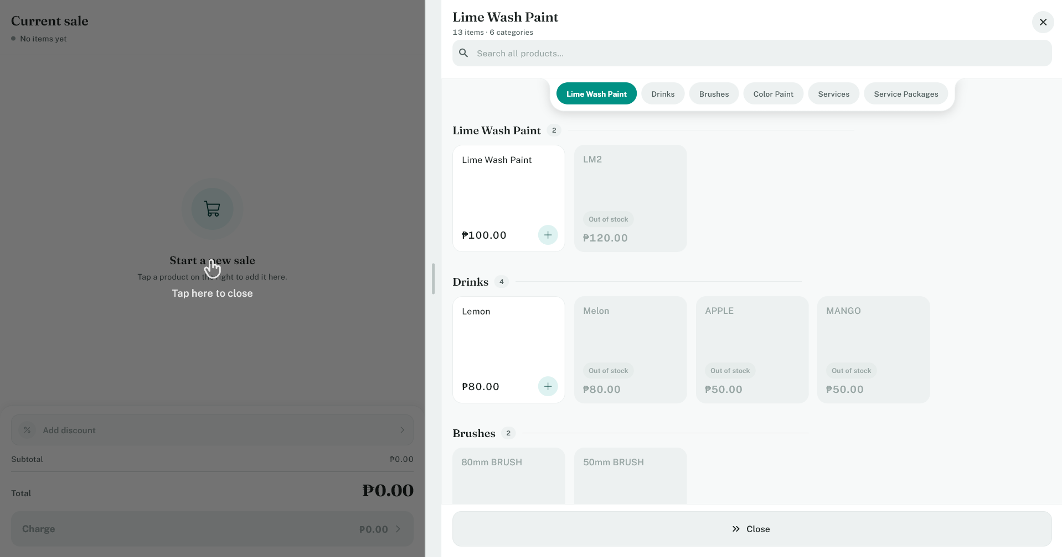

4. Modifying Item Quantities & Cart
Use the inline quantity adjusters in the cart row to add, reduce, or delete items if a customer changes their order prior to payment.
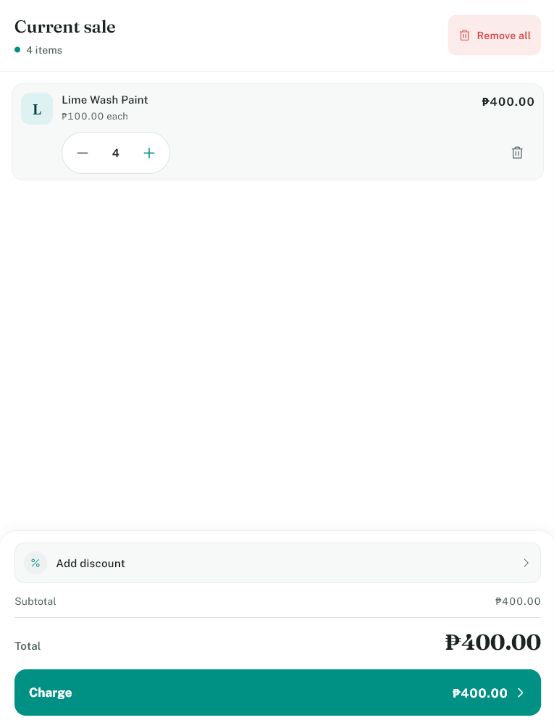

5. Applying & Removing Discounts
To apply a discount:
1. Tap the Add Discount button near the total area.
2. Select the authorized discount type from the list.
3. Enter customer details/ID if prompted, then tap Confirm.
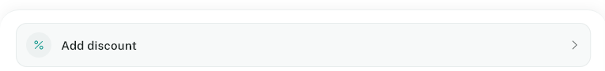
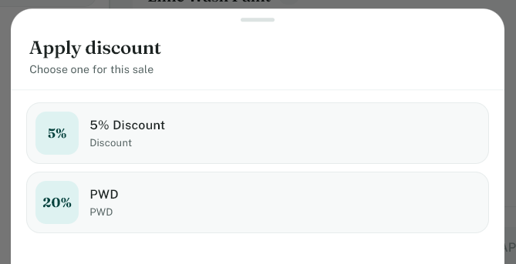
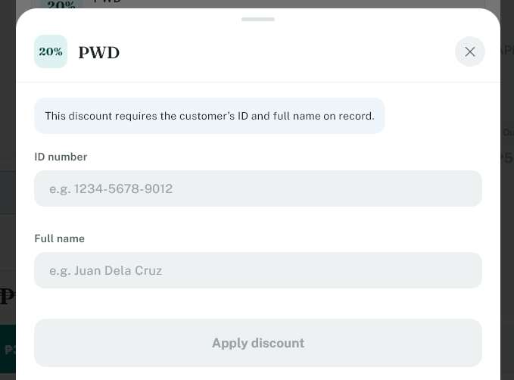

To remove a discount, tap the active discount tag in the cart area and select Clear/Remove.
6. Processing Customer Payment
1. Verify the subtotal, discounts, and final amount due.
2. Tap the Charge button to open payment options.
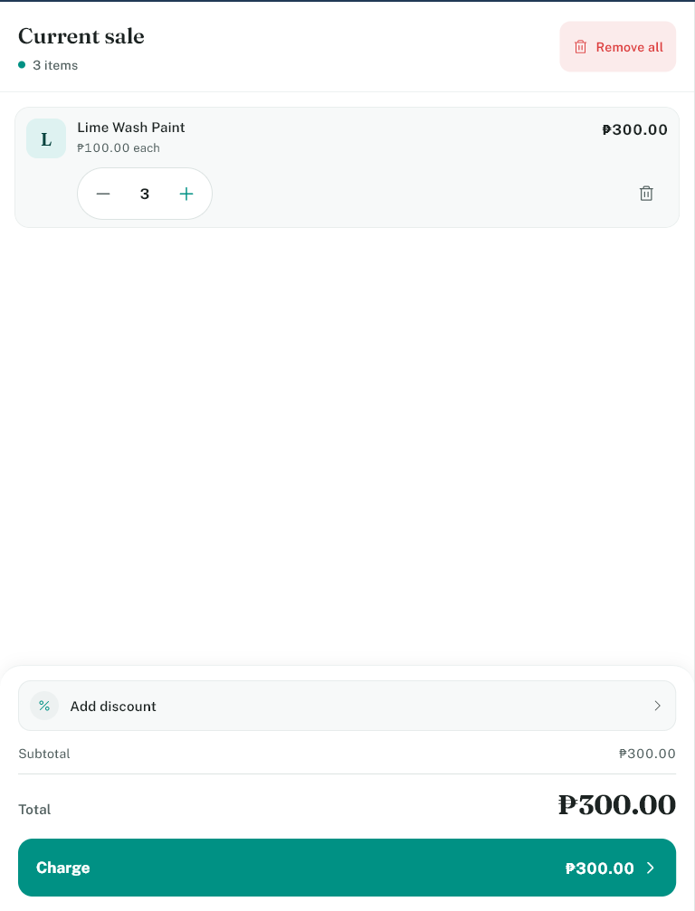

Method 1: Cash Payment
1. Select Cash.
2. Enter the amount of cash received from the customer.
3. Tap Confirm. The screen displays the exact change to return.
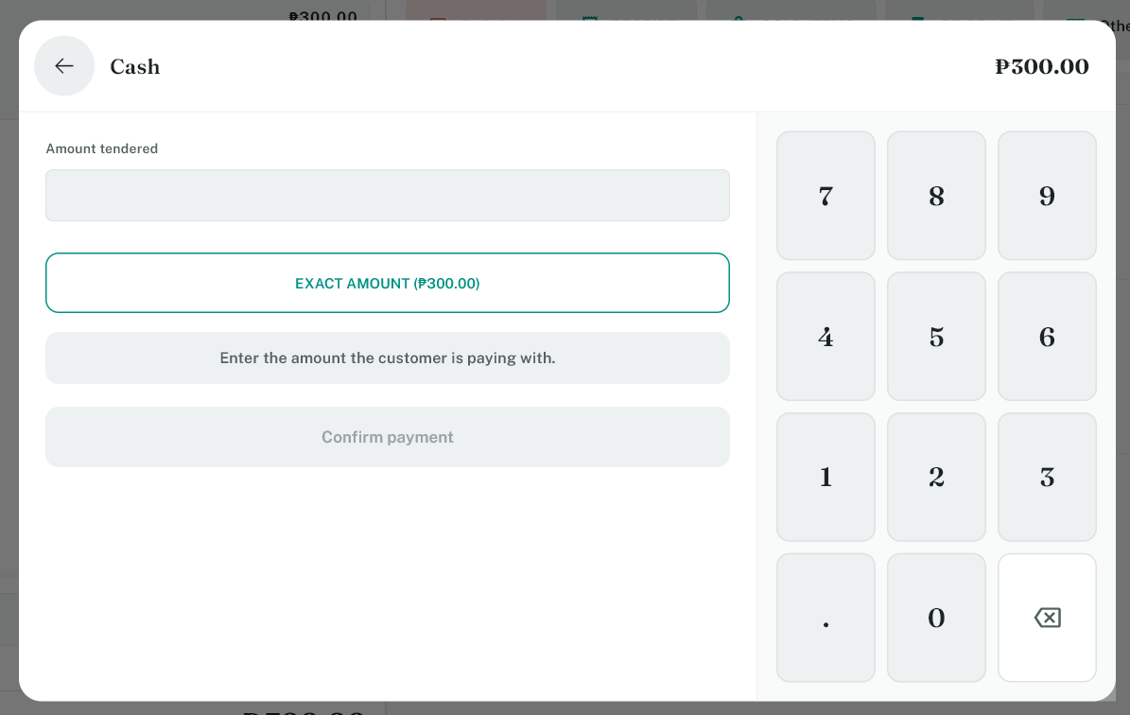

Method 2: E-Payment (Cards & Digital Wallets)
1. Select E-Payment.
2. Verify amount and complete payment on the external terminal/QR display.
3. Tap Confirm after authorization.
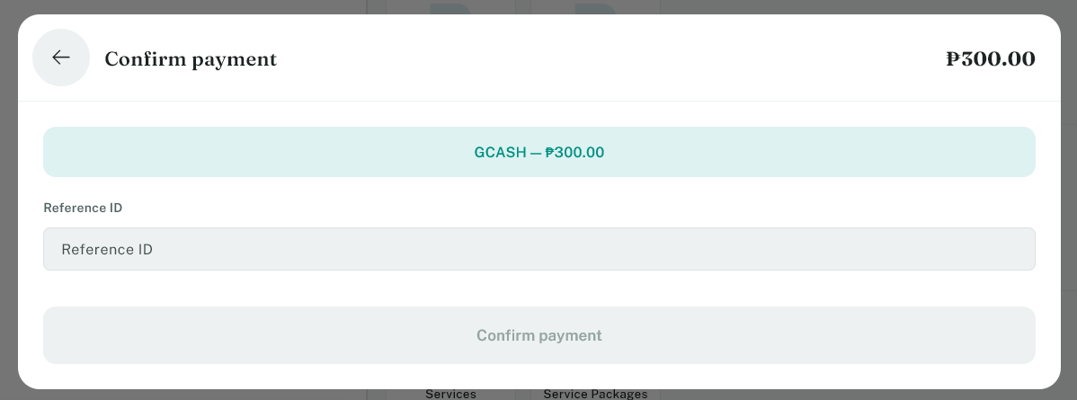

Method 3: Split Payment
1. Select Split Payment.
2. Enter the amount for Tender 1 (e.g., Cash) and confirm.
3. Enter the remaining balance for Tender 2 (e.g., Card) and confirm.
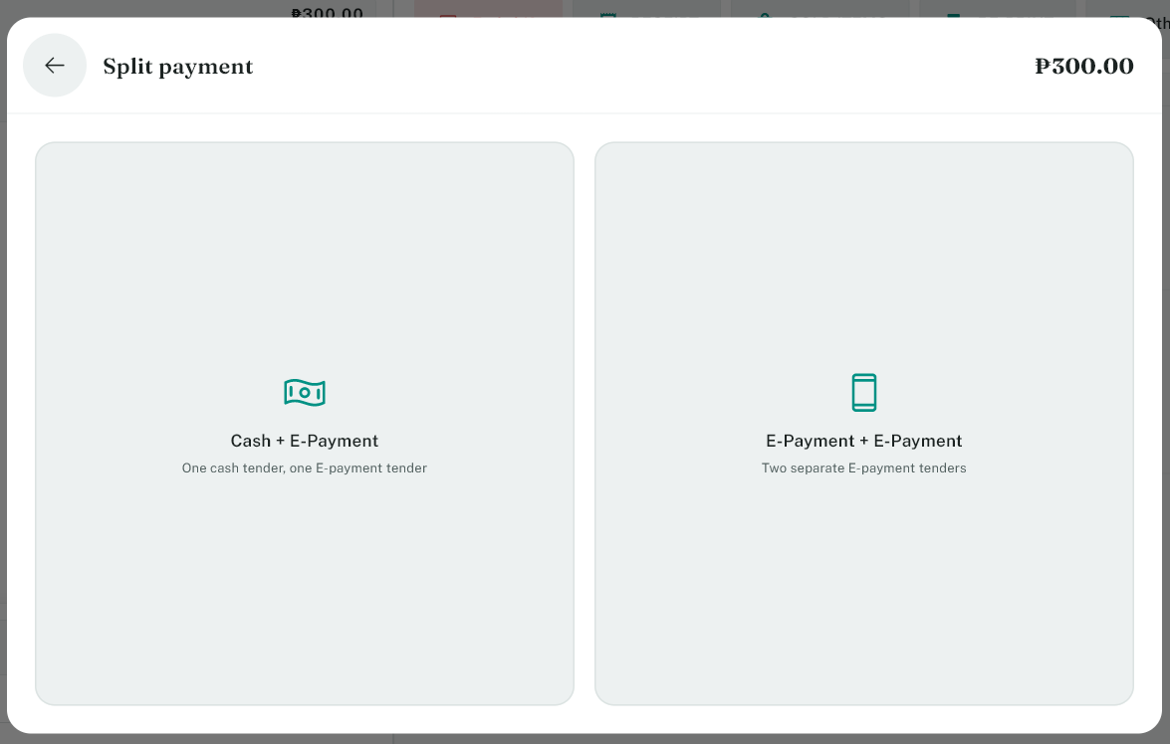
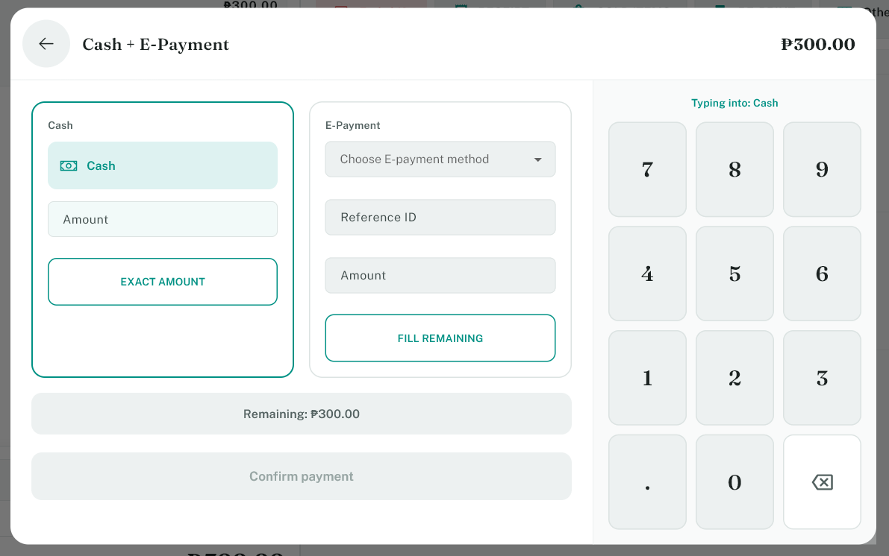

7. Printing & Handling Receipts
Receipts print automatically upon transaction completion. If printing fails, check connections under Others > Printer Settings.
8. The 'Others' Menu & Utility Actions
Tap the Others button on the dashboard to access manager tools and daily drawer utilities.
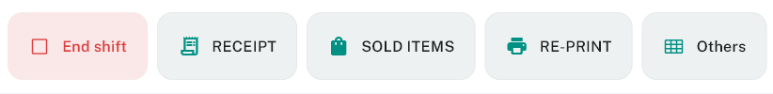

- Cash Drop: Tap Cash drop > Enter amount removed > Confirm. Places excess drawer cash into safe storage.
- Open Drawer: Tap Open Cash Drawer > Confirm to manually release the drawer latch.
- Refunds: Tap Refund > Select original receipt/transaction > Process return approval.
- E-Receipt: Tap Send e-receipt > Enter customer email > Send.
- Reports & Sales: View Sold Items, Daily Cash Movement, and Shift Summaries.
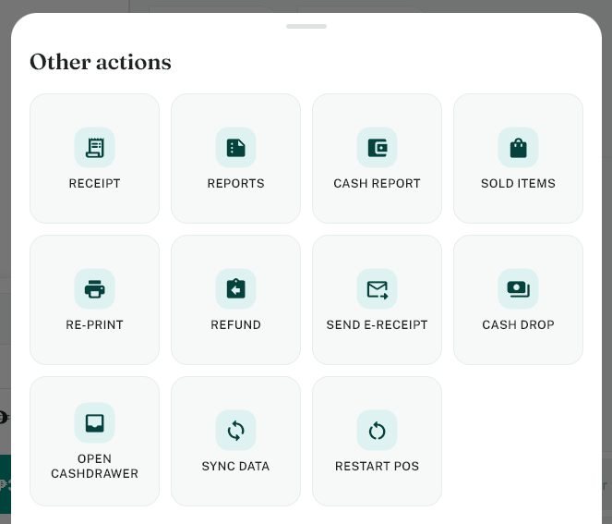

9. Ending Your Shift
1. Tap End Shift on the dashboard.
2. Perform final drawer cash count and input totals when prompted.
3. Tap Confirm Close to lock terminal and finalize summary reports.
