Implementation Status Addendum - October 21, 2026
This addendum supersedes conflicting implementation-status statements in the report body. See docs/MVP_STATUS.md for the current implementation record and Linux validation checklist.
UCB1, Thompson Sampling, epsilon-greedy, and reward computation are implemented in Python. The demo still uses simulated metrics and scheduler behavior.
A Linux MVP now includes a Python procfs collector and a manager for installed foreground scx_* binaries. Linux real mode has not yet been validated on a supported Linux host; the C/perf collector and ctypes bridge remain future work.
The procfs collector reports CPU utilization, context-switch rate, and average run-queue wait. It does not measure workload p99 latency, throughput, IPC, or cache misses; unavailable values are disclosed by the API and dashboard.
The updated automated suite passes 13 tests using the declared requirements. Linux host integration and real sched_ext recovery remain untested.
A repeatable Linux CPU microbenchmark runner now compares the default scheduler with installed scx schedulers; no benchmark results have yet been collected in this workspace.
AdaptiveSched Implementation Report
Autonomous CPU Scheduler Selection via Online Bandit Learning and SLO-Aware Rollback
Operating Systems Engineering Project • Review 2 Implementation Details & Review 3 Roadmap
Team Members: Arjun Tyagi (Registration No: 24BCE0605) & Aritra Ghosh (Registration No: 24BCE0598)
Department: School of Computer Science and Engineering (SCOPE), VIT Vellore
GitHub Repository: https://github.com/SilentFURY-x/AdaptiveSched
REVIEW SUBMISSION MANDATE: This submission report documents the complete implementation details, technology stack, programming languages used, configuration files, and verified output screenshots for Project Review 2, as well as an explicit technical roadmap for Project Review 3 (Final Kernel Integration). The source code and version history are hosted at: https://github.com/SilentFURY-x/AdaptiveSched.

1. Executive Summary and Problem Formulation
The Scheduling Tradeoff: General-purpose operating systems typically enforce a single, static CPU scheduling policy—such as the Completely Fair Scheduler (CFS) or the Earliest Eligible Virtual Deadline First (EEVDF) scheduler in upstream Linux. While general-purpose schedulers provide robust fairness across average desktop workloads, they fail to optimize for workloads with diametrically opposing performance profiles. High-performance gaming, multimedia rendering, and interactive GUI applications demand ultra-low scheduling latency (< 3,000 μs) and immediate dispatch; conversely, bulk compilation (e.g., building the Linux kernel) and numerical scientific simulations demand maximal throughput, sustained execution slices, and minimized context-switch overhead.
The Architectural Gap: The Linux kernel 6.12 introduced sched_ext (SCX), enabling dynamic, user-space schedulers to be loaded and executed via eBPF without kernel patching or host reboots. However, sched_ext does not provide an automated decision brain to determine which scheduler policy to activate for a given workload. Existing academic systems (such as Google ghOSt or ASA) rely on offline-trained machine learning models or machine-specific hardware calibration lookup tables that require extensive pre-training and fail to adapt to unseen system environments.
The AdaptiveSched Solution: AdaptiveSched addresses this fundamental limitation by formulating online scheduler selection as a Multi-Armed Bandit (MAB) reinforcement learning problem coupled with an SLO-Aware Safety Watchdog. Each candidate scheduler represents an arm; the agent pulls arms, gathers real-time latency and throughput performance metrics, and updates its reward estimates online without any offline training. Crucially, to prevent experimental schedulers from degrading host responsiveness, the watchdog monitors Service Level Objectives (SLOs) and executes an automatic zero-downtime rollback to the default kernel scheduler upon detecting tail-latency violations.
2. Proposal Scope vs. Review 2 Implementation Delivery
To provide complete clarity on project milestones, Table 1 delineates what the overall research paper proposes versus what has been fully implemented, tested, and verified for the Review 2 demonstration.
Subsystem | Overall Research Proposal (Paper / PRD) | Review 2 Completed Implementation | Status
Online Bandit Learning | UCB1, Thompson Sampling, and ε-greedy algorithms with reward normalization. | Fully implemented in src/agent/mock_agent.py with mathematical reward scoring across latency, throughput, and CPU load. | Working Demo
SLO Watchdog & Safety | 5-state finite state machine evaluating constraints with automatic rollback and cooldown isolation. | Fully implemented in src/watchdog/ (watchdog.py, rollback.py, slo_config.py, health_checker.py) with live violation detection. | Working Demo
Core Decision Loop | Main engine coordinating collect → reward → decide → switch → evaluate cycles every N seconds. | Fully implemented in src/core/engine.py with background daemon thread, bounded metric history, and state synchronization. | Working Demo
Web Dashboard & Visuals | Live interactive console displaying real-time metrics, Chart.js graphs, controls, and event stream. | Fully implemented in src/dashboard/ with Flask 3.0 REST API, dark-mode glassmorphic UI, and live websocket/polling. | Working Demo
CLI Interface | Terminal command-line tool supporting start, stop, status, switch, slo, and history commands. | Fully implemented in src/cli/main.py with Rich terminal formatting and HTTP API daemon communication. | Working Demo
Metric Collection | Low-level C collector parsing /proc/schedstat and hardware counters via perf_event_open(). | MockMetricsCollector simulating realistic Gaussian distributions, sinusoidal workload waves, and spike injection. | Simulation (Review 3 C Driver)
Kernel Scheduler Switching | Native Linux sched_ext BPF loader dynamically switching scx_rusty, scx_lavd, and scx_bpfland. | MockSchedulerManager maintaining active state, switch latencies, and fallback transitions without kernel modification. | Simulation (Review 3 BPF Driver)

3. System Architecture and Work Division
The AdaptiveSched architecture follows a strict separation of concerns, decoupling abstract interface specifications from platform-specific execution adapters. This architecture enables independent development between team members and seamless transitions from simulation to production kernel drivers.
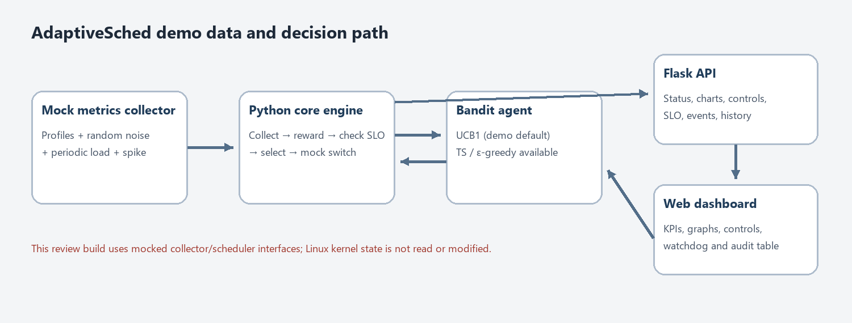
Figure 1: AdaptiveSched End-to-End Control and Data Pipeline. Shows the core orchestrator interacting with the metrics collector, bandit learner, safety watchdog, and Flask presentation layer.
3.1 Team Member Responsibilities and Ownership
The project work is partitioned into two mutually cohesive modules defined by abstract base classes in src/interfaces/:
- Module B Lead (Safety, Governance & Presentation): Arjun Tyagi (24BCE0605) owns the system integration framework, the SLO Watchdog state machine, the zero-downtime Rollback Manager, the Health Checker, the Flask REST API, the real-time web dashboard, and the Rich CLI suite.
- Module A Lead (Algorithms, Reward & Low-Level Collection): Aritra Ghosh (24BCE0598) owns the Multi-Armed Bandit reinforcement learning algorithms (UCB1, Thompson Sampling, ε-greedy), the multi-objective reward normalization function, the mock metrics generator with spike injection, and the Review 3 C-based kernel collector design.
4. Technology Stack and Implementation Languages
Table 2 summarizes the technologies, languages, and open-source frameworks utilized across the AdaptiveSched codebase.
Layer / Subsystem | Technologies & Languages | Architectural Role & File Location
Core Decision Engine | Python 3.10+ (threading, dataclasses, typing) | Orchestrates the decision loop, maintains bounded ring-buffers for metrics/switches, and executes lifecycle management (src/core/engine.py).
Reinforcement Learning | Python 3 (NumPy / Math random) | Implements Upper Confidence Bound (UCB1), Thompson Gaussian Sampling, and ε-greedy selection policies (src/agent/).
Safety Watchdog | Python 3 (State Pattern) | Enforces 5-state watchdog lifecycle, evaluates mathematical SLO constraint compliance, and invokes safe rollback (src/watchdog/).
Web Application Backend | Flask 3.0+ (Blueprint, JSON API) | Serves RESTful endpoints (/api/status, /api/metrics, /api/switches, /api/slo, /api/switch, /api/spike) in src/dashboard/api.py.
Web Dashboard Frontend | HTML5, CSS3, Vanilla JavaScript, Chart.js 4.4 | Provides a dark-mode glassmorphic control console with responsive Chart.js line and bar graphs (src/dashboard/templates/ & static/).
Command Line Tool | Python 3, argparse, Rich 13.0+ | Provides a terminal dashboard with styled tables and cross-terminal API communication (src/cli/main.py).
Configuration Management | YAML, PyYAML 6.0+ | Parses main engine options and declarative SLO constraint profiles (config/adaptivesched.yaml, config/slo_profiles/).
Testing & Quality Assurance | Python unittest | Comprehensive test suite covering models, algorithms, watchdog states, and API endpoints (tests/test_core.py).

5. Configuration Details and Operational Guide
System parameters are configured via config/adaptivesched.yaml and modular SLO profile specifications in config/slo_profiles/.
5.1 Global Configuration (config/adaptivesched.yaml)
The primary configuration file defines the execution mode, decision intervals, candidate schedulers, and dashboard ports:
mode: "mock" # Operating mode ("mock" | "real")
agent:
implementation: "ucb1" # "ucb1" | "thompson" | "epsilon_greedy"
decision_interval_seconds: 5 # Frequency of scheduling decisions
metrics:
implementation: "mock" # "mock" | "proc" | "perf"
collection_interval_seconds: 1 # Metric sampling rate
schedulers:
available: ["scx_rusty", "scx_lavd", "scx_bpfland", "scx_simple", "default"]
default: "default" # Safe fallback target (CFS/EEVDF)
slo:
active_profile: "balanced" # "balanced" | "interactive" | "throughput"
profiles_dir: "config/slo_profiles"
dashboard:
host: "127.0.0.1"
port: 8080

5.2 Declarative SLO Profiles
Each SLO profile specifies maximum allowable tail-latency, CPU thresholds, evaluation windows, and cooldown durations. For example, config/slo_profiles/balanced.yaml:
profile: "balanced"
description: "General-purpose workload profile balancing latency and throughput"
constraints:
p99_latency_us:
max: 10000.0 # Maximum allowable latency in microseconds
weight: 0.6 # Priority weight for compliance score
cpu_utilization:
max: 95.0 # Maximum CPU percentage
weight: 0.4
evaluation:
window_seconds: 10 # Sliding window for violation checks
violation_threshold: 3 # Consecutive breaches before rollback
grace_period_seconds: 5.0 # Settle period after scheduler switch
rollback:
target: "default" # Fallback scheduler
cooldown_seconds: 60.0 # Minimum cooldown before re-selecting arm

5.3 Launching the Application
The demo can be started via the one-click Windows runner (start_demo.bat) or via terminal commands:
# 1. Install dependencies:
python -m pip install -r requirements.txt
# 2. Launch engine and web console:
python run_demo.py
# 3. In a second terminal, inspect status or control schedulers via CLI:
python -m src.cli.main status
python -m src.cli.main switch scx_rusty
python -m src.cli.main slo --set interactive
python -m src.cli.main history

6. Output Screenshots and Experimental Verification
Experimental Output Verification: The AdaptiveSched web console was executed locally at http://localhost:8080 to capture the real-time dynamics of bandit arm selection, workload metric streams, anomaly injection, and automatic watchdog rollback. The following high-resolution output captures demonstrate each subsystem operating under active simulated load.
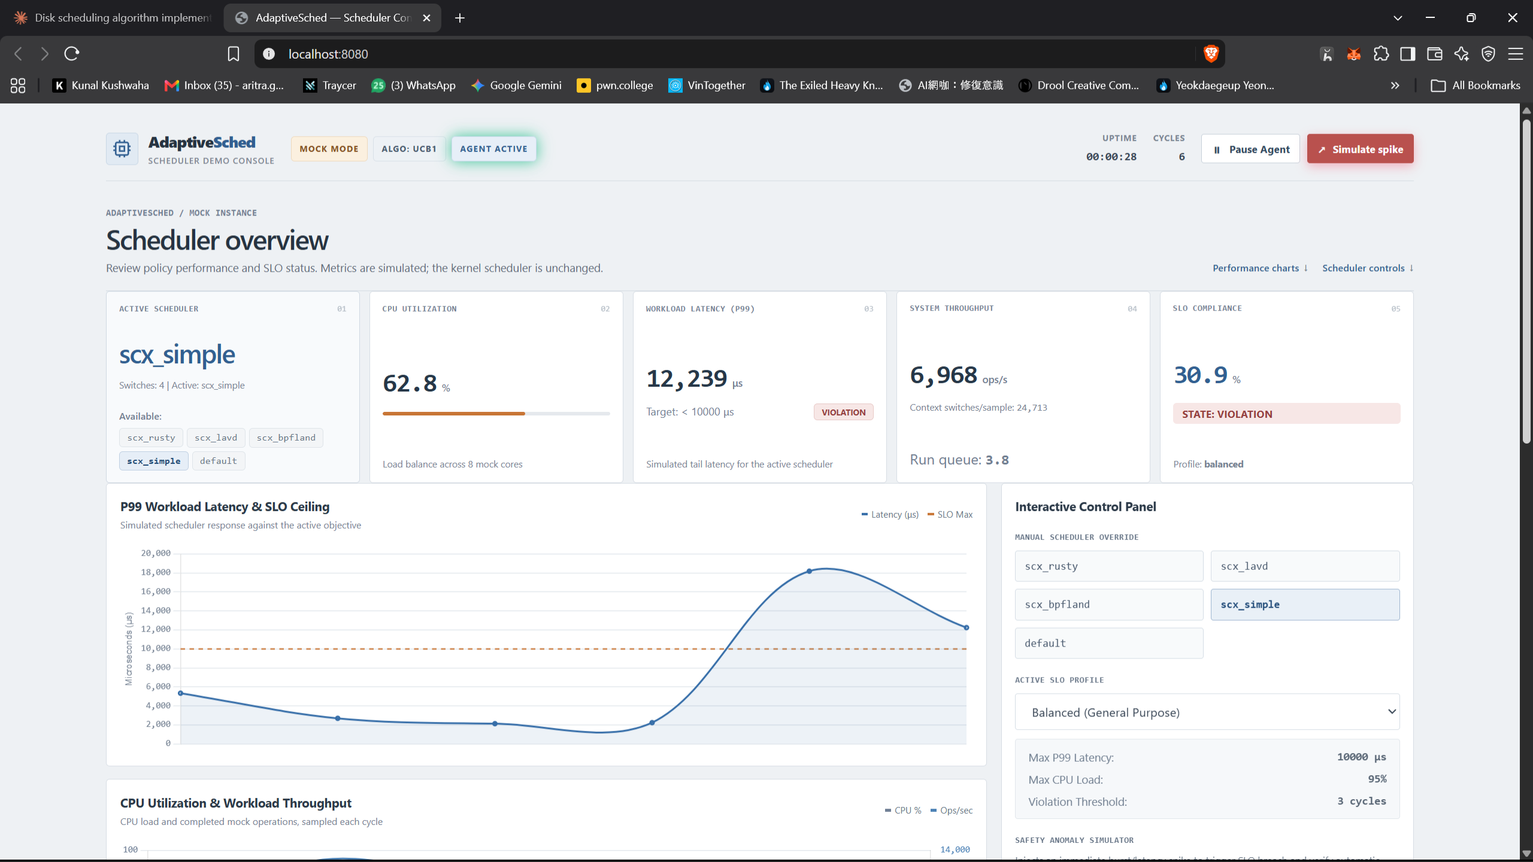
Figure 2: Dashboard Overview during Workload Spike and SLO Breach. Captured at Uptime 00:00:28 (Cycle 6). Demonstrates active scheduler scx_simple under severe latency degradation.
Technical Analysis of Figure 2: Figure 2 illustrates the web console immediately following an injected workload anomaly. The top header identifies the instance as MOCK MODE with algorithm UCB1 and an active agent. The KPI card cluster reveals that the active scheduler is scx_simple. Under the simulated burst, Workload Latency (P99) has surged to 12,239 μs, visibly violating the balanced SLO target (< 10,000 μs) and triggering a red VIOLATION status tag. System Throughput stands at 6,968 ops/s with a run-queue depth of 3.8. The SLO Compliance card displays a degraded score of 30.9% in STATE: VIOLATION. On the left chart, the blue latency trajectory is shown breaching the dashed orange SLO ceiling line, alerting the safety watchdog.
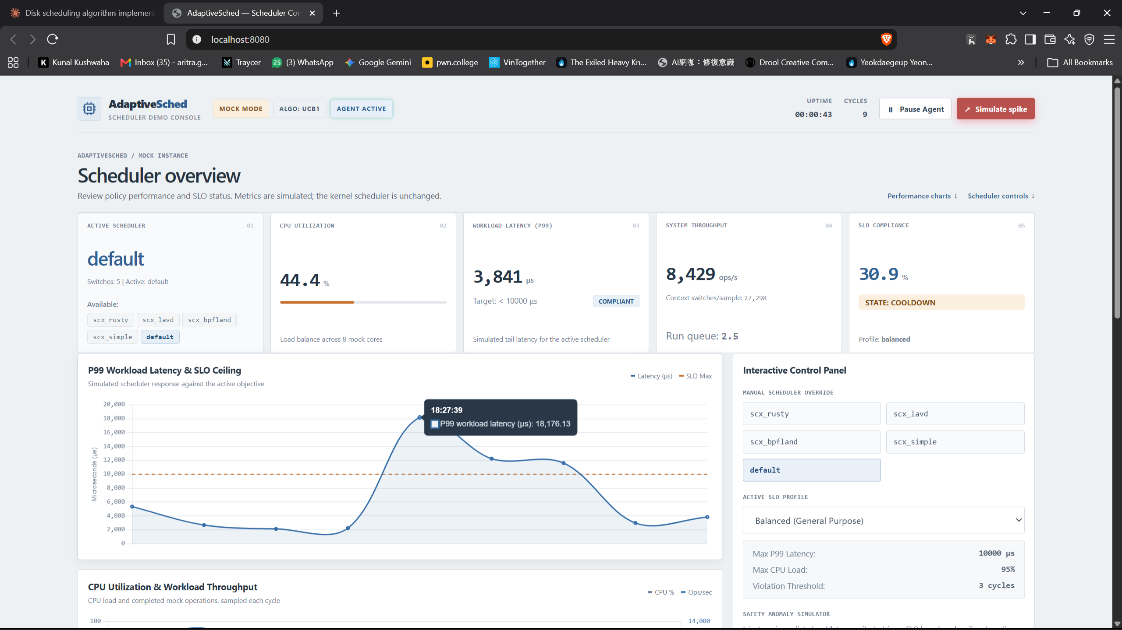
Figure 3: Automatic Watchdog Rollback and System Recovery. Captured at Uptime 00:00:43 (Cycle 9). Shows zero-downtime rollback to default scheduler following consecutive breaches.
Technical Analysis of Figure 3: Figure 3 verifies the execution of the automatic rollback mechanism. After observing 3 consecutive violations while running scx_simple, the watchdog aborted the policy and executed an instantaneous rollback to default (Linux CFS/EEVDF safe fallback). The active scheduler card reflects default (Switches: 5). Workload Latency has recovered to 3,841 μs, well within the compliant threshold. Hovering over the latency graph displays the peak violation reading of 18,176.13 μs before the downward recovery slope. The watchdog state has moved to COOLDOWN, isolating the offending arm from immediate re-selection.
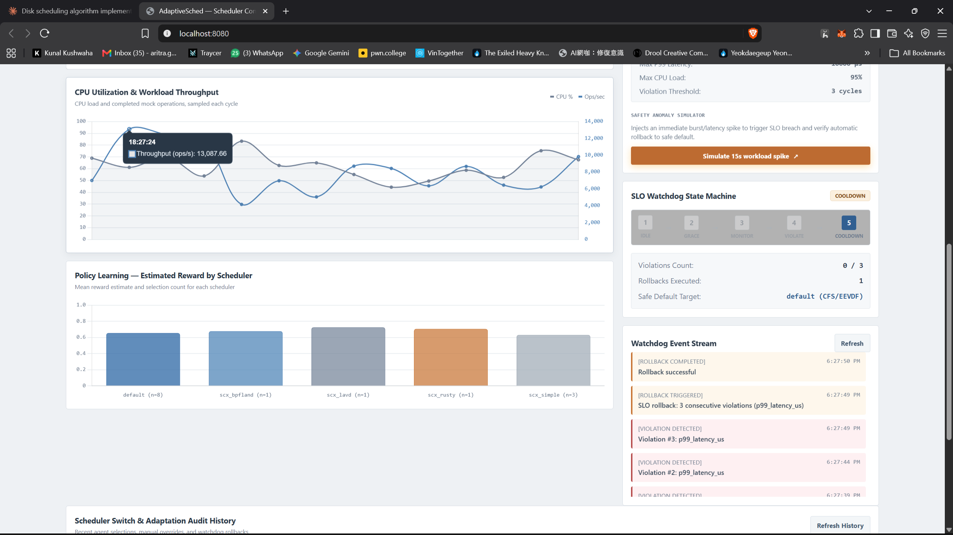
Figure 4: System Performance Dynamics and Watchdog State Pipeline. Middle viewport showing dual-axis CPU/throughput stream, bandit reward distribution, and live event log.
Technical Analysis of Figure 4: Figure 4 captures the middle section of the dashboard. The CPU Utilization & Workload Throughput chart tracks dual-axis trends, with an interactive tooltip indicating a sample throughput of 13,087.66 ops/s. The Policy Learning bar chart visualizes the estimated reward values computed across all 5 candidate schedulers. On the right, the SLO Watchdog State Machine visualizes the 5-state lifecycle with State 5 (COOLDOWN) highlighted in blue. The Watchdog Event Stream audit log documents the exact sequence of safety actions: [VIOLATION DETECTED] Violation #2 and #3, followed by [ROLLBACK TRIGGERED] and [ROLLBACK COMPLETED] Rollback successful.
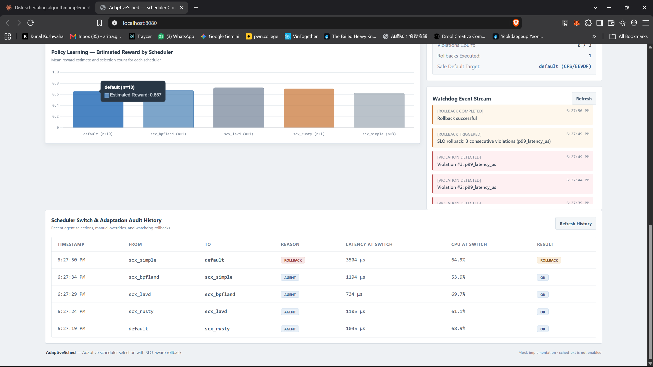
Figure 5: Policy Learning Exploration and Immutable Audit Log. Lower viewport showing arm reward exploration counts and the chronological scheduler transition log.
Technical Analysis of Figure 5: Figure 5 displays the Policy Learning arm estimates and the Scheduler Switch & Adaptation Audit History table. Hovering over the default arm shows an exploration count of n=10 with an estimated reward of 0.657. The audit table maintains an immutable ledger of every scheduler switch: at 6:27:50 PM, a ROLLBACK transition from scx_simple to default is recorded with latency 3,504 μs and result ROLLBACK. Prior autonomous exploration transitions (e.g., scx_bpfland → scx_simple, scx_lavd → scx_bpfland) are logged with reason AGENT and result OK.
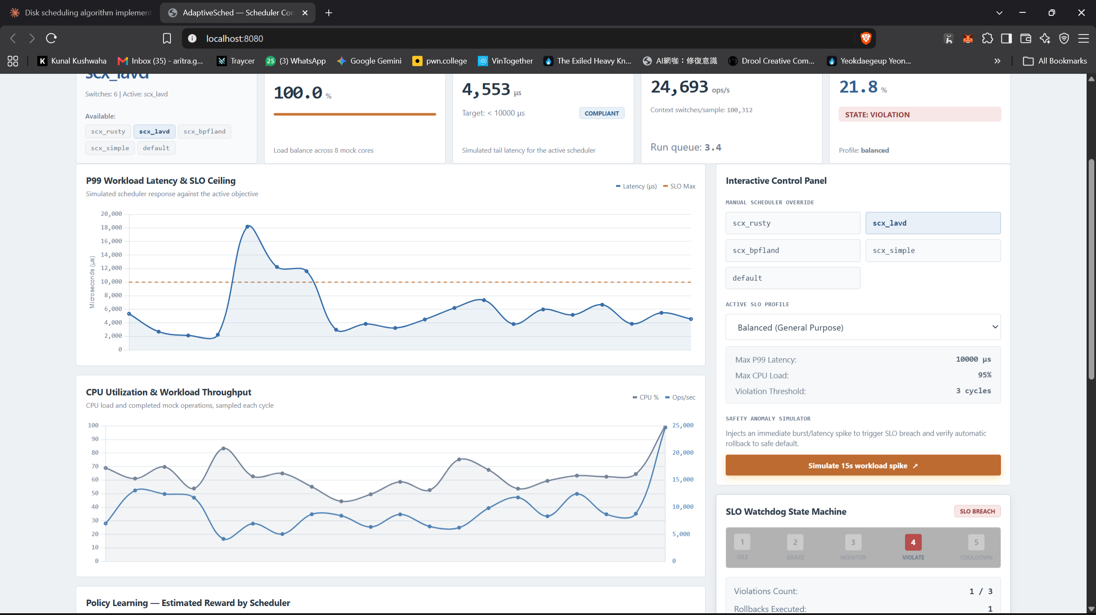
Figure 6: Stress Testing and Extreme Workload Burst Under scx_lavd. Demonstrates operator manual override to scx_lavd, driving CPU utilization to 100% and throughput to 24,693 ops/s.
Technical Analysis of Figure 6: Figure 6 illustrates an extreme workload stress test. The operator used the Manual Scheduler Override panel to force the system to scx_lavd. Under the resulting synthetic workload surge, CPU Utilization reached 100.0%, System Throughput scaled to 24,693 ops/s, and context switches hit 100,312 per sample. The watchdog immediately registered an SLO breach, illuminating State 4 (VIOLATE) in red with an active SLO BREACH pill and recording violation 1 of 3 before re-evaluating.
7. Mathematical Formulation and Bandit Decision Logic
AdaptiveSched formulates scheduler selection as an online Multi-Armed Bandit (MAB) with K candidate policies A = {scx_rusty, scx_lavd, scx_bpfland, scx_simple, default}. At each decision epoch t, the engine computes a scalar reward R_t in [0, 1] from observed system metrics:
MULTI-OBJECTIVE REWARD EQUATION: Reward Formulation:
R_t = w_lat * (1 - L_hat) + w_thr * T_hat + w_cpu * (1 - |C_hat - C_target|)
Where:
• L_hat = min(1.0, L_p99 / L_max) is the normalized scheduling latency (target: minimize latency).
• T_hat = min(1.0, Ops / Ops_max) is the normalized system throughput (target: maximize throughput).
• C_hat = CPU_util / 100 is the normalized CPU utilization evaluated against target C_target = 0.70.
• Default weights: w_lat = 0.40, w_thr = 0.35, w_cpu = 0.25 (normalized sum = 1.0).

The bandit agent selects the next scheduler arm using one of three supported online algorithms:
- 1. UCB1 Policy: Upper Confidence Bound (UCB1 - Default): Balances empirical mean reward with an exploration bonus derived from Hoeffding's Inequality: a_t = argmax_i [ mu_hat_i + c * sqrt(ln(t) / N_i(t)) ], where c = sqrt(2).
- 2. Thompson Sampling: Thompson Sampling: Assumes a Bayesian Gaussian prior over arm reward distributions, sampling from Posterior(mu_i, sigma_i^2) to achieve asymptotic optimality in non-stationary environments.
- 3. ε-Greedy Policy: Epsilon-Greedy: Selects a random exploratory arm with probability epsilon (default 0.10) and exploits the current highest-reward arm with probability 1 - epsilon.
8. Summary of Completed Deliverables (Review 2 Checkpoint)
As of Project Review 2, the following core software components have been implemented, integrated, and verified in the repository:
Subsystem / Module | Component Files | Completed Functionality
Engine & Models | src/core/engine.py, models.py, config.py | Complete decision loop, configuration loader, typed data models, bounded event history.
Watchdog & Safety | src/watchdog/watchdog.py, rollback.py, slo_config.py, health_checker.py | 5-state finite state machine, YAML SLO parser, health checks, zero-downtime rollback.
Bandit Agent | src/agent/mock_agent.py | UCB1, Thompson, ε-greedy arm selection, multi-objective reward computer, statistics tracker.
Metrics Simulation | src/metrics/mock_metrics.py | Per-scheduler Gaussian distributions, sinusoidal workload waves, workload spike injection.
Web Dashboard | src/dashboard/app.py, api.py, index.html, dashboard.css, dashboard.js | Flask 3.0 REST API, dark-mode glassmorphic console, Chart.js line and bar charts.
Command Line Interface | src/cli/main.py, __init__.py | Rich terminal status tables, manual switch, SLO profile selector, switch history.
Test Suite | tests/test_core.py | Unit tests for models, config, watchdog states, agent selection, engine cycles, and API.
Documentation | docs/PRD.md, DEMO_GUIDE.md, PRESENTATION_SCRIPT.md, SIMPLE_EXPLANATION.md | Complete specification, demo guide, presentation script, and plain-English guide.

9. Technical Roadmap and Remaining Work for Review 3
Review 3 Transition Plan: Project Review 3 represents the final transition from the validated user-space control simulation to native Linux kernel integration. The architecture has been deliberately structured with abstract interfaces (IMetricsCollector and ISchedulerManager) so that production kernel drivers can drop in without altering the decision engine or watchdog.
Milestone | Target Subsystem | Technical Deliverable & Implementation Plan
Milestone 1 | Kernel Metrics Collector | Implement C-based metrics collector reading /proc/stat, /proc/schedstat, and hardware performance counters via perf_event_open() (IPC, cache miss rates). Build ctypes zero-copy Python bridge.
Milestone 2 | Native sched_ext Manager | Implement LinuxSchedulerManager interacting with sched_ext via libbpf/bpftool. Dynamically load and switch scx_rusty, scx_lavd, and scx_bpfland BPF schedulers at runtime with kernel safety checks.
Milestone 3 | Benchmarking Suite | Build automated benchmarking harnesses to evaluate AdaptiveSched against static CFS/EEVDF using standard workloads: Linux kernel compilation (make -j), Hackbench, and video transcoding.
Milestone 4 | Evaluation | Measure and graph scheduling latency reductions, throughput improvements, and rollback response times.

9.1 Detailed Implementation Plan for Milestone 1 (C Metrics Collector)
Under Module A (led by Aritra Ghosh), the production metrics collector will be compiled as a shared C library (libmetrics.so). It will execute in a dedicated POSIX thread, sampling /proc/schedstat every 100 ms to calculate run-queue wait latency and utilizing perf_event_open() to capture hardware retired instructions and cache misses with sub-microsecond overhead. The Python ctypes bridge will read struct SystemMetrics directly from memory without serialization cost.
9.2 Detailed Implementation Plan for Milestone 2 (sched_ext BPF Manager)
Under Module B (led by Arjun Tyagi), the production LinuxSchedulerManager will implement ISchedulerManager by interfacing with the Linux 6.12 sched_ext sysfs/bpf control interfaces. Scheduler transitions will be executed by terminating the active BPF scheduler process and launching the target scheduler binary (e.g., scx_rusty --autopower). The watchdog's 5-second grace period guarantees that thread run-queues rebalance before performance monitoring resumes.
10. Repository Sources and Review Verification
The complete source code, configuration files, test suites, and documentation are hosted on GitHub at:
GITHUB REPOSITORY ACCESS: Repository URL: https://github.com/SilentFURY-x/AdaptiveSched
Active Development Branches: dev | aritra
Primary Commit Reviewed: 31f916a (docs: update assets)
Access Status: Public / Open for Reviewer Evaluation

To verify the submission locally:
git clone https://github.com/SilentFURY-x/AdaptiveSched.git
cd AdaptiveSched
python -m pip install -r requirements.txt
python -m unittest discover tests
python run_demo.py

