Product Design
Team Name | Elite
Project Name | Elektoo
Team Members | Aman Rai  Ayushi Goyal  Prachi Agrawal  Vinay Singh

Design Model
Search | Class state  - Generate a concrete query from the input typed in by the user.  Class behavior  - Method named “Generate_query is implemented by this class.
Search Query Box | Class state  - Process the query given by user as per the search query box parameters.  Class behavior  - Methods implemented includes auto-correct, auto-complete, spelling and grammar check, ambiguous query resolving.
Choice Matrix | Class state  - Process the query as per the selection/deselection by the user in the choice matrix.  Class behavior  Methods implemented includes  - updating the matrix on every select and deselect in the choice matrix  - Restore the initial state of the matrix on user's choice.
User | Class state  - Provides an option before the user to select the mode of search i.e. “search query box” or “choice matrix”.  Class behavior  Methods implemented includes  - Retrieving information from the system as per the user's wish.
Query | Class state  - Provides methods for formulating the user input into a concrete query to fetch data from the database.  Class behavior  Methods implemented includes  - Tokenization is splitting entire sentence into individual words to formulate the query and normalization is simply converting the entire query into lowercase english alphabets.
Display | Class state  - Displaying the desired results as per user's wish.  - Also displaying the count of available results corresponding to user's input query.  Class behavior  Methods implemented includes  - “Search_results” and “count_results”.
System | Class state  - To update the database (as per the earning system requirements).  - Fetching results from the database .  Class behavior  Methods implemented includes  - “update_database” to update the database, “Render_results” to get the results for the input query.
.
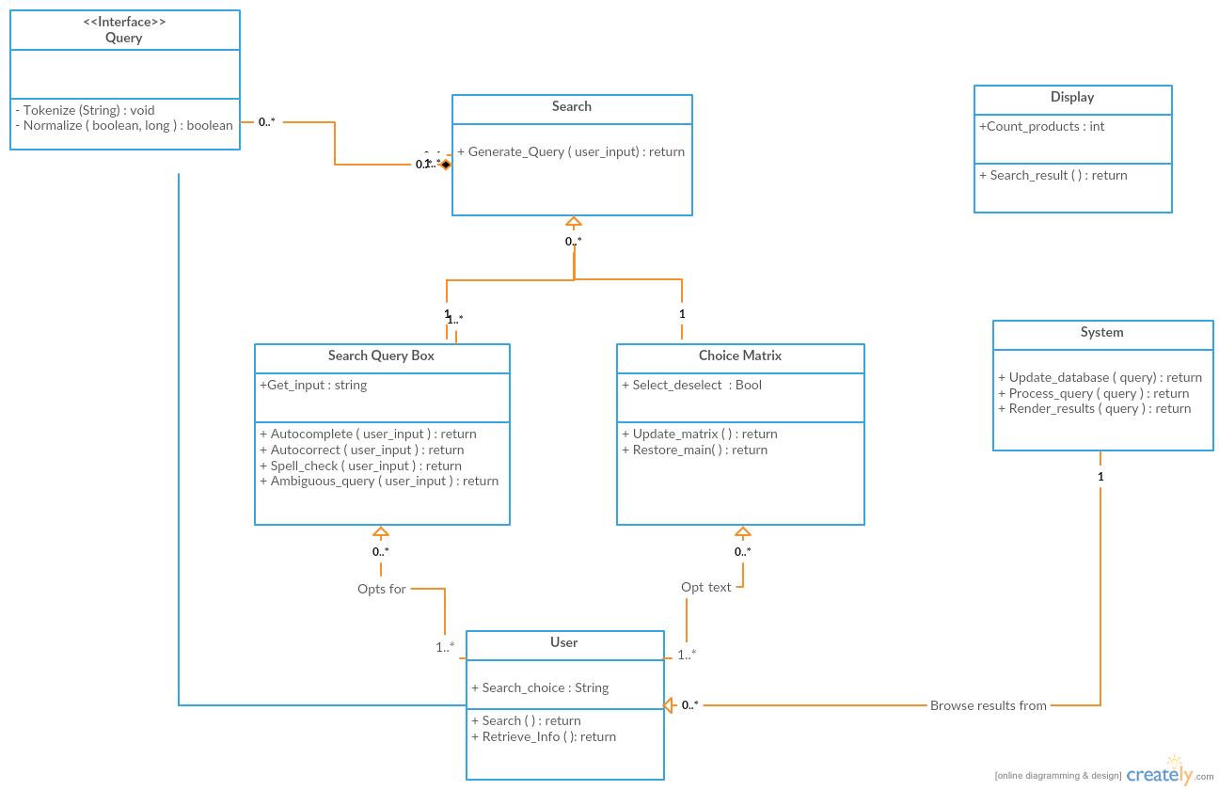

Sequence Diagram(s):

Autocomplete
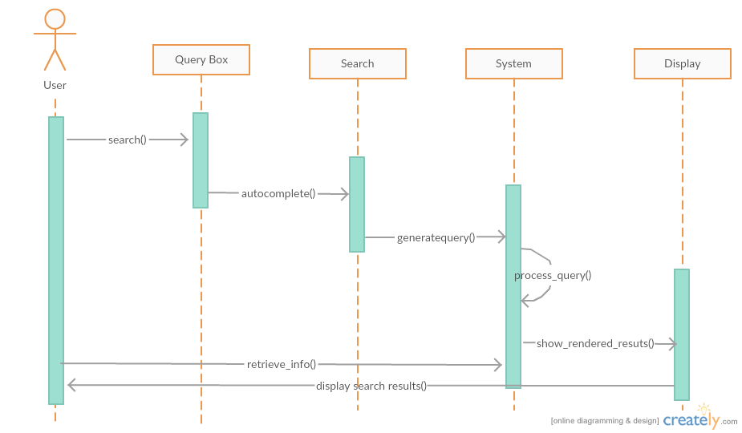

Autocorrect
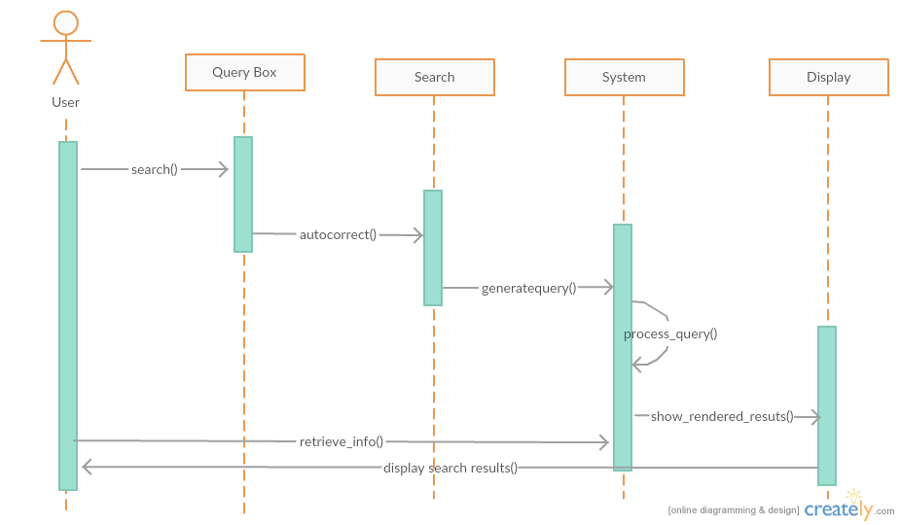

Resolve Ambiguity
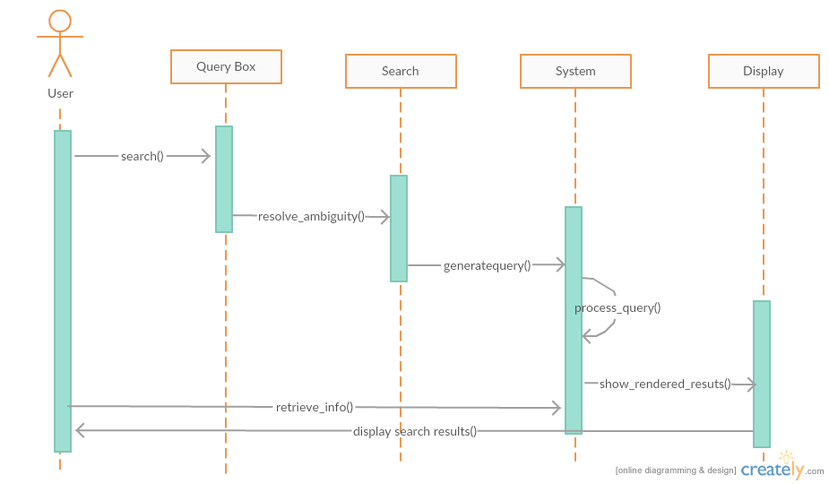
Update matrix
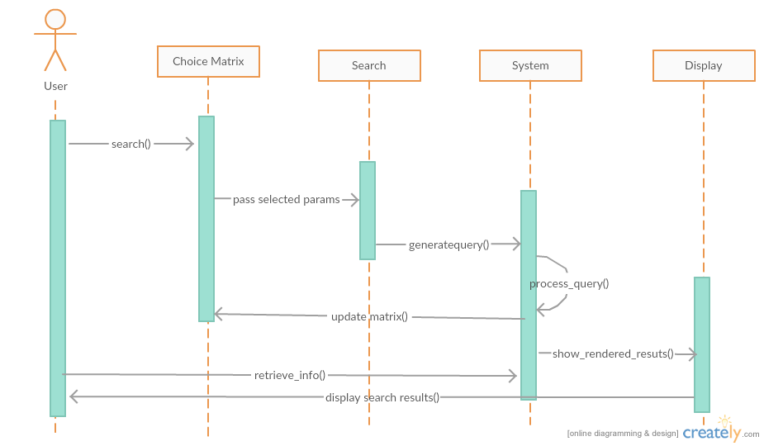

Design Rationale

Processing The Query

For project “Elektoo” it is required for us to implement a search query box and a choice matrix which will be helpful for the customers to navigate through commodities (mainly mobile phones for now) in E-commerce .
The main problem related to the search box was to generate an algorithm which could convert the input given by the user into rationale sql query to fetch results from the database . This step involves two processes -

a) Tokenization (along with normalization)

b) Parametrization
The search query is then tokenized and individual words are stored as the elements of an array. This can be achieved by splitting the query considering white-spaces as delimiter. One important assumption is that the the query will have rationale keywords separated by a space i.e. the user is will not make mistakes while giving the input.
Next, we need to identify the list of important parameters for a given commodity and store their index. A mobile phone for example will have company name,brand name , price , camera size and many other parameters.
These parameters will have a list of identifiers to detect them . For example 'price' parameter will have a list which will contain “related” keywords like { amount , rs, money} as identifiers.
After identifying all the parameters , operators associated with these parameters are searched for . The operators are identified through keywords. For example '<' operator is identified by keywords {less than, below, under, etc}. An important assumption made here is that operators associated with a parameter will be present in a given range of the parameter index. The value of the parameters is then looked for using the same logic as operators. The values are stored in a matrix and the query is generated using this matrix.
The matrix generated will roughly contain 3 rows namely as Parameter , operator and values

Example- “Asus phone below 20000rs and camera-size 5px”

Parameter | phone | Price | Camera-size
Operator | '=' | < | '='
Values | Asus | 200000 | 5

The above matrix could be implemented in the following way-
We will create a JSON object for each of the parameter values and enter the 'operator - value' pair at a given specific index . In this way multiple operator query could be resolved. A simple example will clear it further .

Asus phone having price between 10000 and 20000.

In this example we have a keyword “between” which implies both '>=' and '<=' so we can resolve this by creating a simple JSON object of parameter 'price'

var Price={
price:[
{operator :'<',value:20000},
{operator :'>',value:10000}

]
}
Price.price[0].operator and Price.price[0].value will give us the operator , value pair if we have multiple operators for a parameter.

While processing a query if we come across a parameter with no value then we do not consider it for quering .

For example – Phone with price lessthan 20000 rs
Here parameter phone does not have a value , therefore we do not create a JSON object for it . Therefore our query will just result into .
“select * from <tablename> where 'price' < 20000 rs”
Regarding the case with “parameter but no value”,
while processing the query, if we encounter that there is no value corresponding to a parameter, then we will simply set the operator as “!=” i.e. “not equal to” and the corresponding parameter values as “NULL”.
For example, let the query be “ Coloured phone with 10mp camera “
Here the parameters identified will be “color” , “phone” and “camera”.
As for the parameters “color” and “phone” , there are no specifications mentioned,
the corresponding json object for these parameters will look like,

var Color={

color:[

{operator :'!=',value:NULL},

]

}

var Phone={

phone:[

{operator: “!=”, value:NULL}

]

}
var camera={

camerasize:[

{operator: “=”, value:10mp}

]
}
So the resultant query will be of the form -
“select * from <tablename> where color!=NULL and phone!=NULL and camerasize=”10mp”;
This will make sure that the specified parameter ( for which the value isn’t mentioned) should be present in the final results fetched.

Now consider a typical use-case.

Samsung Phone with price less than 10000rs and color blue or white
We can process the text and identify for the keyword 'or' if there exits any then we can split the query into parts , run all of these individually and concatenate the final results obtained .
We can split it into two parts around 'or'
Samsung Phone with price less than 10000rs and color black
Samsung Phone with price less than 10000rs and color blue.
Query both the statements individually. Then Concantenate the final result.
This is what typically happens when query is made to the database.

The query is then generated by going through each of these JSON objects .
To generate the query, we initialize a string “s” as -
s=”select * from <tablename> where “;
Now we start building up the query by joining the parameter value with 'where' clause and then appending the corresponding operator and value pair
For example in the case mentioned above , the query will be built up as
s=”select * from <tablename> where phone=”Asus” and”;
then again iterating for the second parameter and so on , the entire concrete query is built up.

Correction of misspelt words
We can possibly apply some heuristic approach in which we could save all the
misspelt words and map it to a single correct word .
In this way we will have a N-1 mapping for misspelt words with the correct words
The list of all these misspelt words can have a possible list of keywords .
Let's consider a simple Example .
{Sam,Sung,Sasung}
Sasung
Samsug Samsung
Samnung
Sanung
The list of misspelt words could also be updated with user inputs.
The keywords stored for this mapping could be used for auto-correction as well.

Resolving Ambiguity
Our system will have a fixed set of predefined “ambiguous words” along with their specific “meaning” stored as key-value pairs in a dictionary object. For example,
for the parameter “camerasize” the dictionary would look like
{ “big”: [ {operator: “>=”, value:”10mp”}, {operator:”<=” , value:”12mp”} ] ,
“small”:[ {operator: “>=”, value:”2mp”}, {operator:”<=” , value:”4mp”} ]
}
Now when the user types “ Samsung phone with big camera size”, the “big” keyword would be identified corresponding to the parameter camera size. So the json object for parameter “camerasize” would get assigned its value from the above mentioned dictionary object.

Assumptions for query algorithm:

1. All words should be space separated, i.eSam. the query should not be of the form,“ Samsungphonewith price less then2000rs”.
2. Autocomplete feature woould not be implemented on “sentence level”. i.e. if user types “ Samsung phone with “, then there won’t be query completion as
“Samsung phone with price 10000 rs” or “Samsung phone with 13mp camera” , etc.
Although autocomplete would be available to complete a “word”. For example,
if user types “Sam” then a dropdown list would pop up with suggestions of the words having “Sam” as the prefix in them.
e.g. “sam”
samsung .However this search would also be at a restricted level. For example is the user types only “s” then there won’t be any suggestions for word completion. The user is required to type at least a minimum of around 3 or 4 characters for the system to identify the “related words”.
3. There should not be any spelling error in the query typed by the user.
e.g. “ samsumg phone below 20000 rs”.
Although our search engine would display a list suggested words (as mentioned in the previous point) , but is user’s wish to either correct the word by utilizing the suggestions or ignore the suggestions.
4. It is assumed that the query that the user types is in context with the system’s database.
The query should not contain junk words, as it would lead to ambiguity while processing it.
For example, as our database is restricted to “mobile phones” ,so the user is not expected to give the query as “ Television with price less than 40000 rs.”
5. Images related to the product will not be displayed in the first place (as is a case in

search engines like”google”) . Image and “other details” about a product would only be available once the user clicks on the link for that product. The initial display would only contain links for specific products.
6. There should not be repetition of words in the query, e.g. “ Samsung phone phone with 12 mp camera”.
7. Only english language would be supported by the system.
8.) We have build the Algorithmn in such a way that parameters are very necessary to be identified for further processing . These Parameters are identified by their identifiers . For example 'price' parameter is identified by {rs,amount,money,amt,price}. Now if we have a query like Samsung Phone under 20000 as you have mentioned, we can't identify what '20000' is specifically.
But,Since we are clear with domain and it is only for mobile phones. We can create a list of important keywords which could be mapped to a relevant parameter.
For Example- an Integer greater than 2000 could be price.
a string referring 'blue,black,brown' could be phone color.
a string referring 'Samsung,Asus' or any company name will be phone name and so-on.

9.) One major assumption for our application is that we will “always fetch all the columns from our database for the given specifications”.
For example, if the user types “ model numbers of all samsung phones” or “ available camera sizes for all apple phones”, then our applications won’t only fetch the “model numbers” or “camera sizes” respectively, but also our parameter values like “brand name”, “price”, etc .
10.) As far as resolving the ambiguity is concerned, only the ambiguous words present in our predefined dictionary object will get resolved . No other ”foreign term”(the term not present in our predefined list) would be taken care of.

Choice Matrix:
Assumptions:
- Initially Implementing only for phones.
- Prices will have ranges, and rest of all rows will have exact values.
- After selection/deselection all the other unselected rows(i.e whose “selected” variable is “False”) will get updated.
- Updation here means the output of the newly altered query for each row which will include the conditions of the selected tabs.(changing the values of the non-selected rows based on the selected rows)
- If number of results of any query will be more than 5 then using some heuristic algorithm we'll select the best 5 to be displayed in the matrix.
- If the result of any query is 'k' which is less than 5 for any row then the first 'k' tabs of the row will get updated and the rest (5-k) will be the same as previous state tabs but are now disabled.
- On selection of the product the variables row1, row2, row3,.... will get the values Price, Camera-size, Screen-Size,.... as per mentioned in the product list, here for phones.
Constraints:
- User can select only one tab from a row at a time.
- On selection of a tab in a row, that tab will be highlighted.
- On selecting the next tab from any other row the previous unhighlighted tabs which do not match with the newly selected tab of the previously selected rows will be disabled so that the user cannot switch between those tabs in the previous selected rows.
- User can switch between tabs only in those selected rows where there are some non-disabled tabs in the row.

The main thing here in the Choice Matrix is the initial filling of the Matrix and then updation of matrix on every selection/deselection of any tab in any row.
First things first, when the Matrix of a product is initially displayed-
- The first row only the Price will be having values of the tab in ranges.
- Initially the “selected” variable of all the rows will be kept “False” i.e no tab is selected from any row.
- A query is made for all the rows “select row1 from <table-name>” and limit it only to 5 values.
Product(here phone) brand specifications-
Taking example of let's say Samsung phone.
- will have phone of price range from 5k to 30k.
- Low_price=5k, high_price=30k, range_size=(30-5)/5=5.
- Hence row ranges will be (5+n*5)k-(5+5*(n+1))k where n=0,1,2,3,4.
Initial state of matrix will be something like:
Price | 5-10k | 10-15k | 15-20k | 20-25k | 25-30k
Camera | 2Mpx | 4Mpx | 8Mpx | 12Mpx | 15Mpx
Screen-Size | 4” | 4.7” | 5.3” | 5.7” | 7”
RAM | 512MB | 1GB | 2GB | 4GB | 8GB
Internal-Memory | 2GB | 4GB | 8GB | 16GB | 32GB
color | Gray | Black | White | Metallic | Red
... | ... | ... | ... | ... | ...
... | ... | ... | ... | ... | ...
... | ... | ... | ... | ... | ...
Whenever a tab is selected in any row, its value/range is get stored in a variable specific to that row.
The “selected” variable is also made “True” and the rest tabs of the row are made disabled.
Now to update the matrix as per the selected tabs the following steps will be followed:
- Check whether the “selected” variable of the row is “True/False”.
- If “True” then, include that row's variable value in the constraints to be made in the query we use to update the rest of the rows.
- If “False” the leave the row as it is.
- Once the above three is done we'll have all the variables of specific seleted rows which are to be used as constraints.
- Now again start from row[0].
- If “selected” variable of the row is “True”, run the query and disable those non-selected tabs which do not satisfy the selected features.
- If “selected” variable of the row is “False”, run the query on the row and display the new updated results as per the assumptions #5, #6.
- End. We'll get the updated matrix as per the selected row tabs.

The user selects tabs in the initially generated matrix . After each selection a query is generated. The query includes the values of the selected features. The query is run for all the rows. In case the row has selected values, the non-selected values of that row that do not satisfy the selected rows will be disabled. If the row is does not have any selected values, the values of that row are updated based on the results of the query.
For eg.
User searching for a phone : Samsung phone in between 10-15k having 8Mpx camera and “gray” in color.
First the user will select Samsung brand from the list of product brands.
Then the user is displayed with a matrix having the configuration same as mentioned above.
When the user selects the 10-15k tab in the price row. Query runs for all the other rows as per the selected constraints from the price row. The selected tab will be highlighted and rest will remain unhighlighted but can be accessible i.e. can be switched to.

The new state of the Matrix will be something like:
Blue: Selected
Grey: Unhighlighted
Black: Disabled
Price | 5-10k | 10-15k | 15-20k | 20-25k | 25-30k
Camera | 2Mpx | 4Mpx | 8Mpx | 12Mpx | 15Mpx
Screen-Size | 4.7” | 5.7” | 6” | 6.7” | 7”
RAM | 2MB | 4GB | 8GB | 4GB | 8GB
Internal-Memory | 4GB | 8GB | 16GB | 32GB | 64GB
color | Gray | Black | White | Metallic | Red
... | ... | ... | ... | ... | ...
... | ... | ... | ... | ... | ...
... | ... | ... | ... | ... | ...

Now we select the grey tab from the color row. Which will update the rows having no tabs selected and disable all the unselected tabs in the rows where there is any selected tab already.
The new state of the Matrix will be something like:
Price | 5-10k | 10-15k | 15-20k | 20-25k | 25-30k
Camera | 2Mpx | 4Mpx | 8Mpx | 12Mpx | 15Mpx
Screen-Size | 5” | 5.7” | 6” | 6.7” | 7”
RAM | 2MB | 4GB | 8GB | 4GB | 8GB
Internal-Memory | 4GB | 8GB | 16GB | 32GB | 64GB
color | Gray | Black | White | Metallic | Red
... | ... | ... | ... | ... | ...
... | ... | ... | ... | ... | ...
... | ... | ... | ... | ... | ...

Similarly the user keeps on selecting the tabs of the specific rows and the matrix keeps on Updating as per the selected tabs of the rows.
When the User clicks to the search button he will be redirected to the list of items fetched using the specified constraints from the rows tabs.
On click on any of the listed items complete description of the product will be displayed to to user.

