Module 1
Java OOP(Object Oriented Programming) Concepts
Object-Oriented Programming (OOP) is a programming paradigm based on the concept of objects that contain data (fields) and behavior (methods). It focuses on designing software that closely represents real-world entities. It is used to:
- Improves code reusability
- Enhances maintainability and scalability
- Makes programs easier to understand and manage
- Closely models real-world entities
Characteristics of an OOP(Object Oriented Programming)
The diagram below demonstrates the Java OOPs Concepts
OOP's concept
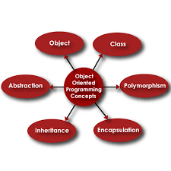
Class
A Class is a user-defined blueprint or prototype from which objects are created. It represents the set of properties or methods that are common to all objects of one type. Using classes, you can create multiple objects with the same behavior instead of writing their code multiple times. In general, class declarations can include these components in order:
- Modifiers: A class can be public or have default access (Refer to this for details).
- Class name: The class name should begin with the initial letter capitalized by convention.
- Body: The class body is surrounded by braces, { }.
Example: A Car represents a class (blueprint), while BMW, Mercedes, and Audi represent objects (instances) created from that class.
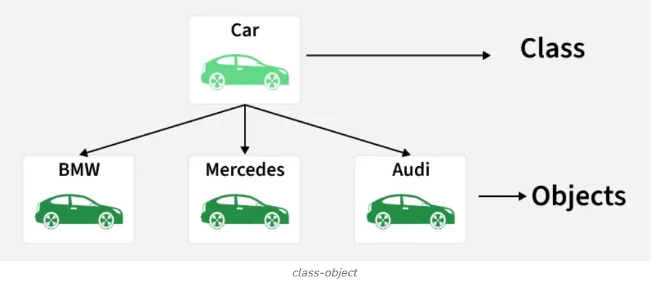
Object
An Object is a basic unit of Object-Oriented Programming that represents real-life entities. A typical Java program creates many objects, which as you know, interact by invoking methods. The objects are what perform your code, they are the part of your code visible to the viewer/user. An object mainly consists of:
- State: It is represented by the attributes of an object. It also reflects the properties of an object.
- Behavior: It is represented by the methods of an object. It also reflects the response of an object to other objects.
- Identity: It is a unique name given to an object that enables it to interact with other objects.
- Method: A method is a collection of statements that perform some specific task and return the result to the caller.
Abstraction
Abstraction in Java is the process of hiding implementation details and showing only the essential features of an object. It helps users focus on what an object does rather than how it does it.
- Hides complexity: Internal implementation details are hidden from the user.
- Improves maintainability: Changes in implementation do not affect the user code.
- Enhances flexibility: Supports loose coupling through abstract classes and interfaces.
Example: An ATM or a coffee machine represents abstraction, where the user interacts with simple operations while the internal working and implementation details remain hidden
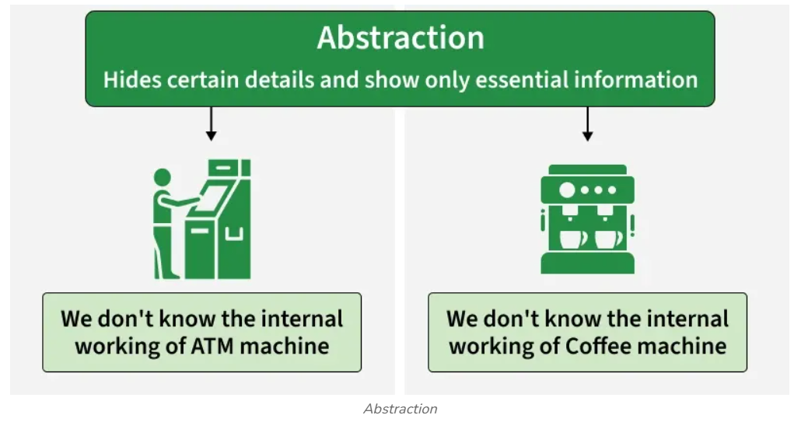

How to Achieve Abstraction
- It is achieved in Java using abstract classes and interfaces.
- Interfaces can provide 100% abstraction, while abstract classes provide partial abstraction.
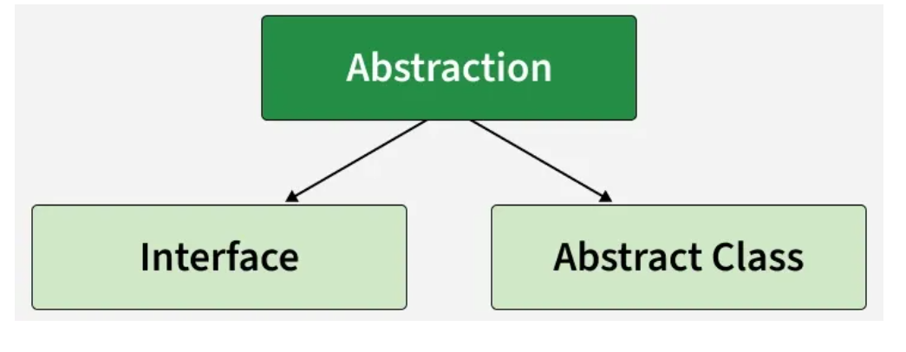
Encapsulation
Encapsulation is the process of wrapping data and methods into a single unit, usually a class, and restricting direct access to the data. It acts as a protective shield that prevents data from being accessed directly from outside the class.
- Data members are hidden using the private access modifier.
- Access to data is provided through public getter and setter methods.
- It improves data security, maintainability, and controlled access.
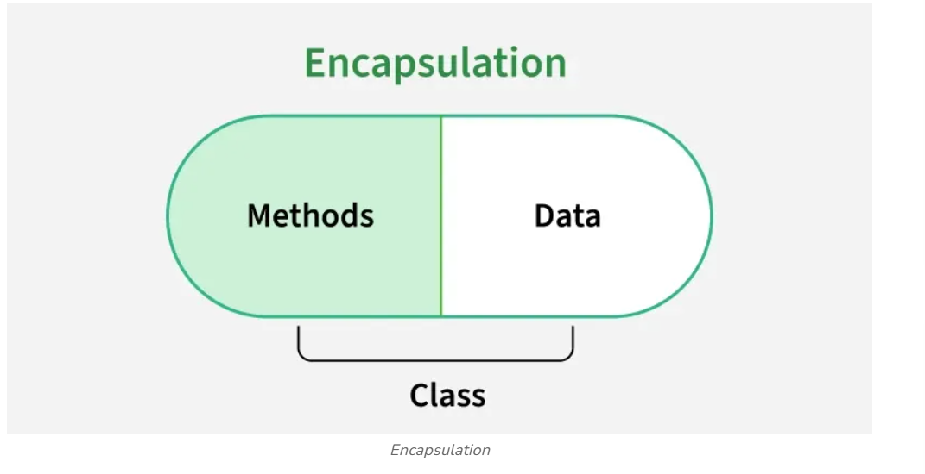
Association
Association is an OOP concept that defines a relationship between two or more classes that are connected to each other. It represents how objects interact with each other and communicate. In association, objects of one class are related to objects of another class, but they can exist independently.
- Represents a relationship between objects
- Does not imply ownership
- Objects are independent of each other
- Helps in building flexible and modular systems
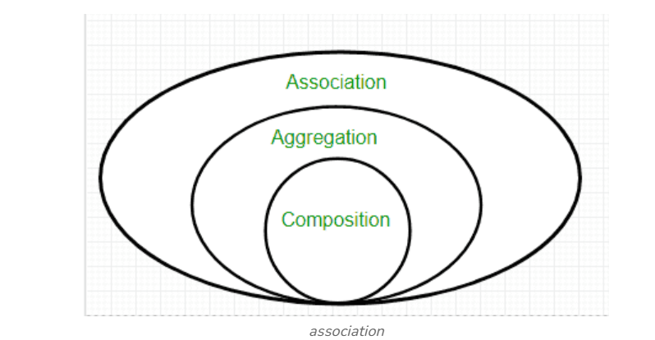
Types of Association
Association in Java can be further classified into the following types:
1. Aggregation (Weak Association)
Aggregation represents a “has-a” relationship where one class contains a reference to another class, but both can exist independently.
- It is a weak relationship
- Objects have independent lifecycles
- One object can exist without the other
- Example: A Department has Employees, but employees can exist even if the department is removed
2. Composition (Strong Association)
Composition is a strong form of association where one class owns another class. If the parent object is destroyed, the child object also gets destroyed.
- It is a strong relationship
- Objects have dependent lifecycles
- Child object cannot exist without the parent
- Example: A Car has an Engine
Inheritance
Inheritance is a core OOP concept in Java that allows one class to acquire the fields and methods of another class using the extends keyword. It represents an “is-a” relationship between classes.
- The class being inherited is called the superclass, and the inheriting class is the subclass.
- A subclass can use existing features of the superclass and also add its own.
- Inheritance promotes code reusability and reduces redundancy.
Example: Dog, Cat, Cow can be Derived Class of Animal Base Class.
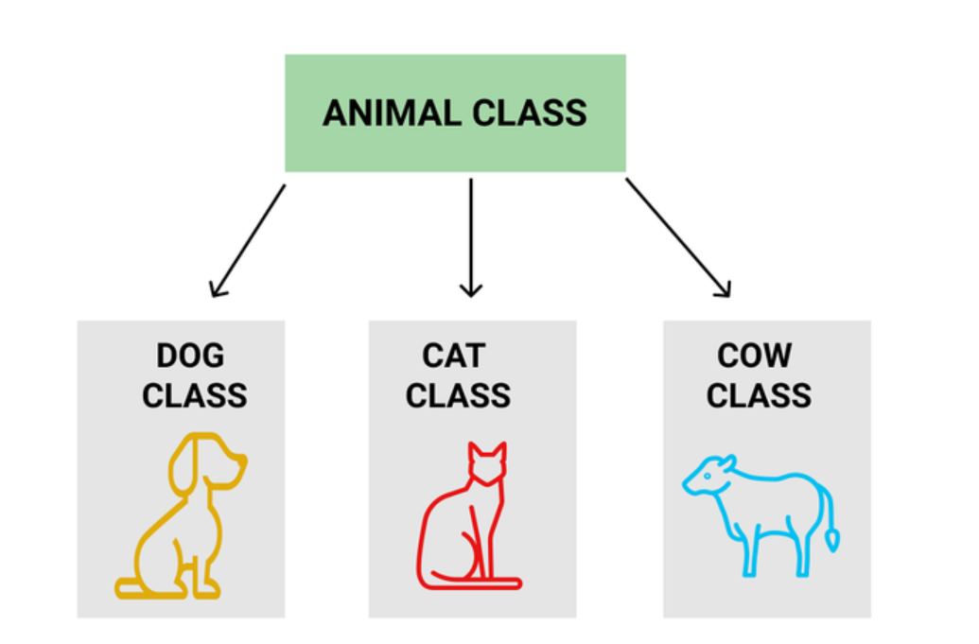
Types of Inheritance in Java
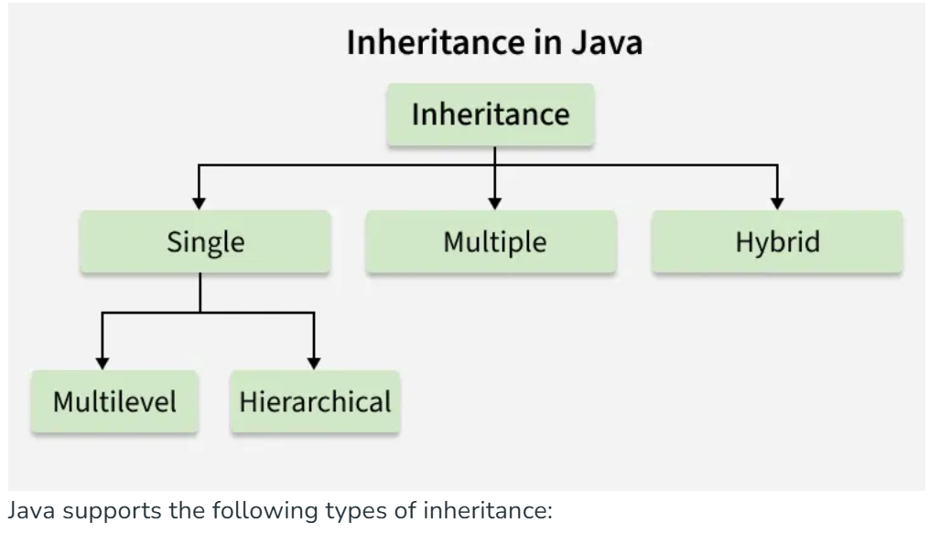
Java supports the following types of inheritance:
- Single Inheritance: One subclass inherits from one superclass.
- Multilevel Inheritance: A class is derived from another derived class, forming a chain.
- Hierarchical Inheritance: Multiple subclasses inherit from a single superclass.
- Multiple Inheritance (through Interface): A class inherits from multiple interfaces since Java does not support multiple inheritance using classes.
- Hybrid Inheritance (through Interface): A combination of two or more types of inheritance, achievable using interfaces.

Polymorphism
- The word polymorphism means having many forms, and it comes from the Greek words poly (many) and morph (forms), this means one entity can take many forms. In Java, polymorphism allows the same method or object to behave differently based on the context, specially on the project's actual runtime class.
- 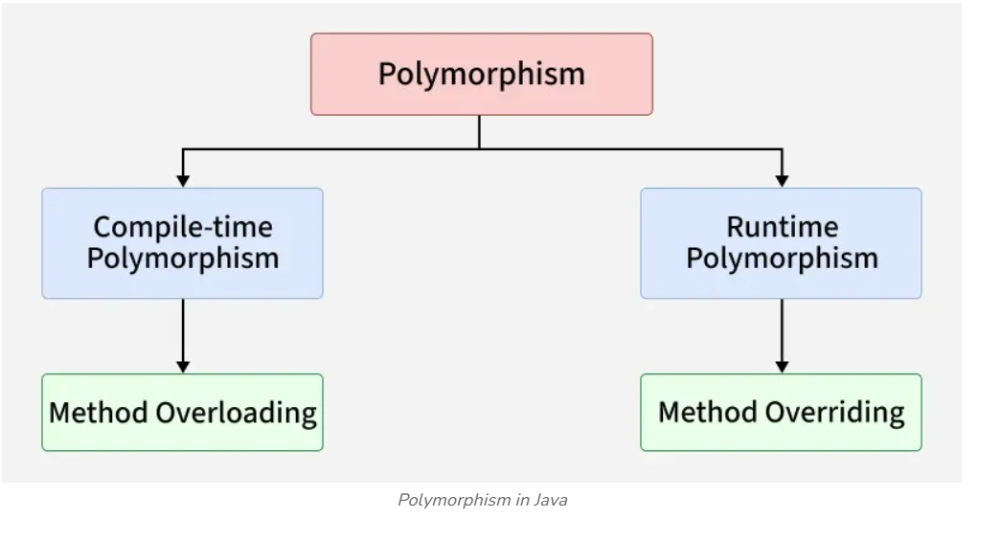
Types of Polymorphism
Polymorphism in Java is mainly of 2 types as mentioned below:
1. Compile-time Polymorphism(Method Overloading) :Achieved when multiple methods have the same name but different parameters. The method call is resolved at compile time.
2. Runtime Polymorphism (Method Overriding ): Achieved when a subclass provides a specific implementation of a method already defined in its superclass. The method call is resolved at runtime based on the object
Advantage of OOP over Procedure-Oriented Programming Language
Object-oriented programming (OOP) offers several key advantages over procedural programming:
- Code reusability: Classes and objects allow reuse of existing code, reducing duplication and improving efficiency.
- Better structure and maintainability: Programs are organized into logical units, making code easier to understand, debug, and maintain.
- Supports DRY principle: Common functionality is written once and reused, leading to cleaner and more maintainable code.
- Faster development: Modular and reusable components help in quicker and scalable application development.
Disadvantages of OOP
- Steep learning curve: Concepts like classes, objects, inheritance, and polymorphism can be difficult for beginners.
- Overhead for small programs: OOP may require more code and structure than necessary for simple applications.
- Debugging complexity: Code spread across multiple classes and layers can make debugging more time-consuming.
- Higher memory usage: Creating many objects can consume more memory compared to procedural programs.
//Structure of a java program
A standard Java program follows a strict hierarchical structure, beginning with optional declarations and moving into mandatory class definitions that contain logic.
Core Structure of a Java File
A typical Java source file (.java) is organized into the following sections in this exact order:
- Documentation Section (Optional): Used for comments to explain the program's purpose, author, and date. You can use single-line (//), multi-line (/* ... */), or Javadoc comments (/** ... */).
- Package Declaration (Optional): Defines a namespace for the class, helping to organize related classes and avoid name conflicts. It must be the first statement if used (e.g., package com.example;).
- Import Statements (Optional): Links your code to other Java classes or packages from the standard library or custom sources (e.g., import java.util.Scanner;).
- Interface Section (Optional): Used if the program requires defining specific constants or method signatures that other classes must follow.
- Class Definition (Mandatory): The primary container for all code. Every Java program must have at least one class. The filename must match the name of the public class within it.
- Main Method (Mandatory for Applications): The entry point where execution begins. Its standard signature is:
public static void main(String[] args)
/**
* Documentation Section: Simple calculator program
* Author: Your Name
*/

package com.myproject; // Package Declaration

import java.util.Scanner; // Import Statement

public class Calculator { // Class Definition

// Class Variables (Data Members)
static String operationName = "Addition";

public static void main(String[] args) { // Main Method
Scanner input = new Scanner(System.in);
System.out.println("Entering " + operationName);

// Local Variables and Statements
int a = 10;
int b = 20;
int result = add(a, b);

System.out.println("The result is: " + result);
}

// User-defined Method
public static int add(int x, int y) {
return x + y;
}
}
Detailed Explanation
Java, initially named Oak, was created by James Gosling for Sun Microsystems in 1991 and later acquired by Oracle. Renamed Java symbolizes James Gosling, Arthur Van Hoff, and Andy Bechtolsheim. Java follows the "Write Once, Run Anywhere" principle as an object-oriented, platform-independent language, compiling code into bytecode. JVM translates bytecode into machine code for execution, enabling Java programs to operate seamlessly across diverse systems.
It is essential to understand the structure of Java program. With a defined syntax, Java ensures portability, security, and ease of debugging, embodying high-level language principles.
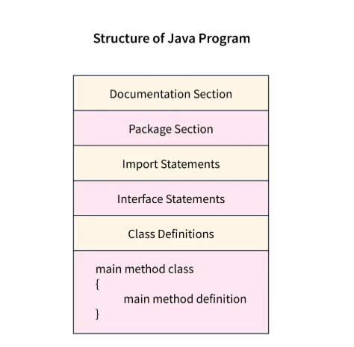

A Java program typically consists of the following components:
- Documentation Section
- Package Declaration
- Import Statements
- Interface Section
- Class Definition
- Class Variables and Variables
- Main Method Class
- Methods and Behaviors
Documentation Section
The documentation section in the structure of a Java program serves as a vital but optional part of a Java program, providing essential details about the program. This includes the author's name, creation date, version, program name, company name, and a brief description. While these details enhance the program's readability, the Java compiler ignores them during program execution. To include these details, programmers typically use comments.
Comments are non-executable parts of a program. A compiler does not execute a comment. It is used to improve the readability of the code.
Writing comments is a good practice as it improves the documentation of the code. There are three different types of comments- single-line, multi-line, and documentation comments.
- Single line comment- It is a comment that starts with // and is only used for a single line.
//Single-line comment
- Multi line comment- It is a comment that starts with /* and ends with */ and is used when more than one line has to be enclosed as comments.
/* Multiline comment
in Java */
- Documentation comment- It is a comment that starts with /** and ends with */
/** Documentation comment */
Package Declaration
Declaring the package in the structure of Java is optional. It comes right after the documentation section. You mention the package name where the class belongs. Only one package statement is allowed in a Java program and must come before any class or interface declaration. This declaration helps organize classes into different directories based on the modules they're used in. You use the keyword package followed by the package name. For instance:

package scaler; //scaler is the package name
package com.scaler; //com is the root directory, and scaler is the subdirectory
In Java, we have to save the program file name with the same name as the name of public class in that file.
The above is a good practice as it tells JVM which class to load and where to look for the entry point (main method).
The extension should be java. Java programs are run using the following two commands:
javac fileName.java // To compile the Java program into byte-code
java fileName // To run the program
Import Statements
Import statements are used to import classes, interfaces, or enums that are stored in packages or the entire package. A package contains many predefined classes and interfaces.
We need to mention which package we are using at the beginning of the program. We do it by using the import keyword. We either import the entire package or a specific class from that package.
The following is the description of how we can write the import statement.
import java.util.*; //imports all the classes in util package
import java.util.StringTokenizer; // imports only the StringTokenizer class from util package

Explanation-
We have imported java.util package in the first and second lines we have imported only the StringTokenizer class from java.util package.
Interface Section
This is an optional section. The keyword interface is used to create an interface. An interface comprises a set of cohesive methods that lack implementation details., i.e. method declaration and constants.
interface Code {
void write();
void debug();
}
Explanation-
In the above code, we have defined an interface named Code, which contains two method declarations, namely write() and debug(), with no method body. The body of abstract methods is implemented in those classes that implement the interface Code.
Class Definition
This is a mandatory section in the structure of Java program. Each Java program has to be written inside a class as it is one of the main principles of Object-oriented programming that Java strictly follows, i.e., its Encapsulation for data security.
There can be multiple classes in a program. Some conventions need to be followed to name a class. They should begin with an uppercase letter.
class Program{
// class definition
}
Class Variables and Variables
Identifiers are used to name classes, methods, and variables. It can be a sequence of uppercase and lowercase characters. It can also contain '_' (underscore) and '$' (dollar) signs. It should not start with a digit(0-9) and not contain any special characters.
Variables are also known as identifiers in Java. It is a named memory location which contains a value. In a single statement, we're able to declare multiple variables of the same type.
Syntax:
<Data-Type> <Variable Name> or <Data-Type> <Variable Name> = value;
Example:
int var=100;
int g;
char c,d; // declaring more than one variable in a statement
Rules for Naming a Variable-
- A variable may contain characters, digits and underscores.
- The underscore can be used in between the characters.
- Variable names should be meaningful and depict the program's logic.
- Variable names should not start with a digit or a special character.
Main Method Class
This is a compulsory part of the structure of Java program. This is the entry point of the compiler where the execution starts. It is called/invoked by the Java Virtual Machine or JVM.
The main() method should be defined inside a class. We can call other functions and create objects using this method. The following is the syntax that is used to define.
Syntax
public static void main(String[] args) {
// Method logic
}
Methods and Behaviors
A method is a collection of statements that perform a specific task.Method names typically begin with a lowercase letter.
It provides the reusability of code as we write a method once and use it many times by invoking the method. The most important method is Java's main() method.
The following are the important components of the method declaration.
Modifier- Defines access type, i.e., the method's scope.
The return data type- It is the data type returned by the method or void if does not return any value.
Method Name- The method names should start with a lowercase letter (convention) and not be a keyword.
Parameter list- It is the list of the input parameters preceded by their data type within the enclosed parenthesis. If there are no parameters, you must put empty parentheses ().
Exception list- The exceptions that a method might throw are specified.
Method body- It is enclosed between braces {}. The code to be executed is encapsulated within them.
Method signature- It contains the method name and a parameter list (number, type, and order of the parameters). The return data type and exceptions are not a part of it.
Example:
public void add(int a, int b){
int c = a + b;
System.out.println(c);
}
Explanation-
In the above method, we added two numbers passed as parameters and printed the result after adding them. This is only executed when the method is called.
The resulting structure typically resembles the following format when incorporating the components above into a Java program.
import java.io.*;

public class Main{

public static void main(String[] args) throws Exception {

System.out.println("Hello, Java!");
}

}
Output-
Hello, Java!
Explanation-
In the above program, we printed a line on the console using System.out.println(), which gets displayed after the code is executed.
Conclusion
- Java is an OOP language which is case-sensitive, platform-independent, and uses both compiler and interpreter.
- Java program structure consists of compulsory classes to be written.
- The main() method is the entry point of the compiler from where it starts the execution.
- Variables and identifiers are used for naming variables and classes.
- Keywords are reserved words which are predefined and have a meaning.
- Access modifiers serve to specify the visibility and accessibility of classes, methods, constructors, or data members within a program.
- Java file should be saved with the name of the public class and should have the extension .java after the file name.

Structure of a java program
In Java, every program is structured into classes, with one containing the main() method as the entry point. Classes include data members to store information and methods to define actions on that data.
Basic Blocks of a Java Program
To write a Java program, we first need to define classes and then put them together. Generally, a standard Java program consists of the following blocks, as shown below:
public class GFG{
public static void main(String[] args) {
System.out.println("Hello World!!");

int num1 = 2;
int num2 = 5;

int total = num1 * 1 + num2 * 2;

System.out.println("Total: " + total);
}
}
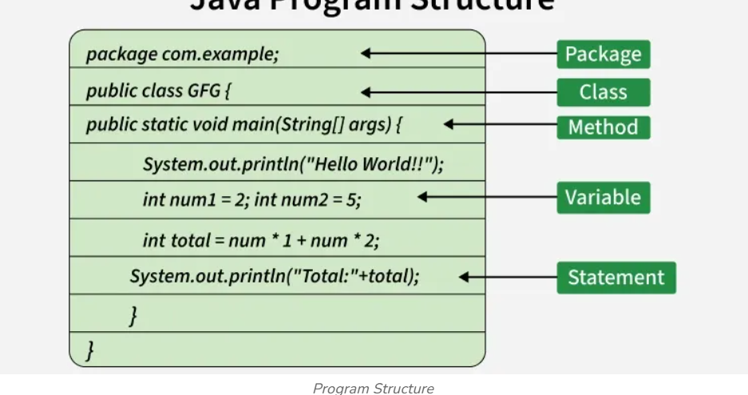

- Package: Groups related classes and interfaces, helping organize code and prevent naming conflicts.
- Class: Defines variables and methods, serving as a blueprint for creating objects in Java.
- Method: A block of code that performs a specific task; the main() method acts as the program’s entry point.
- Variable: A named memory location used to store and manipulate data during program execution.
- Statement: An instruction that performs an action, such as computation or displaying output.
User-Defined Methods
User-defined methods in Java can be instance or static and contain the core logic of the program. The main() method is the starting point of every Java program, must be public static void, and takes a String[] as an argument.
Types of Data Members
Java Class is a collection of data members and functions. Any Java program may contain two types of data members.
- Instance or non-static data members
- Static or class data members

Instance Data Members vs Static Data Members
- The table below demonstrates the difference between Instance data member and Static data member.
Instance Data Members | Static Data Members
Memory is allocated every time an object is created. | Memory is allocated only once when the class is loaded.
Each object has its own copy of instance variables. | All objects share a single copy of static variables
Declared without the static keyword | Declared using the static keyword.
Accessed using the object name | Accessed using the class name
It is known as Object-level data members. | It is Known as Class-level data members.
Value can be different for each object. | Value is common for all objects of the class.
Types of Methods
In Java programs generally, we may define two types of methods apart from the constructor.
- Instance or non-static methods
- Static or class methods
Instance Methods vs Static Methods
The table below demonstrates the difference between Instance methods and Static methods.
Instance Methods | Static Methods
Used to perform tasks related to individual objects, such as reading records from a file or processing object-specific data. | Used to perform operations that are related to the class as a whole, such as utility functions or managing shared resources.
Do not require the static keyword in their definition.  Syntax: void net_salary(parameters) { statements; } | Must include the static keyword in their definition.  Syntax: static void basic_salary(parameters) { statements; }
Accessed through an object of the class | Accessed through the class name.
Can access both instance variables and static variable | Cannot access instance variables or methods without an object reference.

Two Control Statements
1.IF Statement
The if Statement The Java if statement works much like the IF statement in any other language. Further, it is syntactically identical to the if statements in C, C++, and C#. Its simplest form is shown here: if(condition) statement; Here, condition is a Boolean expression. If condition is true, then the statement is executed. If condition is false, then the statement is bypassed. Here is an example: if(num < 100) System.out.println("num is less than 100"); In this case, if num contains a value that is less than 100, the conditional expression is true, and println( ) will execute. If num contains a value greater than or equal to 100, then the println( ) method is bypassed.
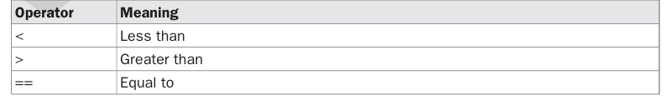
Here is a program that illustrates the if statement:
/*
Demonstrate the if.
Call this file "IfSample.java".
*/
class IfSample {
public static void main(String args[]) {
int x, y;
x = 10;
y = 20;
if(x < y) System.out.println("x is less than y");
x = x * 2;
if(x == y) System.out.println("x now equal to y");
x = x * 2;
if(x > y) System.out.println("x now greater than y");
// this won't display anything
if(x == y) System.out.println("you won't see this");
}
}
The output generated by this program is shown here:
x is less than y
x now equal to y
x now greater than y
Notice one other thing in this program. The line
int x, y;
declares two variables, x and y, by use of a comma-separated list
For Loop
The for loop in Java is a control flow statement used to execute a block of code repeatedly based on a condition. It is especially useful when the number of iterations is known in advance, such as iterating over a range of values, arrays, or collections.
Example:
class Geeks {
public static void main(String[] args) {
for (int i = 1; i <= 5; i++) {
System.out.println(i);
}
System.out.println("Loop has ended.");
}
}
Output
1
2
3
4
5
Loop has ended.
- The loop variable i starts from 1.
- The loop runs as long as i <= 5.
- After each iteration, i is incremented by 1.
- When the condition becomes false, the loop terminates.
Syntax
for (initialization; condition; update) {
// loop body
}
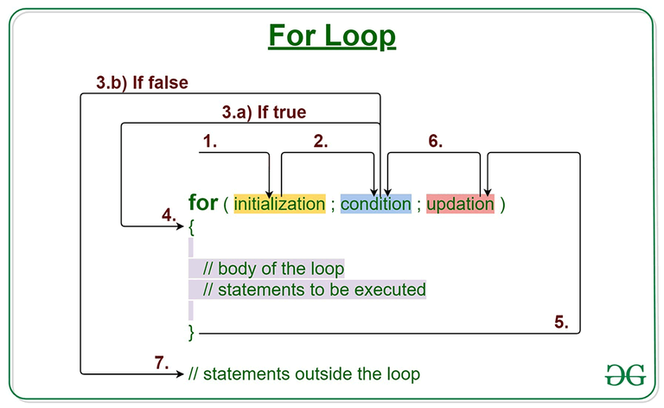
Working:
- Initialization is executed once when the loop starts.
- The condition is evaluated before every iteration.
- If the condition is true, the loop body executes.
- After execution, the update expression runs.
- Steps 2–4 repeat until the condition becomes false.
- Control exits the loop once the condition fails.

Flow Chart of For Loop in Java
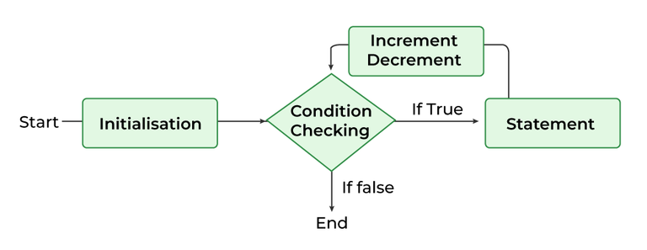
Examples and Usage of for loop
The following examples demonstrate how for loops and nested for loops are used in Java for iteration, pattern printing, and calculations.

Example 1. Printing "Hello World" Multiple Times
class Geeks {
public static void main(String args[]) {

// Writing a for loop
// to print Hello World 5 times
for (int i = 1; i <= 5; i++)
System.out.println("Hello World");
}
}
Output
Hello World
Hello World
Hello World
Hello World
Hello World
Using Blocks of Code
Java allows two or more statements to be grouped into blocks of code, also called code blocks.
This is done by enclosing the statements between opening and closing curly braces. Once a
block of code has been created, it becomes a logical unit that can be used any place that a
single statement can. For example, a block can be a target for Java’s if and for statements.
Consider this if statement:
if(x < y) { // begin a block
x = y;
y = 0;
} // end of block
Here, if x is less than y, then both statements inside the block will be executed. Thus, the two
statements inside the block form a logical unit, and one statement cannot execute without
the other also executing. The key point here is that whenever you need to logically link two
or more statements, you do so by creating a block.
Let’s look at another example. The following program uses a block of code as the target
of a for loop.
/*
Demonstrate a block of code.
Call this file "BlockTest.java"
*/
class BlockTest {
public static void main(String args[]) {
int x, y;
y = 20;
// the target of this loop is a block
for(x = 0; x<10; x++) {
System.out.println("This is x: " + x);
System.out.println("This is y: " + y);
y = y - 2;
}
}
}
The output generated by this program is shown here:
This is x: 0
This is y: 20
30 Part I : The Java Language
This is x: 1
This is y: 18
This is x: 2
This is y: 16
This is x: 3
This is y: 14
This is x: 4
This is y: 12
This is x: 5
This is y: 10
This is x: 6
This is y: 8
This is x: 7
This is y: 6
This is x: 8
This is y: 4
This is x: 9
This is y: 2
In this case, the target of the for loop is a block of code and not just a single statement.
Thus, each time the loop iterates, the three statements inside the block will be executed.
This fact is, of course, evidenced by the output generated by the program.
JAVA Class Libraries
1. Java.util
The java.util package provides utility classes used in everyday programming.
Key Features:
- Data structures: ArrayList, LinkedList, HashMap, HashSet
- Date & time (older API): Date, Calendar
- Random numbers: Random
- Collections framework: sorting, searching
Example Use:
- Storing and managing collections of data
- Implementing lists, sets, and maps

2. Java.lang
The java.lang package is the core package of Java and is automatically imported.
Key Features:
- Fundamental classes: String, Object, System
- Wrapper classes: Integer, Double, Boolean
- Math operations: Math
- Threading support: Thread, Runnable
Example Use:
- Basic operations like printing (System.out.println)
- String manipulation and primitive conversions

3. Java.math
The java.math package is used for high-precision calculations.
Key Features:
- BigInteger → for very large integers
- BigDecimal → for precise decimal calculations
- Useful in financial and scientific applications
Example Use:
- Calculating large factorials
- Accurate monetary calculations (avoiding floating-point errors)

4. Java.net
The java.net package supports network programming.
Key Features:
- URL, URLConnection
- Socket, ServerSocket
- IP handling: InetAddress
Example Use:
- Building client-server applications
- Communicating over the internet

5. Java.io
The java.io package is used for file handling and stream-based I/O.
Key Features:
- File handling: File
- Reading/writing: FileReader, FileWriter
- Stream classes: InputStream, OutputStream
Example Use:
- Reading from files
- Writing data to files

6. Java.nio
The java.nio package provides faster and more efficient I/O operations.
Key Features:
- Buffers and channels
- Non-blocking I/O
- File operations: Files, Path
Example Use:
- High-performance applications
- Handling large files efficiently
Data Types in Java
1. byte
- Size: 1 byte (8 bits)
- Range: -128 to 127
- Usage: Saves memory in large arrays
- Example:
byte b = 100;

2. short
- Size: 2 bytes (16 bits)
- Range: -32,768 to 32,767
- Usage: Used when memory saving is needed instead of int
- Example:
short s = 20000;

3. int
- Size: 4 bytes (32 bits)
- Range: -2³¹ to 2³¹-1
- Usage: Most commonly used integer type
- Example:
int num = 50000;

4. long
- Size: 8 bytes (64 bits)
- Range: -2⁶³ to 2⁶³-1
- Usage: Used for large integer values
- Note: Ends with L
- Example:
long l = 10000000000L;

5. char
- Size: 2 bytes (16 bits)
- Range: 0 to 65,535 (Unicode characters)
- Usage: Stores a single character
- Example:
char grade = 'A';

6. float
- Size: 4 bytes (32 bits)
- Usage: Stores decimal numbers (less precision)
- Note: Ends with f
- Example:
float pi = 3.14f;

7. double
- Size: 8 bytes (64 bits)
- Usage: Stores decimal numbers (more precision than float)
- Example:
double d = 3.1415926535;

8. boolean
- Size: 1 bit (logical)
- Values: true or false
- Usage: Used for conditions and decision-making
- Example:
boolean isJavaEasy = true;

Scope of Variables in Java
Scope refers to where a variable can be accessed in a program.
Java defines scope using blocks { }.

1. Local Variables
Declared inside a method, constructor, or block.
Scope:
- Accessible only within that method/block
Example:
void display() {
int x = 10; // local variable
System.out.println(x);
}
// x cannot be accessed outside display()
Key Points:
- Must be initialized before use
- No default values
- Stored in stack memory

2. Instance Variables (Non-static fields)
Declared inside a class but outside methods.
Scope:
- Accessible throughout the class
- Accessed using an object
Example:
class Student {
int age; // instance variable
void show() {
System.out.println(age);
}
}
Key Points:
- Each object has its own copy
- Stored in heap memory
- Default values assigned (e.g., 0, null)

3. Static Variables (Class variables)
Declared using the static keyword.
Scope:
- Shared across all objects of the class
Example:
class Test {
static int count = 0;
void increment() {
count++;
}
}
Key Points:
- Only one copy exists
- Accessed using class name (Test.count)
- Stored in method area (class memory)

4. Block Variables
Declared inside a block like if, for, or while.
Scope:
- Limited to that specific block
Example:
if (true) {
int y = 5;
System.out.println(y);
}
// y cannot be accessed here

🔹 Lifetime of Variables in Java
Lifetime refers to how long a variable exists in memory.

1. Local Variable Lifetime
- Created when the method/block is executed
- Destroyed when the method/block ends
Exists only during method execution

2. Instance Variable Lifetime
- Created when an object is created (new)
- Destroyed when the object is garbage collected
Exists as long as the object exists

3. Static Variable Lifetime
- Created when the class is loaded into memory
- Exists until the program ends
Exists throughout the program execution

4. Block Variable Lifetime
- Created when the block is entered
- Destroyed when the block exits

Typecasting And Type Conversion
Type Conversion and Casting in Java
🔹 Introduction
In Java, it is common to assign a value of one data type to another.
- If types are compatible, Java performs automatic conversion.
- If not, we use casting (explicit conversion).

🔹 1. Automatic Type Conversion (Widening)
✅ Definition
Automatic conversion happens when:
- The two types are compatible
- The destination type is larger than the source type
👉 This is called widening conversion.

✅ Example
int x = 10;
long y = x; // automatic conversion (int → long)

✅ Key Points
- No data loss occurs
- Done automatically by Java
- Applies to numeric types (int, float, double, etc.)

✅ Valid Widening Conversions
byte → short → int → long → float → double
char → int → long → float → double

❌ Not Allowed Automatically
- No conversion between:
  - Numeric types ↔ boolean
  - char ↔ boolean

✅ Special Case
Java automatically converts integer literals into:
- byte
- short
- long
- char
(if the value fits within the range)

🔹 2. Type Casting (Narrowing Conversion)
✅ Definition
When converting from a larger type to a smaller type, Java does not do it automatically.
You must use casting (explicit conversion)

✅ Syntax
(target-type) value

✅ Example
int a = 100;
byte b = (byte) a; // explicit cast

⚠️ Key Points
- May cause data loss
- Required when types are incompatible
- Called narrowing conversion

🔹 3. Important Conversion Behaviors
🔸 1. Integer to Byte (Modulo Operation)
If value exceeds range:
- Result = remainder after division by range
int i = 257;
byte b = (byte) i; // result = 1
Because:
257 % 256 = 1

🔸 2. Floating-point to Integer (Truncation)
- Fractional part is removed
double d = 323.142;
int i = (int) d; // result = 323
Decimal part is lost (not rounded)

🔸 3. Double to Byte (Combination)
- Fraction removed + modulo applied
double d = 323.142;
byte b = (byte) d; // result = 67
Steps:
- Remove decimal → 323
- Apply modulo → 323 % 256 = 67

🔹 4. Example Program
class Conversion {
public static void main(String args[]) {
byte b;
int i = 257;
double d = 323.142;
System.out.println("\nConversion of int to byte.");
b = (byte) i;
System.out.println("i and b " + i + " " + b);
System.out.println("\nConversion of double to int.");
i = (int) d;
System.out.println("d and i " + d + " " + i);
System.out.println("\nConversion of double to byte.");
b = (byte) d;
System.out.println("d and b " + d + " " + b);
}
}

🔹 5. Output
Conversion of int to byte.
i and b 257 1
Conversion of double to int.
d and i 323.142 323
Conversion of double to byte.
d and b 323.142 67

🔹 6. Summary Table
Conversion Type | Description | Example
Widening | Smaller → Larger | int → long
Narrowing | Larger → Smaller | int → byte
Truncation | Removes decimal | double → int
Modulo | Wraps value in range | int → byte

Type Casting: In type casting, a data type is converted into another data type by the programmer using the casting operator during the program design. In type casting, the destination data type may be smaller than the source data type when converting the data type to another data type, that's why it is also called narrowing conversion.
Syntax/Declaration:-
destination_datatype = (target_datatype)variable;
(): is a casting operator.
target_datatype: is a data type in which we want to convert the source data type.
Type Casting example -
float x;
byte y;
...
...
y=(byte)x; //Line 5
In Line 5: you can see that, we are converting float(source) data type into byte(target) data type.
2. Type conversion : In type conversion, a data type is automatically converted into another data type by a compiler at the compiler time. In type conversion, the destination data type cannot be smaller than the source data type, that's why it is also called widening conversion. One more important thing is that it can only be applied to compatible data types.
Type Conversion example -
int x=30;
float y;
y=x; // y==30.000000.

.NO | TYPE CASTING | TYPE CONVERSION
1. | In type casting, a data type is converted into another data type by a programmer using casting operator. | Whereas in type conversion, a data type is converted into another data type by a compiler.
2. | Type casting can be applied to compatible data types as well as incompatible data types. | Whereas type conversion can only be applied to compatible datatypes.
3. | In type casting, casting operator is needed in order to cast a data type to another data type. | Whereas in type conversion, there is no need for a casting operator.
4. | In type casting, the destination data type may be smaller than the source data type, when converting the data type to another data type. | Whereas in type conversion, the destination data type can't be smaller than source data type.
5. | Type casting takes place during the program design by programmer. | Whereas type conversion is done at the compile time.
6. | Type casting is also called narrowing conversion because in this, the destination data type may be smaller than the source data type. | Whereas type conversion is also called widening conversion because in this, the destination data type can not be smaller than the source data type.
7. | Type casting is often used in coding and competitive programming works. | Whereas type conversion is less used in coding and competitive programming as it might cause incorrect answer.
8. | Type casting is more efficient and reliable. | Whereas type conversion is less efficient and less reliable.

