A
Full Stack Java Programming Lab Mini Project Report
on
CivicConnect: Smart Municipal Complaint and Resolution Management System
Submitted in partial fulfillment of the requirements for the
Degree
Second Year Engineering – Information Technology
by
Arman Raturi - 25104183
Kshitij Shete - 25104165
Ayush Shinde - 25104061
Soham Shinde - 25104144

Under the guidance of

Prof. Rucha Kulkarni

DEPARTMENT OF INFORMATION TECHNOLOGY
A.P. SHAH INSTITUTE OF TECHNOLOGY
G.B. Road, Kasarvadavali, Thane (W)-400615
UNIVERSITY OF MUMBAI

Academic year: 2025-26

CERTIFICATE

This is to certify that the FSJPL Mini Project report on CivicConnect: Smart Municipal Complaint and Resolution Management System has been submitted by 25104183, 25104061 and 25104165 & 25104144 who are bonafide students of A. P. Shah Institute of Technology, Thane as a partial fulfillment of the requirement for the degree in Information Technology, during the second half of academic year 2025-2026 in the satisfactory manner as per the curriculum laid down by University of Mumbai.

Prof. Rucha Kulkarni
Guide

Internal Examiner: External Examiner:
- 1.

Place: A. P. Shah Institute of Technology, Thane
Date:

ACKNOWLEDGEMENT

This project would not have come to fruition without the invaluable help of our guide Prof. Rucha Kulkarni. Expressing gratitude towards our Head of Department, Dr. Kiran Deshpande, and the Department of Information Technology for providing us with the opportunity as well as the support required to pursue this project.

TABLE OF CONTENTS
Abstract
- Introduction…………………………………………………………………..……..1
  - Problem Statement……………………………………….…………………...2
  - Objectives…………………………………………………………………… 2
  - Scope..........................................................................................................…...3
- Project Design ………………………………….…………………………………..7
  - Features and Functionality…………………………………..…………….….8
  - System Architecture……………………………………….…….……...….…9
  - E-R Diagram……………..……………………………………..…...…….…10
- Technical Specification…………………………………………………………….12
- Project Implementation…………………………………………………………….13
- Results……………..……………………………………………………………….15
- Conclusion and Future Scope……………………………………………………...17

CIVICCONNECT
Smart Municipal Complaint and Resolution Management System

ABSTRACT
CivicConnect is a web-based municipal complaint-management system designed to improve the process of reporting, managing, tracking, and resolving civic issues. The platform provides citizens with a digital interface to report problems such as damaged roads, potholes, overflowing garbage, water leakage, drainage issues, and broken streetlights. It enables municipal staff to review complaints, manage assignments, update their status, and record resolution details through a centralized system.
The system provides different levels of access for citizens, staff, field staff, department officers, supervisors, and administrators. Citizens can submit complaints with descriptions, photographs, and location information, while authorized municipal personnel can manage complaints according to their departmental responsibilities. Administrative features include staff management, complaint assignment, audit logs, departmental workload analytics, and CSV report generation.
CivicConnect is developed using React.js for the frontend, Java Spring Boot for the backend, and MySQL as the intended relational database. The application also incorporates duplicate complaint suggestions based on text and geographic information, multilingual interface support, and a municipal ward map. Its current classification mechanism uses keyword-based rules rather than a machine-learning model. External notification services and complete live database integration require further verification.
The project aims to provide a more organized and transparent approach to municipal grievance management while establishing a foundation for future improvements in automated classification, geographic analysis, and administrative decision-making.

1. INTRODUCTION
Municipal authorities are responsible for maintaining essential civic services, including roads, drainage systems, water supply, streetlights, and waste management. Citizens frequently encounter problems in these areas and require an accessible method to report them to the appropriate authorities.
Traditional complaint-handling processes may involve telephone calls, emails, paper records, or separate digital systems. When complaint information is distributed across different channels, tracking progress, assigning responsibility, identifying repeated complaints, and monitoring resolution performance can become difficult.
CivicConnect is a proposed web-based solution that brings these activities together within a centralized complaint-management platform. It connects citizens with municipal departments through a structured workflow for complaint submission, assignment, status tracking, and resolution.
The platform provides separate interfaces and access permissions for citizens and municipal personnel. Citizens can submit complaints and view permitted updates, while staff can manage authorized complaint queues and document their work. Administrators can monitor departmental workloads, manage staff accounts, inspect audit records, and generate reports.
The project also includes supporting capabilities such as multilingual interfaces, geographic complaint visualization, duplicate complaint suggestions, and rule-based classification assistance. These features are intended to make complaint handling more systematic while allowing further development of intelligent capabilities in the future.

1.1 PROBLEM STATEMENT
Citizens require a convenient and transparent way to report civic problems and monitor their progress. Municipal departments, in turn, require an organized system to receive, categorize, prioritize, assign, and resolve complaints efficiently.
When complaint records are maintained through disconnected channels or separate departmental processes, several difficulties may arise. Complaints can be repeated, incorrectly categorized, delayed, or difficult to track. Municipal authorities may also face challenges in identifying pending cases, understanding departmental workloads, monitoring service-level targets, and evaluating resolution performance.
A centralized complaint-management system is therefore needed to organize civic grievances, maintain complaint history, provide appropriate access to authorized users, and improve the visibility of complaint-handling activities.
A centralized complaint-management system is therefore needed to organize civic grievances, maintain complaint history, provide appropriate access to authorized users, and improve the visibility of complaint-handling activities.

1.2 OBJECTIVES
- To develop a web-based platform for submitting and managing municipal complaints.
- To provide citizens with unique complaint reference numbers and permitted status-tracking facilities.
- To organize complaints according to their categories, locations, departments, and assigned personnel.
- To implement role-based access control for citizens, municipal staff, supervisors, and administrators.
- To maintain complaint status history, internal notes, resolution evidence, and audit records.
- To suggest potentially duplicate complaints using textual similarity and geographic distance.
- To provide rule-based complaint classification and priority recommendations as assistance to users and municipal staff.
- To develop administrative dashboards for monitoring complaint statistics, departmental workloads, and overdue complaints.
- To support complaint reporting through searchable records and CSV export facilities.
- To establish a modular foundation for future improvements in automated classification, mapping, notifications, and municipal service management.

1.3 SCOPE
The scope of CivicConnect includes the development of a centralized digital platform for civic complaint submission, departmental complaint handling, administrative monitoring, and resolution tracking. The current development scope includes:
- Citizen registration, login, profile management, and complaint submission.
- Generation of unique complaint references and access to personal complaint history.
- Complaint submission with descriptions, location information, and optional photographs.
- Complaint status updates, status history, resolution evidence, feedback, and reopening requests.
- Department-scoped complaint queues and authorized staff access.
- Administrative management of staff accounts, roles, departments, and complaint assignments.
- Duplicate complaint suggestions using text and geographic heuristics.
- A municipal ward map with location markers and marker clustering.
- Administrative audit logs, departmental analytics, overdue complaint monitoring, and CSV export.
- Multilingual interface support for English, Marathi, and Hindi.
- Security mechanisms such as server-side sessions, password hashing, CSRF protection, and access-control checks.
Some capabilities require further development or verification. These include genuine AI-based classification, semantic duplicate detection, live email and SMS delivery, complete MySQL integration, automated ward-based staff routing, and full end-to-end deployment verification. The project is intended to provide a foundation that can be configured for municipal procedures, departmental responsibilities, and approved service-level targets.

2.PROJECT DESIGN
CivicConnect follows a client-server architecture in which the frontend communicates with a backend application through REST APIs. The backend manages authentication, authorization, complaint-processing rules, database operations, and administrative functions.
The system is divided into functional modules for citizens, municipal staff, supervisors, and administrators. Each module provides access to the operations permitted for the corresponding role.
The complaint-management workflow begins when a citizen submits a complaint. The backend validates the request, creates the complaint record, and generates a reference number. Authorized municipal personnel can then review the complaint, manage its status, record internal notes, and document the resolution. The system maintains status history and audit information to support traceability.

2.1 FEATURES AND FUNCTIONALITY

1. User Registration and Authentication
CivicConnect provides registration and login facilities for users. The authentication system uses server-side sessions, and passwords are protected through hashing.
The system supports role-based access for CITIZEN, STAFF, FIELD_STAFF, DEPARTMENT_OFFICER, SUPERVISOR, and ADMIN. Access to complaint records and administrative operations is controlled by backend authorization rules.

2. Complaint Submission
Citizens can submit civic complaints by providing relevant descriptions, categories, and location information. They can also attach photographs as supporting evidence.
The complaint submission process generates a unique reference number. The system additionally supports a submission key to help prevent duplicate complaint creation when a submission is retried because of a network interruption.

3. Complaint Tracking
Citizens can view their complaint history and access permitted complaint updates. A public tracking facility allows complaints to be checked using their complaint reference number.
The system maintains complaint status history so that changes in the complaint lifecycle can be recorded and reviewed.

4. Complaint Assignment and Department Management
Municipal staff can access complaint queues according to their departmental permissions. Authorized personnel can review complaints, update their status, and document actions taken.
Administrators can assign complaints to department staff and manage staff accounts, roles, and departmental associations. Department-based access helps ensure that staff members handle complaints within their authorized responsibilities.

5. Duplicate Complaint Detection
CivicConnect includes a duplicate complaint suggestion mechanism that compares complaint text and geographic information.
The current implementation uses lexical similarity and geographic distance calculations to identify potentially related complaints. These suggestions can help users and staff recognize repeated reports of the same civic issue.
This functionality is based on heuristics and should not be described as a fully implemented semantic AI system.

6. Complaint Classification and Priority Assistance
The system includes a classification component that can suggest complaint categories and priorities using keyword matching and predefined rules.
The current provider uses regular expressions and keyword dictionaries that include English, Marathi, and Hindi terms. It does not use a connected machine-learning model or external AI service, and the classification capability is disabled by default according to the supplied technical report.
Further development can introduce validated classification models and municipality-approved priority criteria.

7. Resolution Evidence, Feedback, and Reopening
Authorized staff can upload resolution photographs and record information about completed work.
Citizens can provide feedback and ratings after resolution. The application also supports requests to reopen complaints, with the review decision requiring an appropriate note.
These facilities help maintain a record of the reported problem, the resolution process, and subsequent citizen feedback.

8. Internal Notes and Audit Logging
The system provides internal notes for departmental communication about complaints. These notes are intended for authorized municipal personnel rather than public display.
Administrative audit logs record important actions, including staff-management operations, complaint assignments, and data exports. These records support the review of administrative activities and complaint handling.

9. Administrative Dashboard and Analytics
CivicConnect provides dashboard metrics for authorized users. Departmental staff can view information relevant to their permitted complaint queues, while administrators can access system-wide complaint information.
The administrative analytics module provides departmental workload information. The application also calculates overdue complaints using configured service-level agreement (SLA) thresholds and supports filtered complaint export in CSV format.
The usefulness of these reports depends on the accuracy of the underlying data and the configuration of departmental rules and SLA targets.

10. Municipal Map and Geographic Information
The application includes an interactive municipal ward map with location markers and marker clustering. It uses Leaflet.js with public OpenStreetMap tile layers.
The project also contains location-handling logic based on local Thane landmark coordinates, with an optional OpenStreetMap Nominatim fallback.
Automated routing according to authoritative ward boundaries and geographic assignment of complaints to individual field officers are not fully implemented.

11. Multilingual Interface
CivicConnect supports interface content in English, Marathi, and Hindi through dedicated frontend text resources.
This feature is intended to make the application more accessible to citizens who prefer different languages.

12. Security and Data Protection
The application includes server-side session authentication, password hashing, role-based authorization, CSRF protection, and configured CORS policies.
It also provides access controls for complaint records and validation for uploaded photographs. Complaint images are stored using a local filesystem configuration in the current implementation.
Cloud-based file storage and complete production security verification have not been established by the supplied project information.

2.2 SYSTEM ARCHITECTURE
CivicConnect follows a layered client-server architecture. Each layer performs a specific responsibility and communicates with the other layers through defined interfaces.

1. Frontend Layer
The frontend is developed using React.js, JavaScript, HTML5, CSS3, and Vite. It provides the user interfaces for citizens, municipal staff, field staff, department officers, supervisors, and administrators. The frontend handles user interactions, form validation, complaint display, filtering, map visualization, and communication with the backend APIs.

2. Backend Controller Layer
The backend is developed using Java 21 and Spring Boot. REST controllers receive requests from the frontend, validate incoming data, and direct requests to the appropriate service methods. The application exposes its APIs under the /api base path. The controllers also participate in enforcing access restrictions for protected operations.

3. Service Layer
The service layer implements the main complaint-management rules and operations. Its responsibilities include complaint processing, status transitions, duplicate detection, SLA calculations, assignment operations, and audit-related activities. Transaction management and event publishing are also handled at the service level where applicable.

4. Repository and Database Layer
Spring Data JPA and Hibernate manage relational persistence through repository interfaces and entity mappings. MySQL is the intended relational database for storing application records. Flyway is used to manage versioned database schema migrations. The current automated tests do not establish that the live MySQL database integration and existing-schema compatibility are fully verified.

5. Security Layer
The security layer uses Spring Security, server-side sessions, password hashing, CSRF protection, CORS configuration, and authorization checks. The application uses session cookies for authentication rather than JWT bearer tokens stored in browser local storage. The frontend sends the required CSRF token with applicable requests. Backend authorization is responsible for enforcing permissions; frontend interface restrictions alone are not considered sufficient security.

6. Supporting Services
The system includes local filesystem storage for complaint and resolution photographs, CSV reporting, geographic visualization, and configurable notification-related components. Email and SMS delivery remain in mock or dry-run mode according to the supplied technical report. External AI integrations and cloud-based photo storage are not verified.

System Architecture Flow
Citizen / Municipal Staff / Administrator
↓
React.js Frontend
↓
REST API Communication
↓
Spring Boot Controllers
↓
Service Layer and Business Logic
↓
Spring Data JPA / Hibernate
↓
MySQL Database
Supporting components include session-based security, Flyway migrations, complaint-photo storage, geographic visualization, duplicate detection, audit logging, and reporting.

2.3 E-R DIAGRAM
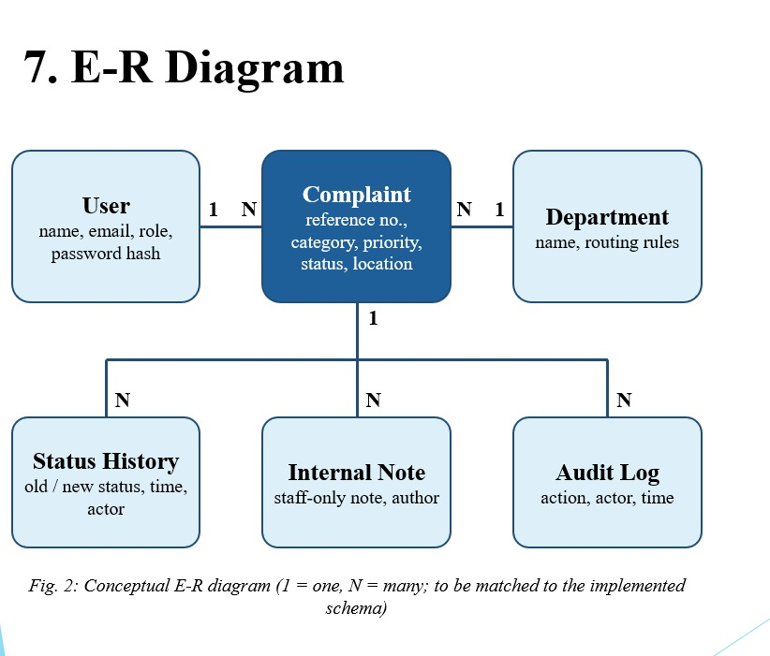

3. TECHNICAL SPECIFICATION
CivicConnect uses a modern web technology stack that separates the frontend interface from backend processing and relational data management.

3.1 Frontend Technologies
React.js: Used to develop reusable interface components and interactive user experiences for the different user roles.
JavaScript (ES6+): Implements client-side application logic, form handling, complaint interactions, and API communication.
HTML5: Provides the structural elements of the web interface.
CSS3: Handles styling and responsive layouts.
Vite: Provides frontend development and production-build tooling.
Leaflet.js: Supports interactive map visualization, location markers, and marker clustering.

3.2 Backend Technologies
Java 21: Serves as the backend programming language and runtime.
Spring Boot: Provides the application framework and configuration for backend services.
Spring Web / REST APIs: Enables communication between the frontend and backend through HTTP endpoints.
Spring Security: Supports authentication, session management, CSRF protection, and authorization controls.
Spring Data JPA: Simplifies database access through repository interfaces.
Hibernate: Provides object-relational mapping between Java entities and relational database tables.
Apache Maven: Manages backend dependencies and build operations.

3.3 Database Technologies
MySQL: Intended as the primary relational database for storing application records.
Flyway: Manages versioned database schema changes through migrations.
H2: Used as a test database for the reported backend application-context test.

3.4 Development and Testing Tools
Visual Studio Code and IntelliJ IDEA: Used for code editing and application development.
Postman: Supports manual testing of backend APIs.
Git and GitHub: Support source-code version control and team collaboration.
Docker and Docker Compose: Support containerization and deployment preparation. Successful configuration parsing does not by itself confirm that the complete application has been deployed successfully.

3.5 Security Specifications
The project includes the following security mechanisms:
- Server-side session-based authentication.
- Password hashing.
- Role-based and department-based authorization.
- CSRF protection using a cookie-based token mechanism.
- Configured cross-origin resource sharing policies.
- Citizen-scoped and department-scoped complaint access.
- Validation and access controls for complaint photographs.
- Audit logging for selected administrative activities.
- Environment-based configuration for secrets.
The complete production security review and deployment security checks remain to be verified

PROJECT IMPLEMENTATION
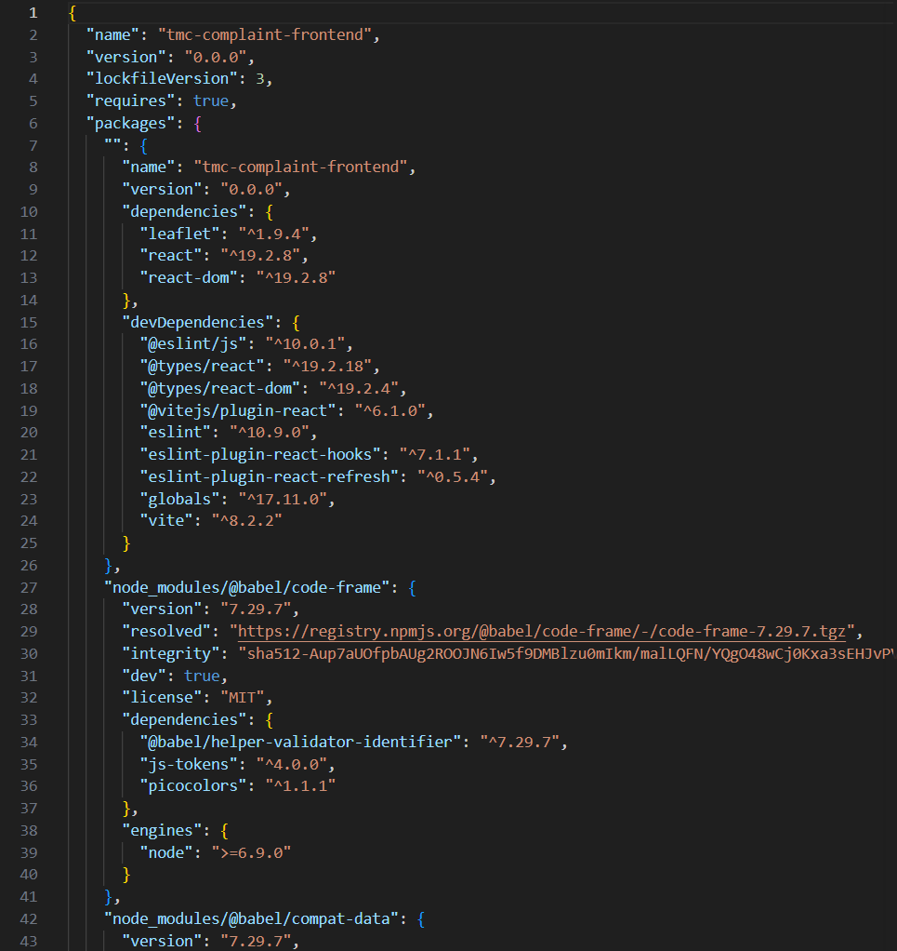
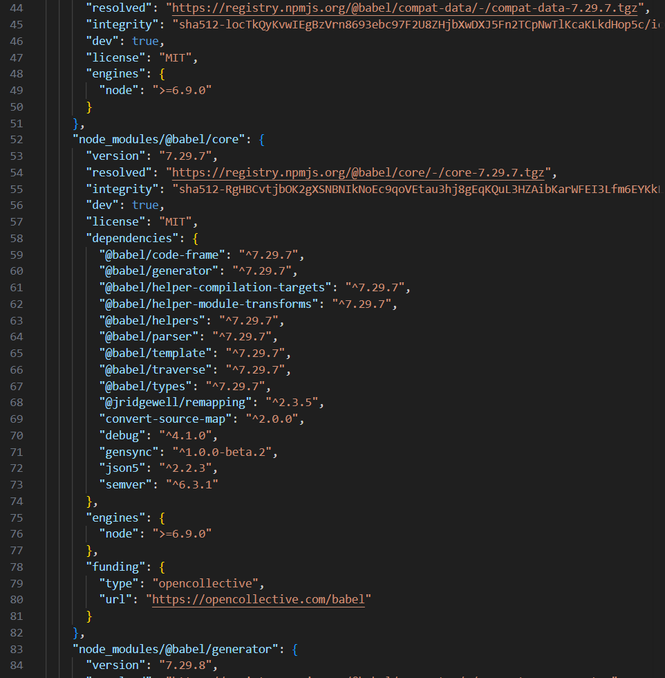

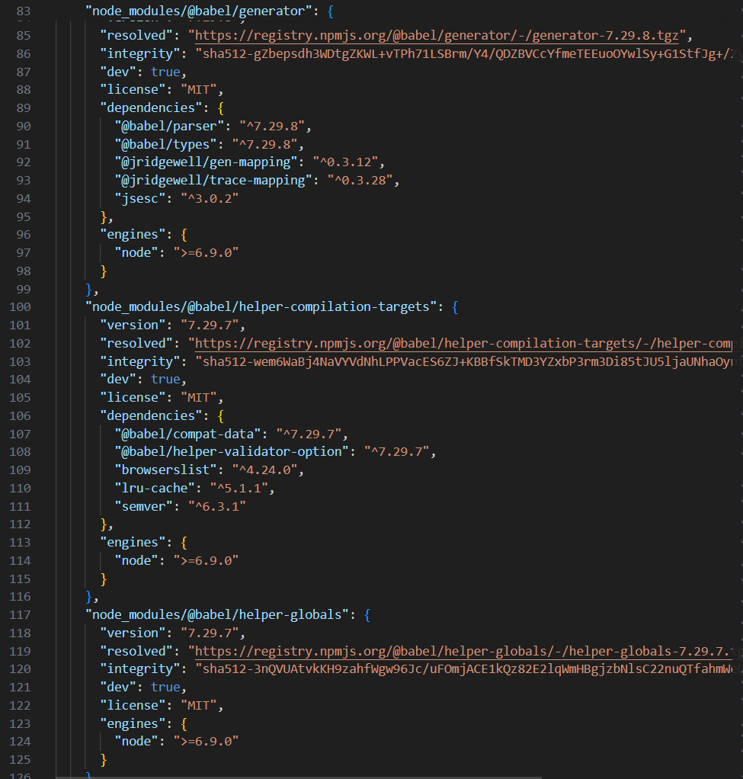

RESULTS
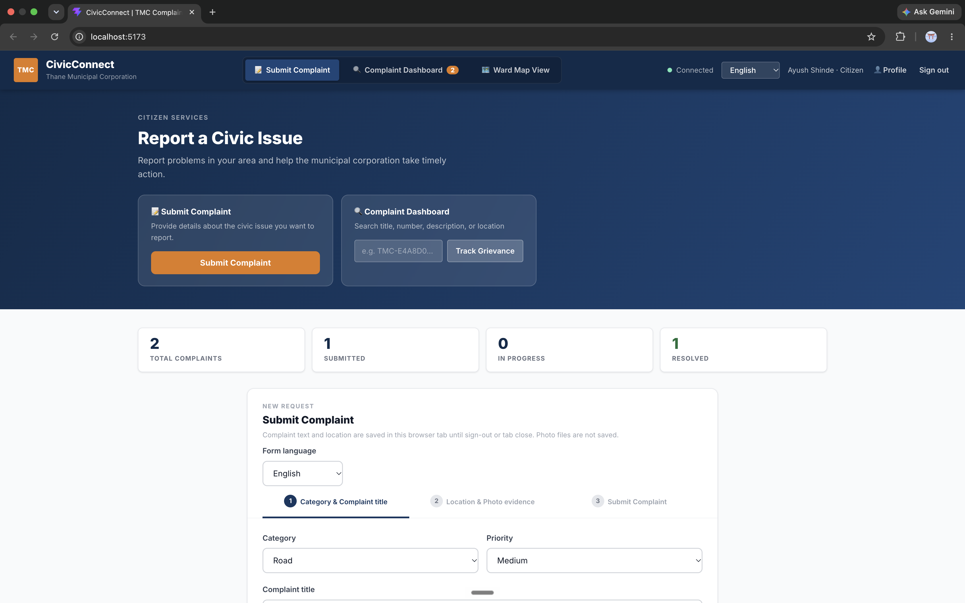
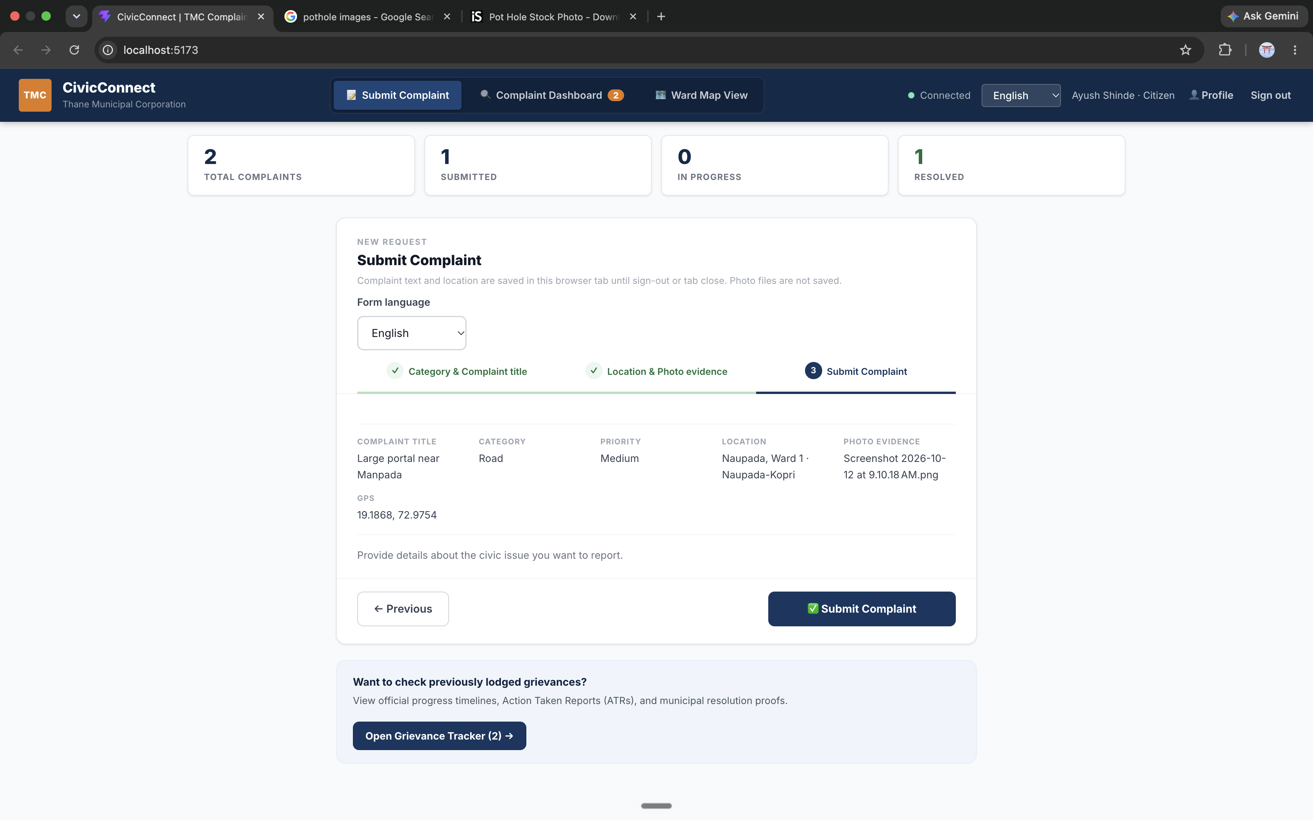

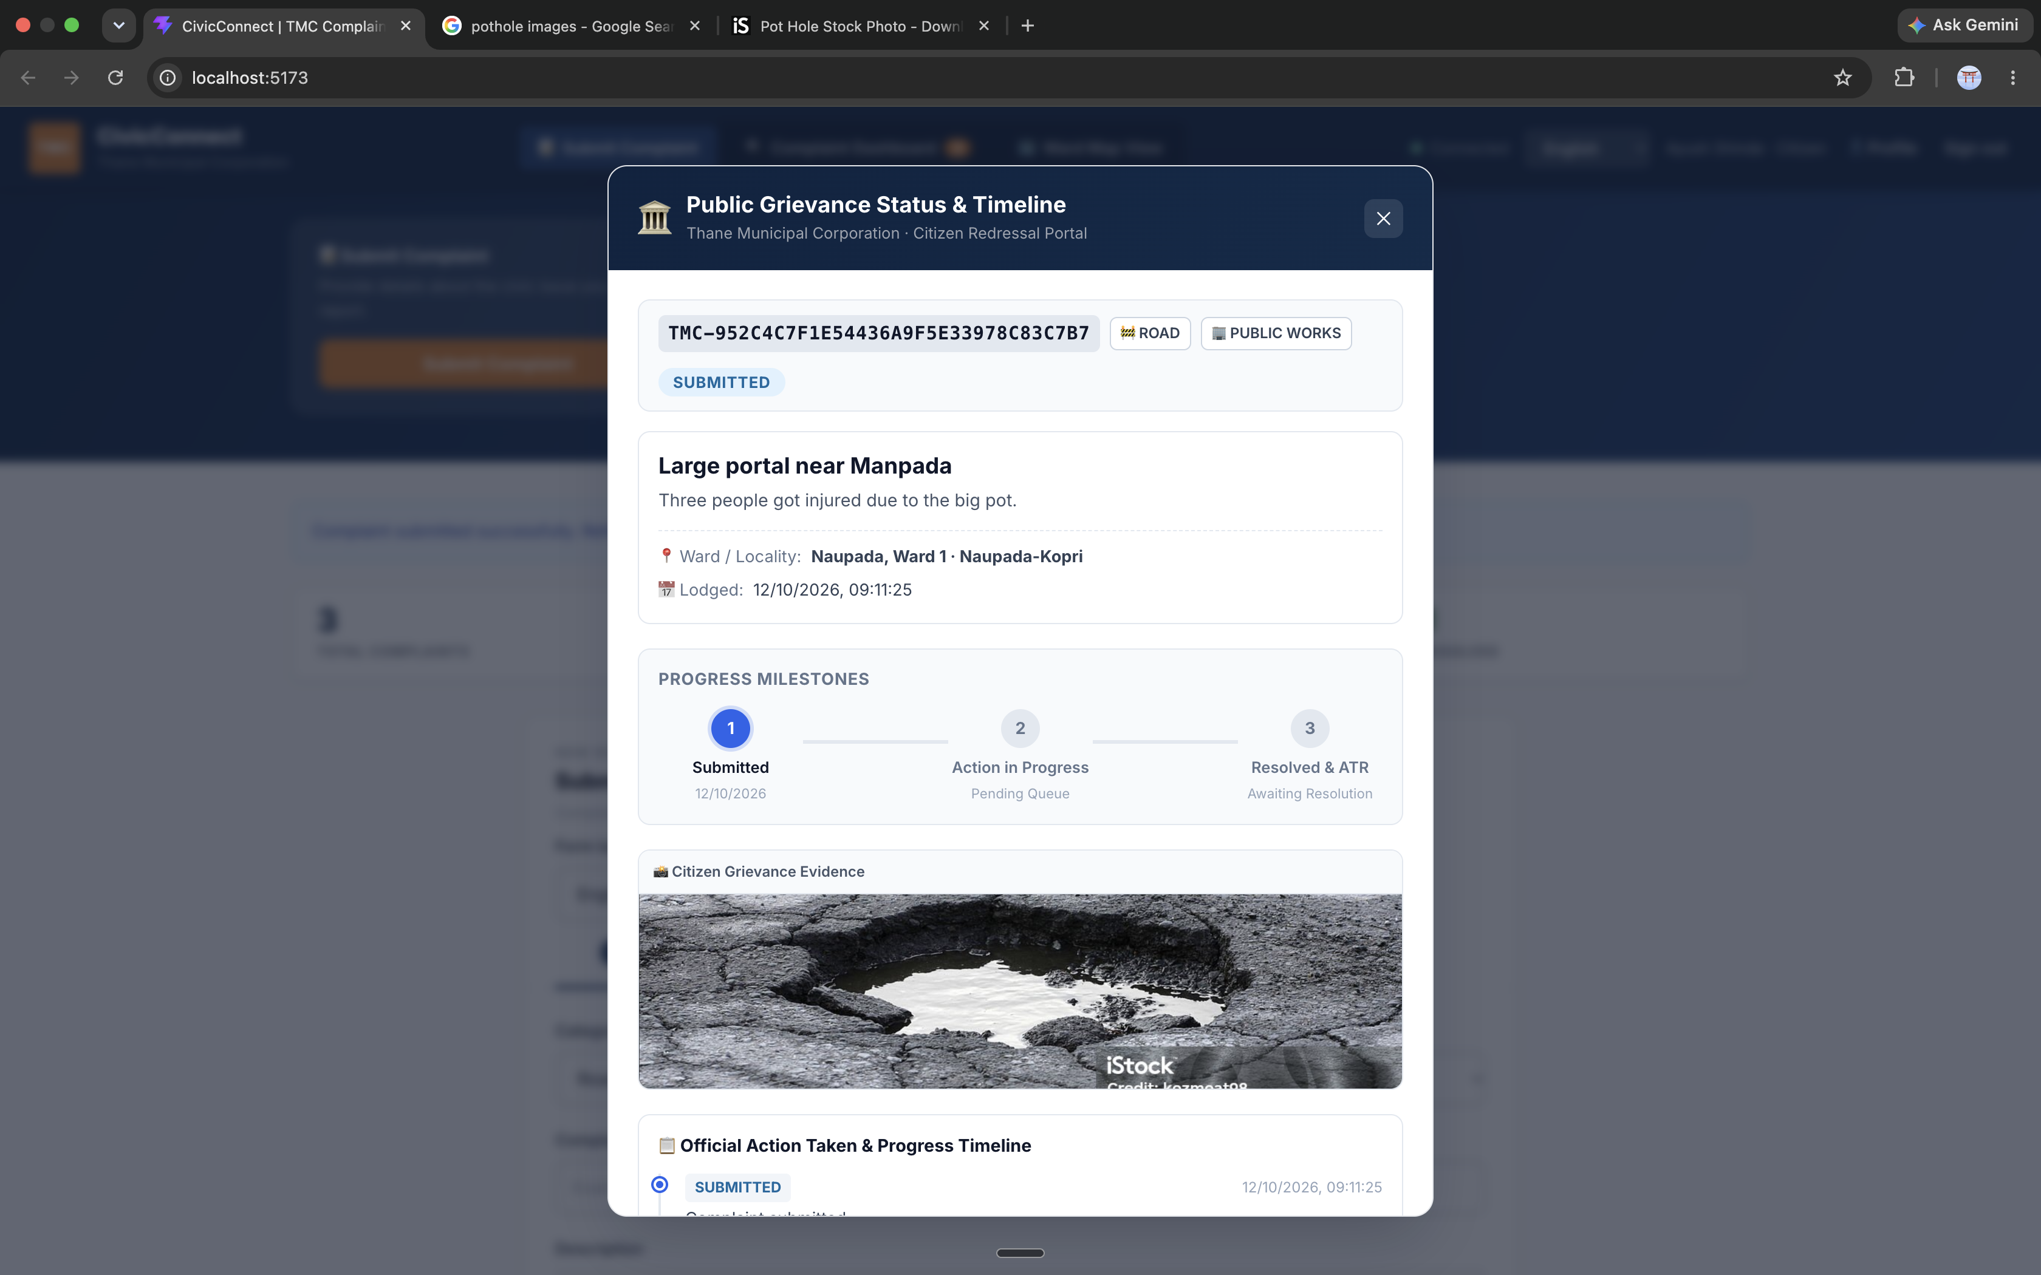

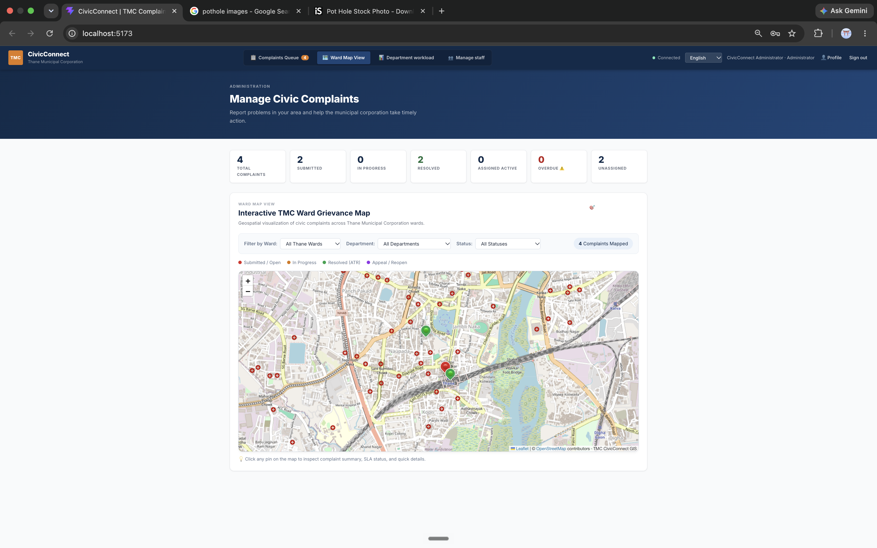

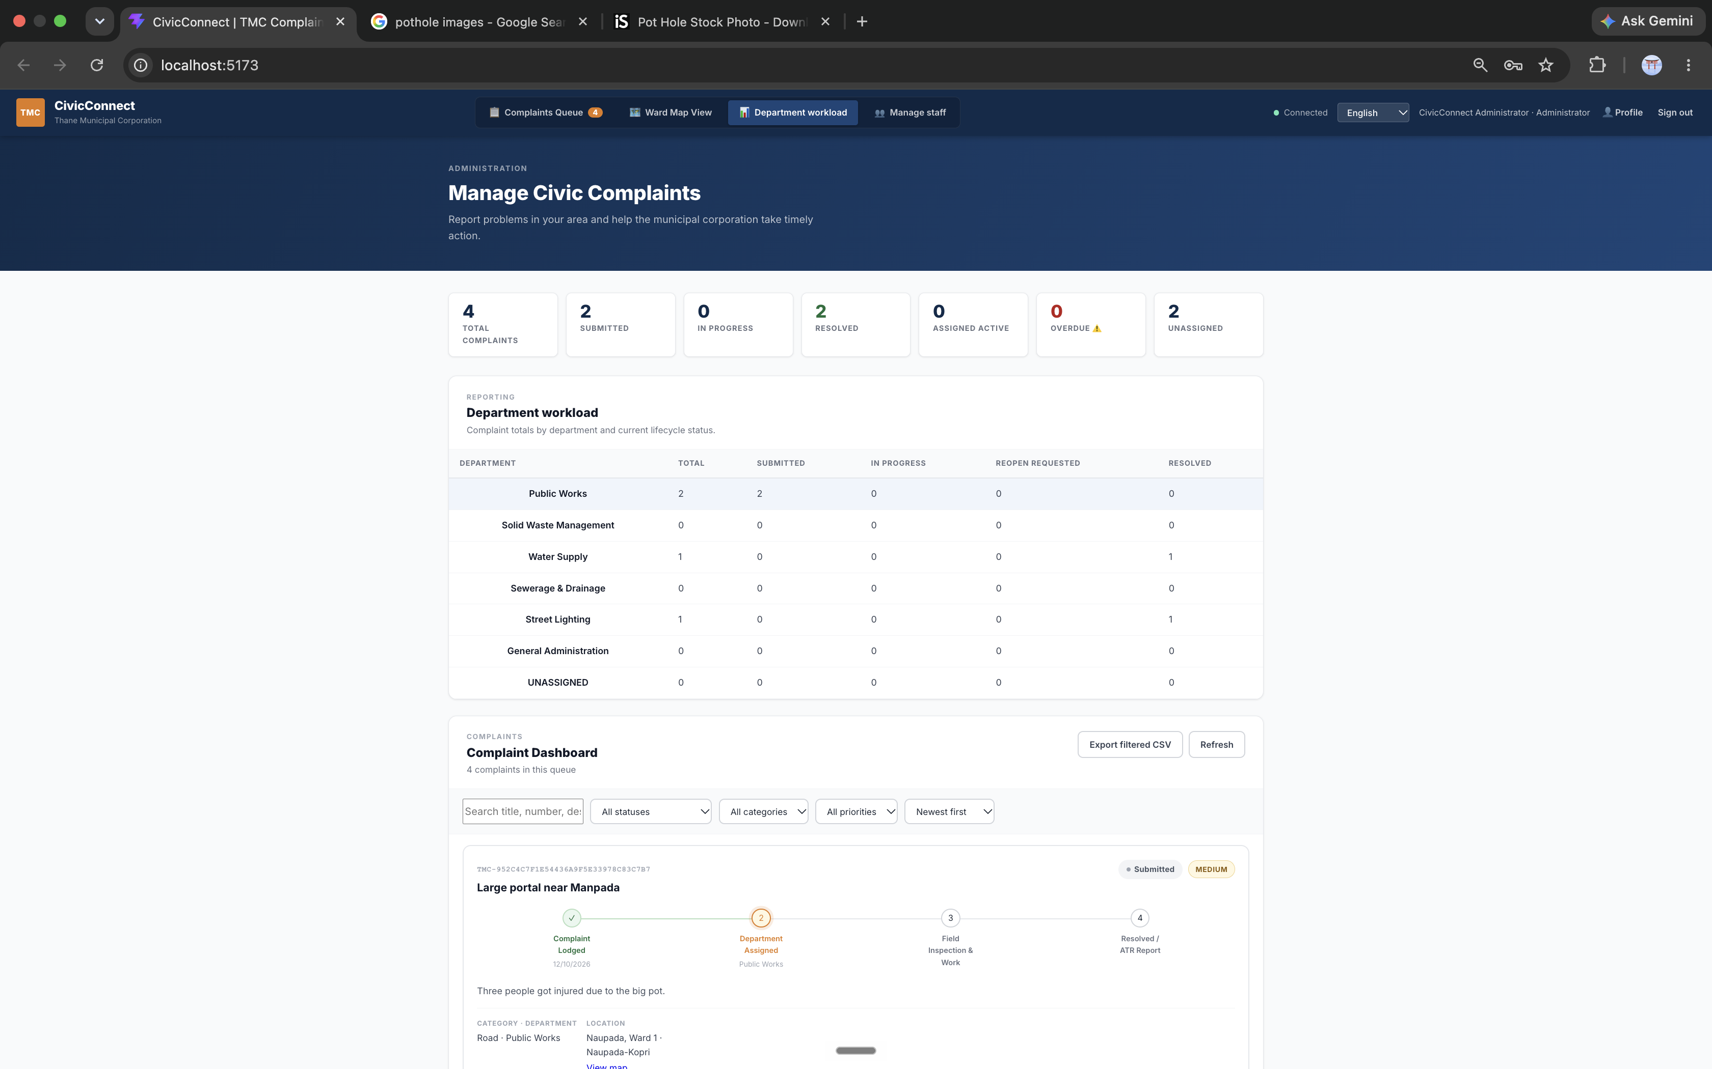

6. CONCLUSION AND FUTURE SCOPE
CivicConnect is a web-based municipal complaint-management system designed to organize the reporting, assignment, tracking, and resolution of civic issues. It provides a common platform through which citizens can submit complaints and municipal personnel can manage them according to their authorized responsibilities.
The system incorporates complaint reference generation, status history, departmental complaint queues, internal notes, resolution evidence, feedback, and reopening requests. Administrative features include staff management, complaint assignment, audit logs, departmental workload analytics, and CSV export. The application also provides multilingual interface support, geographic visualization, and heuristic-based duplicate complaint suggestions.
The use of React.js, Java Spring Boot, and relational data-access technologies establishes a modular foundation for further development. The supplied test report records 95 passing backend tests and 13 passing frontend tests, with successful frontend lint and production-build checks.
However, several important activities remain incomplete or unverified. These include live MySQL integration, database migration compatibility, full end-to-end deployment, live notification delivery, and production security verification. The classification mechanism currently uses predefined keyword rules rather than a machine-learning model.

Future Scope
AI-Assisted Classification: Integrate and evaluate a genuine multilingual classification model to recommend complaint categories and responsible departments.
Semantic Duplicate Detection: Introduce embedding-based similarity techniques to improve the identification of potentially repeated complaints.
Advanced Geographic Analysis: Extend the existing map functionality with verified geocoding, authoritative ward boundaries, and geographic hotspot visualization.
Automated Complaint Routing: Develop routing based on approved departmental rules, geographic boundaries, and authorized staff responsibilities.
Notification Integration: Connect verified email and SMS services to support complaint updates and notifications.
Improved SLA Management: Introduce configurable escalation rules and notification preferences based on municipality-approved service-level targets.
Advanced Analytics: Improve workload forecasting and resolution-time analysis to help administrators evaluate complaint-handling performance.
Municipal System Integration: Integrate with approved municipal systems where suitable APIs are available.
Complete Testing and Deployment: Perform end-to-end, security, accessibility, performance, and reliability testing. Verify persistent database and file storage, backups, monitoring, and recovery procedures before production deployment.
In conclusion, CivicConnect provides a foundation for a more centralized, organized, and traceable approach to municipal grievance management. Further integration, testing, and operational verification will be necessary to establish the system as a fully operational production solution.

