# Question #1: Do enough customers buy equipment to keep equipment sales?

This report shows a breakdown of equipment transactions, comparing the number of items sold vs. rented, and the total revenue generated from each type. It helps determine whether equipment sales are profitable and worth continuing alongside rental offerings.

Input:

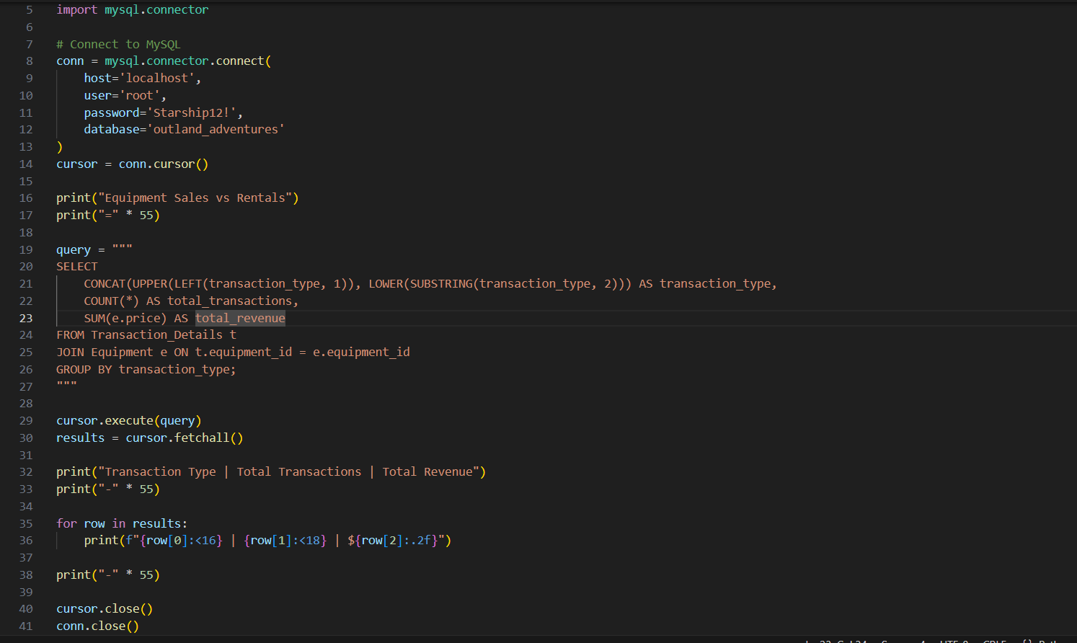

Your Passowrd

# Question #2: Is there any one of those locations (Africa, Asia, Southern Europe) that has a downward trend in bookings?

This report tracks trip bookings over time, grouped by region and year. It highlights any declines in interest for trips to Africa, Asia, or Southern Europe, which helps guide marketing efforts and trip planning decisions.

Input:

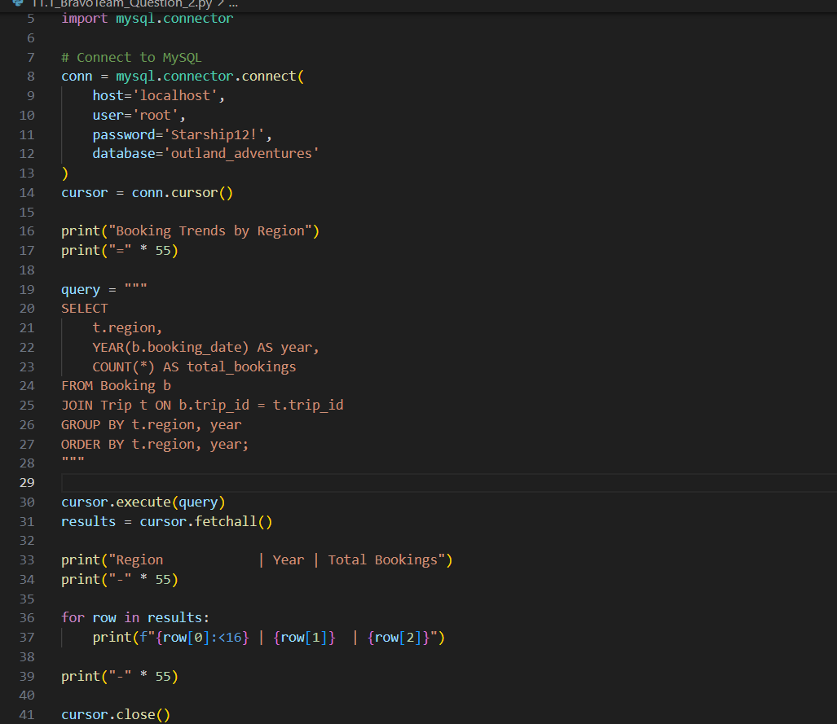

Output:

# Question #3 Are there inventory items that are over five years old?

This report lists all equipment items that were purchased more than five years ago, showing the purchase date and the age in years. This helps identify outdated or aging inventory that may need replacement for safety or quality reasons.

Input:

Output:

