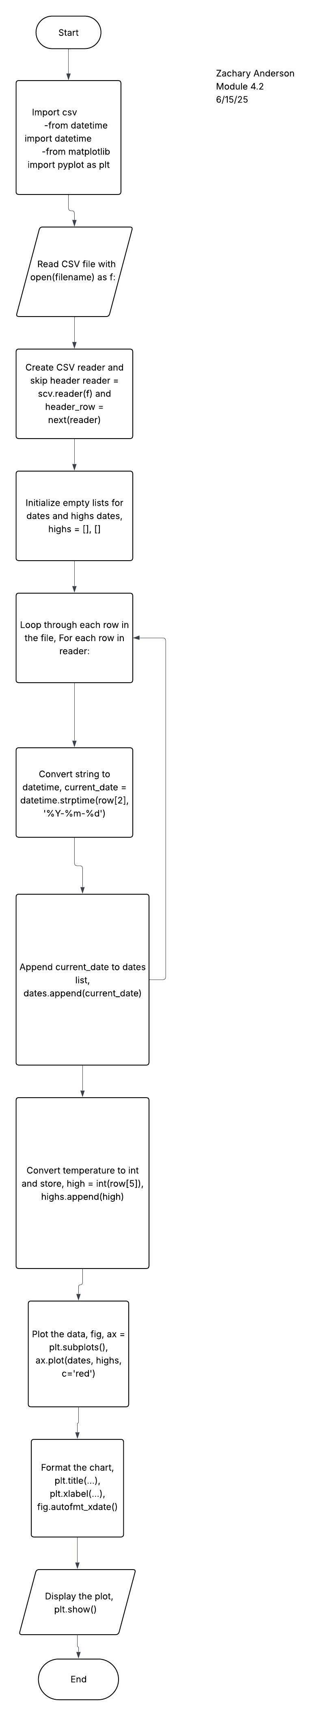First Flowchart

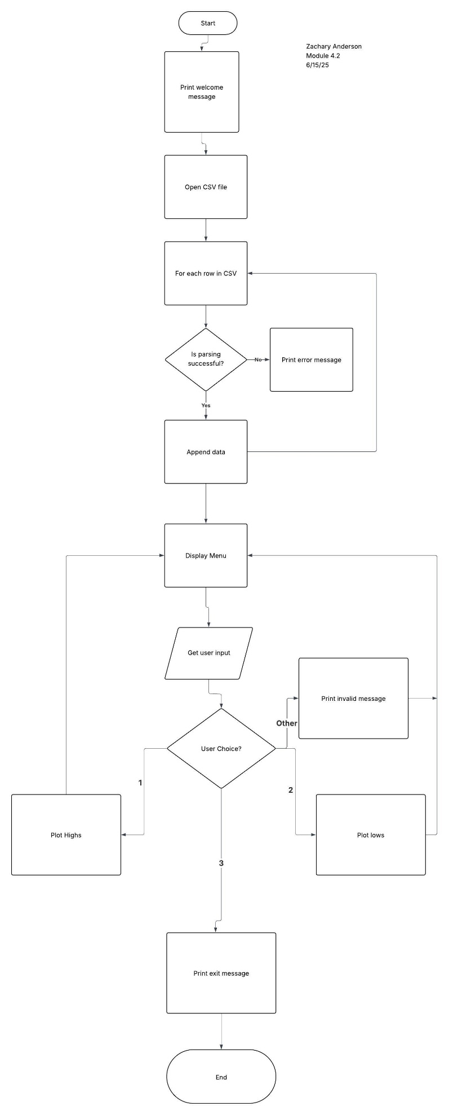

After the Changes Flowchart, I made it simpler to make it easier to read and understand without a lot of the code in the flowchart itself.