Value Stream Mapping
Meal Prepping:
Time Span - Weekly
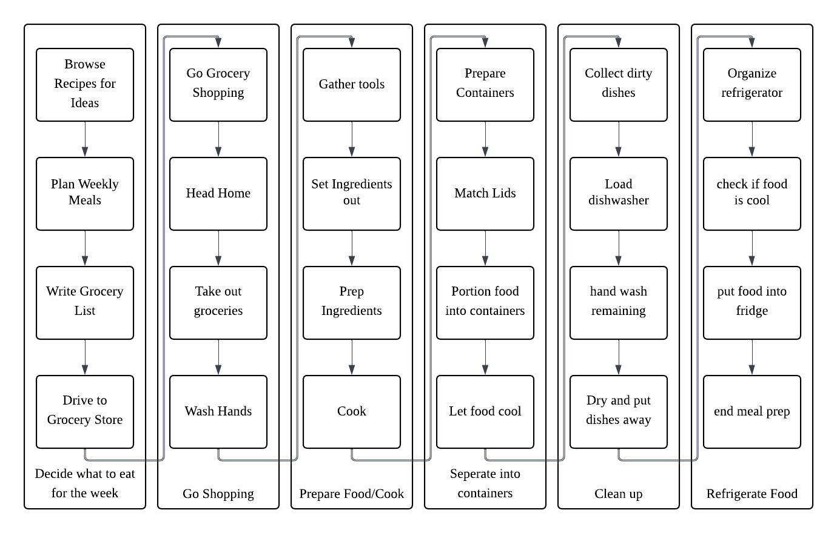
Analyzing Lean Metrics:
Estimated Average Flow Time
Decide What to eat for the week | 40 minutes
Go Shopping | 50 minutes
Prepare Food/Cook | 60 minutes
Separate into containers | 35 minutes
Clean up | 30 minutes
Refrigerate Food | 10 minutes

Estimated Cycle Time = 3.5 hours
Optimizing – Using the information gathered from the lean metrics I can begin to improve on the meal prep process. Improving efficiency by different approaches to the problem leading to a shorter cycle time and more time for other activities. Maybe even some baking thrown in.

Eliminating Waste –
Trimming the fat as the saying goes, the VSM I have made shows a lot of time lost during the shopping, cooling and cleaning portions of the weekly meal preparation. Driving and grocery shopping alone takes a third of the time. This time can be saved by online grocery pickup services or even delivery of groceries to spend more time cooking and less time buying the ingredients. This can save over an hour of prep time during the process. As for the cooling, setting the food under a cooling fan can help it cool faster allowing for the separation and refrigeration segments to be chopped up as well.
Workflow Orchestration –
As it stands right now all my tasks occur in a designated sequence of events, but if I was to move some around or perform some at the same time, time would be saved that way. This could take the form of cleaning while food is cooking, like all the tools used. Also, gathering all portioning containers while organizing necessary ingredients saves time at the end. Changing up the workflow reduces time spent waiting or looking by overlapping it with other tasks.
Governance Models –
This may seem to be over analyzing, but in order to improve consistency and quality in the process, a checklist could be arranged that can be collected in order to improve the flow time. Almost a standard operating procedure of the process to be followed during preparation to avoid time loss. That way I don’t forget ttolls or ingredients along the way and setting up the schedule to avoid having to constantly search for recipes at the beginning of the process.

Conclusion:
After implementing these improvements, the overall lead time of my meal preparation process can be reduced significantly. Online shopping and better planning can save approximately 25 minutes. Parallel cleaning and cooking can reduce cleanup time by about 10 minutes. Faster cooling methods can save another 5–10 minutes. Together, these changes can reduce total flow time from approximately 230 minutes to about 165 minutes. This represents a time savings of over one hour per session and increases the percentage of value-added activities.

References
Knight, L. (2020, October 29). 3 Easy Steps for Using VSM in Everyday Life. ConnectALL. Retrieved from https://www.connectall.com/3-easy-steps-for-using-vsm-in-everyday-life/
OpenAI. (2026). ChatGPT (GPT-5.2) [Large language model]. https://openai.com/chatgpt

