Project: Test Plan
Course: Alexis Mitchell - CSD380
Description: 5 functional tests plan
Date: February 7, 2026
To complete the test case plan, fill out the information for Project, Course, Description and Date in the header below.
.
TABLE OF CONTENTS

The table of contents is empty because you aren’t using the paragraph styles set to appear in it.

For each test, the developer should: provide a test description, a test objective, the developer name and date tested. For each step, fill out the actions to be taken and describe the expected results, and indicate yes or no for each step depending upon the result. The peer tester should provide their name, date tested, indicate yes or no for each step depending upon the result, and a screenshot (thumbnail) of the result.

Test 1 | Add a New Todo Task
 | Test Objective: Verify that a user can add a new todo item using the input field and that item appears on the todo list | Developer: Alexis Mitchell  Date tested: February 7, 2026 | Peer tester: Zachary Anderson  Date tested: <2026/2/7>
Step | Action | Expected results: | Developer pass/fail | Tester pass/fail  + Screenshot
1 | Locate the todo input field | Input field is visible and enabled | <yes> | <yes> 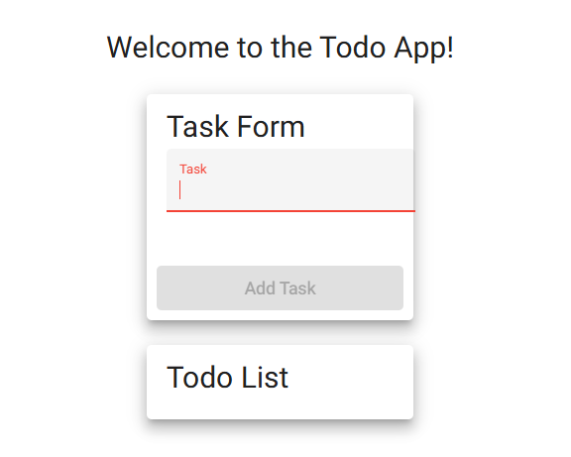
2 | Enter a valid todo item | Text appears in the input field | <yes/no> | <yes>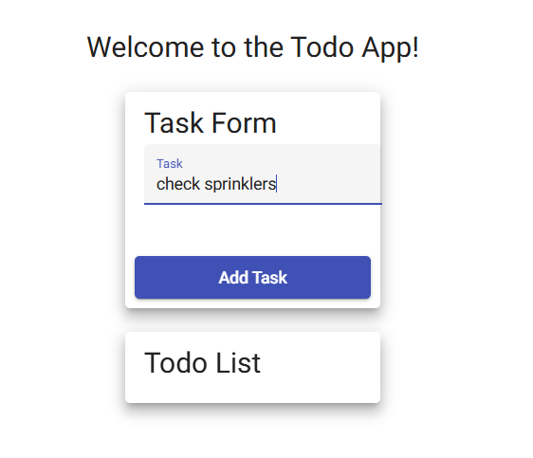
3 | Click the “Add” button | The todo item is added to the list | <yes/no> | <yes> 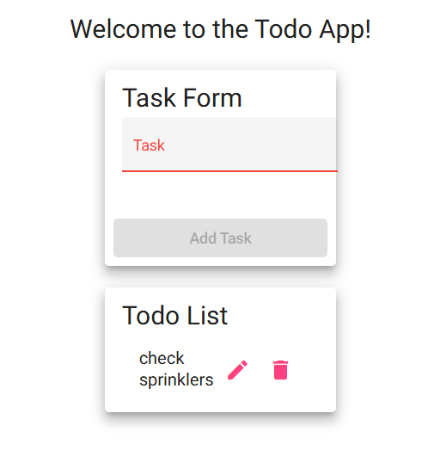
Comments | Comments should be substantive; this means there should be at least 2-3 well-structured sentences with constructive feedback.

Test 2 | Delete a Todo Task
 | Test Objective: verify that a user can delete an existing todo item and that it is removed from the todo list | Developer: Alexis Mitchell  Date tested: February 7, 2026 | Peer tester: Zachary Anderson  Date tested: <2026/2/7>
Step | Action | Expected results: | Developer pass/fail | Tester pass/fail
1 | Locate the delete button associated with a todo item | Delete button is visible | <yes/no> | <yes>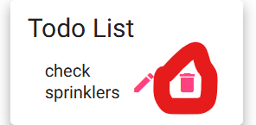
2 | Click the delete button | Todo item is removed from the list | <yes/no> | <yes>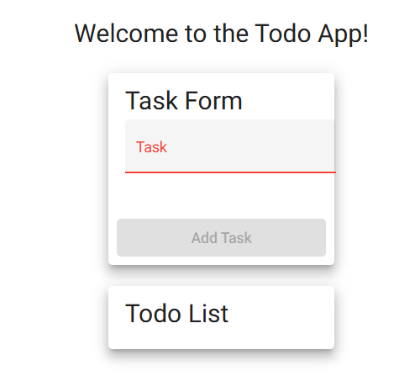
Comments | Comments should be substantive; this means there should be at least 2-3 well-structured sentences with constructive feedback.

Test 3 | Edit a Todo Task
 | Test Objective: verify that a user can edit an existing todo item and that the updated text is saved correctly | Developer: Alexis Mitchell  Date tested: February 7, 2026 | Peer tester: Zachary Anderson  Date tested: <2026/2/7>
Step | Action | Expected results: | Developer pass/fail | Tester pass/fail
1 | Click the edit button for the todo item | Edit button is visible | <yes/no> | <yes>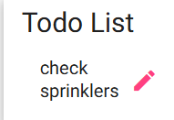
2 | Modify the todo text | Text appears in the edit field | <yes/no> | <yes>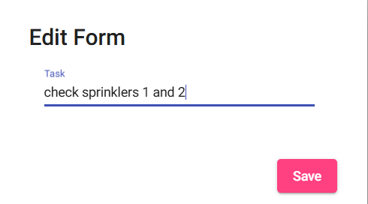
3 | Save the edited todo | Todo item updates with new text | <yes/no> | <yes>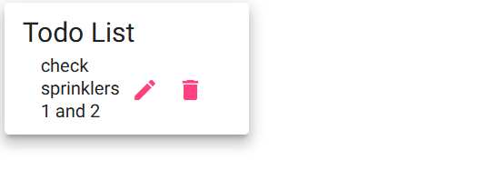
Comments | Comments should be substantive; this means there should be at least 2-3 well-structured sentences with constructive feedback.

Test 4 | Prevent Users from Submitting the Edit Form without Entering a Todo Item
 | Test Objective: verify that the application prevents users from submitting an empty todo item when editing and provides feedback | Developer: Alexis Mitchell  Date tested: February 7, 2026 | Peer tester: Zachary Anderson  Date tested: <2026/2/7>
Step | Action | Expected results: | Developer pass/fail | Tester pass/fail
1 | Click the edit button on the todo item | Edit form is displayed | <yes/no> | <yes>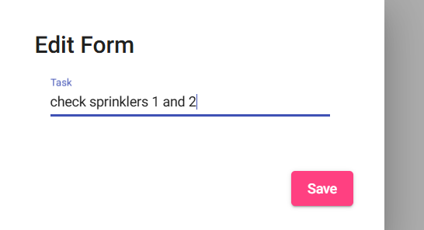
2 | Remove all text from the todo field | Input field is empty | <yes/no> | <yes>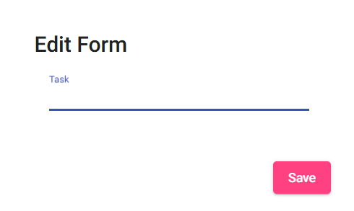
3 | Attempt to save the edit | Error message is displayed or edit is not saved | <no> | <no>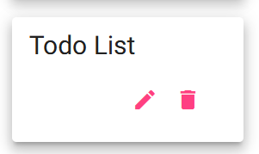
Comments | Comments should be substantive; this means there should be at least 2-3 well-structured sentences with constructive feedback.

Test 5 | Invalid URLs Provide Users with a Custom 404 Error Page
 | Test Objective: verify that users navigating to an invalid URL are shown a custom 404 error page | Developer: Alexis Mitchell  Date tested: February 7, 2026 | Peer tester: Zachary Anderson  Date tested: <2026/2/7>
Step | Action | Expected results: | Developer pass/fail | Tester pass/fail
1 | Open a new web browser | Browser launches | <yes> | <yes>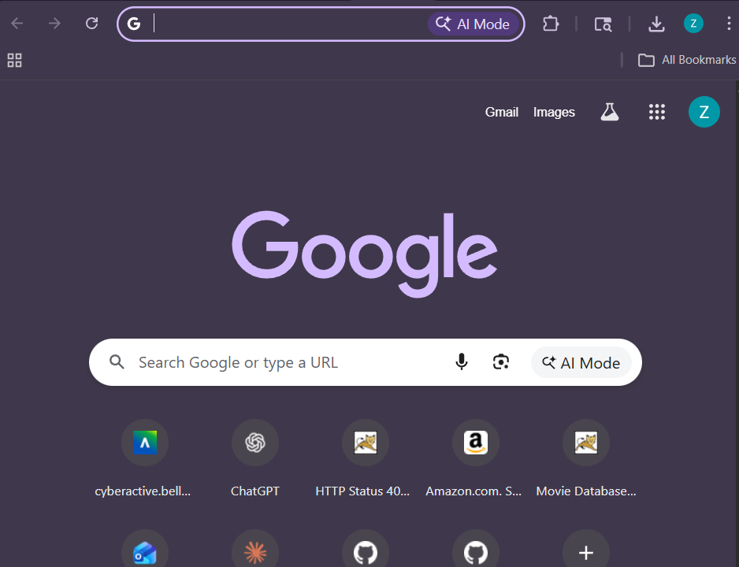
2 | Enter an invalid IRL (e.g. https://buwebdev.github.io/to/ ) | Request is processed | <yes> | <yes>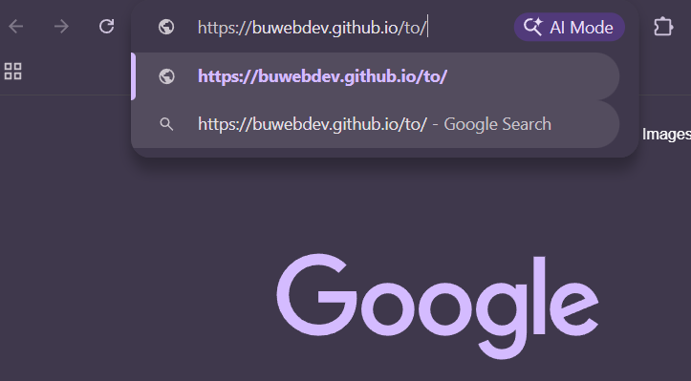
3 | Press Enter | Custom 404 error page is displayed | <yes> | <yes>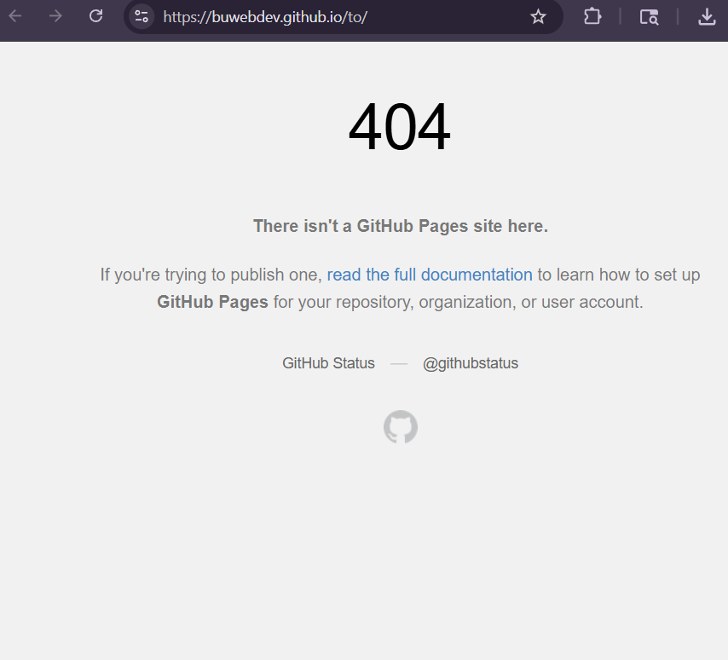
Comments | Comments should be substantive; this means there should be at least 2-3 well-structured sentences with constructive feedback.

