Version Control Guidelines

Software development in the modern era is defined by effective version control and the ways it benefits both consumers and developers alike. The collaborative aspect alone enables monumental increases in efficiency and creativity during the development process. In this paper, I will describe the pros and cons of version control and how it's used today.
The concept of version control doesn’t always pertain to software development, as it can apply to large teams working together towards a common goal. For instance, in Amending the literature through version control by Adam Kane and Bawin Amin, they propose an alternative approach to updating scientific literature using a platform such as GitHub. The ability to maintain an updatable data source, make changes, and communicate those changes to large groups of individuals is invaluable (Kane & Amin, 2023). It is through this collaborative nature that version control can be more effective in scientific research than small teams working alone. There can obviously be downsides when there are “too many cooks in the kitchen,” which can lead to issues and setbacks throughout the process. In their proposal, they recommended that published papers include a link to a repository controlled by the authors for amendment purposes, which in their focus group was only disagreed with by 7% of the participants (Kane & Amin, 2023).
Here is their proposal as a graphic: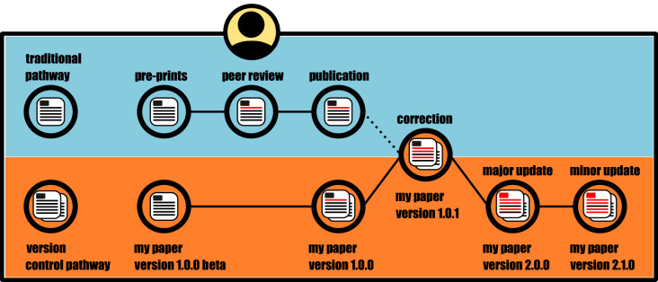

Next on the list is strategies for utilizing version control to improve reliability within a workflow. Git is the name of the game for version control, as it can handle multiple versions at once and revert to previous states with relative ease (Gowda & Gowda, 2022). It also traces all changes made, which is highly valuable in software development. An important use of this is Continuous Integration and Continuous Deployment (CI/CD) which describes the process of automatically integrating all source code from different contributors into a central repository (Gowda & Gowda, 2022). Each change will trigger an automated build and test to implement it into the rest of the codebase. If these are successful, the builds will deployed which cuts down on development time.
Finally, modern version control guidelines emphasize the integration of version control systems with automated workflows and release strategies. As software projects grow in size and complexity, manual testing and deployment become inefficient and error-prone. CI/CD pipelines address this challenge by automatically building, testing, and deploying code whenever changes are committed to a shared repository (Faqih et al., 2024). This approach ensures that errors are detected early and that new features or fixes can be delivered quickly and reliably. Research analyzing GitHub Actions workflows shows that version control tools form the foundation of these automated systems, reinforcing the idea that version control is not just a collaboration tool but a central component of software quality assurance and delivery.
Branching and release strategies further strengthen version control effectiveness by providing structure to collaborative development. Strategies such as Git Flow and GitHub Flow define how and when developers should create branches, merge changes, and prepare releases. These structured workflows help teams avoid conflicts, protect stable codebases, and manage parallel development efforts efficiently (Faqih et al., 2024). Selecting an appropriate branching strategy depends on factors such as team size, project complexity, and release frequency, but all strategies share the goal of improving reliability and maintainability through disciplined version control practices.
Comparison of Version Control Guidelines
While all three sources emphasize collaboration and reliability, they approach version control guidelines from different perspectives. Kane and Amin (2023) focus on transparency and communication, extending version control principles beyond software engineering into academic research. In contrast, Gowda and Gowda (2022) emphasize technical structure through branching and release strategies designed specifically for managing complex software systems. Faqih et al. (2024) highlight automation through CI/CD pipelines, reflecting modern development environments where rapid iteration and continuous deployment are expected. Some earlier guidelines that rely heavily on manual testing, infrequent releases, or centralized control are less relevant today, as automation and distributed collaboration have become standard practices in modern version control workflows.
Proposed Version Control Guidelines
Based on the reviewed research, the following guidelines represent the most important version control practices in modern development:
- Adopt a structured branching strategy (such as Git Flow or GitHub Flow) to manage parallel development and protect stable codebases.
- Use clear and consistent commit messages to improve traceability, accountability, and collaboration.
- Integrate CI/CD pipelines with version control systems to enable automated testing, integration, and deployment.
- Restrict direct commits to main or production branches to reduce risk and maintain system stability.
- Encourage collaboration through pull requests and code reviews to ensure quality and shared ownership of the codebase.
I selected them because they directly address the challenges identified across all three studies, including scalability, reliability, and collaboration. Together, they form a practical framework that supports efficient development while maintaining high software quality.

Despite its many advantages, version control is not without challenges. Poorly managed repositories, unclear branching rules, or inconsistent commit practices can introduce confusion and technical debt. However, the literature suggests that these issues are not flaws of version control itself, but rather a result of inadequate guidelines or inconsistent adoption. When teams follow established best practices—such as clear commit histories, structured branching models, and automated testing—version control systems significantly enhance collaboration, transparency, and software quality.
In conclusion, version control guidelines play a critical role in modern software development by enabling collaboration, supporting automation, and maintaining reliable development workflows. The reviewed research demonstrates that version control principles extend beyond software engineering into other collaborative fields, highlighting their broader value. When applied consistently and thoughtfully, version control systems serve as a powerful framework for managing change, improving efficiency, and delivering high-quality outcomes.

References
Faqih, A. R., Taufiqurrahman, A., Husen, J. H., & Sabariah, M. (2024). Empirical analysis of CI/CD tools usage in GitHub Actions workflows. Journal of Informatics and Web Engineering, 3(2), 251–261. https://doi.org/10.33093/jiwe.2024.3.2.18
Gowda, P., & Gowda, A. N. (2022). Git branching and release strategies. International Journal of Innovative Research in Engineering & Multidisciplinary Physical Sciences, 10(5). https://doi.org/10.5281/zenodo.14221771
Kane, A., & Amin, B. (2023). Amending the literature through version control. Research Integrity and Peer Review. https://pmc.ncbi.nlm.nih.gov/articles/PMC9845965/
OpenAI. (2025). ChatGPT. https://openai.com/

