Creating student1:
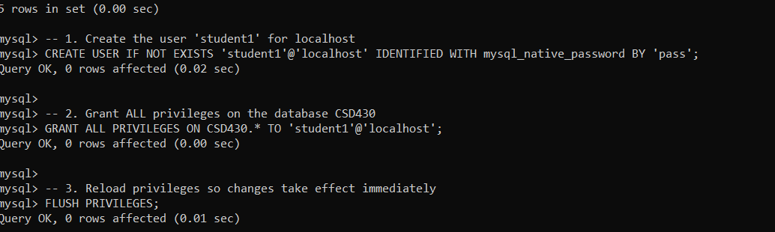
Creating zachary_movies_data table:
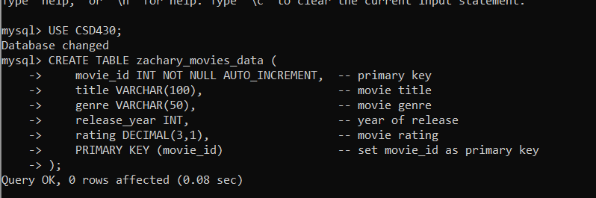
Populating table:
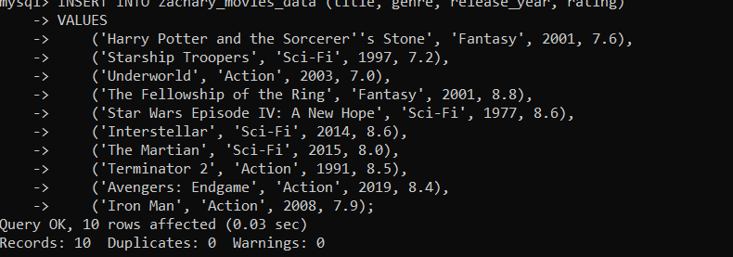

Displaying populated table:
