Java installation and configuration:
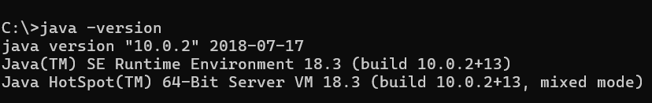
Apache Tomcat Installation:
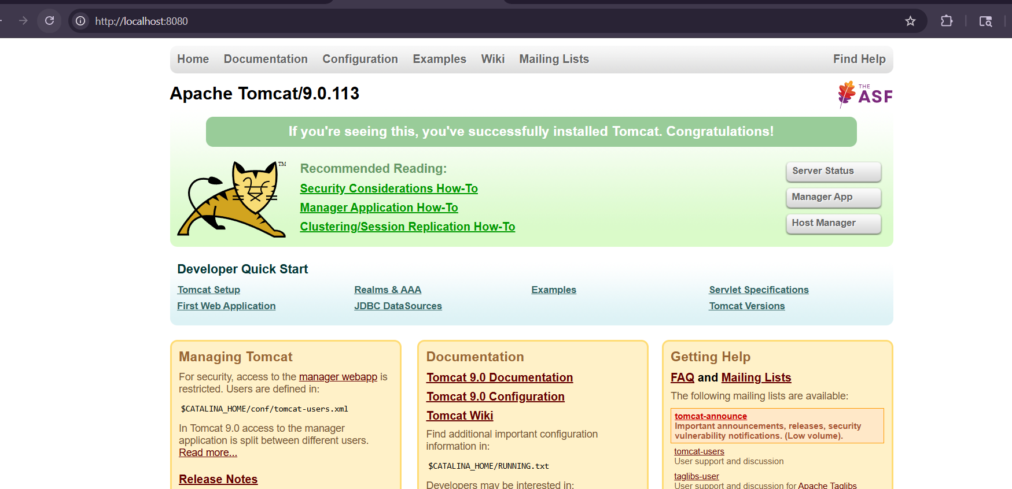

VS Code Running Tomcat:
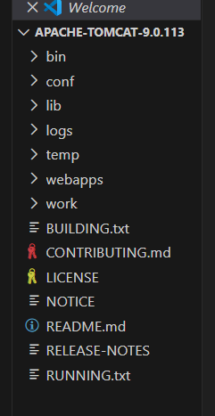
JSP Demo Running :
