**Use “audacity”**

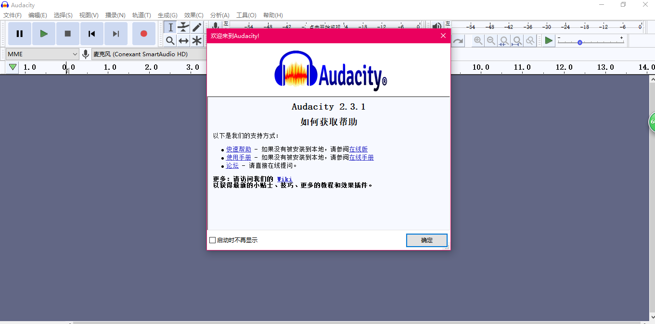

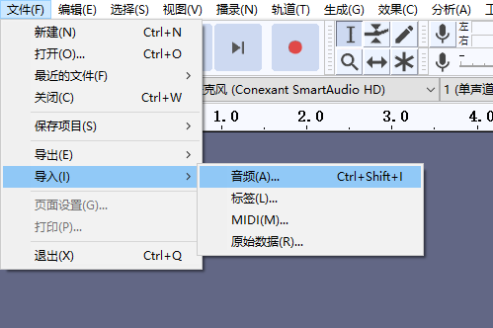

**If dual channel, mix them to mono channel as following:**

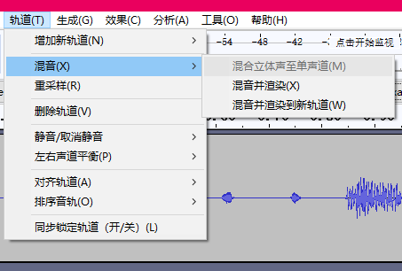

**Change sample rate to 48kHZ as following:**

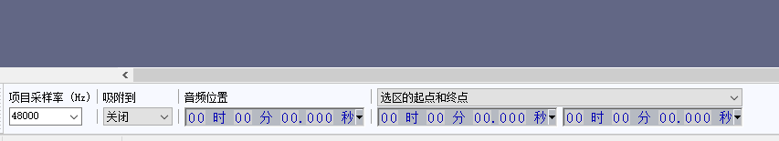

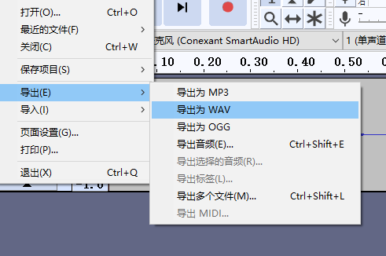

**Important! Change the format to 16-bit PCM:**

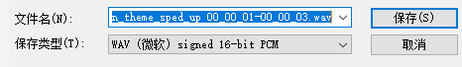

Use the code provided below in Matlab:

[y,Fs] = audioread('main_theme_sped_up.wav','native'); //change the file name

% sound(y,Fs);

wavhex = lower(dec2hex(typecast(y, 'uint16')));

s='16''h ';

space=' ';

fileID = fopen('music.txt','w');

for x = 1:85115

each_16=strcat(s,space,wavhex(x,:),',');

fprintf(fileID,'%10s',each_16);

end

fclose(fileID);