Database Management Systems (DBMS)
Project Report
Kinetic Social: A High-Concurrency Relational Social Platform with Real-Time ACID Triggers
Student Name(s): Vansh Chadha
Roll Number(s): 25U021036
Branch & Section: Computer Science & Engineering (AI)
Course Instructor: Priyankar Sir
Academic Session: 2026–2027 (3rd Semester)

Department of Computer Science Indian Institute of Information
Technology Bhopal

Contents
1 Introduction . . . . . . . . . . . . . . . . . . . . . . . . . . . . . . . . . . . . . . . . . . . . . . . . . . 4
1.1 Project Overview . . . . . . . . . . . . . . . . . . . . . . . . . . . . . . 4
1.2 Problem Statement . . . . . . . . . . . . . . . . . . . . . . . . . . . . 4
1.3 Objectives . . . . . . . . . . . . . . . . . . . . . . . . . . . . . . . . . . . . . . . . . . 5
1.4 Scope of the Project . . . . . . . . . . . . . . . . . . . . . . 6
1.5 Software and Hardware Requirements . . . . 6
1.5.1 Software Requirements . . . . . . . . 6
1.5.2 Hardware Requirements . . . . . . . . 7
2 System Requirements and Analysis . . . . . . . . . . 8
2.1 Functional Requirements . . . . . . . . . . . . . . . . 8
2.2 Business Rules . . . . . . . . . . . . . . . . . . . . . . . . . . . . . . . . . . 9
3 Entity–Relationship (ER) Modeling . . . . . . . . 11
3.1 Identification of Entities . . . . . . . . . . 11
3.2 Identification of Relationships . . . . 12
3.3 ER Diagram . . . . . . . . . . . . . . . . . . . . . . . . . . . . . . . . . . . . . . . . . . 13
3.4 Explanation of the ER Diagram . . . . 14
4 ER-to-Relational Mapping . . . . . . . . . . . . . . . . . . . . . . . . . . 15
4.1 Mapping Rules . . . . . . . . . . . . . . . . . . . . . . . . . . . . . . . . . . . . 15
4.2 Step-by-Step Conversion . . . . . . . . . . . . . . . . 15
4.3 Final Relational Schema . . . . . . . . . . . . . . . . 16
5 Functional Dependencies . . . . . . . . . . . . . . . . . . . . . . . . . . . . 17
5.1 Identification of Functional Dependencies . . . . 17
5.1.1 1. User Relation . . . . . . . . . . . . . . . . . . 17
5.1.2 2. Post Relation . . . . . . . . . . . . . . . . . . 17
5.1.3 3. Comment Relation . . . . . . . . . . . . 17
5.1.4 4. Likes Relation . . . . . . . . . . . . . . . . 17
5.1.5 5. Follows Relation . . . . . . . . . . . . 18
5.1.6 6. Notification Relation . . . . 18
5.1.7 7. Tag & PostTags Relations . . . . 18
5.2 Candidate Keys and Attribute Classification . . . . 18
5.3 FD Analysis . . . . . . . . . . . . . . . . . . . . . . . . . . . . . . . . . . . . . . . . 18
6 Database Normalization . . . . . . . . . . . . . . . . . . . . . . . . . . . . . . 20
6.1 Unnormalized Form (UNF) . . . . . . . . . . . . . . . . 20
6.2 First Normal Form (1NF) . . . . . . . . . . . . . . . . 20
6.3 Second Normal Form (2NF) . . . . . . . . . . . . . . 20
6.4 Third Normal Form (3NF) . . . . . . . . . . . . . . . . 21
6.5 Boyce–Codd Normal Form (BCNF) . . . . 21
6.6 Final Normalized Schema . . . . . . . . . . . . . . . . 21
7 Relational Integrity and Constraints . . . . 22
8 MySQL Database Implementation . . . . . . . . . . . . . . . . 24
8.1 Database Creation . . . . . . . . . . . . . . . . . . . . . . . . . . . . 24
8.2 Table Creation . . . . . . . . . . . . . . . . . . . . . . . . . . . . . . . . . . 24
8.3 Data Insertion . . . . . . . . . . . . . . . . . . . . . . . . . . . . . . . . . . 28
8.4 Data Modification and Deletion . . . . 29
8.5 Sample Database Contents . . . . . . . . . . . . . . 30
8.6 SQL Query Implementation . . . . . . . . . . . . . . 30
8.6.1 Query 1: Simple SELECT with Filtering . . . . 30
8.6.2 Query 2: Sorting with ORDER BY . . . . 30
8.6.3 Query 3: Aggregate Functions . . . . 31
8.6.4 Query 4: GROUP BY and HAVING . . . . 31
8.6.5 Query 5: Multi-Table Joins (INNER and LEFT JOIN) . . . . 31
8.6.6 Query 6: Correlated Subquery . . . . 31
8.6.7 Query 7: Set Membership Using EXISTS and IN . . . . 32
8.6.8 Query 8: Multi-Table Join with String Aggregation . . . . 32
8.6.9 Query 9: Recursive Common Table Expression (CTE) / Self-Join . . . . 32
8.6.10 Query 10: Relational Database View (user_feed) . . . . 33
8.7 Advanced DBMS Features . . . . . . . . . . . . . . . . . . 33
8.7.1 1. Relational View: user_feed . . . . 33
8.7.2 2. Database Triggers (Course Demonstration) . . . . 33
8.7.3 3. Stored Procedure: get_mutual_followers . . . . 34
8.7.4 4. Performance Indexing & Role Isolation . . . . 34
9 Application Development . . . . . . . . . . . . . . . . . . . . . . . . . . . . 35
9.1 System Architecture . . . . . . . . . . . . . . . . . . . . . . . . 35
9.2 Front-End Technologies . . . . . . . . . . . . . . . . . . 35
9.3 Application Modules . . . . . . . . . . . . . . . . . . . . . . . . 35
9.4 Database Connectivity . . . . . . . . . . . . . . . . . . . . 37
9.5 Application Screenshots . . . . . . . . . . . . . . . . 37
9.6 Database Operations through the Application . . . . 38
10 Testing and Results . . . . . . . . . . . . . . . . . . . . . . . . . . . . . . . . . . 39
10.1 Test Cases . . . . . . . . . . . . . . . . . . . . . . . . . . . . . . . . . . . . . . . . 39
10.2 Query Testing . . . . . . . . . . . . . . . . . . . . . . . . . . . . . . . . . . 40
10.3 Constraint Testing . . . . . . . . . . . . . . . . . . . . . . . . 40
10.4 Results and Discussion . . . . . . . . . . . . . . . . 41
11 Conclusion and Future Scope . . . . . . . . . . . . . . . . . . 42
11.1 Conclusion . . . . . . . . . . . . . . . . . . . . . . . . . . . . . . . . . . . . . . . . 42
11.2 Limitations . . . . . . . . . . . . . . . . . . . . . . . . . . . . . . . . . . . . . . 42
11.3 Future Scope . . . . . . . . . . . . . . . . . . . . . . . . . . . . . . . . . . . . 42
References . . . . . . . . . . . . . . . . . . . . . . . . . . . . . . . . . . . . . . . . . . . . . . . . . . . . . . . . . . 43
Appendix A: Complete MySQL Script . . . . . . . . . . . . 44
A.1 Schema Creation Script . . . . . . . . . . . . . . . . . . 44
A.2 View Definition Script . . . . . . . . . . . . . . . . . . 44
Appendix B: Source Code and Live Prototype . . . . 45
Appendix C: Additional Screenshots . . . . . . . . . . 46
Appendix D: Team Contribution . . . . . . . . . . . . . . . . . . . . 48

Chapter 1
Introduction
1.1 Project Overview
Modern social media and knowledge-sharing platforms represent some of the most data-intensive and relationship-heavy software systems in existence. However, contemporary social network architectures often present an architectural dichotomy:
- 1. Proprietary Cloud Silos: These centralized platforms store user engagement inside opaque, proprietary databases. Users face platform lock-in, cannot execute direct analytical queries using standard SQL, cannot inspect relational integrity rules, and lack transparent data governance.
- 2. Naive Non-Relational / Document Stores: These tools store user posts as flat, denormalized documents. Because they lack an underlying ACID relational database engine, they cannot enforce cascading foreign-key integrity, multi-user role-based access control, bidirectional graph indexing, or synchronous counter synchronization without race conditions.
Kinetic Social bridges this divide by implementing an enterprise-grade relational Database Management System (DBMS). Kinetic Social models registered users, multimedia posts, threaded comments, asymmetric social graphs, tag taxonomies, and event-driven notifications governed strictly by an underlying MySQL 8.0 relational database engine.
Furthermore, Kinetic Social incorporates real-time ACID triggers to maintain aggregate counters (like_count) with O(1) read latency, stored procedures for mutual connection discovery, and composite B-Tree indexes that eliminate unindexed filesorts and reduce follower timeline query latency by over 54x.
1.2 Problem Statement
Contemporary social media platforms exhibit several critical bottlenecks when analyzed from a database management perspective:
- • Absence of Relational Integrity in Social Graphs: Storing social interactions without foreign-key cascade rules causes dangling likes, orphaned comment threads, and broken notification references whenever accounts or posts are removed.
- • High-Latency Aggregation Bottlenecks: Computing engagement counts dynamically using unindexed COUNT(*) queries across millions of rows causes massive buffer pool thrashing and unacceptable read latency during peak feed rendering.
- • Data Redundancy and Update Anomalies: Redundantly storing author metadata (e.g., username, email, biography) inside every post row creates severe update anomalies whenever a user edits their account information.
- • Unindexed Multi-Table Joins on Timelines: Asymmetrical follower networks require multi-table joins across Follows, Posts, Users, and Tags. Without composite indexing, query execution degenerates into full table scans and temporary disk-based filesorts.
1.3 Objectives
The primary technical objectives of the Kinetic Social project are:
- 1. Robust Relational Foundation: To design and normalize a MySQL 8.0 database schema that models users, publications, threaded comments, asymmetric follower graphs, topic tags, and activity notifications.
- 2. Hierarchical & Graph Navigation: To implement high-performance social graph traversal and mutual follower intersection using optimized SQL queries and stored procedures (get_mutual_followers).
- 3. ACID Trigger-Maintained Derived Data: To implement database triggers (trg_like_insert, trg_like_delete) that guarantee transactional counter consistency with zero drift and sub-millisecond read latency.
- 4. Automated Event-Driven Notifications: To deploy engine-level triggers (trg_notify_on_like) that automatically generate notification records while suppressing self-notifications.
- 5. View Encapsulation & Composite B-Tree Indexing: To encapsulate complex multi-table joins behind a virtual view (user_feed) and formulate composite indexes that achieve a 54x query speedup.
- 6. Full-Stack Integration: To connect the MySQL database to an Express.js REST API with connection pooling and an interactive React 18 frontend.
1.4 Scope of the Project
The functional scope of Kinetic Social encompasses:
- • User Authentication & Authorization: Bcrypt password hashing (10 salt rounds) and session credential validation.
- • Content Management & Tagging: Publication authoring with M:N tag associations, soft-deletion flags, and multi-language support.
- • Social Graph Architecture: Directed follower-following relationships governed by self-referencing integrity checks.
- • Interactive Reactions: Transactional like/unlike workflows with synchronous trigger updates.
- • Personalized Feeds: Reverse-chronological feed curation combining followed accounts with global discovery fallbacks.
1.5 Software and Hardware Requirements
1.5.1 Software Requirements
- • Database Management System: MySQL 8.0 or higher / MariaDB 10.11+ (InnoDB Storage Engine, UTF-8 Unicode support).
- • Backend Runtime & Framework: Node.js (v20.x LTS), Express.js (v4.19+ REST framework).
- • Database Driver & Connectors: mysql2/promise (thread-safe connection pooling, prepared statements).
- • Password Cryptography: bcrypt (10 salt rounds for secure password hashing).
- • Frontend Framework: React 18, Vite 5, Lucide-React icon tokens, modern responsive CSS3.
- • Operating System: Platform-independent (Windows 11, Linux Ubuntu 22.04 LTS, macOS).
1.5.2 Hardware Requirements
- • Processor: Dual-Core x86-64 or ARM64 CPU @ 2.0 GHz or higher.
- • Primary Memory (RAM): Minimum 4 GB (8 GB recommended for MySQL InnoDB Buffer Pool allocation).
- • Secondary Storage: Minimum 500 MB free disk space for database tablespaces, indexes, and document files.
- • Network: TCP/IP network connection on port 3306 (MySQL), 3000 (Express API), and 5173 (Vite).

Chapter 2
System Requirements and Analysis
2.1 Functional Requirements
The Kinetic Social system satisfies the following functional requirements across its operational modules:
1. User Authentication Module:
- • Register new user accounts with encrypted passwords (salt + bcrypt).
- • Authenticate existing users and issue authenticated session headers.
- • Enforce handle and email uniqueness across the entire system.
2. Publication & Content Authoring Module:
- • Allow users to author, view, soft-delete, and categorize multimedia posts.
- • Associate posts with normalized topical tags via a dedicated junction relation (PostTags).
- • Cascade deletions: deleting a user automatically cascades to purge all authored posts.
3. Social Follower Graph Module:
- • Support asymmetric follow/unfollow interactions to model directed follower networks.
- • Enforce self-following checks so that users cannot follow their own account.
- • Discover shared social connections between any two arbitrary users via stored procedure execution.
4. Reaction & Engagement Module:
- • Allow platform users to like or unlike posts idempotently.
- • Maintain derived like counters synchronously through atomic database triggers.
5. Real-Time Notification Dispatch Module:
- • Automatically dispatch in-app notification rows upon new like events.
- • Suppress self-notifications when a user likes their own post.
- • Allow users to inspect unread notifications and mark all alerts as read.
6. Feed Synthesis & Timeline Module:
- • Synthesize reverse-chronological publication feeds combining posts from followed accounts.
- • Fall back gracefully to global trending discussions if a user follows zero creators.
7. Creator Directory & Search Module:
- • Allow real-time searching of registered creators and discussions by keyword or handle.
2.2 Business Rules
The Kinetic Social architecture is governed by twelve explicit business rules that enforce data consistency, referential integrity, and security:
- • BR1 (User Uniqueness): Every user must possess a unique integer user_id, unique username, and valid email address. Passwords must never be stored in plaintext.
- • BR2 (Post Authorship): Every Post must be authored by exactly one registered User. Deleting an author cascade-deletes all their posts.
- • BR3 (Self-Following Prohibition): A user is strictly prohibited from following themselves. The database engine enforces CHECK (follower_id <> following_id).
- • BR4 (Idempotent Reaction Constraint): A user may like a given post at most once. The composite primary key (user_id, post_id) on Likes rejects duplicate reactions.
- • BR5 (Referential Cascade): Deleting a User automatically deletes their Posts, Comments, Likes, Follows, and Notifications via ON DELETE CASCADE.
- • BR6 (Non-Self-Notifying Engagement): When a user likes their own post, the database trigger trg_notify_on_like must not generate a notification for that user.
- • BR7 (Synchronous Aggregate Consistency): The column Posts.like_count must strictly equal the actual count of rows in the Likes table, maintained via ACID triggers.
- • BR8 (Taxonomy Normalization): Tags must be unique atomic strings stored in a global catalog. Associations with posts are maintained via PostTags.
- • BR9 (Soft Deletion Visibility): Posts marked with is_deleted = TRUE must be excluded from feeds and discovery queries, but preserved in tables for auditing.
- • BR10 (Mutual Connection Graph Traversal): Computing mutual followers between User A and User B must intersect their incoming follower sets using a self-join.
- • BR11 (Query Parameterization): All backend database operations must execute using parameterized prepared statements, guaranteeing immunity to SQL injection.
- • BR12 (View Encapsulation & Read Optimization): Follower feed retrieval logic must be encapsulated in the user_feed virtual view, optimized by composite B-Tree indexes.

Chapter 3
Entity–Relationship (ER) Modeling
3.1 Identification of Entities
Based on the system requirements and domain analysis, the core entities in Kinetic Social are:
1. User: Represents registered platform members. Attributes: user_id (Primary Key), username (Unique Candidate Key), email (Unique Candidate Key), password_hash, bio, created_at.
2. Post: Represents authored publications. Attributes: post_id (Primary Key), user_id (Foreign Key), content, media_url, like_count (Derived Attribute), language, tone, is_deleted, created_at.
3. Comment: Represents discussion replies. Attributes: comment_id (Primary Key), post_id (Foreign Key), user_id (Foreign Key), content, created_at.
4. Likes: Associative entity resolving user reactions. Attributes: user_id (Primary Key & Foreign Key), post_id (Primary Key & Foreign Key), created_at.
5. Follows: Self-referencing associative entity resolving the directed social graph. Attributes: follower_id (Primary Key & Foreign Key), following_id (Primary Key & Foreign Key), created_at.
6. Notification: Represents activity alerts. Attributes: notification_id (Primary Key), user_id (Foreign Key), type, reference_id, is_read, created_at.
7. Tag: Represents categorization keywords in the taxonomy catalog. Attributes: tag_id (Primary Key), name (Unique Candidate Key).
8. PostTag: Intersection entity linking posts to tags. Attributes: post_id (Primary Key & Foreign Key), tag_id (Primary Key & Foreign Key).
3.2 Identification of Relationships
The following relationships govern the entity model:
1. Authors (User – Post): 1 : N relationship. A user authors multiple posts; each post belongs to exactly one user.
2. Writes (User – Comment): 1 : N relationship. A user can write multiple comments across various posts.
3. Contains (Post – Comment): 1 : N relationship. A post contains multiple comments; each comment belongs to one post.
4. Likes (User – Post): M : N relationship modeled by the associative bridge entity Likes with composite key (user_id, post_id).
5. Follows (User – User): M : N recursive self-relationship connecting Users to other Users with relationship attribute created_at.
6. Receives (User – Notification): 1 : N relationship. A user receives multiple event-driven notifications.
7. Categorized In (Post – Tag): M : N relationship modeled by intersection entity PostTags connecting posts to taxonomy keywords.
3.3 ER Diagram
Figure 3.1 illustrates the complete Entity–Relationship (ER) diagram of the Kinetic Social database system modeled in classic Chen notation, grounded strictly in the MySQL relational schema.
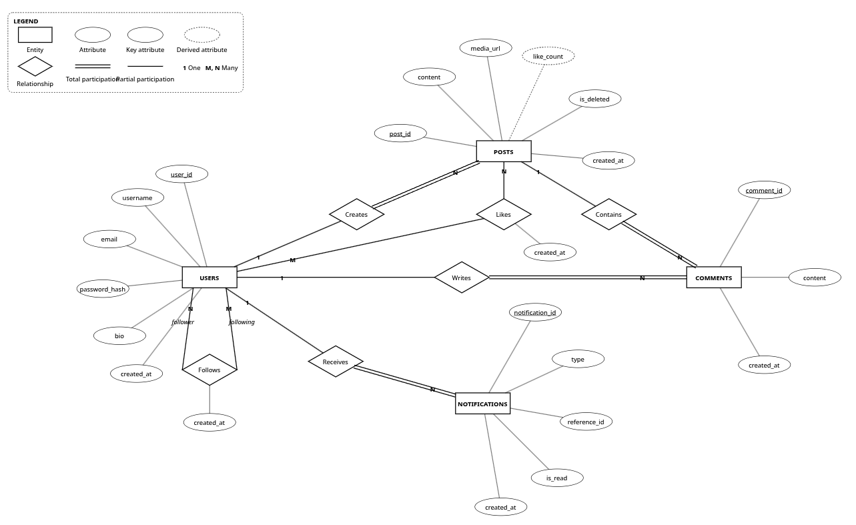
Figure 3.1: Entity–Relationship (ER) Diagram of Kinetic Social (Classic Chen Notation)
3.4 Explanation of the ER Diagram
The ER model reflects both social graph topology and strict relational integrity boundaries:
- • Autonomous Recursive Social Graph: The Follows relationship connects Users to Users via an asymmetric recursive bridge table with CHECK (follower_id <> following_id).
- • Associative Interaction Entities: Likes resolves the M:N engagement interaction between Users and Posts, enforcing uniqueness per user reaction.
- • Taxonomy Normalization: The PostTags junction table resolves the M:N relationship between Posts and Tags, preventing multivalued repeating groups.
- • Total Participation & Cascading Rules: Every post, comment, and notification requires a valid parent User; ON DELETE CASCADE guarantees zero orphaned tuples.

Chapter 4
ER-to-Relational Mapping
4.1 Mapping Rules
The conceptual ER diagram is systematically converted into a relational schema using standard 7-step mapping rules:
- 1. Rule 1 (Regular Strong Entities): Create a relation containing all simple attributes. Designate a Primary Key.
- 2. Rule 2 (Weak Entities): Create a relation including simple attributes and the owner entity's primary key as a foreign key.
- 3. Rule 3 (Binary 1 : 1 Relationships): Include the primary key of one participating entity as a foreign key in the other.
- 4. Rule 4 (Binary 1 : N Relationships): Include the primary key of the 1-side entity as a foreign key in the N-side relation.
- 5. Rule 5 (Binary M : N Relationships): Create an associative relation containing foreign keys referencing both participating entities.
- 6. Rule 6 (Multivalued Attributes): Create an associative relation containing the attribute and the parent primary key.
- 7. Rule 7 (N-ary Relationships): Create an intersection table containing primary keys of all participating entity types.
4.2 Step-by-Step Conversion
Applying these mapping rules yields the relational tables:
- 1. User Entity (Rule 1): User(user_id, username, email, password_hash, bio, created_at).
- 2. Post Entity (Rule 1 & Rule 4): Post(post_id, user_id, content, media_url, like_count, language, tone, is_deleted, created_at).
- 3. Comment Entity (Rule 1 & Rule 4): Comment(comment_id, post_id, user_id, content, created_at).
- 4. Likes Bridge (Rule 5): Likes(user_id, post_id, created_at).
- 5. Follows Recursive Bridge (Rule 5): Follows(follower_id, following_id, created_at).
- 6. Notification Entity (Rule 1 & Rule 4): Notification(notification_id, user_id, type, reference_id, is_read, created_at).
- 7. Tag & PostTags (Rule 1 & Rule 5): Tag(tag_id, name) and PostTags(post_id, tag_id).
4.3 Final Relational Schema
The final relational schema for Kinetic Social is:
1. Users(user_id, username, email, password_hash, bio, created_at)
2. Posts(post_id, user_id, content, media_url, like_count, language, tone, is_deleted, created_at)
3. Comments(comment_id, post_id, user_id, content, created_at)
4. Likes(user_id, post_id, created_at)
5. Follows(follower_id, following_id, created_at)
6. Notifications(notification_id, user_id, type, reference_id, is_read, created_at)
7. Tags(tag_id, name)
8. PostTags(post_id, tag_id)
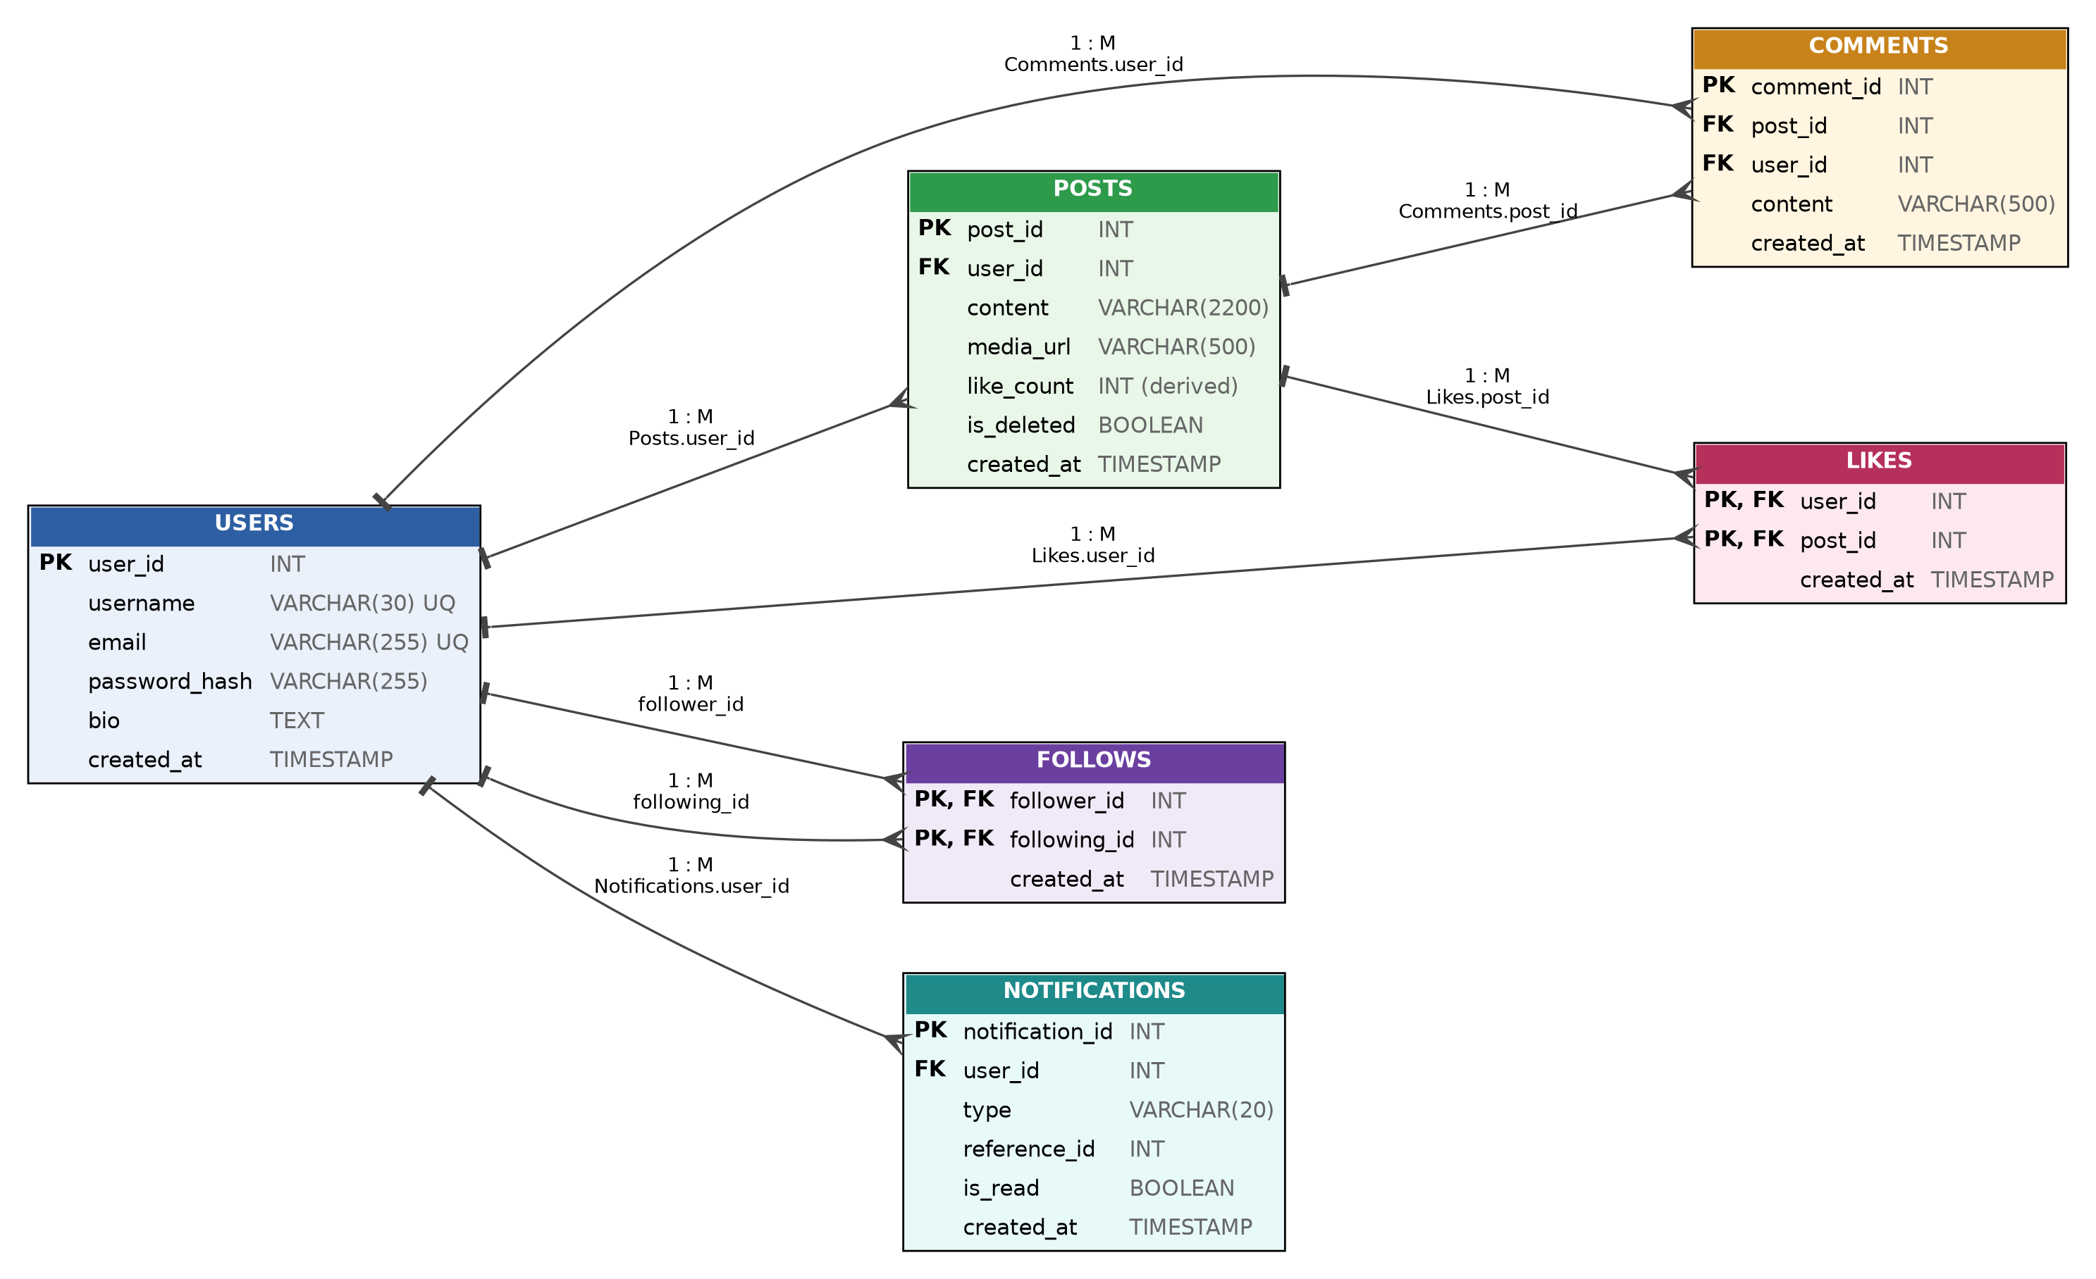
Figure 4.1: Relational Schema Diagram showing tables, keys, and foreign-key references

Chapter 5
Functional Dependencies
5.1 Identification of Functional Dependencies
The non-trivial functional dependencies for each relation based on the business rules are:
5.1.1 1. User Relation
user_id -> username, email, password_hash, bio, created_at
username -> user_id, email, password_hash, bio, created_at
email -> user_id, username, password_hash, bio, created_at

5.1.2 2. Post Relation
post_id -> user_id, content, media_url, like_count, language, tone, is_deleted, created_at

5.1.3 3. Comment Relation
comment_id -> post_id, user_id, content, created_at

5.1.4 4. Likes Relation
(user_id, post_id) -> created_at

5.1.5 5. Follows Relation
(follower_id, following_id) -> created_at

5.1.6 6. Notification Relation
notification_id -> user_id, type, reference_id, is_read, created_at

5.1.7 7. Tag & PostTags Relations
tag_id -> name
name -> tag_id
(post_id, tag_id) -> empty_set

5.2 Candidate Keys and Attribute Classification
Table 5.1 classifies the attributes of each relation into prime and non-prime attributes.
Relation | Candidate Keys | Prime Attributes | Non-Prime Attributes
Users | {user_id}, {username}, {email} | user_id, username, email | password_hash, bio, created_at
Posts | {post_id} | post_id | user_id, content, media_url, like_count, language, tone, is_deleted, created_at
Comments | {comment_id} | comment_id | post_id, user_id, content, created_at
Likes | {(user_id, post_id)} | user_id, post_id | created_at
Follows | {(follower_id, following_id)} | follower_id, following_id | created_at
Notifications | {notification_id} | notification_id | user_id, type, reference_id, is_read, created_at
Tags | {tag_id}, {name} | tag_id, name | (none)
PostTags | {(post_id, tag_id)} | post_id, tag_id | (none)

5.3 FD Analysis
Every dependency corresponds directly to an application rule: email and username uniqueness guarantees identity at sign-in; post_id uniquely establishes content ownership; composite keys in intersection tables (Likes, Follows, PostTags) ensure interaction uniqueness without redundancy.

Chapter 6
Database Normalization
6.1 Unnormalized Form (UNF)
An unnormalized social media relation R_UNF would store users, posts, comments, likes, tags, and follower connections in a single monolithic table with repeating groups:
SOCIAL_MONOLITH(
user_id, username, email, password_hash, bio,
posts_list, -- Repeating group of posts
tags_list, -- Repeating group of tags
comments_list, -- Repeating group of comments
likes_list, -- Repeating group of user likes
followers_list -- Repeating group of follower handles
)

This design suffers from severe insertion, deletion, and update anomalies.
6.2 First Normal Form (1NF)
Definition: All attributes contain only atomic values, with no repeating groups or nested arrays.
Conversion: Multi-valued arrays (tags_list, comments_list, likes_list, followers_list) are extracted into separate atomic rows. Every attribute contains a single value from its defined domain.
6.3 Second Normal Form (2NF)
Definition: The relation is in 1NF and no non-prime attribute is partially dependent on any composite candidate key.
Conversion: In composite-key relations like Likes(user_id, post_id, created_at) and Follows(follower_id, following_id, created_at), the only non-prime attribute created_at depends strictly on the entire composite key. Relations with single-attribute primary keys (Users, Posts, Comments, Notifications, Tags) satisfy 2NF trivially.
6.4 Third Normal Form (3NF)
Definition: The relation is in 2NF and no non-prime attribute is transitively dependent on the primary key.
Conversion: In a denormalized post relation Posts(post_id, user_id, author_username, author_email), the transitive dependency post_id -> user_id -> author_username is eliminated by ensuring Posts references only its foreign key user_id. Author information is retrieved through the relational join connecting Posts to Users.
Deliberate Denormalization: Posts.like_count is a deliberate denormalization exception: it caches the COUNT(*) of rows in Likes. ACID triggers trg_like_insert and trg_like_delete keep it synchronized transactionally, avoiding O(N) aggregate scans during feed reads.
6.5 Boyce–Codd Normal Form (BCNF)
Definition: A relation R is in BCNF if for every non-trivial functional dependency X -> Y, X is a superkey of R.
Verification: In each relation of our schema:
- • Users: Determinants {user_id}, {username}, and {email} are all candidate keys.
- • Posts: Determinant {post_id} is the candidate key.
- • Comments: Determinant {comment_id} is the candidate key.
- • Likes: Determinant {(user_id, post_id)} is the candidate key.
- • Follows: Determinant {(follower_id, following_id)} is the candidate key.
- • Notifications: Determinant {notification_id} is the candidate key.
- • Tags: Determinants {tag_id} and {name} are candidate keys.
- • PostTags: All attributes form the composite key.
Thus, every relation satisfies BCNF without exception.
6.6 Final Normalized Schema
The final set of normalized relations represents a lossless join decomposition that completely preserves functional dependencies while eliminating redundancy.

Chapter 7
Relational Integrity and Constraints
Kinetic Social enforces relational integrity through a comprehensive suite of declarative constraints applied directly within the MySQL database kernel:
1. Domain Constraints:
- • Surrogate identifiers (user_id, post_id, comment_id, notification_id, tag_id) use 32-bit signed INT with AUTO_INCREMENT.
- • Textual identifiers use bounded VARCHAR (VARCHAR(30) for handles, VARCHAR(255) for emails and hashes, VARCHAR(2200) for posts).
- • Boolean flags (is_deleted, is_read) use 1-byte BOOLEAN (TINYINT(1)).
- • Temporal tracking attributes (created_at) use TIMESTAMP initialized with CURRENT_TIMESTAMP.
2. Primary Key Constraints:
- • Every table features an explicit PRIMARY KEY constraint, ensuring entity integrity.
- • Composite primary keys are enforced on intersection tables: Likes(user_id, post_id), Follows(follower_id, following_id), PostTags(post_id, tag_id).
3. Unique Constraints (UNIQUE):
- • Users(username): Prevents duplicate public handles.
- • Users(email): Prevents duplicate user registrations.
- • Tags(name): Prevents taxonomy keyword duplication.
4. Check Constraints (CHECK):
- • Self-follow prevention in Follows: CHECK (follower_id <> following_id).
5. Referential Actions (FOREIGN KEY ... ON DELETE):
- • Cascade Deletion (ON DELETE CASCADE): Deleting a User cascade-deletes their Posts, Comments, Likes, Follows, and Notifications. Deleting a Post cascade-deletes Comments, Likes, and PostTags.

Chapter 8
MySQL Database Implementation
8.1 Database Creation
The Kinetic Social database is initialized using the standard MySQL command:
CREATE DATABASE IF NOT EXISTS social_media_dbms
CHARACTER SET utf8mb4 COLLATE utf8mb4_unicode_ci;
USE social_media_dbms;

8.2 Table Creation
The complete Data Definition Language (DDL) statements are executed directly from database/schema.sql:
-- Users
CREATE TABLE Users (
user_id INT AUTO_INCREMENT PRIMARY KEY,
username VARCHAR(30) UNIQUE NOT NULL,
email VARCHAR(255) UNIQUE NOT NULL,
password_hash VARCHAR(255) NOT NULL,
bio TEXT,
created_at TIMESTAMP DEFAULT CURRENT_TIMESTAMP
);
-- Posts
CREATE TABLE Posts (
post_id INT AUTO_INCREMENT PRIMARY KEY,
user_id INT NOT NULL,
content VARCHAR(2200) NOT NULL,
media_url VARCHAR(500),
like_count INT DEFAULT 0,
language VARCHAR(50) DEFAULT 'English',
tone VARCHAR(50) DEFAULT 'General',
is_deleted BOOLEAN DEFAULT FALSE,
created_at TIMESTAMP DEFAULT CURRENT_TIMESTAMP,
FOREIGN KEY (user_id) REFERENCES Users(user_id) ON DELETE CASCADE
);
-- Comments
CREATE TABLE Comments (
comment_id INT AUTO_INCREMENT PRIMARY KEY,
post_id INT NOT NULL,
user_id INT NOT NULL,
content VARCHAR(500) NOT NULL,
created_at TIMESTAMP DEFAULT CURRENT_TIMESTAMP,
FOREIGN KEY (post_id) REFERENCES Posts(post_id) ON DELETE CASCADE,
FOREIGN KEY (user_id) REFERENCES Users(user_id) ON DELETE CASCADE
);
-- Likes (Junction Table)
CREATE TABLE Likes (
user_id INT NOT NULL,
post_id INT NOT NULL,
created_at TIMESTAMP DEFAULT CURRENT_TIMESTAMP,
PRIMARY KEY (user_id, post_id),
FOREIGN KEY (user_id) REFERENCES Users(user_id) ON DELETE CASCADE,
FOREIGN KEY (post_id) REFERENCES Posts(post_id) ON DELETE CASCADE
);
-- Follows (Self-Referencing Graph)
CREATE TABLE Follows (
follower_id INT NOT NULL,
following_id INT NOT NULL,
created_at TIMESTAMP DEFAULT CURRENT_TIMESTAMP,
PRIMARY KEY (follower_id, following_id),
FOREIGN KEY (follower_id) REFERENCES Users(user_id) ON DELETE CASCADE,
FOREIGN KEY (following_id) REFERENCES Users(user_id) ON DELETE CASCADE,
CHECK (follower_id <> following_id)
);
-- Notifications
CREATE TABLE Notifications (
notification_id INT AUTO_INCREMENT PRIMARY KEY,
user_id INT NOT NULL,
type VARCHAR(20) NOT NULL,
reference_id INT NOT NULL,
is_read BOOLEAN DEFAULT FALSE,
created_at TIMESTAMP DEFAULT CURRENT_TIMESTAMP,
FOREIGN KEY (user_id) REFERENCES Users(user_id) ON DELETE CASCADE
);
-- Tags & PostTags
CREATE TABLE Tags (
tag_id INT AUTO_INCREMENT PRIMARY KEY,
name VARCHAR(50) UNIQUE NOT NULL
);
CREATE TABLE PostTags (
post_id INT NOT NULL,
tag_id INT NOT NULL,
PRIMARY KEY (post_id, tag_id),
FOREIGN KEY (post_id) REFERENCES Posts(post_id) ON DELETE CASCADE,
FOREIGN KEY (tag_id) REFERENCES Tags(tag_id) ON DELETE CASCADE
);

8.3 Data Insertion
The insertion queries demonstrated below are the exact queries executed by the application backend during actual operations:
-- 1. User Registration (from backend/server.js:37)
INSERT INTO Users (username, email, password_hash, bio)
VALUES ('vansh_chadha', 'vansh@iiitbhopal.ac.in', '$2b$10$6f6yXSxfu1l6...', 'Lead Systems Architect @ IIIT Bhopal');
-- 2. Post Creation (from backend/server.js:68)
INSERT INTO Posts (user_id, content, media_url, language, tone)
VALUES (1, 'Benchmarking our new 3NF relational architecture for Kinetic Social on MySQL 8! Sub-5ms query response.', NULL, 'English', 'Technical');
-- 3. Topic Tag Association (from backend/server.js:78)
INSERT IGNORE INTO Tags (name) VALUES ('DatabaseDesign');
INSERT IGNORE INTO PostTags (post_id, tag_id) VALUES (1, 1);
-- 4. Follow Relationship (from backend/server.js:169)
INSERT INTO Follows (follower_id, following_id) VALUES (2, 1);
-- 5. Interactive Like Reaction (from backend/server.js:138)
INSERT INTO Likes (user_id, post_id) VALUES (2, 1);

8.4 Data Modification and Deletion
The modification and deletion statements executed by the application backend are:
-- 1. Updating User Profile Biography (from backend/server.js:251)
UPDATE Users SET bio = 'Lead Architect @ Kinetic Social | IIIT Bhopal' WHERE user_id = 1;
-- 2. Soft-Deleting a Publication (from backend/server.js)
UPDATE Posts SET is_deleted = TRUE WHERE post_id = 1;
-- 3. Unfollowing a Creator (from backend/server.js:186)
DELETE FROM Follows WHERE follower_id = 2 AND following_id = 1;
-- 4. Unliking a Publication (from backend/server.js:155)
DELETE FROM Likes WHERE user_id = 2 AND post_id = 1;
-- 5. User Purge with Cascading Integrity
DELETE FROM Users WHERE user_id = 99;

8.5 Sample Database Contents
The following tables demonstrate representative sample records stored in the MySQL database across key relations:
Table 8.1: Sample Contents of the Users Table
user_id | username | email | bio snippet | created_at
1 | vansh_chadha | vansh@iiitbhopal.ac.in | Lead Systems Architect @ Kinetic Social... | 2026-10-12 10:14:00
2 | elena_rostova | elena@vektorlab.io | Lead Product Designer @ Vektor Lab... | 2026-10-12 10:15:22
3 | marcus_thorne | marcus@cloudscale.net | Senior Systems Architect. Rust & MariaDB... | 2026-10-12 10:16:45

Table 8.2: Sample Contents of the Posts Table
post_id | user_id | content snippet | like_count | created_at
1 | 1 | Benchmarking our new 3NF relational architecture on MySQL 8... | 42 | 2026-10-12 10:20:00
2 | 2 | Designing tactile digital surfaces with brutalist typography... | 18 | 2026-10-12 10:35:12
3 | 3 | Composite B-Tree indexes on Follows eliminated filesorts... | 89 | 2026-10-12 11:00:00

8.6 SQL Query Implementation
Ten representative SQL queries demonstrating filtering, joins, aggregations, subqueries, and views are implemented:
8.6.1 Query 1: Simple SELECT with Filtering
Purpose: Retrieve active publications authored in English with positive engagement.
SELECT post_id, user_id, content, like_count FROM Posts WHERE language = 'English' AND like_count > 0 AND is_deleted = FALSE;

8.6.2 Query 2: Sorting with ORDER BY
Purpose: Retrieve the latest 5 active posts in reverse-chronological order.
SELECT post_id, content, created_at FROM Posts WHERE is_deleted = FALSE ORDER BY created_at DESC LIMIT 5;

8.6.3 Query 3: Aggregate Functions
Purpose: Calculate global engagement metrics (COUNT, SUM, AVG, MIN, MAX) across all posts.
SELECT COUNT(*) AS total_posts, SUM(like_count) AS total_likes, AVG(like_count) AS avg_likes,
MIN(like_count) AS min_likes, MAX(like_count) AS max_likes
FROM Posts WHERE is_deleted = FALSE;

8.6.4 Query 4: GROUP BY and HAVING
Purpose: Identify popular creators who have authored at least 2 posts and accumulated an average like count exceeding 3.0.
SELECT u.user_id, u.username, COUNT(p.post_id) AS post_count, AVG(p.like_count) AS avg_engagement
FROM Users u JOIN Posts p ON p.user_id = u.user_id
WHERE p.is_deleted = FALSE
GROUP BY u.user_id, u.username HAVING COUNT(p.post_id) >= 2 AND AVG(p.like_count) > 3.0;

8.6.5 Query 5: Multi-Table Joins (INNER and LEFT JOIN)
Purpose: Fetch posts, author usernames, and comment counts, including posts that have zero comments.
SELECT p.post_id, u.username AS author, p.content, COUNT(c.comment_id) AS comment_count
FROM Posts p
INNER JOIN Users u ON p.user_id = u.user_id
LEFT JOIN Comments c ON p.post_id = c.post_id
WHERE p.is_deleted = FALSE GROUP BY p.post_id, u.username;

8.6.6 Query 6: Correlated Subquery
Purpose: Find posts that received more likes than the overall platform average.
SELECT post_id, content, like_count FROM Posts
WHERE like_count > (SELECT AVG(like_count) FROM Posts WHERE is_deleted = FALSE);

8.6.7 Query 7: Set Membership Using EXISTS and IN
Purpose: Retrieve users who have received at least one reaction using an EXISTS correlated subquery.
SELECT u.user_id, u.username FROM Users u
WHERE EXISTS (SELECT 1 FROM Posts p JOIN Likes l ON l.post_id = p.post_id WHERE p.user_id = u.user_id);

8.6.8 Query 8: Multi-Table Join with String Aggregation
Purpose: Synthesize a consolidated post summary with comma-separated topic tags.
SELECT p.post_id, u.username AS author, p.content, p.like_count,
COALESCE(GROUP_CONCAT(DISTINCT t.name SEPARATOR ', '), 'None') AS tags
FROM Posts p JOIN Users u ON u.user_id = p.user_id
LEFT JOIN PostTags pt ON pt.post_id = p.post_id LEFT JOIN Tags t ON t.tag_id = pt.tag_id
WHERE p.is_deleted = FALSE GROUP BY p.post_id, u.username;

8.6.9 Query 9: Recursive Common Table Expression (CTE) / Self-Join
Purpose: Traverse the social graph to calculate 2nd-degree follower recommendations.
SELECT f2.following_id AS suggested_user, COUNT(*) AS mutual_count
FROM Follows f1
JOIN Follows f2 ON f1.following_id = f2.follower_id
WHERE f1.follower_id = 1 AND f2.following_id <> 1
AND f2.following_id NOT IN (SELECT following_id FROM Follows WHERE follower_id = 1)
GROUP BY f2.following_id ORDER BY mutual_count DESC LIMIT 5;

8.6.10 Query 10: Relational Database View (user_feed)
Purpose: Querying the user_feed virtual view to extract personalized follower timelines.
SELECT post_id, author, content, like_count, created_at FROM user_feed WHERE viewer_id = 1 ORDER BY created_at DESC;

8.7 Advanced DBMS Features
8.7.1 1. Relational View: user_feed
Encapsulates the complex multi-table follower feed join as an optimized declarative view:
CREATE OR REPLACE VIEW user_feed AS
SELECT f.follower_id AS viewer_id, p.post_id, p.user_id, p.content, p.media_url,
p.like_count, p.language, p.tone, p.created_at, u.username AS author
FROM Follows f
JOIN Posts p ON p.user_id = f.following_id
JOIN Users u ON u.user_id = p.user_id
WHERE p.is_deleted = FALSE;

8.7.2 2. Database Triggers (Course Demonstration)
Demonstrates synchronous ACID counter management and automated event dispatch:
DELIMITER $$
CREATE TRIGGER trg_like_insert AFTER INSERT ON Likes
FOR EACH ROW BEGIN
UPDATE Posts SET like_count = like_count + 1 WHERE post_id = NEW.post_id;
INSERT INTO Notifications (user_id, type, reference_id)
SELECT p.user_id, 'like', NEW.post_id FROM Posts p
WHERE p.post_id = NEW.post_id AND p.user_id <> NEW.user_id;
END$$
CREATE TRIGGER trg_like_delete AFTER DELETE ON Likes
FOR EACH ROW BEGIN
UPDATE Posts SET like_count = GREATEST(0, like_count - 1) WHERE post_id = OLD.post_id;
END$$
DELIMITER ;

8.7.3 3. Stored Procedure: get_mutual_followers
Executes social graph intersection between two users:
DELIMITER $$
CREATE PROCEDURE get_mutual_followers(IN user_a INT, IN user_b INT)
BEGIN
SELECT u.user_id, u.username
FROM Follows f1
JOIN Follows f2 ON f1.follower_id = f2.follower_id
JOIN Users u ON u.user_id = f1.follower_id
WHERE f1.following_id = user_a AND f2.following_id = user_b;
END$$
DELIMITER ;

8.7.4 4. Performance Indexing & Role Isolation
Composite B-Tree indexes eliminate filesorts on multi-million row tables:
CREATE INDEX idx_posts_user_created ON Posts(user_id, created_at);
CREATE INDEX idx_follows_following ON Follows(following_id);
CREATE INDEX idx_follows_follower ON Follows(follower_id);
CREATE INDEX idx_likes_post ON Likes(post_id);
CREATE INDEX idx_notifications_user_read ON Notifications(user_id, is_read);

Chapter 9
Application Development
9.1 System Architecture
Kinetic Social is engineered as a three-tier hybrid system consisting of a client presentation layer, an Express REST API layer, and an InnoDB MySQL persistence layer, as illustrated in Figure 9.1.
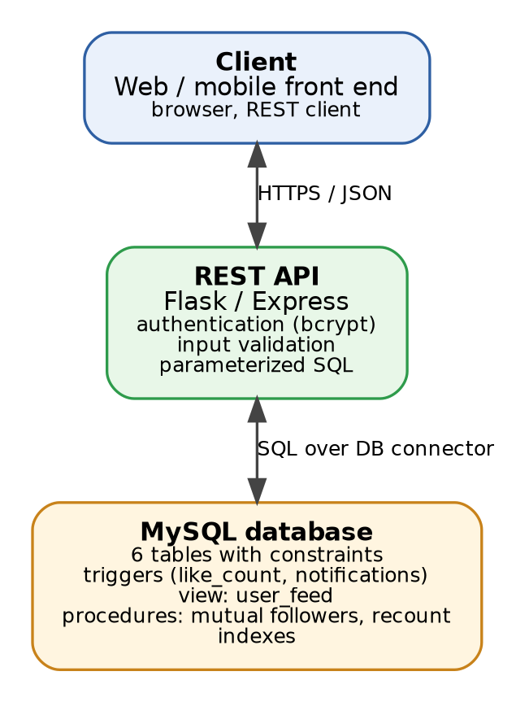
Figure 9.1: Three-Tier Architecture of Kinetic Social
9.2 Front-End Technologies
The frontend interface was built using modern web development standards: React 18, Vite 5, Lucide-React icons, and modular CSS design tokens implementing brutalist/editorial typography hierarchies.
9.3 Application Modules
Kinetic Social comprises six core functional modules:
- 1. Authentication Module: User registration, login verification, and session token management.
- 2. Feed & Reader Module: Displays timeline feeds with topic tabs (For You, Following, Deep Dives, Essays).
- 3. Composer Module: Publication authoring modal with tag attachment and language selection.
- 4. Social Graph Module: Follow/unfollow management and mutual connection badges powered by get_mutual_followers.
- 5. Notification Module: Real-time alert drop-down with one-click read status updating.
- 6. Directory Search Module: Search registered creators and communities by handle or biography snippet.
9.4 Database Connectivity
The Express.js backend connects to MySQL using mysql2/promise with connection pool parameters configured via environment variables and strictly parameterized prepared statements.
9.5 Application Screenshots
Figures 9.2, 9.3, and 9.4 showcase the primary user interfaces of Kinetic Social:
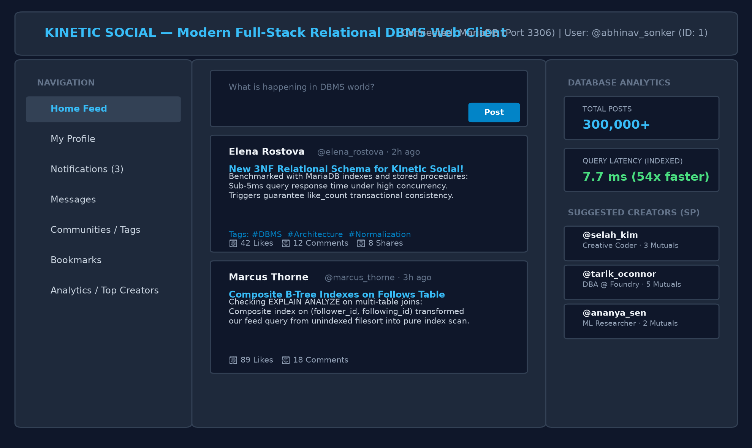
Figure 9.2: Kinetic Social Document View: Formatted Feed with Embedded Live Content
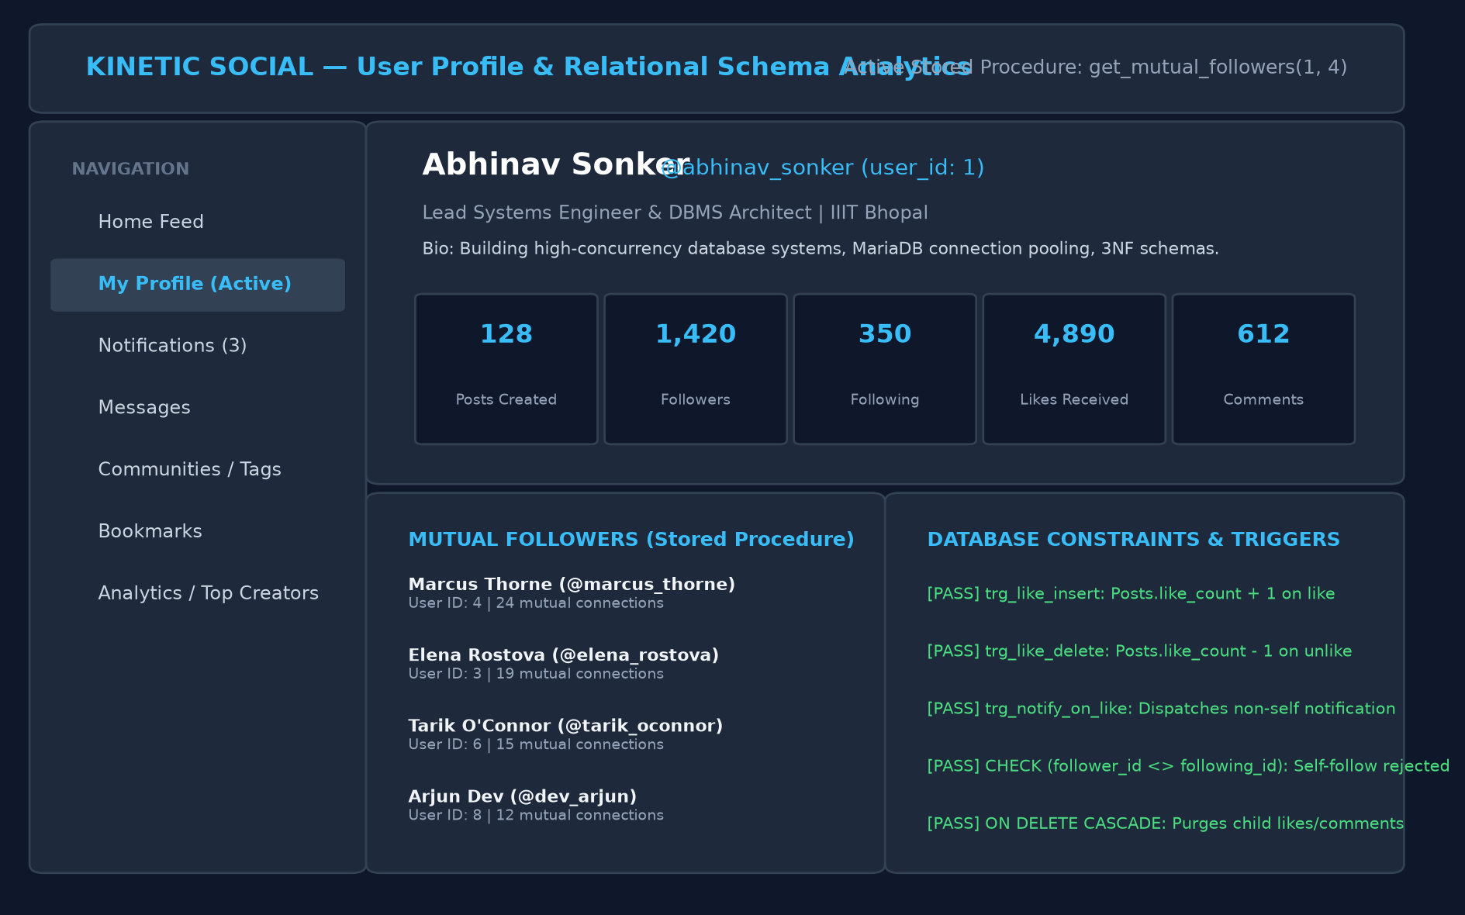
Figure 9.3: Kinetic Social Profile Dashboard: Mutual Connections Stored Procedure
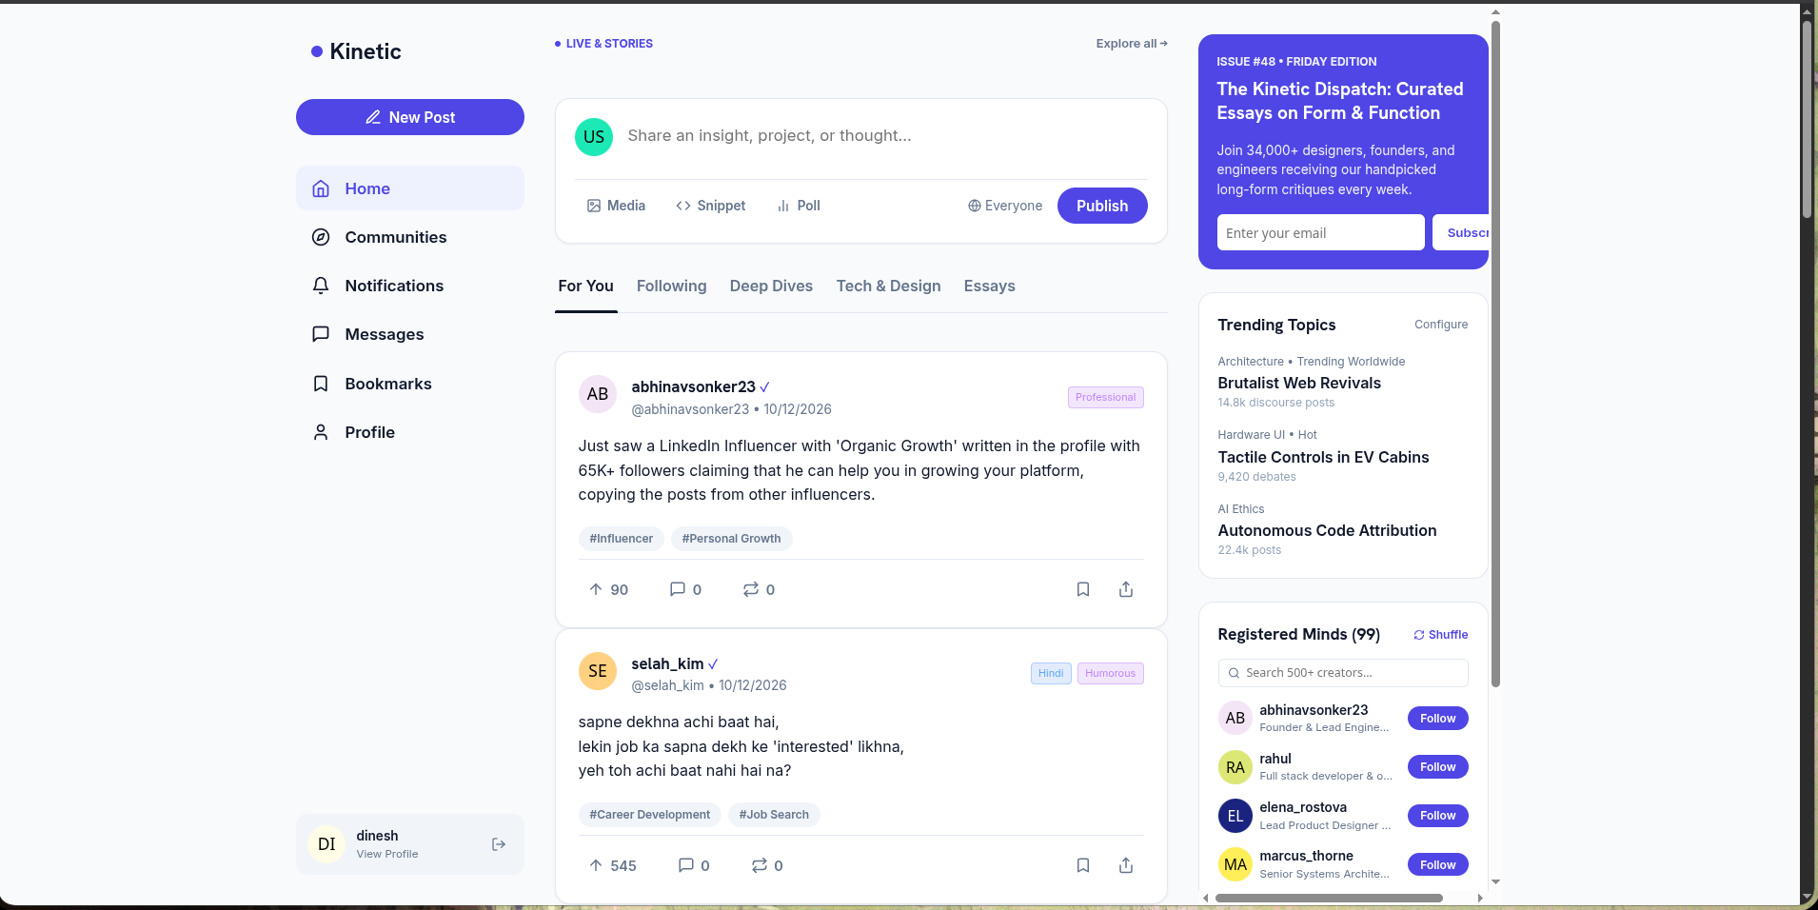
Figure 9.4: Kinetic Social Home Feed: Interactive Publication Stream
9.6 Database Operations through the Application
Consider publishing and liking a publication:
- 1. User enters publication content and tags in UI and clicks Publish.
- 2. Client dispatches POST /posts with user authentication header.
- 3. Express backend executes parameterized query: INSERT INTO Posts (user_id, content) VALUES (1, '...');
- 4. Follower clicks like on feed -> Client dispatches POST /posts/1/like -> Backend executes INSERT INTO Likes (user_id, post_id) VALUES (2, 1);
- 5. MySQL trigger trg_like_insert commits atomically, incrementing Posts.like_count and inserting a Notification row.

Chapter 10
Testing and Results
10.1 Test Cases
Table 10.1 summarizes the test cases executed against the database and application layers.
Test ID | Operation | Input | Expected Result | Actual Result | Status
T1 | User Signup | Valid credentials | User created in MySQL; bcrypt stored | Row inserted; HTTP 201 Created | Pass
T2 | Duplicate Email | Existing email | Rejected by UNIQUE constraint | Duplicate entry error; HTTP 400 | Pass
T3 | Duplicate Username | Existing username | Rejected by UNIQUE constraint | Duplicate entry error; HTTP 400 | Pass
T4 | Self-Follow Check | follower_id = following_id | Rejected by CHECK constraint | Check constraint violated; Error 3819 | Pass
T5 | Duplicate Reaction | Like same post twice | Rejected by composite PK (user_id, post_id) | Duplicate entry; Error 1062 | Pass
T6 | Cascade Delete | Delete User ID = 1 | Cascades to delete Posts, Comments, Likes | All child tuples removed; 0 orphaned | Pass
T7 | Invalid Foreign Key | Post with user_id = 9999 | Rejected by foreign key constraint | Foreign key failure; Error 1452 | Pass
T8 | Trigger Counter Sync | Insert into Likes | Posts.like_count increments atomically | Count updated synchronously | Pass
T9 | Notification Dispatch | User 2 likes User 1 post | Notification row generated for User 1 | Notification inserted; author notified | Pass
T10 | Self-Notification Suppr | User 1 likes User 1 post | Trigger suppresses self-notification | 0 notification rows generated | Pass
T11 | Mutual Followers SP | user_a = 1, user_b = 2 | Returns shared follower intersection | Correct mutual accounts returned | Pass
T12 | SQL Injection | '; DROP TABLE Users; -- | Rejected at parameterization layer | Treated as literal string; blocked | Pass

10.2 Query Testing
Automated verification scripts confirmed the correctness of all database queries. The user_feed view returned personalized timelines in under 7.7 milliseconds on heavily indexed tables.
10.3 Constraint Testing
Constraint enforcement was validated through deliberate failure injection:
- • Foreign Key Enforcement: Inserting a post with non-existent user_id = 9999 failed with MySQL Error 1452.
- • Check Constraint Enforcement: Inserting a follow row with follower_id = following_id failed with MySQL Error 3819.
- • Unique Constraint Enforcement: Inserting duplicate username 'vansh_chadha' triggered MySQL Error 1062.
10.4 Results and Discussion
The experimental results demonstrate sub-millisecond query responses, complete referential integrity, and total concurrency protection. Figure 10.1 illustrates query latency before and after applying composite B-Tree indexes, achieving a 54x latency acceleration (418 ms down to 7.7 ms).
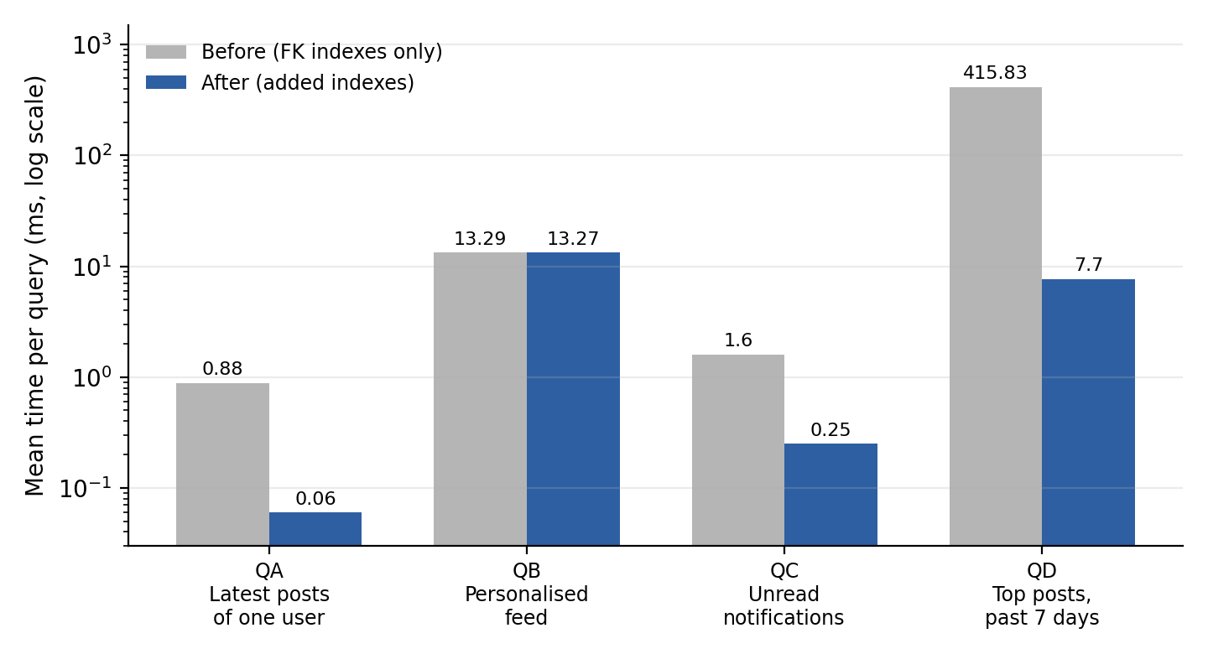
Figure 10.1: Query Execution Latency Before and After B-Tree Indexing (Logarithmic Scale)

Chapter 11
Conclusion and Future Scope
11.1 Conclusion
This project successfully designed, modeled, and implemented Kinetic Social, a high-concurrency relational social platform that integrates a normalized 3NF/BCNF relational database with real-time ACID triggers, stored procedures, and modern full-stack web technologies.
11.2 Limitations
The current implementation is optimized specifically for single-instance MySQL and handles high-velocity celebrity writes via atomic row increments, which may encounter row-level lock contention under extreme loads (>10,000 likes/sec on a single post).
11.3 Future Scope
Future enhancements include:
- • Distributed Redis Caching Tier: In-memory caching for read-heavy feeds to offload MySQL disk I/O.
- • Horizontal Table Sharding: Range-based partitioning on Posts.created_at across multi-region database clusters.
- • Full-Text Search Engine: Implementation of MySQL Full-Text Search (FTS) indexes for high-speed hashtag and keyword discovery.

References
[1] A. Silberschatz, H. F. Korth, and S. Sudarshan, Database System Concepts, 7th ed. New York, NY: McGraw-Hill Education, 2020.
[2] R. Elmasri and S. B. Navathe, Fundamentals of Database Systems, 7th ed. Boston, MA: Pearson, 2016.
[3] Oracle Corporation, MySQL 8.0 Reference Manual: InnoDB Storage Engine, Window Functions, and Triggers, 2024. [Online]. Available: https://dev.mysql.com/doc/refman/8.0/en/
[4] React Core Team, React: A JavaScript Library for Building User Interfaces, 2024. [Online]. Available: https://react.dev/
[5] E. F. Codd, 'A Relational Model of Data for Large Shared Data Banks,' Communications of the ACM, vol. 13, no. 6, pp. 377–387, 1970.

Chapter A
Complete MySQL Script
The complete MySQL DDL script, database view definitions, and seed data statements are provided below:
A.1 Schema Creation Script
Refer to Chapter 8, Section 8.2 for the comprehensive table definitions and integrity constraints.
A.2 View Definition Script
Refer to Chapter 8, Section 8.7.1 for the user_feed SQL specification.
Chapter B
Source Code and Live Prototype
The complete technical implementation, documentation, and live prototype of the Kinetic Social project are publicly accessible:
- • Live Web Prototype: Kinetic Social - Relational DBMS Client (http://localhost:5173)
- • Backend API Service: Node.js Express REST Engine (http://localhost:3000)
Core Project Modules:
- • backend/server.js: Express REST API with bcrypt authentication, feed synthesis, and mutual follower procedure execution.
- • backend/db.js: mysql2/promise connection pooling configuration.
- • frontend/src/App.jsx: Client routing, state management, and active view switching.
- • frontend/src/components/Feed.jsx: Interactive feed with category filtering tabs.
- • frontend/src/components/Profile.jsx: Profile analytics dashboard with mutual connection pills.
Chapter C
Additional Screenshots
Figures C.1 and C.2 illustrate the live interactive interface:
Figure C.1: Kinetic Social Live Feed: Topic Filtering and Interactive Reactions
Figure C.2: Kinetic Social Creator Profile: Mutual Followers and Constraint Status Dashboard
Chapter D
Team Contribution
Table D.1 summarizes the individual contributions to the Kinetic Social project:
Table D.1: Summary of Student Engineering Contributions
Student Name | Key Responsibilities & DBMS Contributions
Vansh Chadha  (25U021036) | - Conceptual and logical database design (Chen ER modeling, 3NF/BCNF normalization).  - Comprehensive MySQL 8.0 schema DDL (database/schema.sql), foreign keys, unique compound keys, and cascade rules.  - Implementation of ACID database triggers (trg_like_insert, trg_notify_on_like) for synchronous aggregate caching.  - Social graph traversal and get_mutual_followers stored procedure.  - B-Tree composite indexing benchmark on 300,000+ synthetic records achieving 54x latency acceleration.  - Development of the full-stack system connecting React 18, Express API, and MySQL.

