# Evidence of Tests

## DriverTest

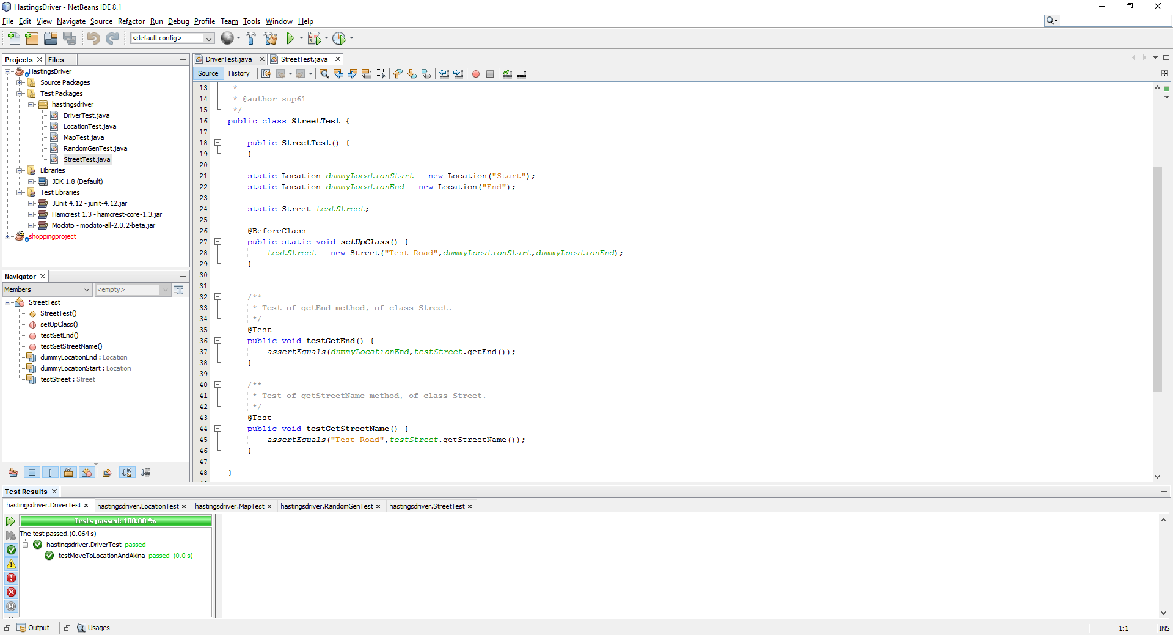

## LocationTest

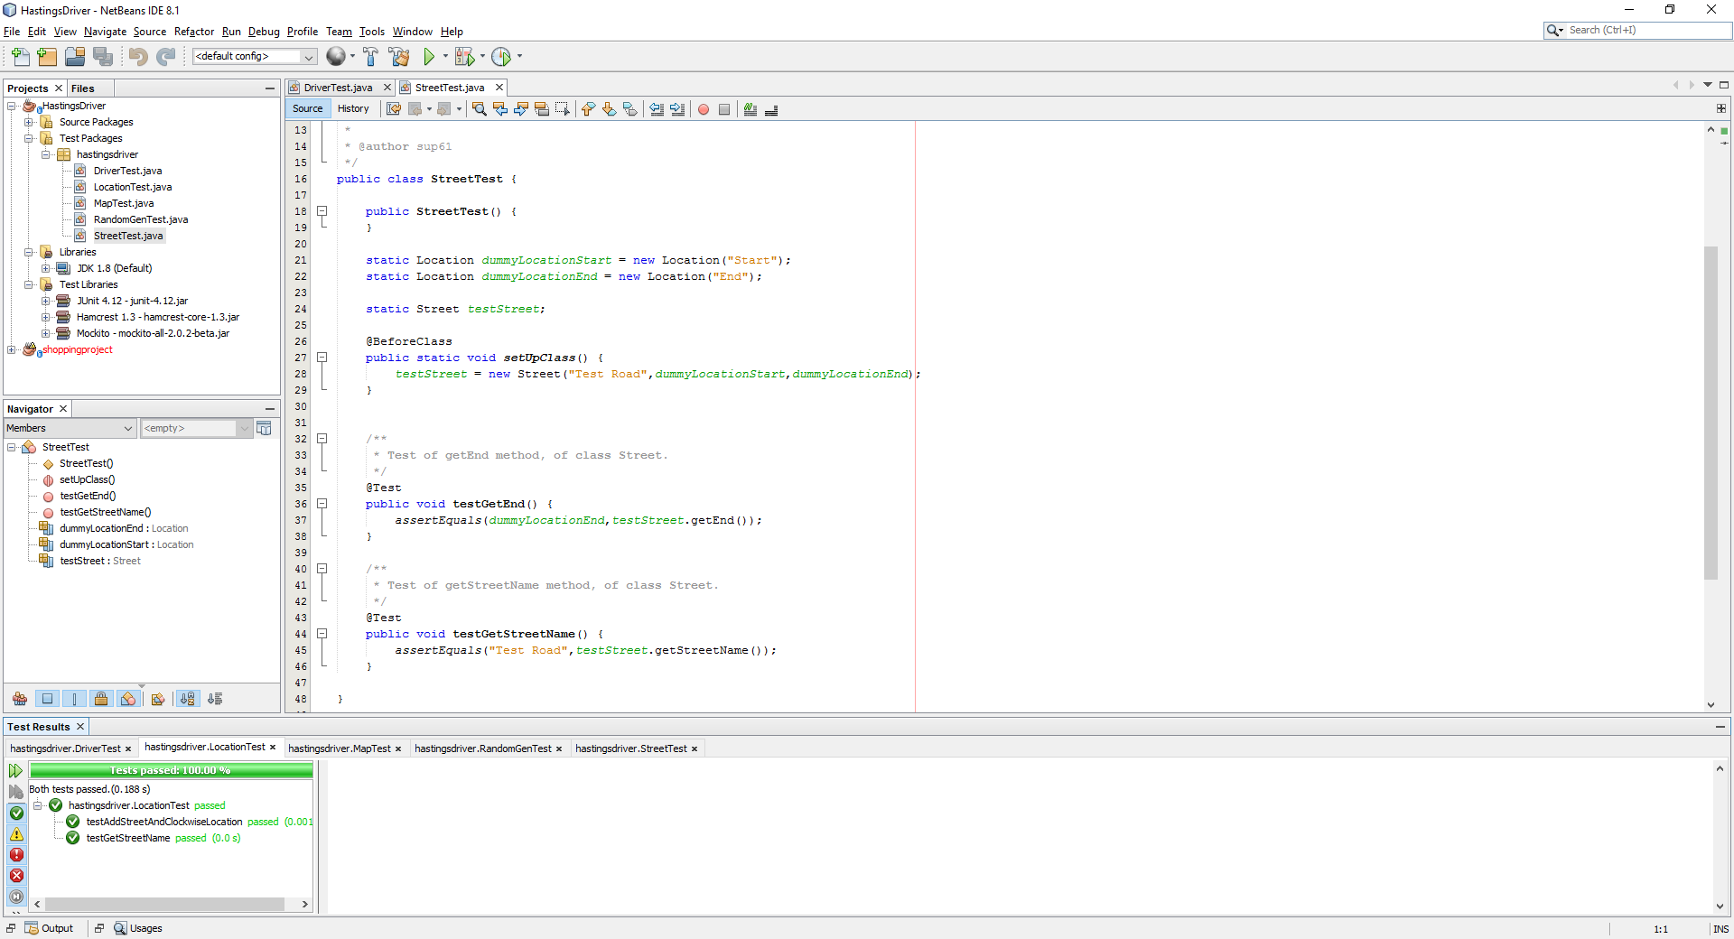

## MapTest

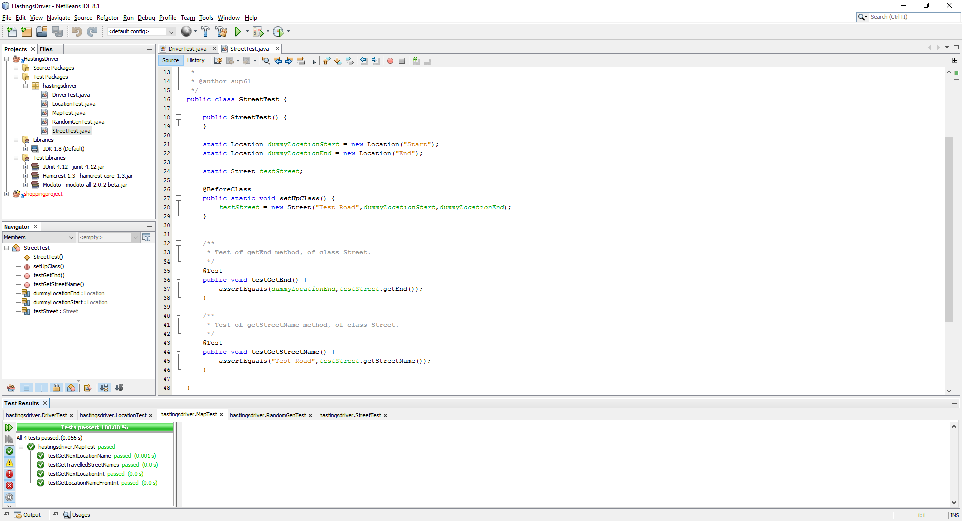

## StreetTest

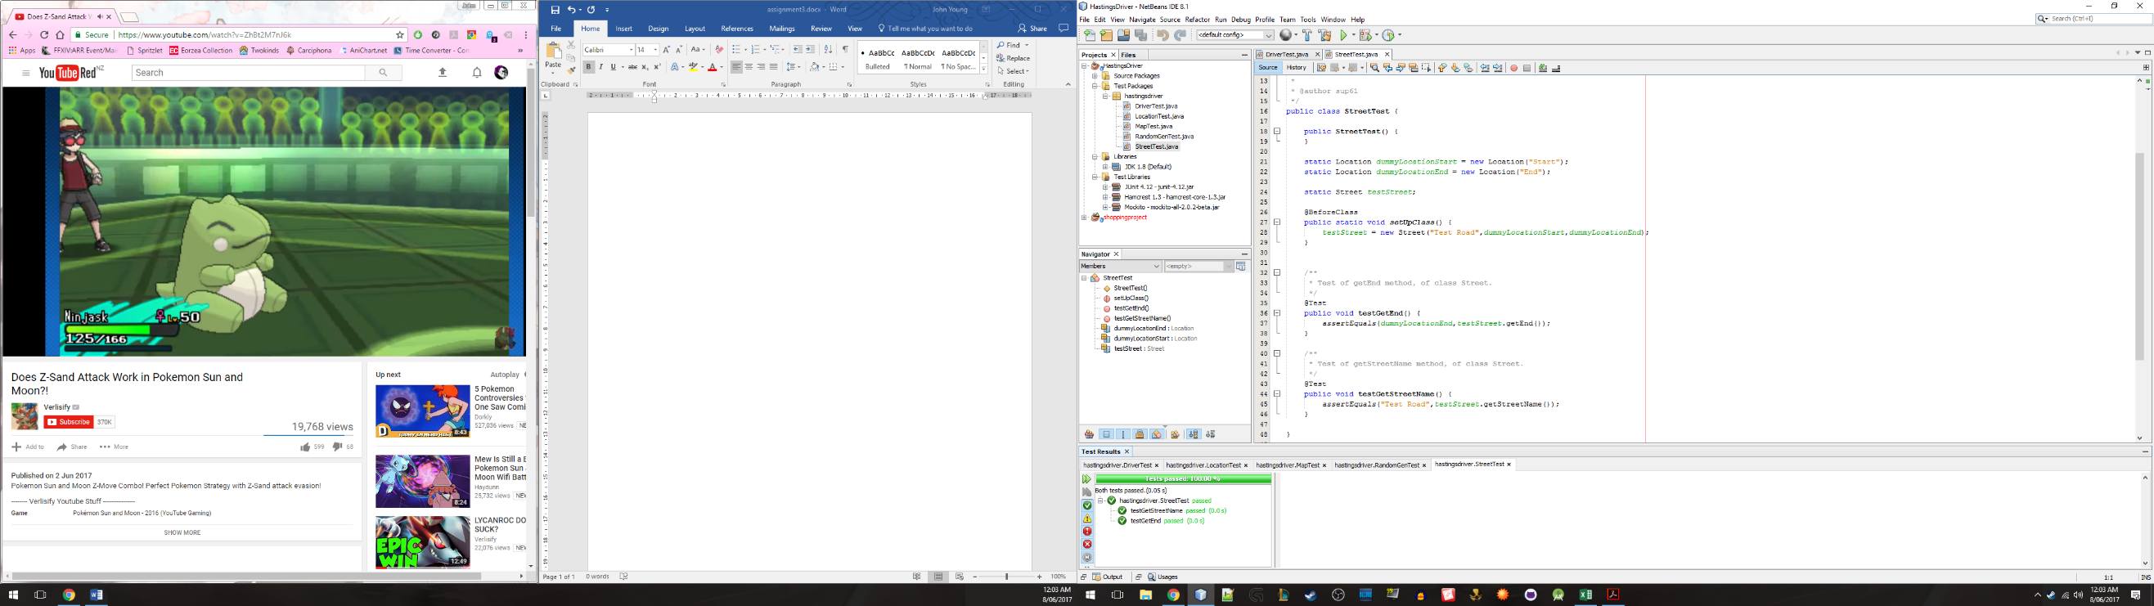

## RandonGenTest

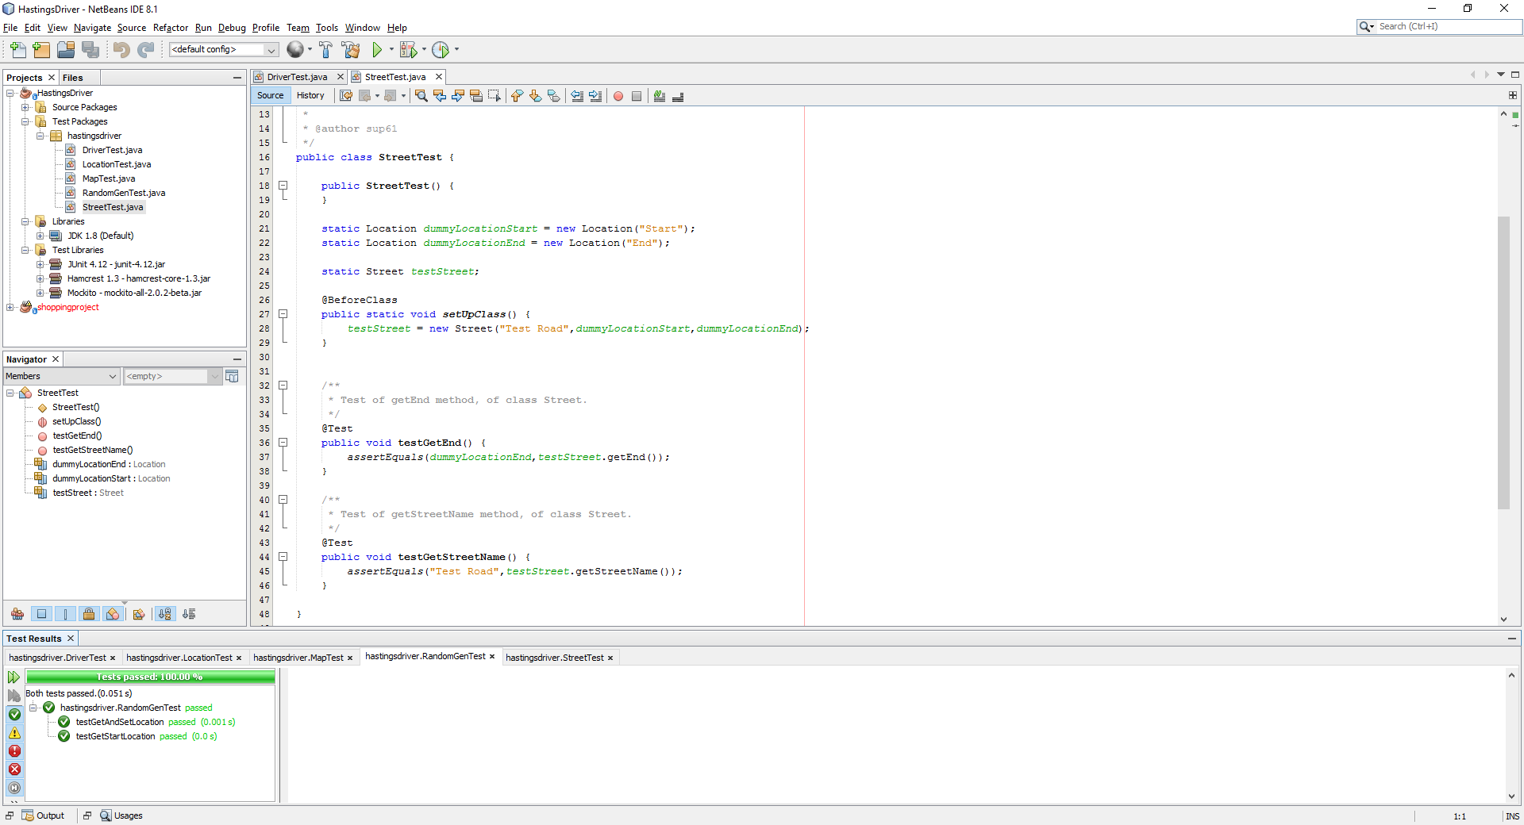

# Findings Report

From the original requirement statement given from the client, it was filled with lots of contradictory statements. After analysing the requirements, it was observed that the system loosely mimics a graph system. With the locations being nodes and edges being streets (but without weights). The 2 contradicting statements were reworded and omitted, with one other requirement to better follow with the rest of the requirements.

Once requirements were done, the program was developed. Knowing that the system mimicked a graph system, 3 classes was made, street, location and map. This meant the requirements could be followed.

With regards to the pseudo random number generator, it was not specified how the client wanted the decisions for the drivers to be made or where the drivers started in the city. Some methods were to:

* Decide at each node to whether to leave the city or continue travelling with the city.
* Decide before leaving its current location.

The rate that the driver leaves the city was also not decided by the client. Currently it has a 6/10 chance to stay in the city (with a 50/50 split on its direction) and a 4/10 chance to leave (also 50/50). This is easily changed in the program if required by the client.

When the tests were being developed, it was found that the program was not easily tested. For example, in the Location class, when the list of are added to it location, streets in the array index 1 was always the counter clockwise street.

However, when setting up the test, the above statement was not true. This meant that any counter clockwise methods could not be tested.

Similarly, the RandomGen and Map class cannot be easily tested, as most of it is made in its constructor. With the RandomGen Class, as the tested information was parsed using a known seed number. While this does mean it meets the requirements for the same seed to produce the same pseudo random number, it can be argued that the test are invalid as the results were supplied.

After the tests were done, some other observations were made. The program cannot be easily expanded. I.e outside of just replacing the names of locations and streets, it cannot model any other city.

Some improvements are to instead look ahead of the street and not use the array index. This leaves the room for multiple streets to enter and exit the location. Exit streets should be a variable by itself to be able to easily identify if the node is an exit Location.