Software Engineering 2: Design

Part 2

# **Main Users of the Application**

Quizzes are enjoyed by a wide spectrum of people, from the young to the old!

Children (4 - 12) are often encouraged to play quiz games as they are rightly perceived as being both fun and educational.

Teenagers (13 -19) play quiz games too, as they are often available for free on Apple’s App Store and Google’s Play Store.

Adults (20+) experience quizzes in a variety of formats – game shows that use challenging quizzes (such as The Chase and Who Wants to Be a Millionaire) are very popular on television, and pub quizzes are a fun way for adults to spend the evening.

Their personal abilities may differ, but the process of answering a question is simple – read the question and select the answer, so it’s easy to design an application that caters to these different kinds of people.

Let’s say we have three people – a child named Danny, a teenager named Louise, and an adult named Mary.

Danny likes to use a user-friendly platform to access fun apps. For him to be able to play the game, he needs to have a simple UI with large, easy-to-read buttons.

Mary and Danny are in the same boat! They both enjoy apps that are visually simple so they don’t have to spend a long time learning how the interface works, and for Louise, this is good too.

Even though these people may be using the Quiz app we’ve created in a variety of different context (at home, on the bus home from school, in a waiting line), by putting emphasis on simplicity in design, we’re making it as usable as possible in all situations.

We’re able to design for three different types of people simply and effectively!

# **Storyboard**

Used <https://moqups.com/> to do out a storyboard, the text may be a bit small.

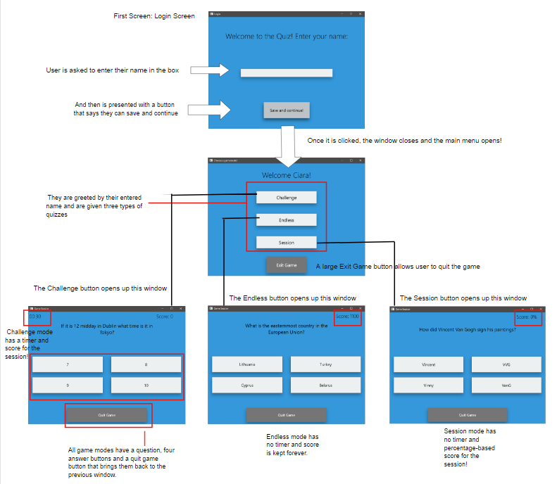

# **Implementing User Interface**

User interface is implemented.

# **Adding Persistence**

Persistence is achieved using a txt file and we have implemented a data access layer through the RetrieveFromFile class.