# Draw Diagrams With Markdown

Typora supports some Markdown extension for diagrams, you could enable this feature from preference panel.

When exporting as HTML, PDF, epub, docx, those rendered diagrams will also be included, but diagrams features are not supported when exporting markdown into other file formats in current version. Besides, you should also notice that diagrams is not supported by standard Markdown, CommonMark or GFM. Therefore, we still recommend you to insert an image of these diagrams instead of write them in Markdown directly.

## Sequence

It is powered by js-sequence, which would turn following code block into rendered diagrams:

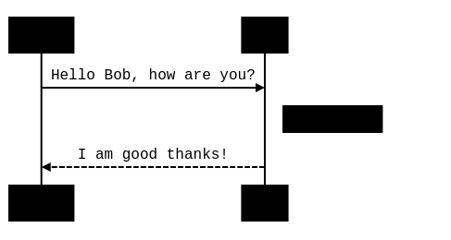

Please refer here for syntax explanation.

## Flowchart

It is powered by flowchart.js, which would turn following code block into rendered diagrams:

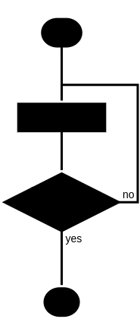

## Mermaid

Typora also has integration with mermaid, which supports sequence, flowchart and Gantt.

## Sequence

see this doc

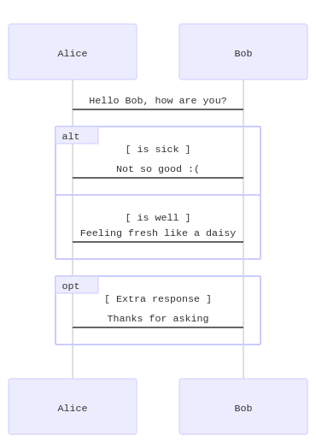

## Flowchart

see this doc

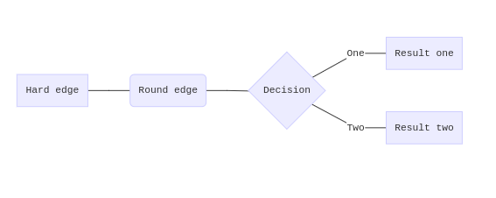

## Gantt

see this doc

