1060 nm IR LED ring illuminator
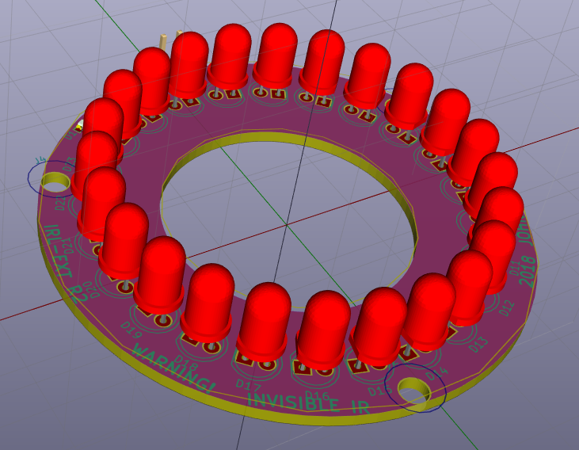
IRL-EXT is an infrared illuminator intended to be fitted to Mityotyo M Plan Apo NIR objectives for backside IC analysis. Its large number of LEDs provides even illumination for high quality backside images.

WARNING: intense invisible IR light. Do not look at LEDs

Specifications
Output power: 192 mW typical @ 100 mA
Working distance: 18 mm from PCB @ 45 degree illumination angle
- May be difficult to use 100x NIR objective (10 or 12 mm WD)
- Note 50x NIR objectives come in 10 and 17 mm WD
Power: current mode, 100 mA max (30 V typical, 36 V max)

Usage
TODO: add reference MU800 data w/ and w/o IR filter
Reccomended to use CCD w/o IR filter
For full power, use a lab bench supply that can supply up to 100 mA at 36 V. Operate it in current mode and don’t exceed 100 mA.

Design
Uses 1060 nm LEDs which are a good compromise between:
- Silicon transparency
- Camera sensitivity
- Resolution
- Cost (even 1550 nm LEDs cost more IIRC)

Fabrication / assembly
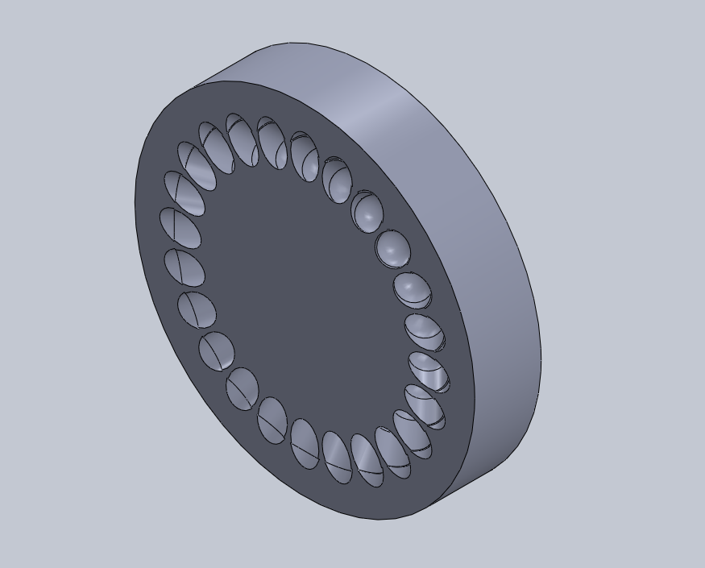
Assembly cost is around $300, mostly dominated by the LEDs. These cost significnatly more than security camera IR LEDs due to the special long wavelength. You can build a lower power version by jumpering LEDs (ex: build a 6 LED version by shorting 3 LEDs and then inserting one).
PCB files:
Reccomend to assemble using the provided assembly jig to properly set the angles. This was printed at my local UPS store for about $50.
Be sure to observe LED polarity!
TODO: figure out screw / magnet to stick to microscope

