Tab 1
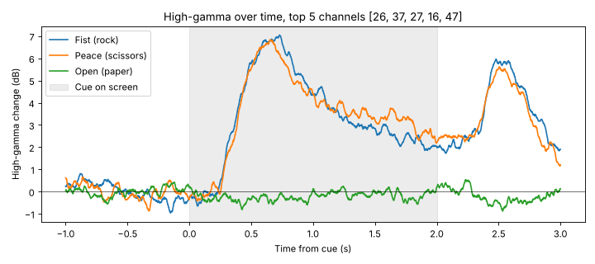
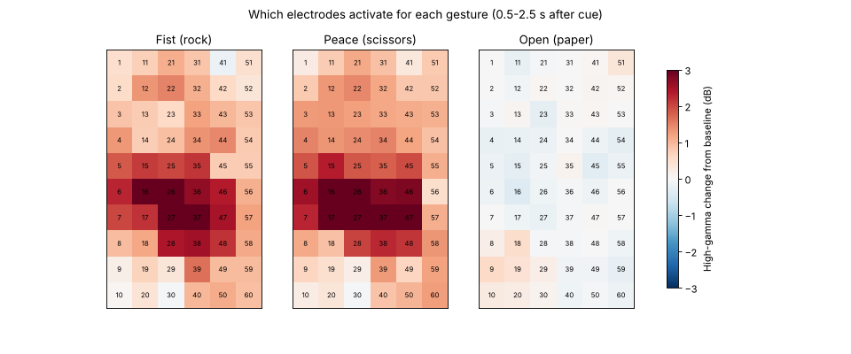
Feature matrix: (90, 480) (trials x features)

3-class accuracy: 93.3% +/- 7.4% (chance = 33.3%)
Fist vs Peace only: 93.5% +/- 9.4% (chance = 50%)
Shuffled-label control: 33.8% (should be near 33%)

Confusion matrix (rows = true, columns = predicted):
Fist Peace Open
Fist 28 2 0
Peace 2 28 0
Open 0 2 28
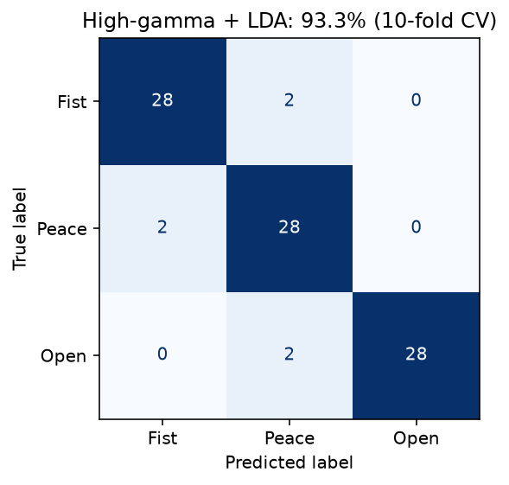
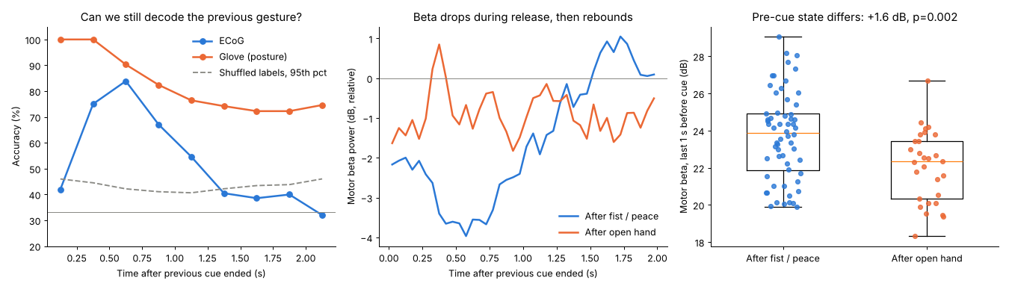
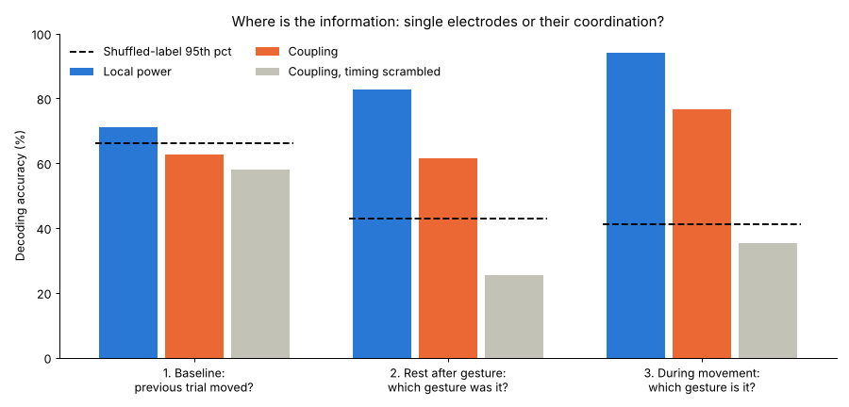

Not mine: Landscape. Where the code is unstable, weak code over time
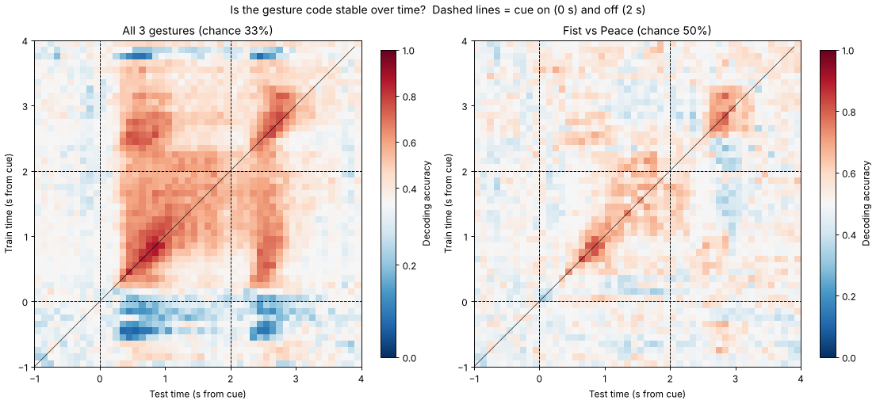

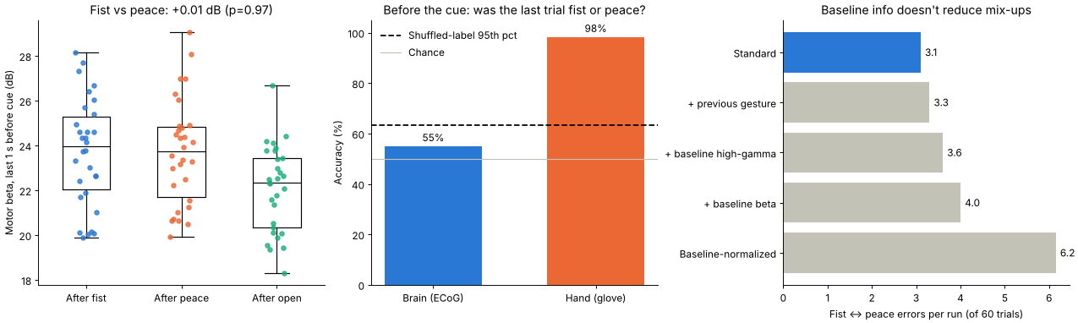
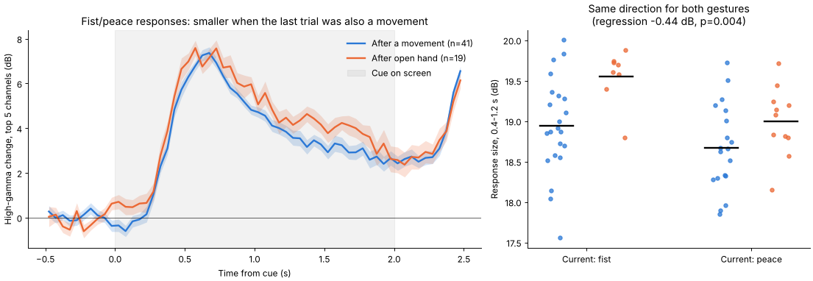
Residue is coarse - nudges the next response - Shift in the dynamics

Tab 2

Data
- 1 epilepsy patient, 60-electrode grid sitting right on the brain surface over the hand area
- Task: screen shows rock / paper / scissors, make the shape for 2 s, rest 2–3 s. 90 trials, 30 each
- Recorded 1,200 times per second:
  - brain signal (60 channels)
  - which cue was on screen
  - sensor glove (how bent each finger is)

Steps 1–3: clean, find the signal, decode
Step 1: cleaning
- Removed noise shared across all electrodes (probably not brain)
- Removed slow drift
- Removed power-line hum at 50 Hz (recorded in Japan, so 50, not 60)
Step 2: finding the movement signal
- When a brain area is working, its fast activity (high-gamma, 50–300 Hz) gets stronger, so I kept just that
- Fist and peace light up the middle of the grid (ch 16/17, 26/27, 36/37)
- Open hand barely does anything (hand is already open at rest)
Step 3: decoder
- Each trial becomes a list of numbers: high-gamma strength per electrode, in short time slices after the cue
- Trained LDA to match patterns to gestures
- Tested on held-out trials (cross-validation): 93% correct
- Sanity check: scrambled the labels and got ~33% (pure guessing), so the 93% is real signal
- Paper benchmark (Gruenwald 2019) is ~99%, so there's room to improve

Step 4: does the past leave a trace?
Looked at the REST period between trials.
- Can the brain still tell which gesture was just made? Yes, but only for ~1 s (peaks at 84%), then gone
  - Glove still shows the old hand position the whole time, so the brain isn't just tracking fingers. It actually moves on
- Does the resting state depend on what came before? Yes
  - After a real movement (fist/peace), beta rhythm dips then rebounds higher ("beta rebound," a known effect)
  - So the brain starts the next trial in a different state depending on whether it just moved: +1.6 dB, p = 0.002, detectable 75% of the time
- Does that mess up the decoder? Mostly no. 94% after a movement, 99% after open hand

Takeaway
The brain forgets which gesture it made within ~1 s, but keeps a general "I just moved" trace that changes its starting state for the next trial. The decoder handles it fine.
Caveats
- 1 patient, epileptic cortex, ~89 trial-to-trial transitions
- Some of the beta difference could be hand posture; the gesture-identity fade is the clearer evidence

