Wi-SUN SDK 1.6.0.0 GA

KEY FEATURES
Wi-SUN Stack
EFR32FG28 support
Connection time improvements
LFN support improvements
Wi-SUN Applications
Firmware over-the-air update
Wi-SUN configurator update

Gecko SDK Suite 4.3

June 7, 2023
Wireless Smart Ubiquitous Network (Wi-SUN) is the leading IPv6 sub-GHz mesh technology for smart city and smart utility applications. Wi-SUN brings Smart Ubiquitous Networks to service providers, utilities, municipalities/local government, and other enterprises, by enabling interoperable, multi-service, and secure wireless mesh networks. Wi-SUN can be used for large-scale outdoor IoT wireless communication networks in a wide range of applications covering both line-powered and battery-powered nodes.
Silicon Labs' Wi-SUN hardware is certified by the Wi-SUN Alliance, a global industry association devoted to seamless LPWAN connectivity. Wi-SUN builds upon open standard internet protocols (IP) and APIs, enabling developers to extend existing infrastructure platforms to add new capabilities. Built to scale with long-range capabilities, high-data throughput and IPv6 support, Wi-SUN simplifies wireless infrastructure for industrial applications and the evolution of smart cities.

These release notes cover SDK versions:

1.6.0.0 released June 7, 2023

Compatibility and Use Notices
For information about security updates and notices, see the Security chapter of the Gecko Platform Release notes installed with this SDK or on the TECH DOCS tab on https://www.silabs.com/developers/wi-sun-protocol-stack. Silicon Labs also strongly recommends that you subscribe to Security Advisories for up-to-date information. For instructions, or if you are new to the Silicon Labs Wi-SUN SDK, see Using This Release.
Compatible Compilers:
IAR Embedded Workbench for ARM (IAR-EWARM) version 9.20.4
- Using wine to build with the IarBuild.exe command line utility or IAR Embedded Workbench GUI on macOS or Linux could result in incorrect files being used due to collisions in wine’s hashing algorithm for generating short file names.
- Customers on macOS or Linux are advised not to build with IAR outside of Simplicity Studio. Customers who do should carefully verify that the correct files are being used.
GCC (The GNU Compiler Collection) version 10.3-2021.10, provided with Simplicity Studio.

Contents
1 Wi-SUN Stack 2
1.1 New Items 2
1.2 Improvements 2
1.3 Fixed Issues 2
1.4 Known Issues in the Current Release 3
1.5 Deprecated Items 3
1.6 Removed Items 3
2 Wi-SUN Applications 4
2.1 New Items 4
2.2 Improvements 4
2.3 Fixed Issues 4
2.4 Known Issues in the Current Release 5
2.5 Deprecated Items 5
2.6 Removed Items 5
3 Using This Release 6
3.1 Installation and Use 6
3.2 Security Information 6
3.3 Support 7

Wi-SUN Stack

New Items
Added in release 1.6.0.0
- Added a new API sl_wisun_set_lfn_parameters() that configures all the LFN-specific settings.
- Added a new API sl_wisun_set_lfn_support() that sets the maximum number of LFNs that can be connected to a single FFN.
- Added a new API sl_wisun_set_mode_switch() that supersedes sl_wisun_set_mode_switch().The old API is still available but it is recommended to move to the more recent one.
- Add a new API sl_wisun_set_pti_state() that enable the Packet Trace Interface (PTI). For more information about the PTI in the context of Wi-SUN, refer to Wi-SUN’s Getting Started section on docs.silabs.com.
- Implemented LFN LGTK rotation
- Added support for a non-standard OFDM 64QAM PHY.
- Added support for EFR32FG28

Improvements
Changed in release 1.6.0.0
- Optimized the reconnection of routers to an existing network: if configured to do so, the routers will now try to skip the scanning and authenticated step of the joining procedure.

Fixed Issues
Added in release 1.6.0.0

ID # | Description
1120635 | Fixed an issue that could cause acknowlges to be sent to the wrong channel.
1113773  1130990 | Fixed several issues that could cause an assert after a call to sl_wisun_disconnect().
1110318 | Fixed an issue that could cause a mutex to be kept for an undefined period of time. It was causing devices to be indefinitely stalled.

Known Issues in the Current Release
ID # | Description | Workaround
1119464 | Packets sent when FSK FEC is enabled can infringe ARIB regulation. | Until this problem has been addressed correctly, the stack will refuse to start if both ARIB enforcement and FEC are enabled.
1067978 | Packets sent using a PHY with a bandwidth larger than the base PHY’s bandwidth can infringe ARIB regulation. | Limit the communications when using mode switch with ARIB enforcement enabled

Deprecated Items
None

Removed Items
None

Wi-SUN Applications

New Items
Added in release 1.6.0.0
- Wi-SUN DFU
- FTP/TFTP
- CoAP status notification service
- Gecko bootloader
- Settings for LFN devices
- LFN profile based, configurable sleep time for Meters

Improvements
Added in release 1.6.0.0
- Network Analyzer: SUN OFDM Support
- Wi-SUN Configurator
- LFN support
- Certification generation
- CLI can be turned ON/OFF completely
- Socket handler refactor
- Memory Optimization
- Aligned the router’s and border router’s CLI commands

Fixed Issues
Fixed in release 1.6.0.0

ID # | Description
1106878 | Applications override ping task stack size.
1106861 | Race condition in recvfrom().
1099841 | Stack overflow in Ping component.
1134408 | Event flag handling for FreeRTOS.
1099260 | Wi-SUN - SoC Empty + app_core + app_setting – connection failed status:35.
1093538 | Collector (COaP) and Ping App freezes after <wisun join_fan10> command.
1102557 | Border Router CLI: Fixed an issue causing an assert after an invalid PHY configuration.
1134137 | Border Router RCP: Fixed an issue causing an assert when receiving large messages from the Linux host.

Known Issues in the Current Release
Issues in bold were added since the previous release.
ID # | Description | Workaround
1067236 | The border router RCP SPI interface is unstable when used with a throughput higher than 1 Mbytes/s | The use of border router RCP SPI interface is not recommended for the time being.
Simplicity Studio – Network Analyzer:
- Wi-SUN Encrypted Packets are not supported
- Undecoded frames (only after Ack) according to PTI issues on Series2

Deprecated Items
None

Removed Items
None

Using This Release
This release contains the following
- Wi-SUN stack library
- Wi-SUN sample applications
- Wi-SUN border router pre-compiled demos
- Documentation
If you are a first time user, see https://docs.silabs.com/wisun/latest/wisun-getting-started-overview/

Installation and Use
The Wi-SUN SDK is provided as part of the Gecko SDK (GSDK), the suite of Silicon Labs SDKs. To quickly get started with the GSDK, install Simplicity Studio 5, which will set up your development environment and walk you through GSDK installation. Simplicity Studio 5 includes everything needed for IoT product development with Silicon Labs devices, including a resource and project launcher, software configuration tools, full IDE with GNU toolchain, and analysis tools. Installation instructions are provided in the online Simplicity Studio 5 User’s Guide.
Alternatively, Gecko SDK may be installed manually by downloading or cloning the latest from GitHub. See https://github.com/SiliconLabs/gecko_sdk for more information.
Simplicity Studio installs the GSDK by default in:
- (Windows): C:\Users\<NAME>\SimplicityStudio\SDKs\gecko_sdk
- (MacOS): /Users/<NAME>/SimplicityStudio/SDKs/gecko_sdk
Documentation specific to the SDK version is installed with the SDK.

Security Information
Secure Vault Integration
This version of the stack does not integrate Secure Vault Key Management.
Security Advisories
To subscribe to Security Advisories, log in to the Silicon Labs customer portal, then select Account Home. Click HOME to go to the portal home page and then click the Manage Notifications tile. Make sure that ‘Software/Security Advisory Notices & Product Change Notices (PCNs)’ is checked, and that you are subscribed at minimum for your platform and protocol. Click Save to save any changes.
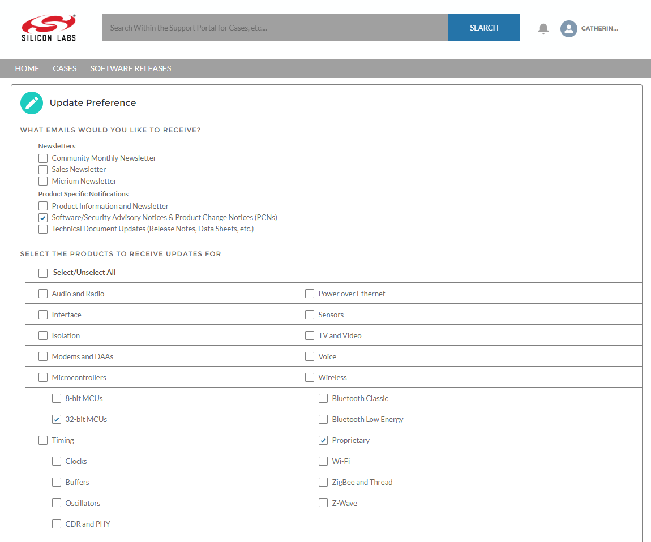

Support
Development Kit customers are eligible for training and technical support. Contact Silicon Laboratories support at http://www.silabs.com/support.

