**Snake And Apple**

Eat the apple and gain more points.

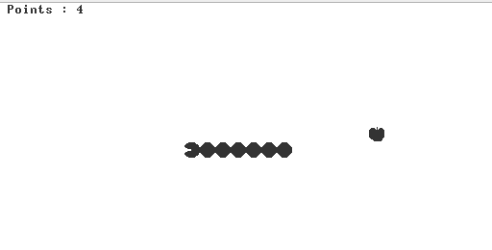

Instructions :

This simple game allows the user to move a snake around the screen, and change the Snake's speed during the movement. When the game starts, a snake is shown at the top-left corner of the screen.

The user controls the snake as follows.

* The 4 arrow keys are used to move the snake up, down, left, and right.
* The 'z' and 'x' keys are used, respectively, to decrement and increment the snake's speed.
* The 'q' key is used to quit the game.

User Interface :

1. Appple is inside stomach

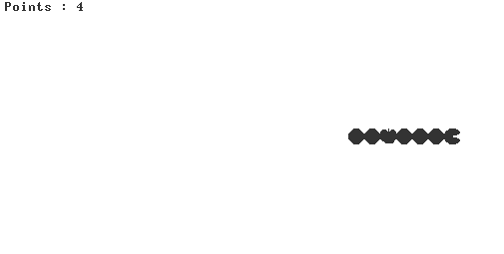

2. Point is earned and length of snake is increased after eating apple and a new apple comes at a randomly decided position .

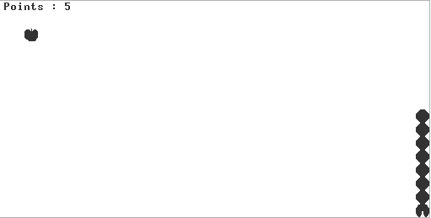

3. The snake automatically moves in anticloclwise direction on touching edges .

