**BINARY TO GRAY CONVERSION**

**Input:0010 Output:0011**

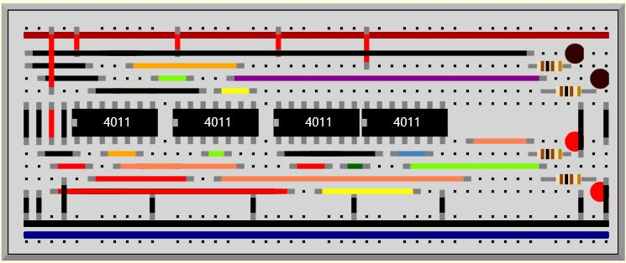

**Input:0011 Output:0010**

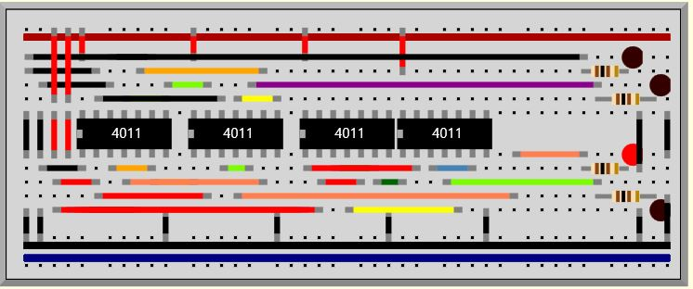

**Input:0100 Output:0110**

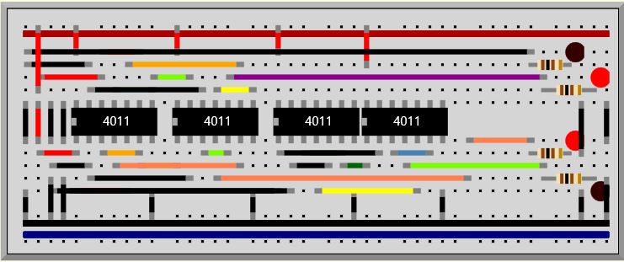

**Input:0101 Output:0111**

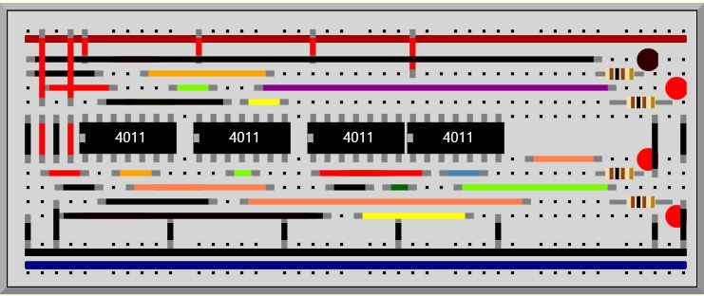

**Input:0110 Output:0101**

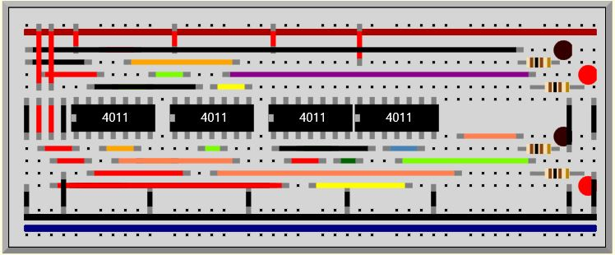

**Input:0111 Output:0100**

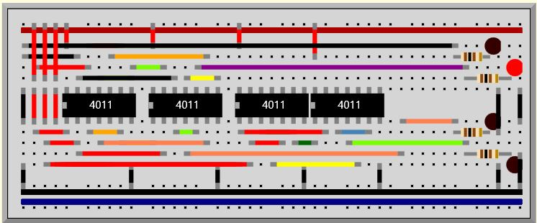

**Input:1000 Output:0000**

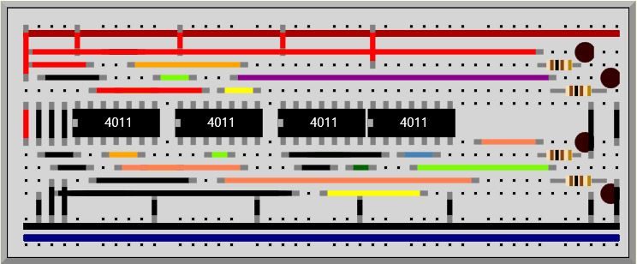

**Input:1001 Output:1101**

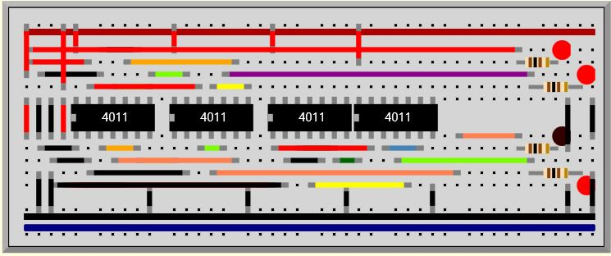

**Input:1010 Output:1111**

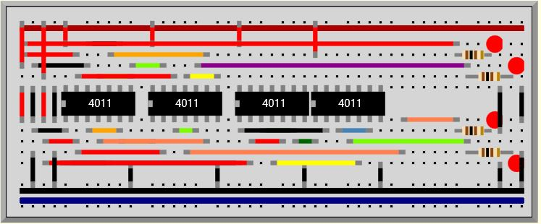

**Input:1011 Output:1110**

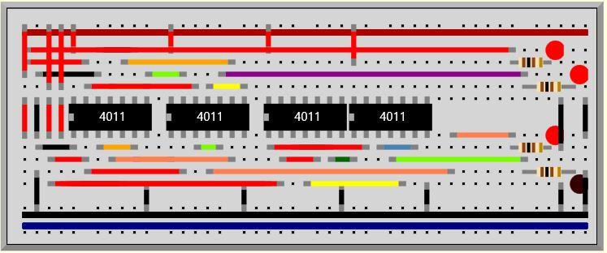

**Input:1100 Output:1010**

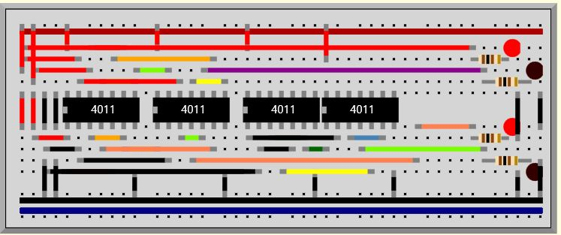

**Input:1101 Output:1011**

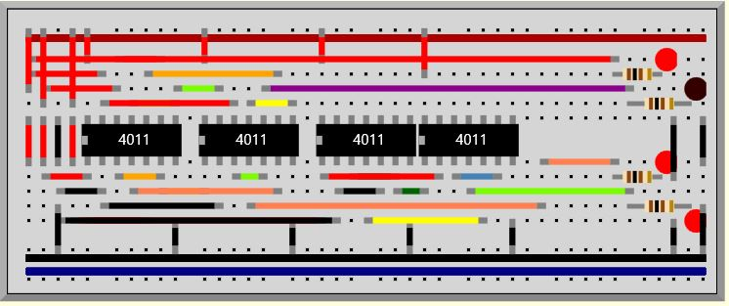

**Input:1110 Output:1001**

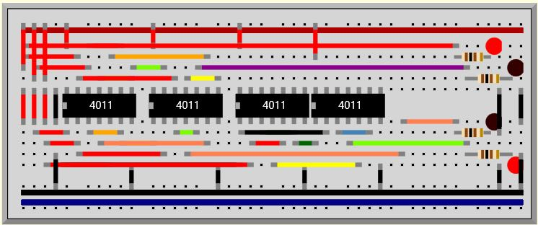

**Input:1111 Output:1000**

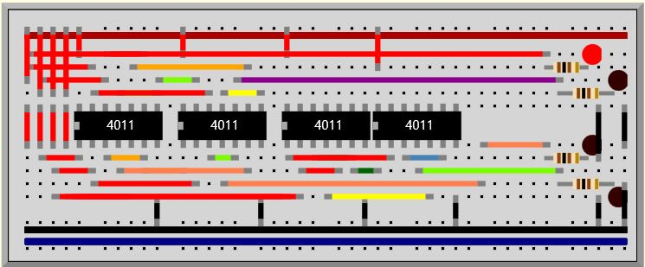

**Binary To Gray Conversion**

**Input:0001 Output:0001**

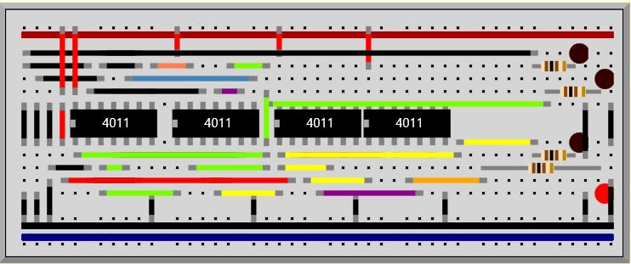

**Input:0010 Output:0011**

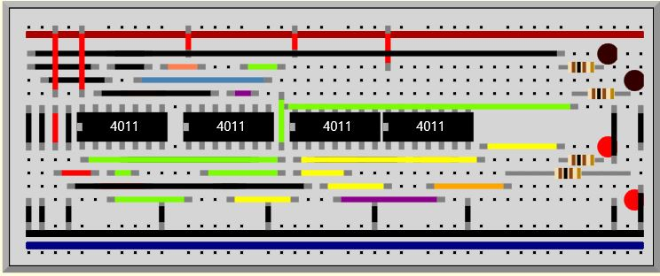

**Input:0011 Output:0010**

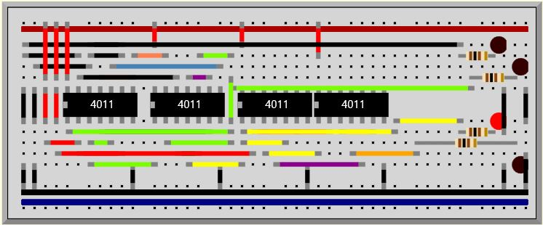

**Input:0100 Output:0111**

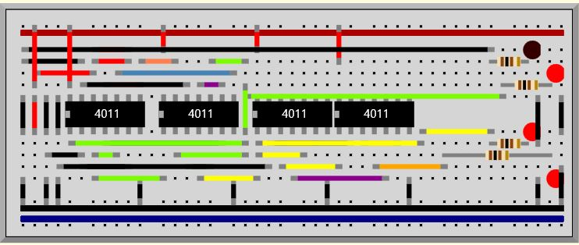

**Input:0101 Output:0110**

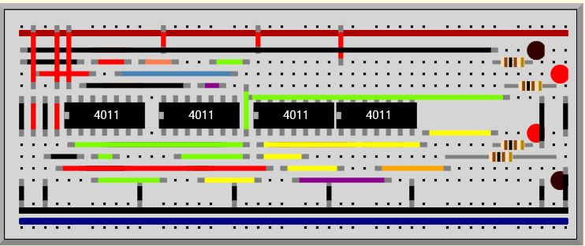

**Input:0110 Output:0100**

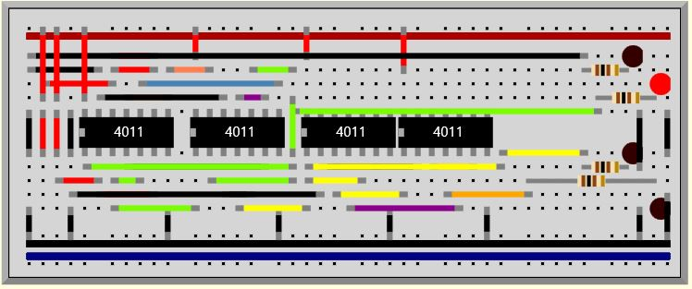

**Input:0111 Output:0101**

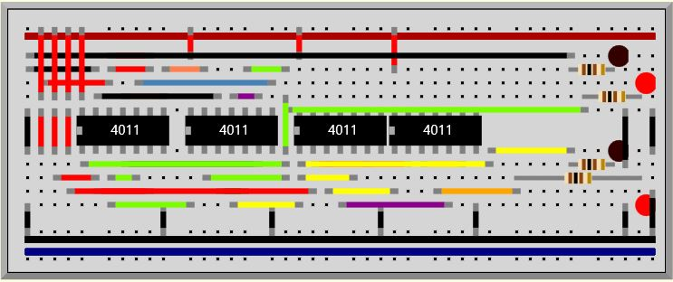

**Input:1000 Output:1111**

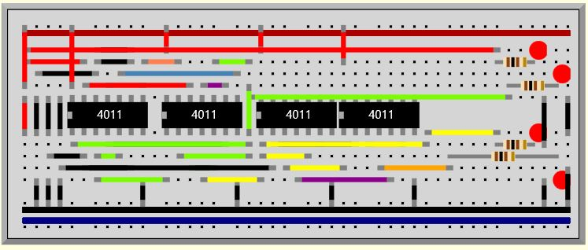

**Input:1001 Output:1110**

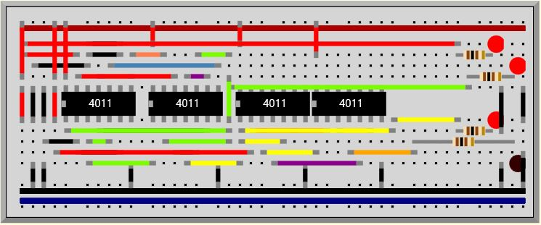

**Input:1010 Output:1100**

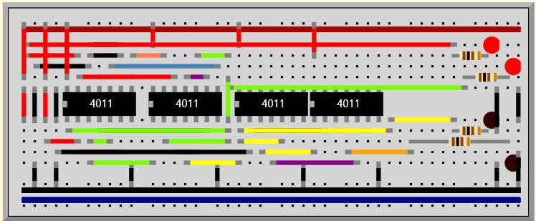

**Input:1011 Output:1101**

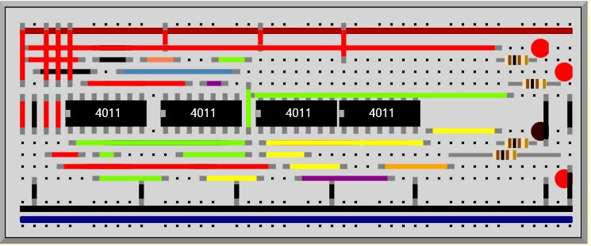

**Input:1100 Output:1000**

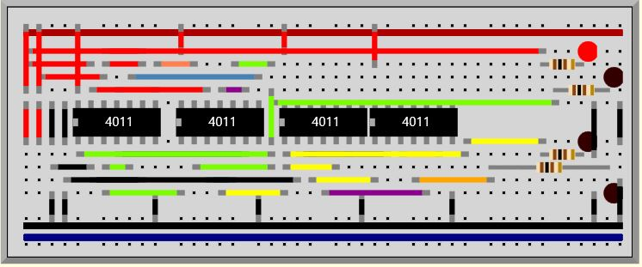

**Input:1101 Output:1001**

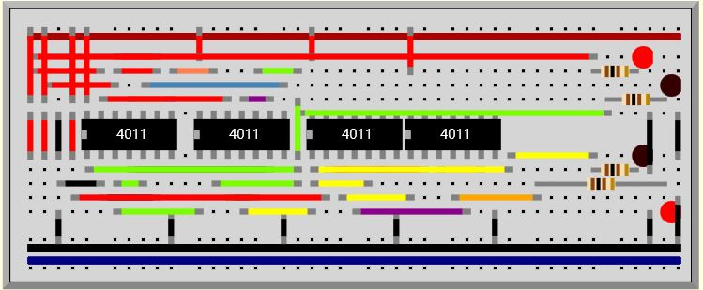

**Input:1110 Output:1011**

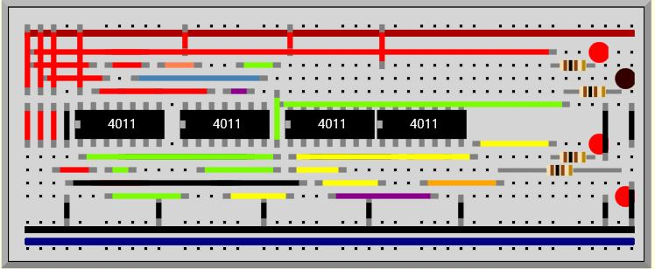

**Input:1111 Output:1010**

