Assignment 1

# Write an Arduino code for a wireless mobile control bot which receives data using Bluetooth and can move forward, backward and turn left and right.

**Note: Use Software Serial to send/receive data. Use pins as given below :**

* Software Serial Rx = 10
* Software Serial Tx = 11
* Right motor PWM = 6
* Left motor PWM = 5
* Right motor -> 7,8 (7 High and 8 Low will move forward)
* Right motor -> 3,4 (3 High and 4 Low will move forward)

**Prerequisites :** Basic C programming (till if else and for loop)

**Study material below contains following topics :**

* Arduino, Arduino IDE, pinMode, delay, digitalWrite, analogWrite, PWM, digitalRead, analogRead, Serial, Software serial.

**Solution will be given on 1st December 2019 (Sunday).**

Arduino UNO

**Arduino Uno** is a microcontroller board based on the ATmega328P. It has 14 digital input/output pins (of which 6 can be used as PWM outputs), 6 analog inputs, a 16 MHz quartz crystal, a USB connection, a power jack, an ICSP header and a reset button. It contains everything needed to support the microcontroller; simply connect it to a computer with a USB cable or power it with a AC-to-DC adapter or battery to get started. You just have to code according to your requirement in Arduino IDE and upload it into Arduino from your laptop.

*6 Analog pins(A0-A5) can work between ov to 5v. But the maximum number of division available is 255. So 0 means 0v and 255 means 5v for analogpins.*

*14 Digital pins (0-13) work only on either 0v or 5v.*

*~ marked pins(0,1,3,5,6,9,10,11) are special types of digital pins. And are known as PWM pins.*

Arduino IDE

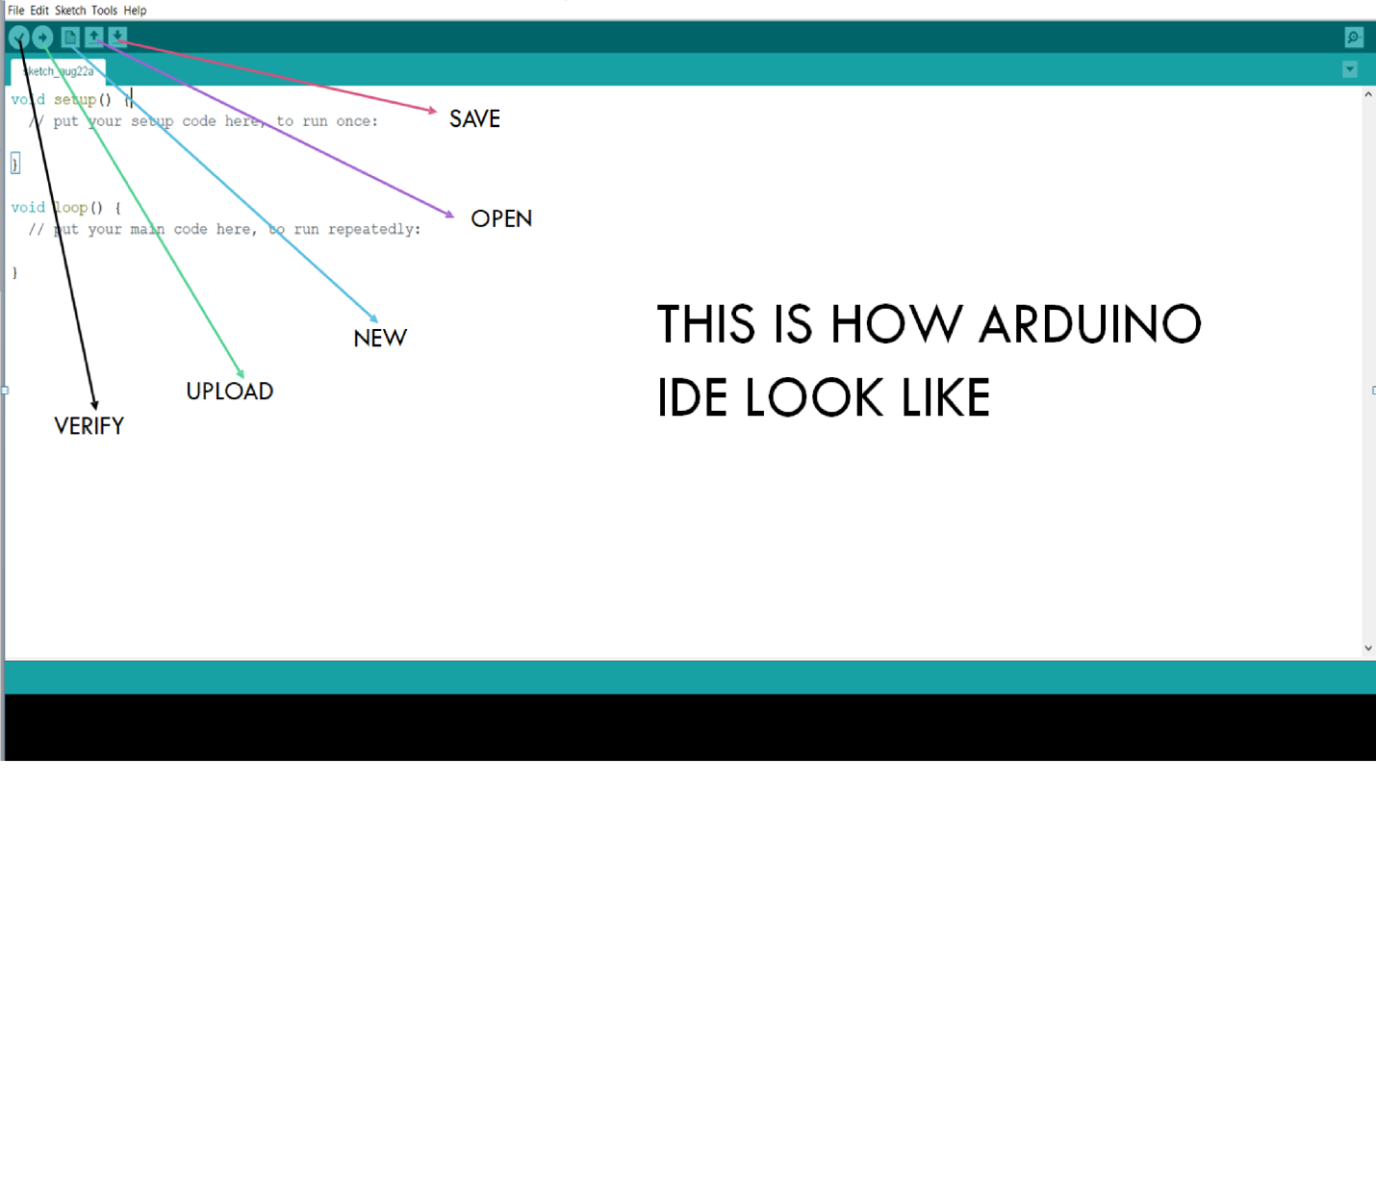

The code written in void setup() runs once at the starting/ reset of arduino. Then the code written in void loop() keeps on running continuously like an infinite loop.

Some basic Arduino commands:

1. **pinMode() :**
   1. Syntax – pinMode( pinnumber, OUTPUT/INPUT);
   2. Function - Declares weather a pin will be used as input or output
2. **delay() :**
   1. Syntax – delay( time in millisecond );
   2. Function - To halt the running program for a specified time. The last command executed will keep running
3. **digitalWrite() :**
   1. Syntax – digitalWrite ( pinnumber, HIGH/LOW);
   2. Function-Write a HIGH or a LOW value to a digital pin. HIGH means 5v and LOW means 0v.
   3. Note-Digital pin used in this function should be declared as OUTPUT using pinMode.

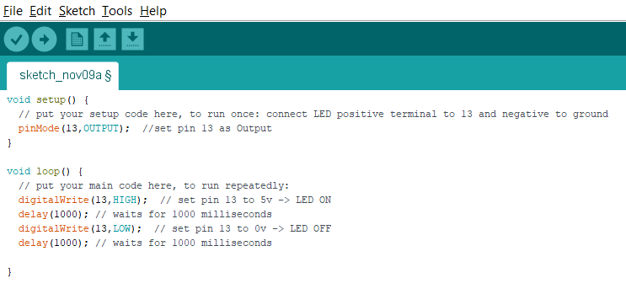

This is the code for LED blink. This code will glow LED for 1 sec and off LED for 1 sec.

1. **analogWrite() :**
   1. Syntax – analogWrite ( pinnumber, value );
   2. Function-Write a value to a analog/PWM pin. 255 means 5v and 0 means 0v.

**PWM pins are discussed in the end of the document.**

* 1. Note-pin used should be analog pin or PWM pin. And value should be between 0 to 255.

1. **digitalRead() :**
   1. Syntax – variable = digitalRead ( pinnumber );
   2. Function –Reads the status of the pin specified and returns 1 or 0 accordingly.
   3. Note –specified pin should be declared as INPUT.
2. **analogRead() :**
   1. Syntax – variable = AnalogRead ( pinnumber );
   2. Function - Reads the status of the pin specified and returns 0 to 1023 accordingly.

**AnalogRead is generally used to read the data from the sensors. Generally the sensor data is accurate and can take many values, using digitalRead won’t be a good option.**

* 1. Note –Specified pin should be declared as INPUT.

1. **Serial**

Used for Communication between laptop, arduino, Bluetooth etc. Serial is the name given to the communication protocol.

* 1. **Serial.begin(9600)**

Starts serial data transmission. 9600 is called baud rate. It is related to the frequency serial communication.

* 1. **Serial.available()**

Checks availability of serial communication. Used to check whether connection has been stablished or not.

**Serial sets digital pin 0 and 1 as Rx and Tx respectively. So, Bluetooth should be connected to 0 and 1 to use commands related to Serial. There are many more serial commands. For eg Serial.println(). But these are sufficient for now.**

* 1. **Serial.read()**

Read incoming data on the serial port.

* 1. **Serial.print()**

Prints data to serial port as human readable text

1. **SoftwareSerial**
   1. This command is used for multiple serial connections. Eg laptop and Bluetooth, 2 Bluetooth etc.
   2. Syntax : SoftwareSerial objname(pinA,pinB);
   3. Above command will create an object of name ‘objname’ with Rx and Tx pin as pinA and pinB. And all the commands available for Serial can be used. For eg- objname(9600); , objname.read();, objname.available(), objname.print(); etc.
   4. Note- pin1 and pin2 should be PWM pins. And to use the commands of objname for Bluetooth connect it to pinA and pinB.

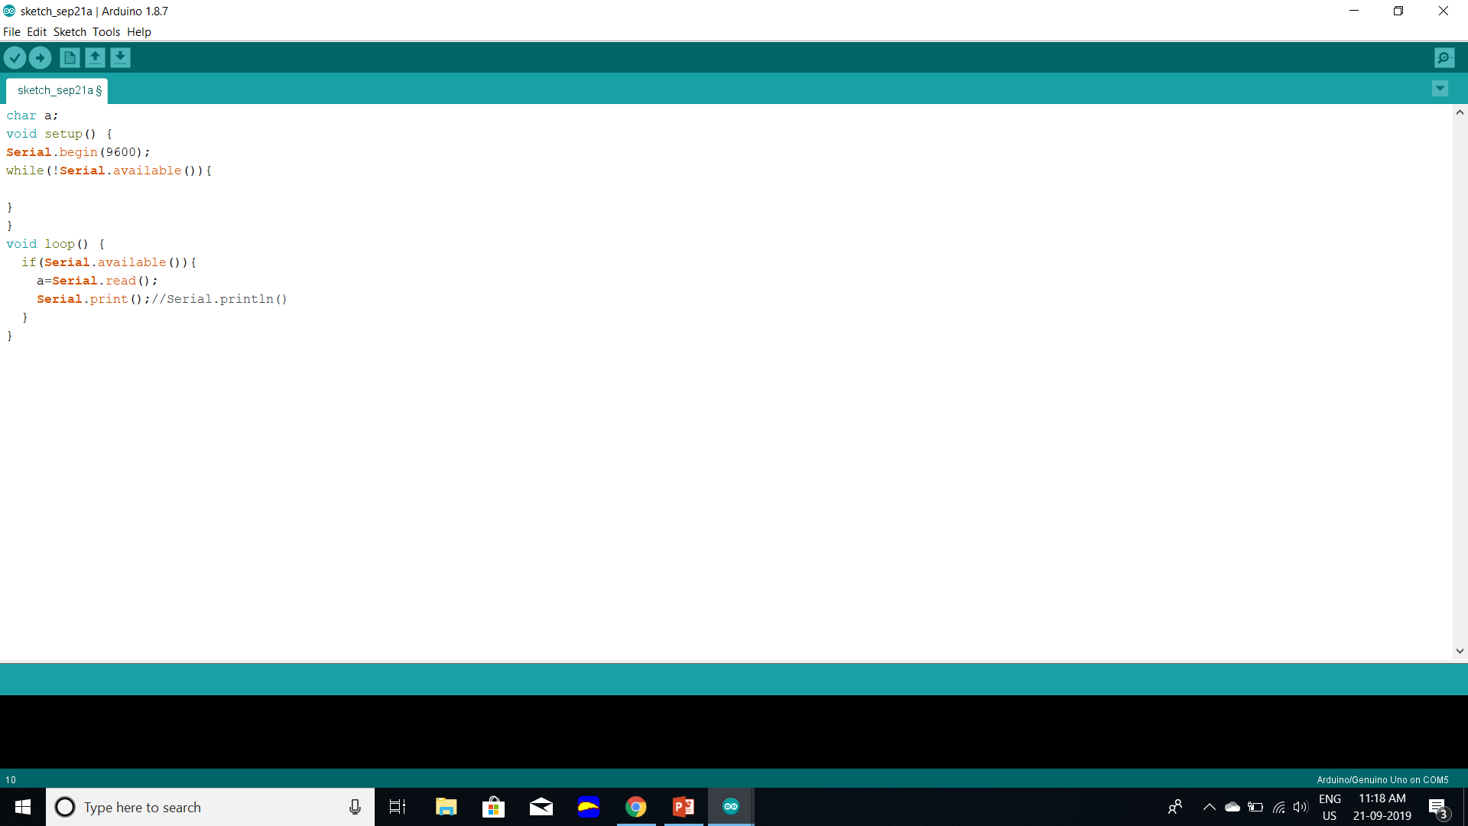

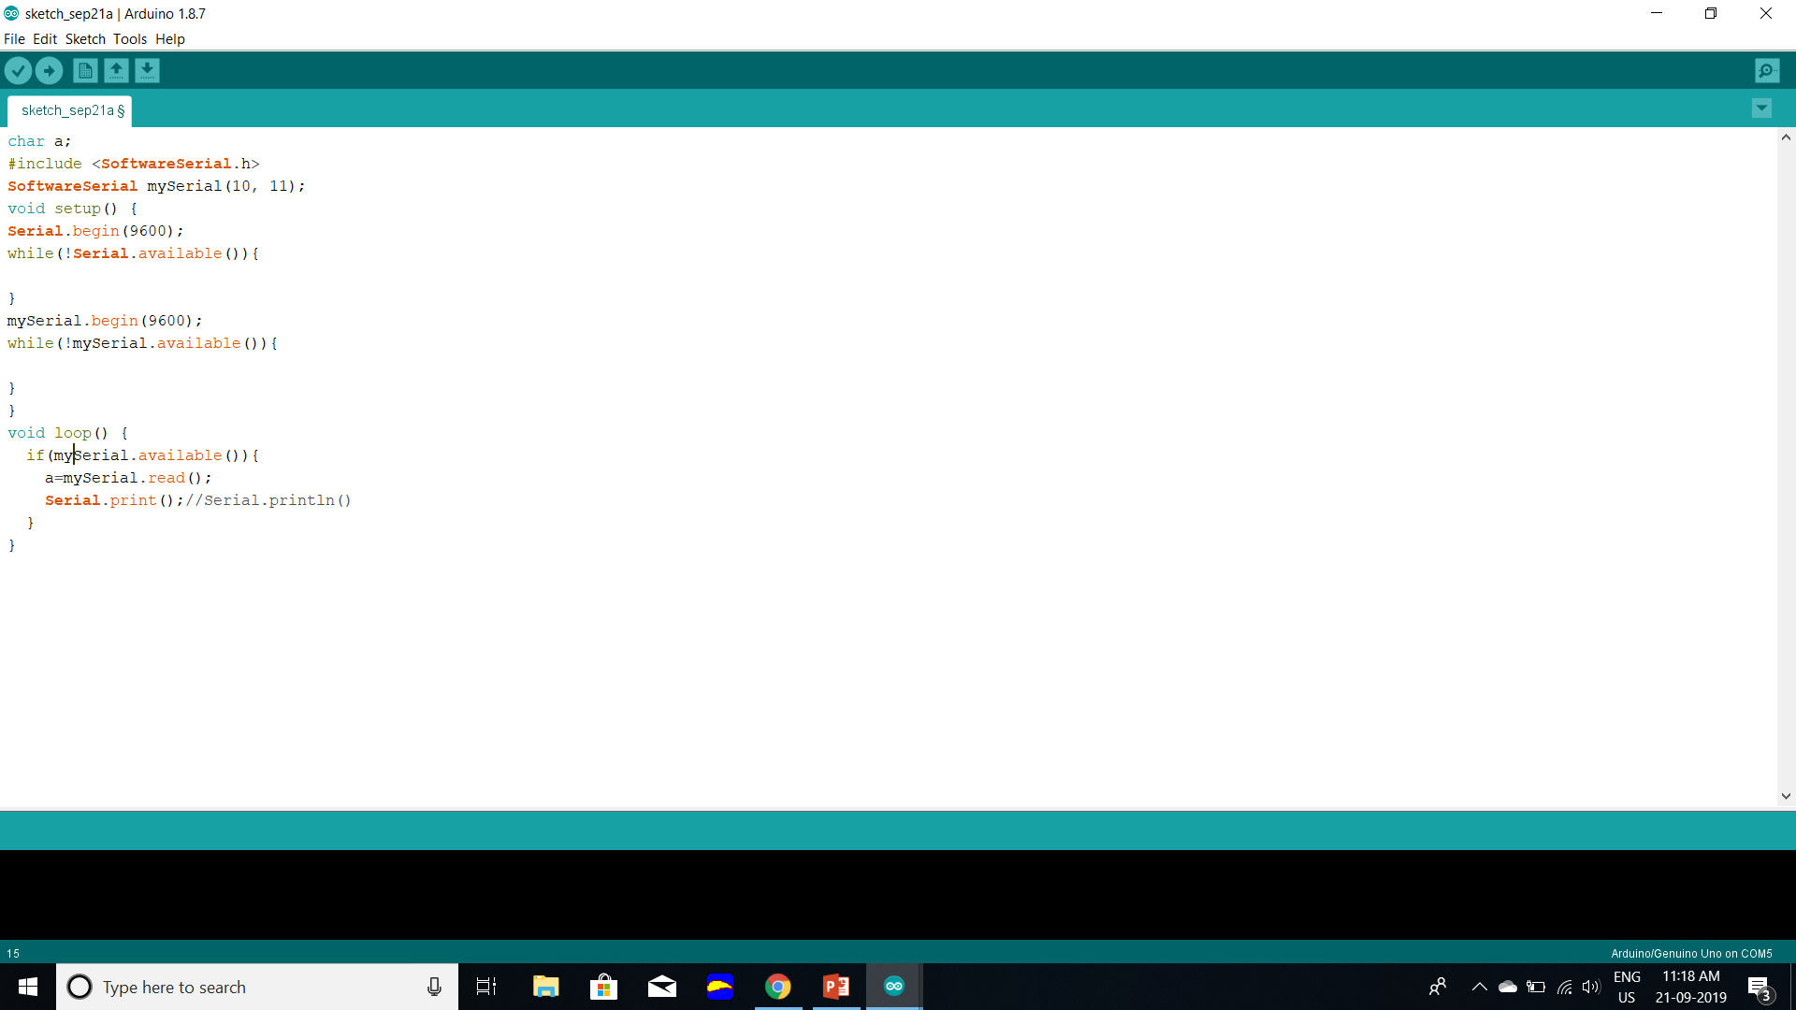

Below is the code to read data from mySerial and print data on Serial. If Bluetooth is connected on mySerial pins and laptop is connected to arduino, then it would read data from Bluetooth and print it in laptop