Assignment 4

Shape detection

Task: Write a python program that tells the shape(s) of the color(s) selected using the SelectRoi function in the given image.

Example:

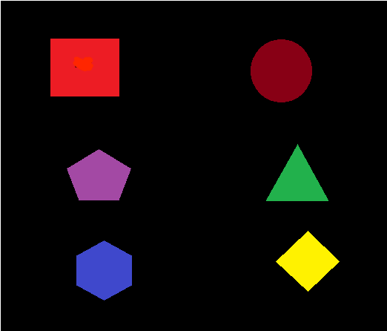

Suppose this is the input image and we select the red color using the SelectRoi function. Then the output image should look like the following:

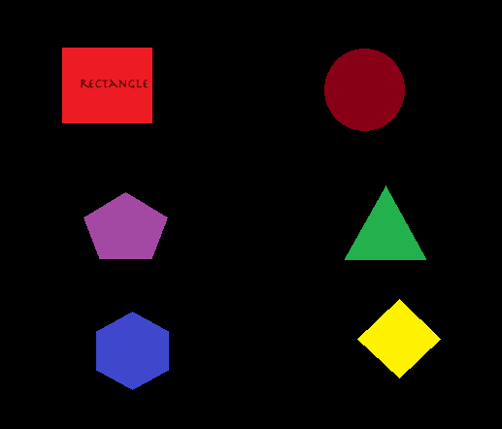

The red colored shape has been named.

Study material :

For shape detection and contours:

<https://www.pyimagesearch.com/2016/02/08/opencv-shape-detection/>

<https://www.youtube.com/watch?v=43pCXboZ5hE>

<https://docs.opencv.org/3.4/d4/d73/tutorial_py_contours_begin.html>

For SelectRoi Function:

<https://www.learnopencv.com/how-to-select-a-bounding-box-roi-in-opencv-cpp-python/>

<https://kite.com/python/docs/cv2.cv2.selectROI>