Title: Software Based Simulation of DishBrain-Inspired Learning Using Spiking Neural Networks

Introduction

Recent advances in biological computing have shown that living neural cultures can interact with digital environments and show adaptive learning behavior. The DishBrain system demonstrates that biological neurons can improve performance in a Pong-like environment with closed-loop feedback.
Such experiments. It performed in specialized biological laboratories with expensive cell cultivation facilities and neuroscience expertise.

First Problem to us

The cultivation and maintenance of biological neurons are costly and not accessible to most student researchers. Thus, there is a need for a computational framework that can reproduce the key features of biological learning and is also practical for academic research.

our decision

Our plan is to simulate a neuron-like learning system in code, connect it to an environment, feed it data, train it, and measure whether it learns a task such as XOR. XOR is useful because it is a classic non-linear problem, so a simple linear model fails while a network with internal dynamics can succeed, which makes it a reasonable first benchmark for a neural-computation paper. This lets us show whether a software-based spiking model can capture the same “adaptive behavior under feedback” .

It’s actually a computational reproduction and analysis of the DishBrain learning mechanism using Spiking Neural Networks (SNNs).

The tools we used

Google colab, pytorch, BindsNet, T4GPU.

Steps:-

Google Colab
↓
PyTorch
↓
BindsNET
↓
Input Layer
↓
Hidden Layer
↓
Output Layer
↓
STDP Learning
↓
XOR Classification

Phase-1

Google Colab:
Google Colab was chosen as the main platform as it provides free cloud computing facilities and does not require high performance hardware. It facilitates collaboration among the team members, is capable of utilizing GPU computing, and permits running the code using the web browser. It is therefore ideal for projects done by students with limited facilities.

Why we use it:
• Cloud-based system
• Facilitates collaboration among the team members
• No software installation needed
• Provides GPU resources
• Compatible with Python, PyTorch, and BindsNET

T4 GPU: Why it is important
The NVIDIA T4 GPU available from Google Colab greatly cuts down simulation time and training time. Spiking Neural Networks contain many spike events and multiple computations of neural networks, necessitating the importance of using GPUs to conduct effective experiments.

Why we choose it:
• Efficient training and simulation
• Ability to perform parallel computation
• Shortens the time required to execute an experiment
• Effectively deals with large scale neural activity

Why bindsNet is important

The choice to use BindsNET was made because of the fact that this framework is built specifically for Spiking Neural Networks (SNNs). The reason behind this is that BindsNET implements artificial neurons which communicate through spikes, thereby making this framework more compatible with biological neural networks.

Why we use it:
• Biologically inspired neural models
• Implements Spiking Neural Networks
• Implements Spike-Timing-Dependent Plasticity (STDP)
• Designed for computational neuroscience
• Integrates seamlessly with PyTorch

Why pytorch is important

This project makes use of the deep learning library, PyTorch, as its base. Due to the fact that BindsNET is implemented in PyTorch, it allows for the computation of tensors as well as GPU usage for effective neural simulation.

Reasons for using PyTorch:
• Computation of tensors
• Support for GPU acceleration
• Neural network design
• Community support
• Necessary foundation for BindsNET

Why it aligns with our research

The basis of our study revolves around learning through feedback, which can be considered more akin to a neural network rather than a static classifier. PyTorch provides a good platform because all SNN frameworks such as BindsNET are created within the PyTorch framework; therefore, we shall be able to use spiking neurons, learning laws, and closed-loop learning in an environment that you are familiar with.

How does it help down the road?

It is important to know that PyTorch is not limited to the XOR task only; it is capable of scaling up to experiments involving reinforcement learning, spike-based learning rules, or any kind of closed-loop experiment. If Phase I works well for you, you can then scale up and compare between different tasks, feedbacks, or networks.

How XOR works

The reason behind choosing the XOR problem as the first task was that XOR is one of the most basic problems studied when dealing with neural networks. XOR is a problem that is impossible to solve using linear models, hence making it the ideal problem to assess the learning capacity of the SNN.

Reasons behind using XOR problem:
• Benchmark problem for neural networks
• Assesses non-linear learning capacity
• Easy to analyze and understand

Input A | Input B | Output
0 | 0 | 0
0 | 1 | 1
1 | 0 | 1
1 | 1 | 0
This problem demonstrates:
- Non linear learning
- Hidden representations
- Neural computation
If our SNN learns XOR, we can prove:
- Information encoding
- Learning capability
- Network adaptation

What the Original Paper Actually Proved
Many people misunderstand this paper.
The main contribution was NOT:
"Neurons learned Pong."
The real contribution was:
"A biological neural network improved performance when placed inside a closed-loop environment and given feedback."
The key concepts were:
- Sensory Input
- Neural Processing
- Action Output
- Feedback
- Learning from feedback
The researchers showed that learning occurred only when feedback existed. Without feedback, learning disappeared
.
Original dishbrain process:-

Ball Position
↓
Neuron Culture
↓
Paddle Movement
↓
Feedback
↓
Learning

Our vision:

XOR Input
↓
Spiking Neural Network
↓
Prediction
↓
Error Feedback
↓
Learning

⭐ This work does not replicate the biological neuron cultivation and electrophysiological interface used in DishBrain. Instead, it investigates whether the underlying learning principles can be reproduced using software-based Spiking Neural Networks.
What are SNN:

Spiking Neural Networks (SNNs) are an artificial intelligence system that is modeled on biological systems. Unlike traditional neural networks that are continuously calculating continuous signals, SNNs only process information when a specific threshold is reached by using discrete electrical spikes.

SNN Operation:-

- Event-Driven Nature: Rather than firing and communicating at every single cycle within the network, cells within the SNN respond and communicate only in response to events, similar to that in living brains.
- Neural Potential: Cells gather spikes over time and, once they reach a certain level of potential, release a spike as an output and reset.
- Temporal Encoding: Not just by the data content, but also in how they are timed and ordered do spikes encode information.

Traditional AI vs. SNNs
Feature | Traditional Neural Networks (ANNs) | Spiking Neural Networks (SNNs)
Information Flow | Continuous (e.g., fractional numbers like 0.85) | Discrete events (spikes over time)
Computation | Every neuron computes in every cycle | Neurons only compute when spiking
Power Efficiency | High consumption (relies heavily on CPUs/GPUs) | Extremely low consumption (ideal for battery-powered tech)
Learning Method | Backpropagation | Spike-Timing Dependent Plasticity (STDP)

Example:-
The Video Camera Analogy
- Traditional AI (ANN): This is like a standard video camera recording 24/7. It processes every single pixel of every single frame, even if the room is completely empty, dark, and silent. It consumes a massive, constant amount of electrical power and computing data.
- Spiking AI (SNN): This is like a motion-activated camera. The pixels do absolutely nothing until they detect a sudden change in light or movement. When movement occurs, individual pixels fire electrical "spikes" to trigger a recording. If nothing moves, it consumes virtually zero power.
Why BindsNET works with SNN
The BindsNET framework is created for the purpose of simulating SNN models in Python, using the PyTorch library, and so it provides the research environment necessary for creating our own neurons, connections, learning rules, and reinforcement learning-like tasks. It is useful because it allows us to work with SNNs on CPU/GPU, with machine learning-related workflows that will be helpful for your Colab-based research. In other words, BindsNET lets us avoid implementing the entire spiking network ourself.

Significance of Spiking Neural Networks (SNNs)

SNNs have multiple benefits in terms of:

- Biological Plausibility
Real neurons send messages via electrical spikes. This is precisely what SNNs do.
- Timing Information Processing

Spikes' timing affects the learning process. Just like in the biological brain.
- Efficiency

Only the spikes of activated neurons are used, resulting in greater efficiency compared to conventional neural networks.
- .Applications in Neuroscience

SNNs offer a link between neuroscience and AI.

- Real DishBrain

Living Neural Cells
↓
Stimulation with Electricity
↓
Activity of Neurons
↓
Feedback from Environment
↓
Learning Process

Our DishBrain Project

XOR Inputs
↓
Spike Coding
↓
BindsNet SNN Model
↓
STDP Learning Algorithm
↓
Output Prediction

⭐ It is important to note that there are two key concepts that make the implementation of an SNN different from an ordinary neural network in that it is biologically plausible: the concepts of LIF and STDP. LIF refers to the process of accumulation of stimuli that eventually results in reaching a threshold and firing of a neuron.

Explanation of LIF in Layman’s Terms
The model of the Leaky Integrate-and-Fire neuron can be thought of as a bucket that leaks a little bit of water. The bucket fills up via the inputs, leaks some water due to leakage, and whenever the bucket reaches a certain level, the neuron emits a spike. Upon emitting a spike, the neuron resets itself; hence, it exhibits time-dependent behavior rather than the behavior of an ordinary artificial neuron.It is designed to mimic the behavior of biological neurons while remaining computationally efficient.

Working Principle

The biological neuron constantly receives impulses from other neurons in the form of electricity. The received impulses get stored in the membrane of the neuron. Once the voltage reaches the specific level, an action potential is produced.

The LIF Model produces this behavior in three ways:
1. Integration
The firing of the spikes increases the membrane potential of the neuron.
2. Leakage
The membrane potential of the neuron decays with time as long as there is no other spike.
3. Firing
The threshold value that is defined causes the neuron to fire a spike.

Spike-Timing-Dependent Plasticity (STDP)

Spike-timing-dependent plasticity (STDP) is a biological approach to learning wherein the weights or strengths of connections between neurons change depending on their spike timings.

As opposed to other machine learning approaches involving error backpropagation, STDP uses local interactions between interconnected neurons for learning.
Or
The principle of Spike-Timing-Dependent Plasticity entails that the synaptic weight depends on the relationship between the presynaptic neuron and the postsynaptic neuron firing. When there is causation in timing between these, the connection becomes stronger; otherwise, the opposite occurs. In relation to your research, Spike Timing-Dependent Plasticity plays a crucial role because of the way it enables learning through experience, apart from just backpropagation.
Learning Mechanism

The synaptic modification depends on spike timings.

Scenario 1: Presynaptic Firing First

Neuron A → Neuron B
In case neuron A fires just before neuron B, their link gets strengthened.
Outcome:
Increased Weight
This process is referred to as Long-Term Potentiation (LTP).

Scenario 2: Postsynaptic Firing First
Neuron B → Neuron A
When neuron B fires before neuron A, the connection gets weaker.
Outcome:
Decreased Weight
This process is known as Long-Term Depression (LTD).
Visualization

Pre-Fired Spike → Post-Fired Spike
↓
Strengthening Weight

Post-Fired Spike → Pre-Fired Spike
↓
Weakening Weight

Significance of STDP

LIF = How a neuron produces spikes.
STDP = How neurons learn from those spikes.

What they could do for XOR problem:-

In an XOR problem, neurons based on LIFs could accept spike-encoded binary values as their inputs, integrate them, and produce output spikes whenever the pattern is powerful enough to trigger one. Synapses can then be strengthened using STDP until the network gets better and better at discriminating between different XOR situations. In effect, this gives you an experimentally testable scenario.

Why this is convincing as a simulation
Software is dependable in this case since artificial neural networks are precise models of biological neural activity that aren’t just a copycat. The BindsNET software library applies these mathematical models using the PyTorch platform; therefore, one can conduct various experiments and measure the learning curve. This is precisely the reason why computational neuroscience is so effective; it allows us to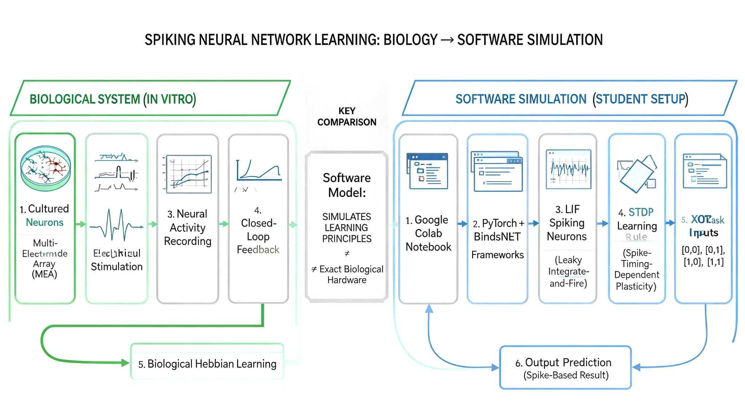 experiment with a biological idea.

Extra:-
1. How They Keep the Cells from Rotting (The Liquid Life Support)
The neurons do not sit out in the open air. Instead, they are completely submerged inside a specialized, thumb-sized petri dish that acts as an artificial womb.
- Nutrient Solution: The cells are flooded with a sterile, pinkish liquid called culture media. This fluid contains sugars, amino acids, vitamins, and salts, which act as the cells' food.
- Continuous Recycling: The system utilizes a perfusion circuit that continuously pumps fresh nutrients in while filtering away the toxic waste products produced by the cells.
- Environment Control: The entire dish is kept at a steady human body temperature (37c) and supplied with a precise mix of oxygen and carbon dioxide. This rigorous control allows the cells to stay alive and healthy for six months to a year without rotting.
How They "Connect" the Small Brain Part to a Computer
Scientists do not cut out a chunk of an adult's brain and attempt to connect it. Rather, they cultivate their own small chunk of brain matter on the specialized microchip itself.
o o o o o o <- Living Neurons

|---|----|---|----|---| <- Sticky Coating (PEI Gel)
▪ ▪ ▪ ▪ ▪ ▪ <- Microelectrodes (Gold/Platinum)
=========================== <- Silicon Chip Surface
The Initial Ingredients: They take stem cells (frequently created from human skin cells) and use chemicals to coax them into becoming loose neurons.The Sticky Coating: The silicon surface of the computer chip gets a thin coating of a biologically compatible sticky substance (such as polyethyleneimine, or PEI).
The Natural Network:
Upon the introduction of neurons into the fluid-filled dish, they automatically adhere to the sticky chip. As it is the natural tendency of the neurons within the brain, they will automatically extend out axons and dendrites, thus creating a neural network.
The Language: In the silicon chip lies a device known as the High-Density Multi-Electrode Array (HD-MEA), consisting of thousands of microscopic gold or platinum grids. Since neurons and computers use electric pulses as language for communication, the neurons are aligned with these electrodes such that whenever a neuron fires, an increase in voltage can be detected by the chip. Whenever the computer "speaks" to the neurons, it sends a tiny pulse down through the electrode.
The meaning of scaling laws:-
In machine learning, scaling laws refer to the relationship between performance improvements when increasing parameter counts, training datasets, or computing power. The key takeaway is that as you scale your system, performance typically improves in a predictable way, allowing you to anticipate whether adding more computing resources will be worthwhile.

Biological Scaling Law
A real brain doesn't start with emotions.
It starts with:
Neurons
↓
Connections
↓
Learning
↓
Memory
↓
Reward
↓
Behavior
↓
Emotion-like states

Scaling Law of the Proposed System:-

The research in this domain uses a systematic scaling method. The system is scaled in a stepwise fashion through increased complexity in terms of neural structure and interaction with the environment.
Stage 1:
Learning simple logical relations through XOR classification using Spiking Neural Network.
Stage 2:
Learning through pattern recognition by performing image-based tasks such as MNIST digit classification.
Stage 3:
Incorporating reward-based learning techniques for adaptive behavior.
Stage 4:
Adding memory capability to allow decisions based on past experiences.
Stage 5:
Creation of the Artificial Affective Layer which includes internal states such as confidence, curiosity, stress, and satisfaction.
Stage 6:
Designing a closed-loop autonomous agent that can interact with the environment.
This scaling law is similar to biological evolution, wherein increasing levels of behavior are generated through a combination of learning, memory, and adaptability.
What is MNIST:-
One of the most well-known databases in machine learning is MNIST.
Its abbreviation means:
Modified National Institute of Standards and Technology Database
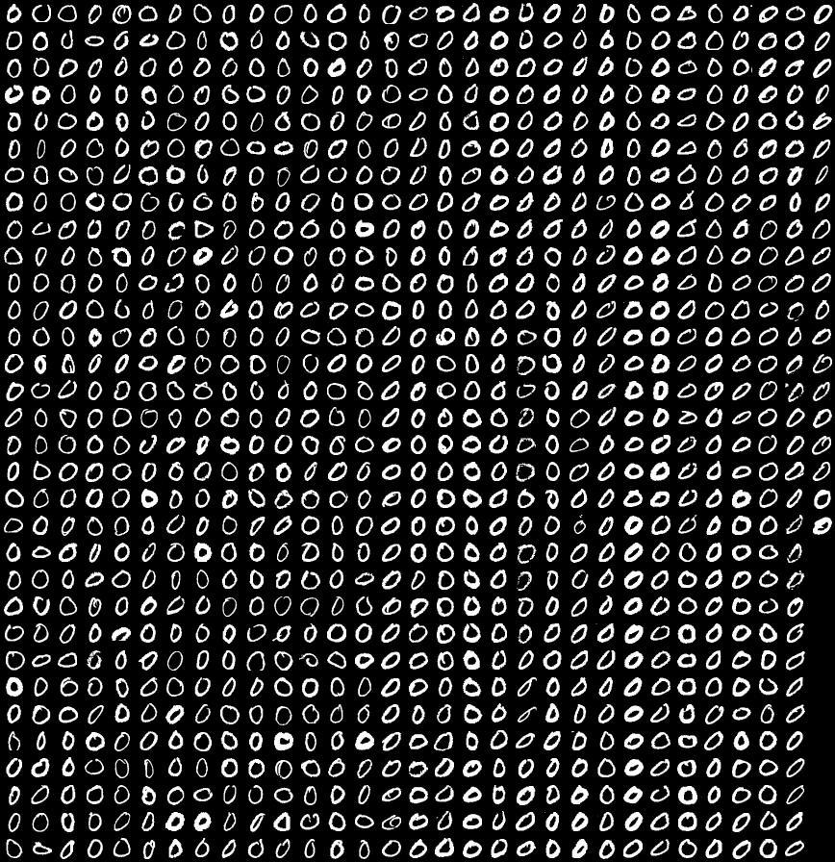
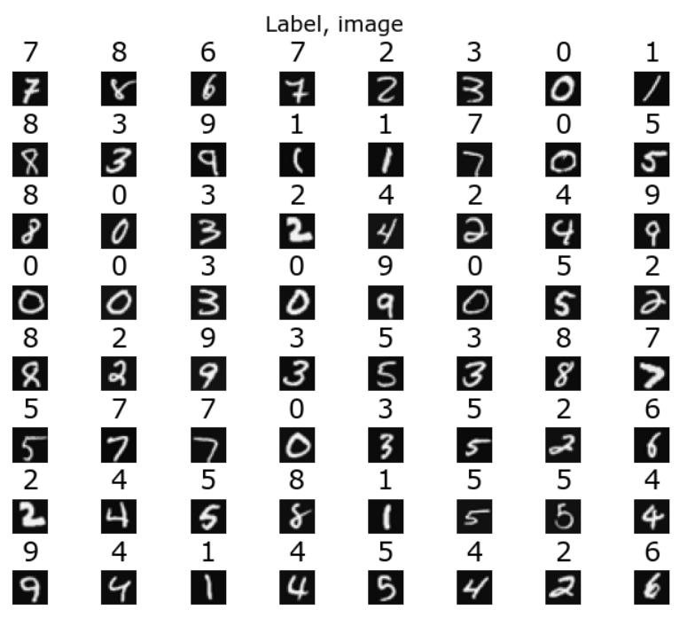
It includes images of handwritten numbers from 0 to 9.

Reasons Why Researchers Use MNIST
Because it is:
1.Small
2.Easy to train
3.Internationally recognized
4.Ideal for experimentation
Before experiments on other complex data sets, researchers experiment on MNIST first.
What is LIF:-
LIF stands for Leaky Integrate-and-Fire, which is the simplest neuron spiking model used in SNNs. This model integrates the inputs received, leaks off some charge through time, and produces a spike upon reaching its firing threshold.

Working:-
- The input causes an increase in voltage of the neuron’s membrane.
- There is gradual dissipation of voltage due to lack of sufficient input.
- Voltage attains threshold value, and there occurs an action potential.
- The neuron then resets, and the process is repeated.

⭐Simple LIF models are helpful, yet they exhibit certain limitations when used in deep SNNs. First, their oversimplified representation fails to account for the dynamics required by deeper architectures; thus, it affects training and expressiveness.
Primary limitations
- Limited biological plausibility. LIF does not take into consideration the complex behavior of a biological neuron including its adaptation properties and spike generation mechanisms.
- Poor temporal dynamics. It can represent elementary time properties, yet LIF struggles to describe complex spiking behavior.
- Training difficulties in stacks. More sophisticated dynamics are required in deep SNNs to maintain signal propagation through multiple layers and time steps.
- Activity vanishing/saturation. Neurons could fail to generate spikes if thresholds, decay, and input scaling are chosen incorrectly; alternatively, they can be prone to excessive spiking.
- Less representational abilities. Simple LIF neurons might prove less capable of discriminating complex data structures compared to more elaborate neuron models.
- Hyperparameter dependence. Training outcome is greatly influenced by the choice of parameters like threshold, leak value, reset, time step, and encoding.
- Difficult scalability to complex tasks. LIF neurons will likely underperform compared to their more expressive counterparts on large-scale datasets and architecture types.

