COMP 2228 MIDTERM EXAM REVIEW QUESTIONS

24.03.2023

1.a)Find the complexity : T(n) = n+ log(nn)

b) Show that T(n)= 5n3 + 2n2 is O(n3)

2. Find the result :

i=100

Σ (2i+1)

i=5

3.Order (in big O): n2, 5n, nlogn, $\sqrt{n}$, nn, n! , ****, 2logn, 2n

4.What is the complexity of the following segment of code ?

int a = 0, b = 0;

for (i = 0; i < n; i++)

    a = a + rand();

for (j = 0; j < m; j++)

    b = b + rand();

5.What is the output and complexity of the following code segment?

int x = 10;

for ( int i = 0; i < n; ++i )

for ( int j = 0; j < i; ++j )

x += j;

6.Solve the following recurrence : T(n) = T(n-1) + 1 , T(0) = 1

7.Determine how much the value of T(n)= log n will change if n becomes 32n ?

8. Answer (7) for T(n) = n logn .

9.If a given O(n2) algorithm runs in 20 ms for an input of size 32, and for another input runs in 400 ms, how big could be that input?

10.a) What does this algorithm perform ?

ALGORITHM ABC(A[0..n − 1, 0..n − 1])  
 for i ←0 to n − 2 do  
 for j ←i + 1 to n − 1 do  
 if A[i, j ] = A[j, i]  
 return false  
 return true

b)Explain Best and worst case complexities of ABC

11.What is the value of alg(5), given the definition below?

int alg ( int n)

{

if(n == 1) return 2;

else return alg(n-1) + 3;

}

12.Write a recursive algorithm or program that finds the sum of cubes of first n integers. Express complexity.

13.What will be returned by the following algorithm if T is a binary tree pointer?

Algorithm Axh ( T )   
 If *T ≠* ∅   
 a1 🡨 Axh( AxleftT)  
 a2🡨 Axh(AxrightT)  
 p 🡨 1 + getMax( a1 , a2)

14.Write a recursive algorithm for computing the ***k***-th power of a given positive integer.  
  
15.Consider the loop in GCD (m,n) algorithm : r = m % n; m = n; n = r. Trace it for m=256, n=10.

16.Describe Insertion Sort briefly.

17.Explain why is the TSP an intractable problem?

18.Explain briefly the “Greedy” algorithm design approach.

19. Show the result of running BFS and DFS on the undirected graph given below

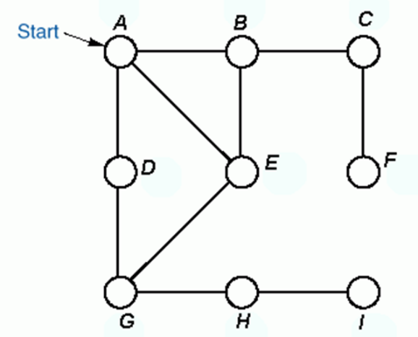

20.Show a)Adjacency list b)Adjacency matrix representations of the following graph.

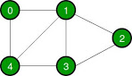

21. Explain the following part of Djkstra’s Algorithm.(What is being performed here ?)

for all v ∈ neighbors[u]   
              do  if   dist[u] + w(u, v) < dist[v]   
                         then     
   d[v] ←d[u] + w(u, v)

22.Find MST of the following graph a) using Kruskal’s algorithm and b) using Prim’s algorithm

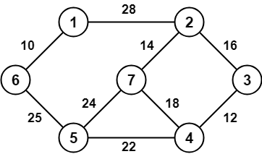

23. What do the following operations perform ?

u ← u + v

v ← u − v

u ← u − v

24.Write a recursive algorithm for computing the k-th power of 2.

25. Show that T(n)= 7n2 +1 is θ (n2)