Impact of Node Density and Propagation Models on Wi-Fi Network
Performance Using ns-3
UDP and TCP Comparative Evaluation of IEEE 802.11g and IEEE 802.11ax WLANs
Student | Leonel Olímpio Silima
Institution | University of Porto - Faculty of Engineering (FEUP)
Programme | PDEEC
Course | Wireless Network
Academic year | 2025/2026

Abstract
This report presents a reproducible ns-3 evaluation of how node density, propagation conditions, transport protocol and Wi-Fi generation jointly affect wireless LAN performance. The experimental campaign compared IEEE 802.11g and IEEE 802.11ax under Friis, LogDistance and cascaded Friis-Nakagami propagation, with 5, 10, 20, 30 and 50 stations placed at distances from 5 m to 50 m. UDP and TCP were executed as independent campaigns using three random seeds per scenario. The design scheduled 540 runs per protocol (1,080 in total); 536 UDP and 537 TCP raw CSV outputs were valid, while seven executions were excluded after internal ns-3/cppyy segmentation failures. The evaluation uses throughput, packet delivery ratio (PDR), packet loss, end-to-end delay, offered load, throughput per station, efficiency, Jain fairness and 95% confidence intervals. TCP maintained effective PDR near unity because acknowledgements, retransmissions and congestion adaptation recover losses, whereas UDP exposed channel degradation directly. IEEE 802.11ax achieved the highest mean throughput in the favourable Friis condition; however, under fading and LogDistance attenuation, capacity and fairness remained constrained by distance and contention. These results demonstrate that delivery reliability, capacity and fairness must be interpreted jointly: high TCP PDR does not imply high radio capacity, and very low measured delay may coexist with low throughput or poor fairness.
Keywords - IEEE 802.11g; IEEE 802.11ax; ns-3; UDP; TCP; Friis; LogDistance; Nakagami fading; throughput; PDR; delay; Jain fairness.

1. Introduction
Wireless local area networks support residential connectivity, enterprise services, industrial monitoring and cyber-physical applications. Their performance is determined not only by the nominal physical-layer data rate, but also by the received signal power, channel attenuation, multipath fading, contention among stations and the transport protocol used by applications. As node density increases, more stations compete for the same medium, which can reduce per-station throughput and fairness even when aggregate traffic initially rises.
IEEE 802.11g provides a legacy OFDM-based baseline in the 2.4 GHz band, whereas IEEE 802.11ax introduces a high-efficiency PHY/MAC generation intended to improve operation in dense WLANs. In this study, the ns-3 Wi-Fi standard selector was used to compare the configured 802.11g and 802.11ax modes under identical topologies. The experiments do not explicitly enable advanced multi-user scheduling, OFDMA resource allocation or multi-stream MIMO; therefore, the results quantify the behaviour of the configured ns-3 PHY/MAC modes rather than every optional capability of Wi-Fi 6.
The transport layer changes the meaning of observed reliability. UDP is connectionless and does not recover lost packets, so its PDR exposes radio and contention losses directly. TCP is connection-oriented and uses acknowledgements, retransmission, sequencing and congestion control. Consequently, TCP can preserve effective delivery reliability by reducing or adapting the sending process, potentially sacrificing throughput or increasing overhead. A valid comparison must therefore consider PDR, throughput, delay, fairness and efficiency together.
The objective is to quantify the combined effect of station density, distance, propagation model, Wi-Fi standard and transport protocol using a factorial and reproducible simulation design. The contribution is not a single best-case benchmark, but a multi-metric characterization across 360 grouped scenario cells (180 for UDP and 180 for TCP), supported by seed-based statistical aggregation and final comparative visualizations.

2. Technical Background

2.1 IEEE 802.11g and IEEE 802.11ax
IEEE 802.11 defines the WLAN medium access control (MAC) and physical (PHY) specifications [1]. IEEE 802.11g extended higher-rate OFDM operation in the 2.4 GHz band and is used here as a legacy reference [2]. IEEE 802.11ax is the high-efficiency amendment associated with Wi-Fi 6 and targets higher basic service set throughput and improved dense-network operation [3]. The ns-3 Wi-Fi model provides packet-level abstractions of 802.11 PHYs and MAC procedures, including 802.11g and 802.11ax modes [4].
At the MAC layer, stations share a contention-based medium. As the number of active stations increases, the probability of backoff overlap and collision rises, queues may grow, and channel access becomes less uniform. At the PHY layer, received power and signal-to-noise ratio determine whether a frame can be decoded. Propagation loss and fading therefore interact with MAC contention: a weak link occupies airtime, produces errors or retransmissions, and can indirectly degrade other stations.

2.2 UDP and TCP
UDP provides a datagram service with minimal protocol mechanism and no built-in acknowledgement, ordering or retransmission [5]. It is suitable for exposing direct packet loss and for applications that prefer timeliness over recovery. TCP provides a reliable byte stream with acknowledgements, retransmission, sequencing, flow control and congestion control [6]. When loss is detected, TCP adapts its congestion window and retransmits data, so the protocol can increase effective delivery reliability while reducing offered transmission pressure.
FlowMonitor detects TCP traffic in both directions: application data travel from stations to the access point, while acknowledgements travel in the reverse direction. To prevent ACK traffic from being counted as useful payload throughput, the TCP post-processing stage retained only station-to-AP data flows for aggregate application metrics. Reverse flows remain available in the raw output for traceability.

2.3 ns-3 measurement model
The simulator was instrumented with one FlowMonitor helper, which records per-flow transmitted and received packets and bytes, lost packets, first and last transmission/reception times, and accumulated delay [7]. These quantities were exported to CSV files at flow and aggregate levels. The Python analysis pipeline normalized types, rebuilt TCP data-only aggregates, grouped scenarios across seeds, computed dispersion and confidence intervals, and generated final tables, boxplots and heatmaps.

Table 1. Computational pipeline and traceability
Stage | Main file | Purpose
Experimental design | generate_experimental_matrix.py / generate_tcp_experimental_matrix.py | Creates all factorial scenario combinations and output paths.
Execution | run_experiments.py / run_tcp_experiments.py | Launches ns-3 runs, captures logs and records failures.
Simulation engine | wifi_density_propagation.py | Configures topology, Wi-Fi mode, propagation, UDP/TCP applications and FlowMonitor.
Statistical analysis | analyze.py / analyze_tcp.py | Builds flow, aggregate, seed-statistics and scalability datasets.
Protocol comparison | compare_udp_tcp.py | Aligns equivalent UDP/TCP scenario cells and computes deltas.
Publication outputs | final_publication_outputs.py | Generates final heatmaps, boxplots and summary tables.

3. Propagation and link-level quantities
The carrier wavelength is determined by the speed of electromagnetic propagation c and the carrier frequency f_c:
(1)
For a line-of-sight free-space link, the Friis equation relates received power to transmit power, antenna gains, wavelength and separation distance [8]:
(2)
The corresponding free-space path loss in decibels is:
(3)
Friis is an optimistic reference because it assumes unobstructed propagation. The LogDistance model introduces an environmental path-loss exponent n and expresses attenuation relative to a reference distance d_0 [4]:
(4)
The cascaded Friis-Nakagami configuration combines large-scale deterministic attenuation with small-scale fading. The Nakagami envelope probability density is:
(5)
where m controls fading severity and Ω is the mean received power parameter. The instantaneous signal-to-noise ratio is conceptually:
(6)
Although BER was not exported directly by the scripts, PHY decoding errors connect SNR to packet loss. For an L-bit frame under an independent-bit approximation, the packet error probability is:
(7)
This analytical chain - propagation loss to received power, SNR, frame error and packet delivery - explains why distance and fading reduce UDP PDR and throughput. In TCP, transport recovery masks part of the resulting loss but cannot restore unavailable radio capacity.

3.1 Performance metrics
Throughput was derived from received bytes and the actual FlowMonitor observation interval:
(8)
PDR and packet loss rate were obtained from transmitted and received packet counters:
(9)
Mean end-to-end delay used the accumulated FlowMonitor delay divided by the number of received packets:
(10)

3.2 Load, efficiency, fairness and uncertainty
The nominal application offered load scales with the number of stations. Aggregate throughput was also normalized by station count, and a relative efficiency indicator compared delivered throughput with configured load:
(11)
Jain's index quantifies whether throughput is evenly distributed among flows [9]:

(12)
A value close to one indicates equal allocation; lower values indicate that a subset of stations receives a disproportionate share. Sample mean and variance across seeds were calculated as:
(13)
Because the target design used three independent seeds, the 95% confidence interval employed the Student t distribution:
(14)
For groups affected by a failed run, the available seed count was used. Such groups have wider or less stable confidence intervals and must be interpreted with additional caution.

4. Experimental Methodology

4.1 Scenario configuration
Parameter | Configuration
Topology | One access point and multiple stations; uplink traffic from STA to AP.
Wi-Fi standards | IEEE 802.11g and IEEE 802.11ax.
Protocols | UDP and TCP, executed as independent campaigns.
Propagation | Friis, LogDistance and cascaded Friis-Nakagami.
Station counts | 5, 10, 20, 30 and 50.
Distances | 5, 10, 20, 30, 40 and 50 m.
Seeds | 1, 2 and 3.
Simulation time | 10 s; sink active from 1 s and sources from approximately 2 s.
Application payload | 1024 bytes.
Configured per-source rate | 1 Mbps for 5 stations; 2 Mbps for 10-50 stations.
Rate adaptation | IdealWifiManager in the implemented ns-3 scenario.
Table 2. Controlled parameters used in the UDP and TCP campaigns.

4.2 Run calculation and data completeness
For each protocol, the Cartesian product contains two standards, three propagation models, five station densities, six distances and three seeds:
(15)
The execution produced 536 valid UDP CSV files and 537 valid TCP CSV files. Four UDP and three TCP runs failed with internal ns-3/cppyy segmentation violations. The failed executions were preserved in logs and excluded from raw aggregation. The final comparison contains 180 grouped scenario cells per protocol after removing the seed dimension.

4.3 Reproducibility controls
- UDP and TCP campaigns use equivalent standard, propagation, density and distance combinations.
- Randomness is controlled with RngSeedManager and three independent run indices.
- Every run writes a dedicated CSV file and execution log.
- TCP ACK-direction flows are excluded from useful-throughput aggregates but retained in raw files.
- All comparative figures are generated from final scenario-statistics and summary datasets.

5. Results

5.1 Global comparison
Figure 1 summarizes the final mean throughput and PDR for every protocol-standard-propagation combination. The largest mean throughput was obtained by TCP over IEEE 802.11ax with Friis (26.52 Mbps), closely followed by UDP under the same PHY and propagation model (25.88 Mbps). TCP over IEEE 802.11g with Friis reached 21.08 Mbps, compared with 17.11 Mbps for UDP. Under IEEE 802.11ax with Friis-Nakagami, UDP achieved higher mean throughput than TCP (21.09 versus 17.98 Mbps), illustrating TCP congestion backoff under variable fading even while TCP preserved substantially higher delivery reliability.
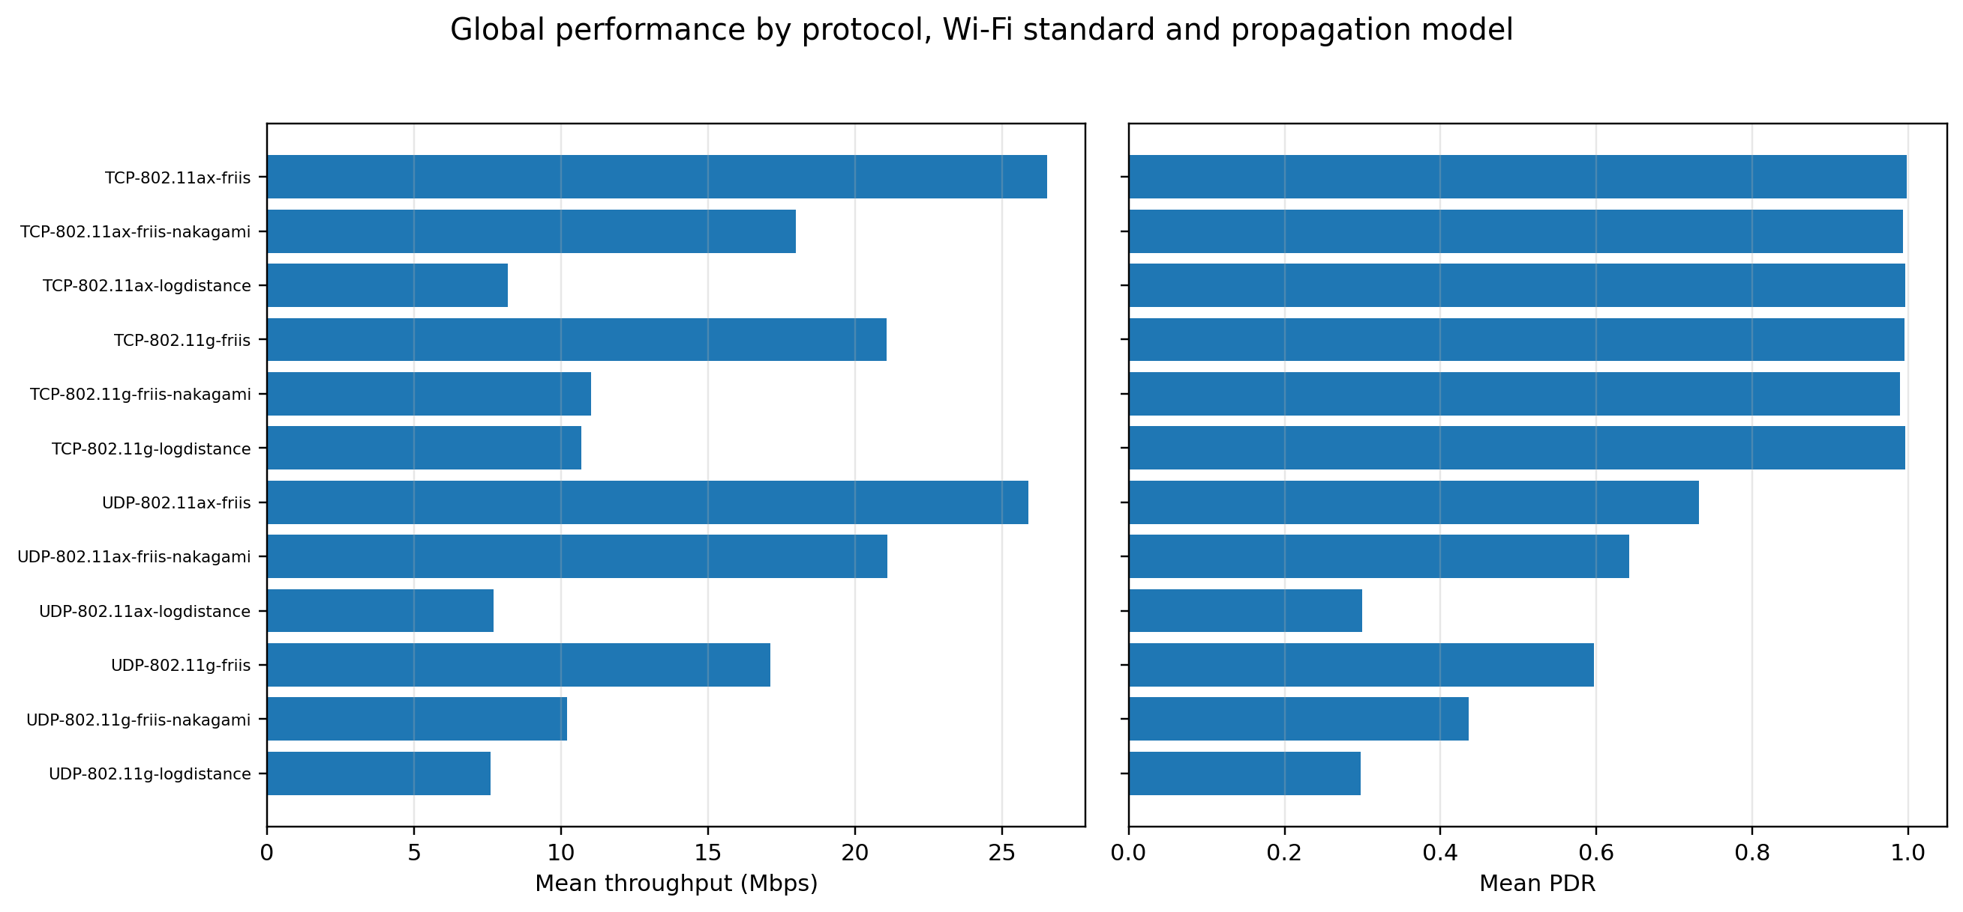
Figure 1. Mean throughput and PDR by protocol, Wi-Fi standard and propagation model.
TCP mean PDR remained between 0.9894 and 0.9978 across the six standard-model combinations. UDP PDR ranged from 0.2978 to 0.7311. The result is not evidence that TCP improves the physical channel; it shows that acknowledgements, retransmissions and congestion adaptation convert raw loss into transport-layer recovery. The LogDistance cases are particularly instructive: TCP retained PDR near 0.996, but mean throughput remained only 8.19 Mbps for 802.11ax and 10.68 Mbps for 802.11g, with fairness near 0.30. Hence, high TCP PDR can coexist with limited capacity and unequal service.

Table 3. Final mean results over all density and distance cells
Protocol | Standard | Model | Throughput  (Mbps) | PDR | Delay  (s) | Fairness | Efficiency
TCP | 802.11ax | friis | 26.52 | 0.9978 | 0.0068 | 0.7475 | 0.7850
TCP | 802.11ax | friis-nakagami | 17.98 | 0.9928 | 0.0255 | 0.6562 | 0.6320
TCP | 802.11ax | logdistance | 8.19 | 0.9963 | 0.0002 | 0.2994 | 0.3282
TCP | 802.11g | friis | 21.08 | 0.9953 | 0.0096 | 0.7334 | 0.9551
TCP | 802.11g | friis-nakagami | 11.03 | 0.9894 | 0.0401 | 0.4906 | 0.6946
TCP | 802.11g | logdistance | 10.68 | 0.9957 | 0.0008 | 0.2971 | 0.5515
UDP | 802.11ax | friis | 25.88 | 0.7311 | 0.0171 | 0.7504 | 0.7544
UDP | 802.11ax | friis-nakagami | 21.09 | 0.6423 | 0.0688 | 0.6843 | 0.6714
UDP | 802.11ax | logdistance | 7.71 | 0.2997 | 0.0000 | 0.2996 | 0.3079
UDP | 802.11g | friis | 17.11 | 0.5971 | 0.1215 | 0.6926 | 0.6145
UDP | 802.11g | friis-nakagami | 10.19 | 0.4359 | 0.1599 | 0.4897 | 0.4489
UDP | 802.11g | logdistance | 7.60 | 0.2978 | 0.0047 | 0.2994 | 0.3061

5.2 Protocol-level distributions
The boxplots in Figure 2 aggregate all final scenario groups. Throughput distributions overlap substantially, demonstrating that transport protocol alone does not determine capacity; the Wi-Fi standard, propagation model, distance and density remain dominant. In contrast, PDR clearly separates the protocols: UDP spans a broad range because it records unrecovered losses, while TCP values cluster close to one.
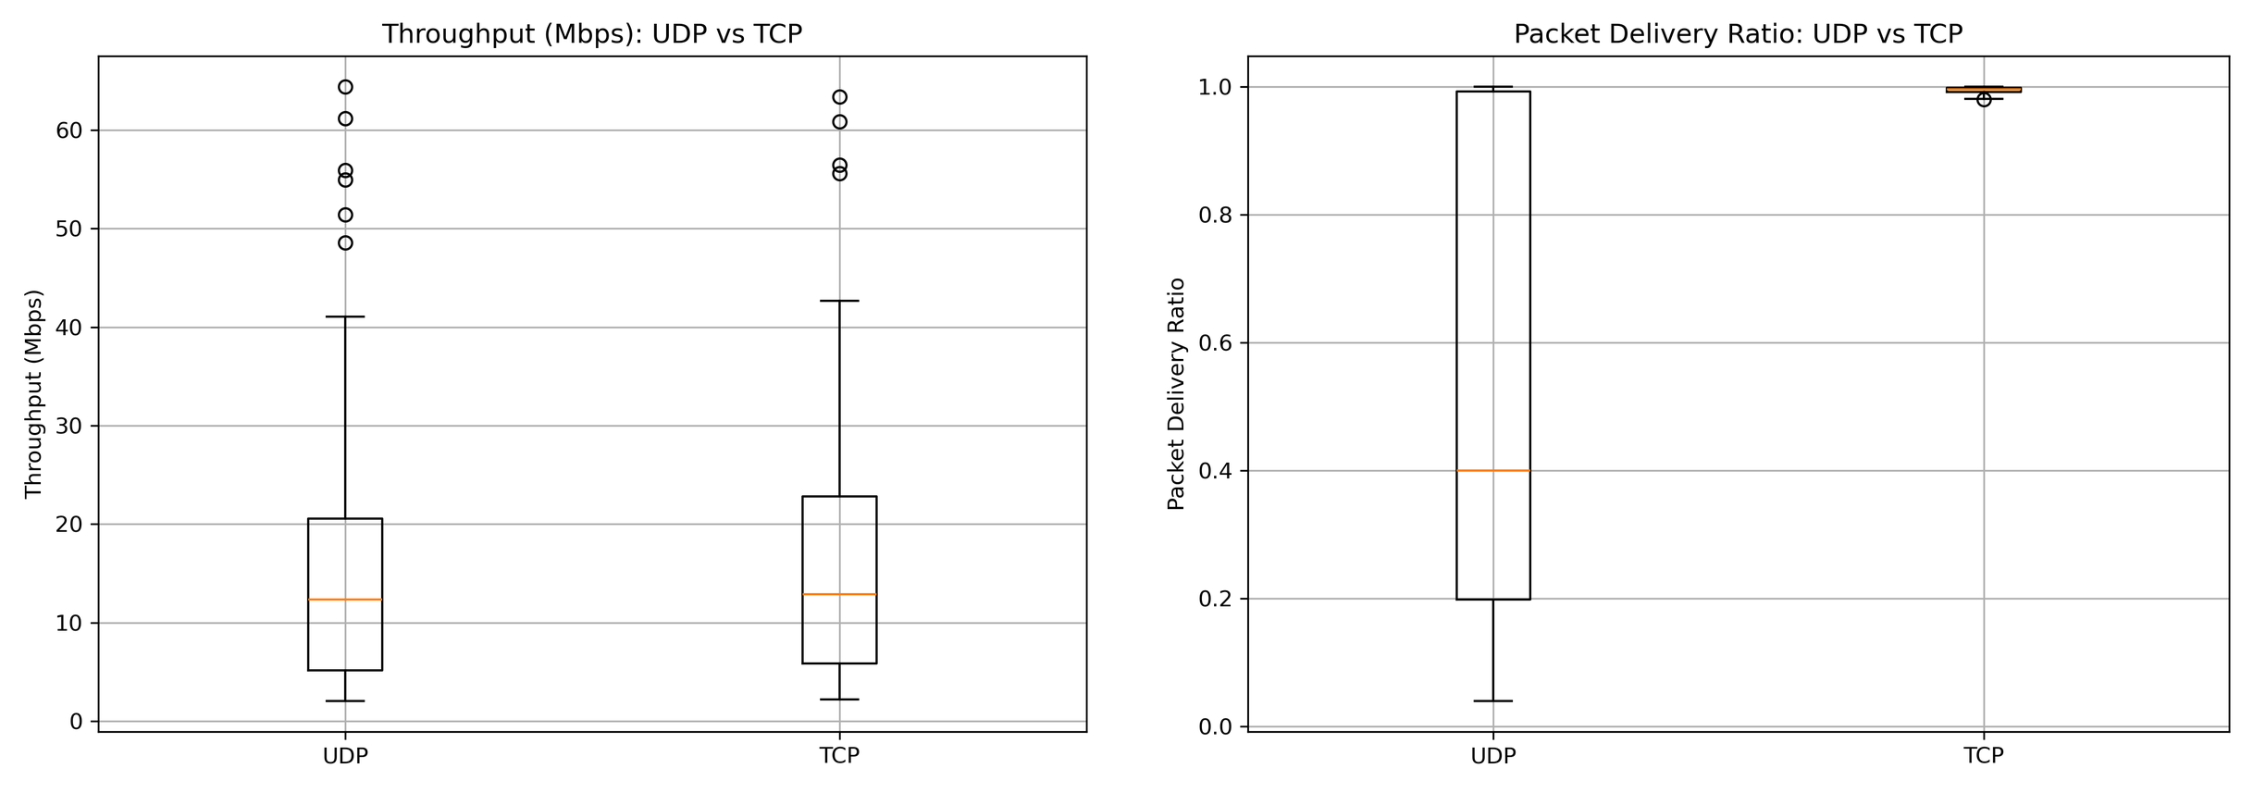
Figure 2. Final throughput and PDR distributions across UDP and TCP scenario groups.

Figure 3 compares delay, fairness and efficiency. TCP exhibits a lower and narrower delay distribution than UDP in these processed results. This does not mean that TCP is intrinsically latency-free: congestion control can reduce the sending pressure and therefore queueing, while UDP continues to inject traffic despite loss. Fairness distributions are similar at the protocol level because both protocols share the same contention domain; the more important fairness degradation appears with increasing station count. TCP efficiency is generally higher, but the indicator must be interpreted relative to the nominal application rate and FlowMonitor byte accounting.
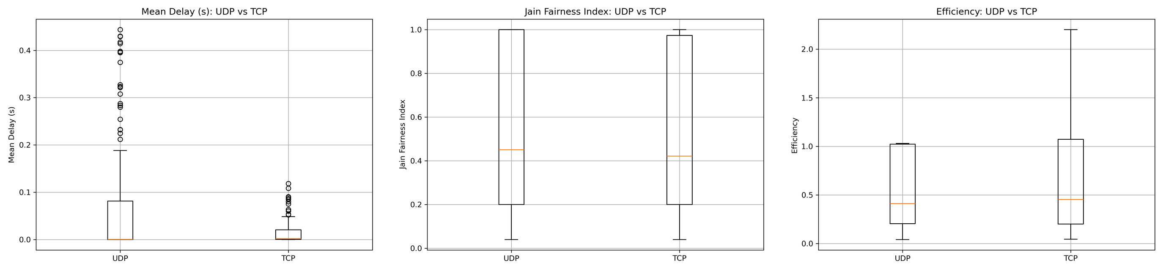
Figure 3. Final distributions of mean delay, Jain fairness and throughput-to-offered-load efficiency.
Individual efficiency values may exceed one because the configured offered load represents application payload rate, whereas FlowMonitor throughput is calculated from received IP bytes over the actual flow interval. The indicator is therefore used comparatively, not as a strict spectral or energy efficiency measure.

5.3 Reliability under density and distance
Figure 4 visualizes PDR jointly across station count and distance. UDP over IEEE 802.11ax with LogDistance degrades from values near one in sparse and short-range cells to approximately 0.04 in the 50-station, long-distance region. TCP over the same radio configuration remains near 0.99 because lost segments are recovered or sending is reduced. However, the associated throughput and fairness results confirm that the channel remains severely constrained.
The IEEE 802.11g Friis-Nakagami comparison shows the same distinction. UDP reliability decreases strongly with density and distance under fading, while TCP preserves effective delivery close to one. This is a transport-layer outcome and must not be interpreted as elimination of multipath fading.
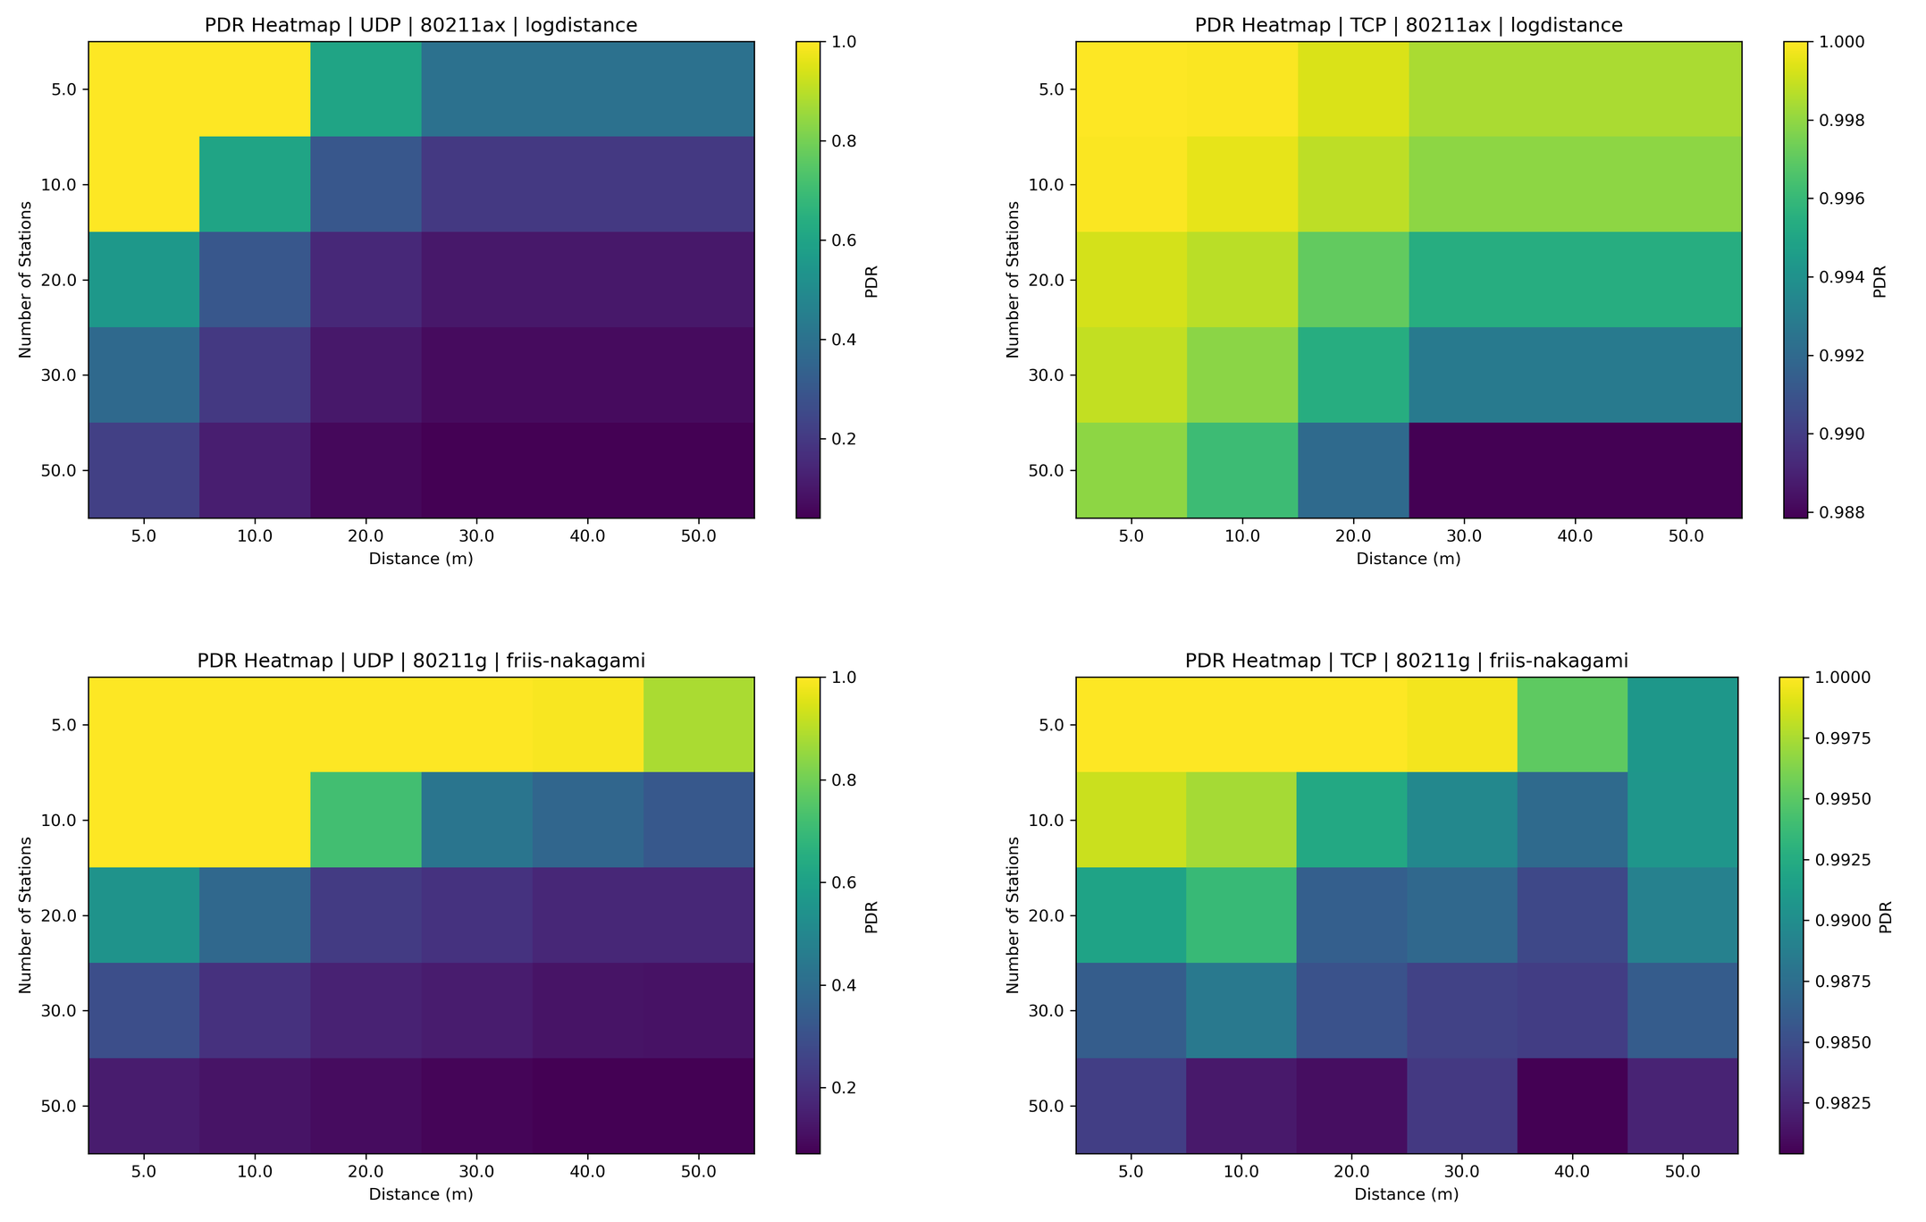
Figure 4. Selected final PDR heatmaps: UDP and TCP under IEEE 802.11ax LogDistance and IEEE 802.11g Friis-Nakagami.

5.4 Throughput capacity surfaces
The throughput heatmaps in Figure 5 show that favourable Friis propagation permits high aggregate capacity, particularly for IEEE 802.11ax. As station count rises, aggregate throughput can initially increase because more sources contribute traffic, but the benefit saturates and the per-station share falls. Under Friis-Nakagami, TCP throughput is more conservative than UDP in several dense cells because TCP reacts to losses and delay, whereas UDP keeps transmitting at the configured rate.
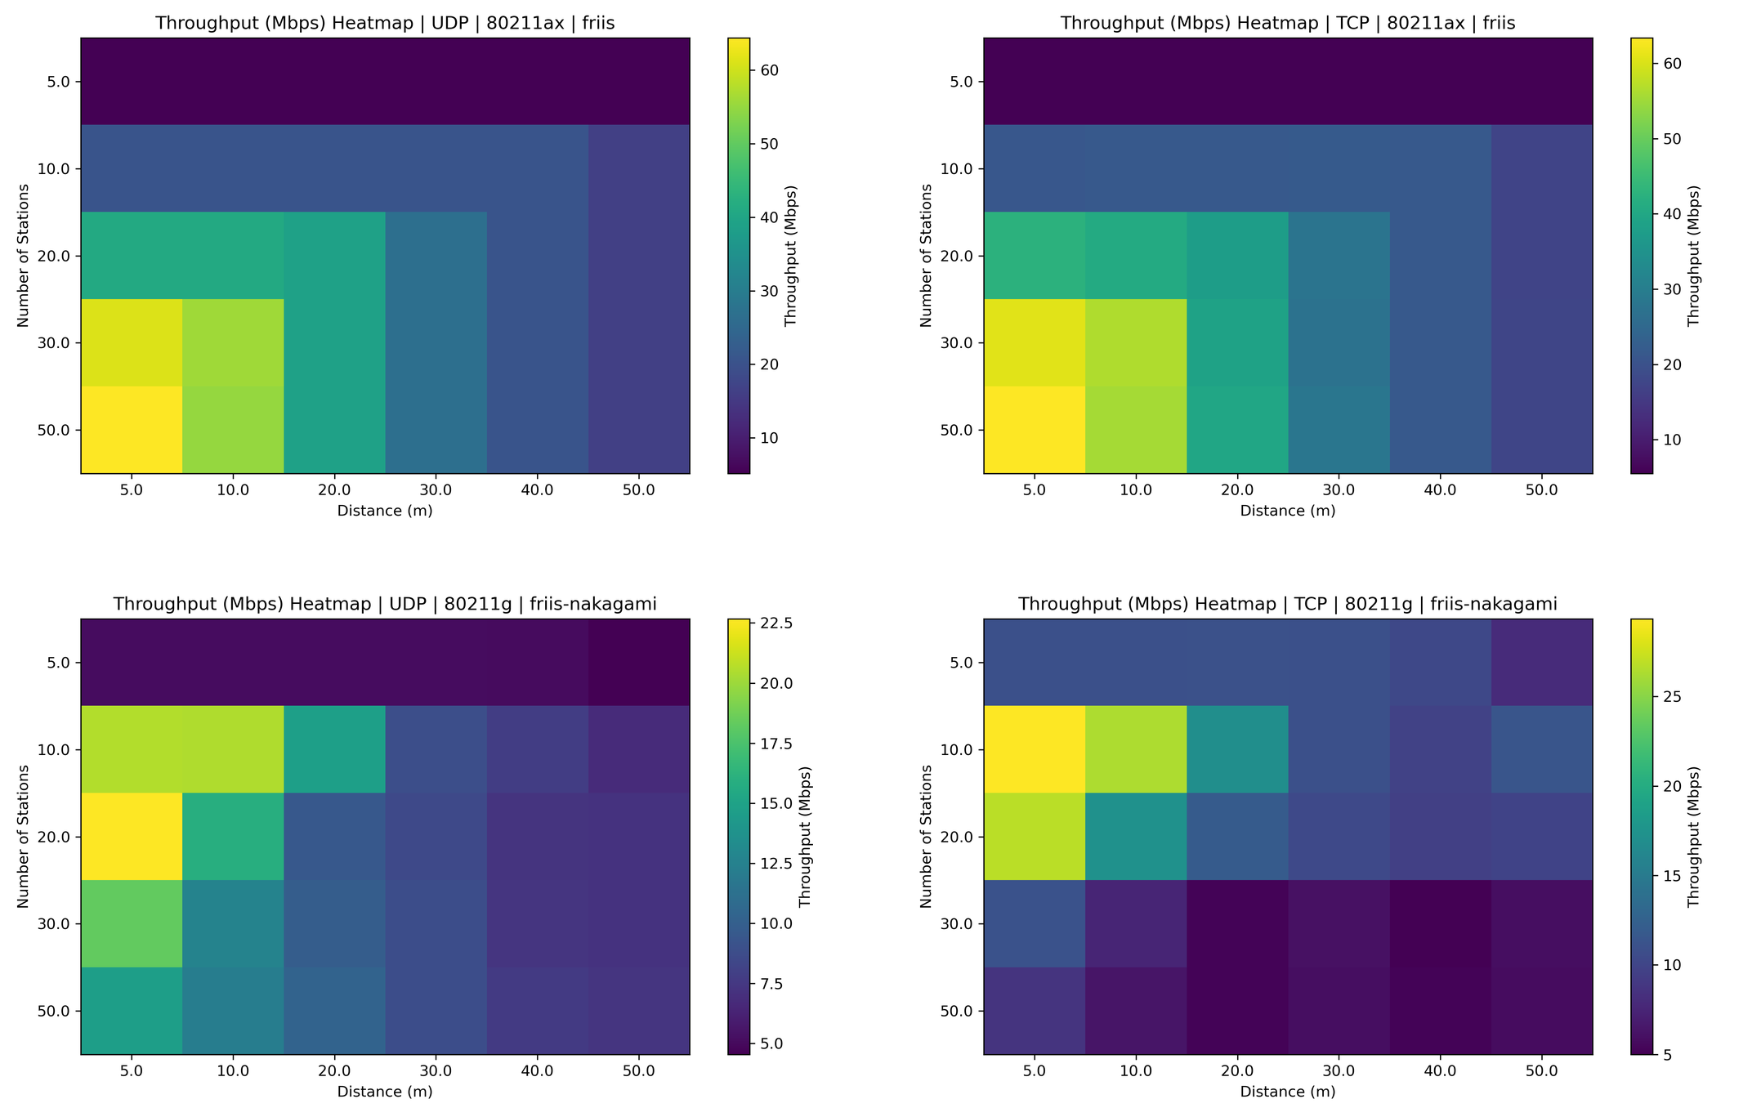
Figure 5. Selected final throughput heatmaps for favourable Friis and fading Friis-Nakagami conditions.

6. Discussion

6.1 Effect of propagation
Friis produced the most favourable capacity because received power decreases according to an unobstructed free-space law. LogDistance introduced stronger deterministic attenuation and sharply reduced the number of stations that could sustain useful throughput. Friis-Nakagami added fast fading, producing greater variability and making transport adaptation relevant. The results support the physical chain expressed in Section 3: larger path loss reduces received power and SNR, increases frame errors, lowers PDR and useful throughput, and may alter delay through retransmission, queueing or flow adaptation.

6.2 Effect of node density
Increasing density has two simultaneous effects. First, offered load grows because each station generates traffic. Second, contention grows because all stations share the same medium. Aggregate throughput can therefore increase at low-to-moderate density before saturating, while throughput per node and Jain fairness decline. This explains why a scenario can show reasonable aggregate throughput but poor user experience for individual stations.

6.3 UDP versus TCP
UDP is the clearer indicator of intrinsic network loss because it does not retransmit. Its PDR falls under distance, fading and density, directly exposing the WLAN limitations. TCP trades transmission aggressiveness and overhead for recovery. It achieved near-unity effective PDR, but not uniformly higher throughput: under IEEE 802.11ax Friis-Nakagami, TCP mean throughput was approximately 14.7% lower than UDP. In severe LogDistance conditions, TCP improved useful delivery and sometimes throughput, but fairness remained low. Therefore, protocol selection depends on application requirements rather than on a single ranking.

6.4 IEEE 802.11g versus IEEE 802.11ax
The highest capacity results were obtained with the configured 802.11ax mode, particularly under Friis. Nevertheless, superiority was not universal across every propagation and transport combination. Differences in configured PHY behaviour, rate adaptation, contention and application load can produce cases in which 802.11g shows higher mean efficiency or throughput per station. The conclusion is therefore that 802.11ax offers a stronger capacity ceiling in favourable conditions, while propagation and contention still dominate in degraded environments.

6.5 Interpretation of delay
Delay must be read jointly with PDR and throughput. A low delay value may result from a lightly loaded or congestion-controlled flow, but it may also occur because only a limited subset of packets or stations contributes to the measured sample. The very low LogDistance delay values are therefore not evidence of superior service; they coexist with low throughput and low fairness. The best operating region requires simultaneously high PDR, useful throughput, acceptable delay and adequate fairness.

7. Threats to Validity and Limitations
- Only three seeds were scheduled per scenario; this is suitable for preliminary confidence intervals but more repetitions would improve statistical power.
- Seven runs failed because of internal ns-3/cppyy segmentation errors, leaving some groups with fewer observations.
- The topology uses static stations and a single AP; mobility, obstacles, co-channel interference and multiple BSSs were not included.
- Advanced 802.11ax OFDMA scheduling, explicit MU-MIMO/spatial streams and channel-width sweeps were not configured.
- TCP results depend on the selected ns-3 TCP implementation, application pattern and data-only flow filtering.
- The efficiency indicator compares IP-layer throughput with nominal application offered load and is not a direct PHY spectral-efficiency measure.

8. Conclusions
This study implemented and executed a reproducible ns-3 framework for comparing UDP and TCP over IEEE 802.11g and IEEE 802.11ax under three propagation models, five station densities, six distances and three random seeds. The 1,080-run design produced 1,073 valid raw outputs and 360 grouped protocol scenario cells for final comparison.
The main finding is that no single metric is sufficient. TCP produced effective PDR close to one across all global combinations, but this reliability was achieved through transport recovery and adaptation rather than an improved radio channel. UDP exposed the underlying propagation and contention losses, with PDR falling to approximately 0.30 on average under LogDistance. IEEE 802.11ax reached the highest mean throughput under Friis, but fading and dense contention continued to reduce throughput and fairness. Under IEEE 802.11ax Friis-Nakagami, UDP retained greater mean throughput than TCP, illustrating the cost of congestion response in a variable channel.
For real-time applications that can tolerate loss, UDP can minimize protocol mechanisms and expose raw channel behaviour. For applications prioritizing reliable delivery, TCP offers strong recovery but can reduce sending pressure or capacity under adverse conditions. Network design should therefore jointly consider transport protocol, station density, propagation environment and fairness. Future work should add larger seed sets, mobility, multiple access points, interference, explicit 802.11ax OFDMA/MU-MIMO configurations, channel-width variations and TCP congestion-control comparisons.

References
[1] IEEE, IEEE Std 802.11-2020, IEEE Standard for Information Technology - Telecommunications and Information Exchange Between Systems - Local and Metropolitan Area Networks - Specific Requirements - Part 11: Wireless LAN MAC and PHY Specifications, 2021.
[2] IEEE, IEEE Std 802.11g-2003, Further Higher Data Rate Extension in the 2.4 GHz Band, 2003.
[3] IEEE, IEEE Std 802.11ax-2021, Enhancements for High-Efficiency WLAN Operation, 2021.
[4] ns-3 Project, Wi-Fi Design Documentation and Propagation Model Library, ns-3 Model Library.
[5] J. Postel, User Datagram Protocol, RFC 768, Internet Standard, Aug. 1980.
[6] W. Eddy, Ed., Transmission Control Protocol (TCP), RFC 9293, Internet Standard, Aug. 2022.
[7] ns-3 Project, Flow Monitor Model Library and FlowStats Documentation.
[8] H. T. Friis, “A Note on a Simple Transmission Formula,” Proceedings of the IRE, vol. 34, no. 5, pp. 254-256, May 1946.
[9] R. Jain, D. Chiu, and W. Hawe, “A Quantitative Measure of Fairness and Discrimination for Resource Allocation in Shared Computer Systems,” DEC Research Report TR-301, 1984.
[10] M. Nakagami, “The m-Distribution - A General Formula of Intensity Distribution of Rapid Fading,” in Statistical Methods in Radio Wave Propagation, Pergamon Press, 1960.
[11] G. Bianchi, “Performance Analysis of the IEEE 802.11 Distributed Coordination Function,” IEEE Journal on Selected Areas in Communications, vol. 18, no. 3, pp. 535-547, Mar. 2000.

