Question 1

1. **Identify the problem and obtain approval**
   1. First meet the principal of the university -4 hours
   2. Meet some lectures -3 hours
2. **Plan and monitor the project**

2.1 Develop or Build up a project characterizing every one of the requirements of the university 7 hours

2.2 Make a project group to do the assignment given by the University1hours

2.3 Appoint everybody to his/her activity or task of the project – 3hours

2.4 Decide a calendar, where the project group will hold fast to all an opportunity to check on the off chance that they are on timetable – 3hours

**3.)** **Discover and understand details**

**4.)** **Design system components**

4.1 Design screens, yield screens and reports – 10 hours

4.2 Design a database – 9hours

4.3 Design in general engineering - 5 hours

4.4 Design program details – 8 hours

**5.) Build, test and integrate system components**

5.1 Code and unit test GUI layer programs – 14 hours

5.2 Code and unit test logic layer programs – 5 hours

**6.) Complete system tests and deploy solution**

6.1 Perform system functionality test – 4 hours

6.2 Perform Blunder taking care of test and investigating – 6hours

6.3 Perform user acceptance – 7 hours

**Satzinger, J., 2018. *System analysis and design*. 7th ed. Mexico: Cengage learning**

Question 2

<https://www.surveymonkey.com/create/?sm=CpRTgXMVSfbzoOXo2cLOA_2B6hLS_2FOLjSrEf_2BBrMxrKhs_3D>

Open ended Question

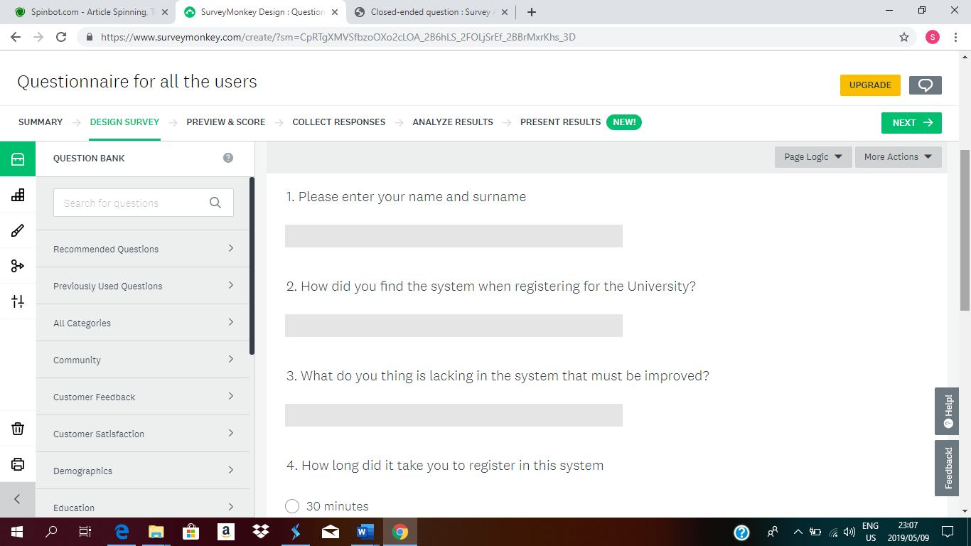

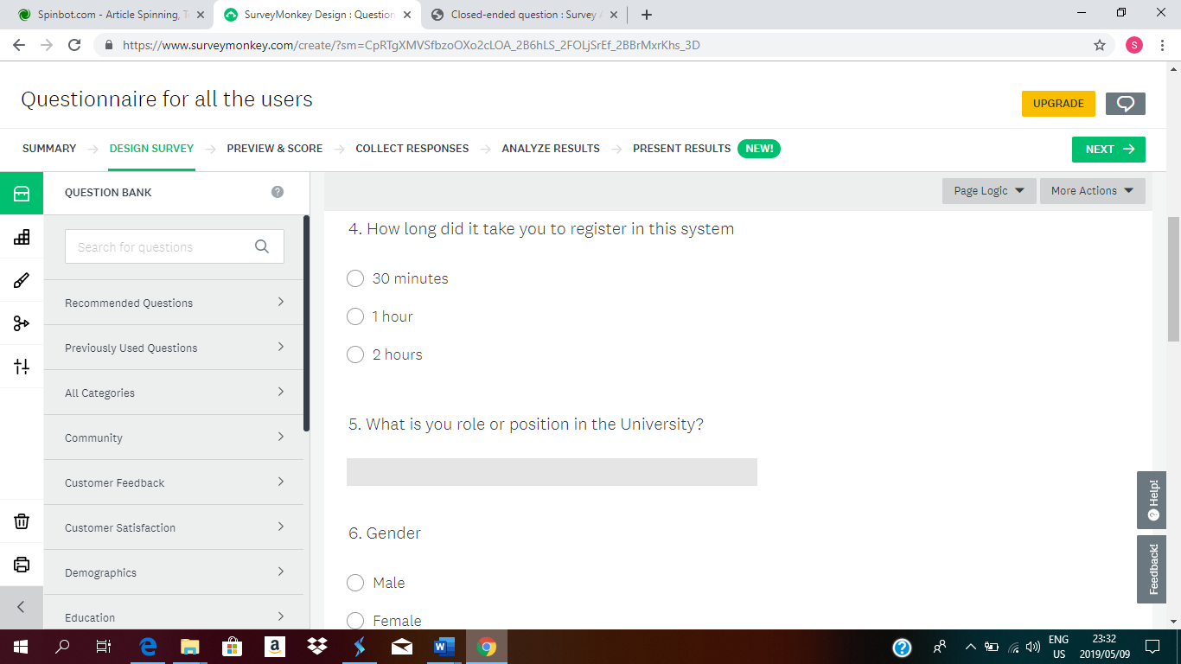

Closed ended question (From Question 6)

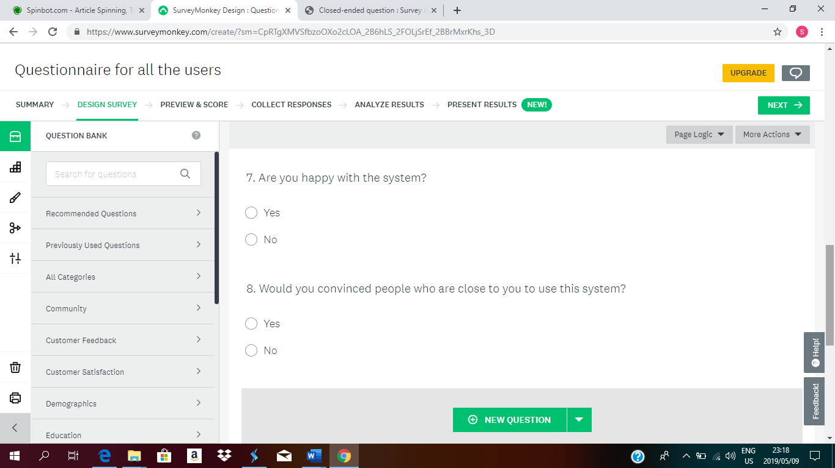

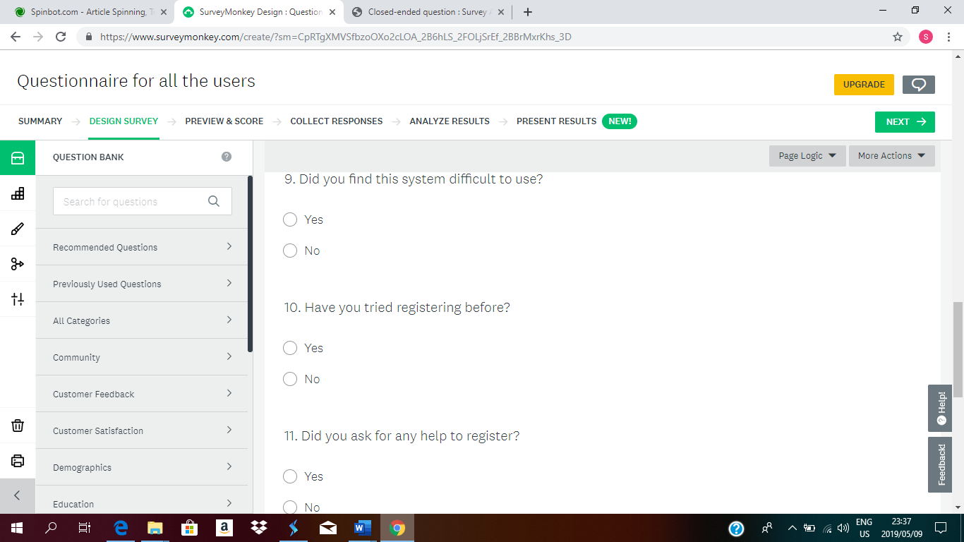

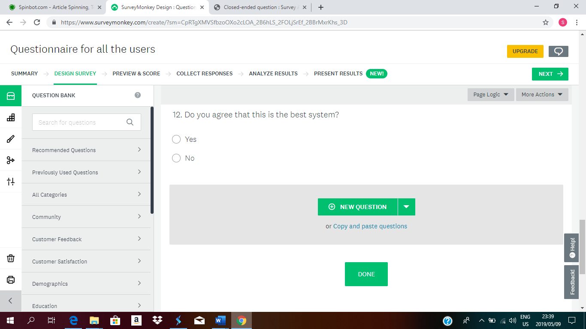

Question 3

View marks

Library

Register



Welcome to University of Mpumalanga

N









Forget password?

Password

Username

 

 

Cancel

;

Save

Register

Cancel

 

Name

Surname

Date of birth

Course

Gender

Registration type

Year

Create username

Password  
 Confirm Password

  

Library

View previous papers

Order books

 



View marks

DATABASE 78%

COAR 80%

FIMA 65%

SAND 67%

 



Question 4

A password is an essential security instrument that comprises of a mystery pass express made utilizing alphabetic, numeric, alphanumeric and representative characters, or a mix. A secret word is utilized to limit access to a framework, application or administration to just those clients who have remembered or put away as well as are approved to utilize it. A password may likewise be called an entrance code, PIN or mystery code

1. The **Minimum password length of the password is** a value of between 1 and 14 characters. It must include a lowercase uppercase alphabetic characters, numbers and symbols if permitted.
2. The span of the password is actually 3 months, the system will send an sms or an email that the password is about to expire and it requires you not to use the previous password but a new and a totally different one for safety purposes. A reason why a password must be changed every3 months is that some people can find it easy to hack your password.
3. Changed at least every 90 days and must between 8 and 128 characters long and must use at least 3 of the following types of characters: (a) uppercase letters, (b) lowercase letters, (c) numbers, and/or (d) special characters. Password must be unique and cannot be re-used.

<https://century.custhelp.com/app/answers/detail/a_id/511/~/what-is-a-complex-password%3F>

<https://docs.microsoft.com/en-us/windows/security/threat-protection/security-policy-settings/minimum-password-length>

Question 5