第八章 联接查询和分组查询
- 复习
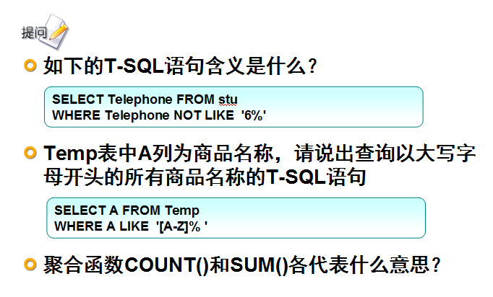
- 本章任务
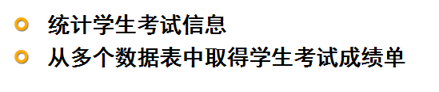
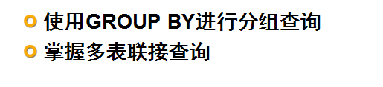
- 授课内容
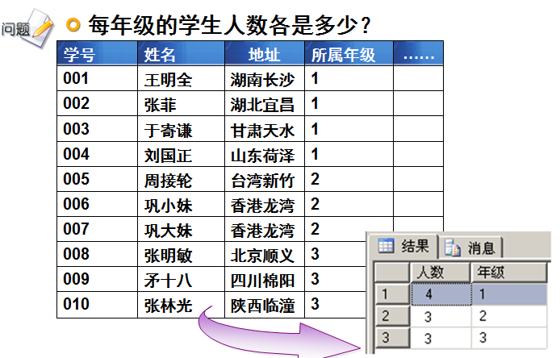
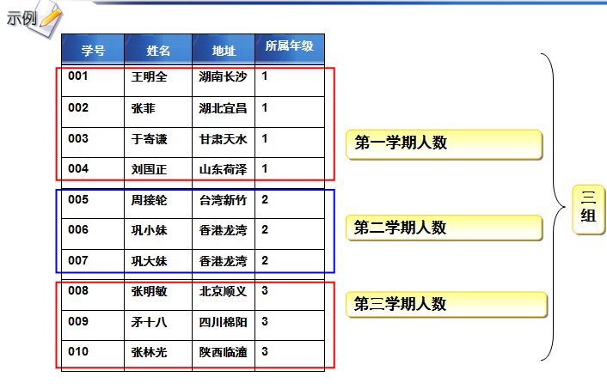
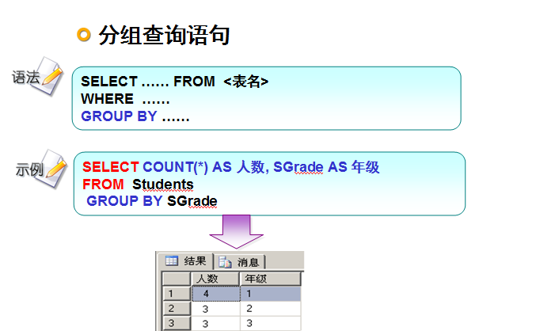

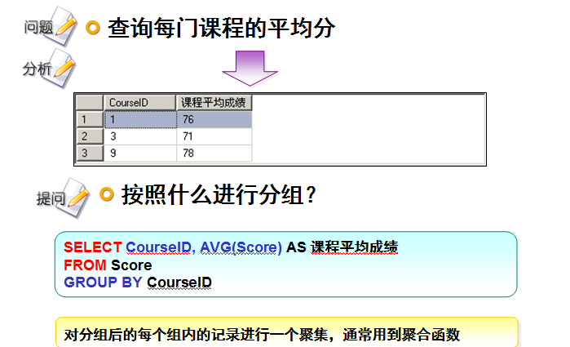

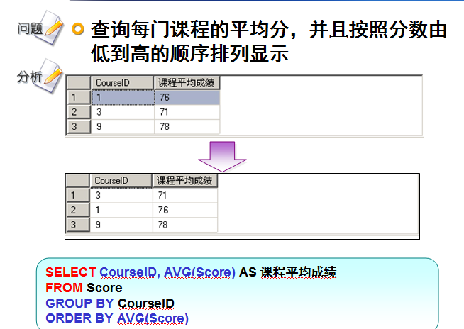

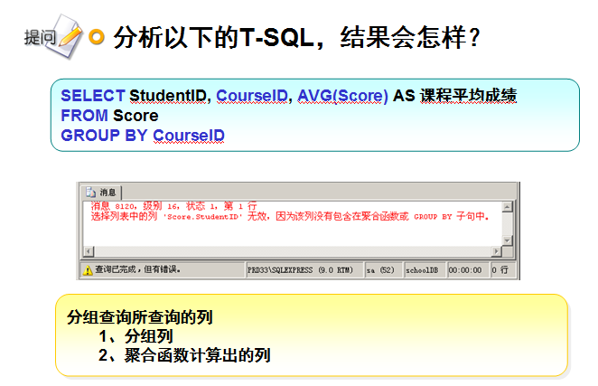

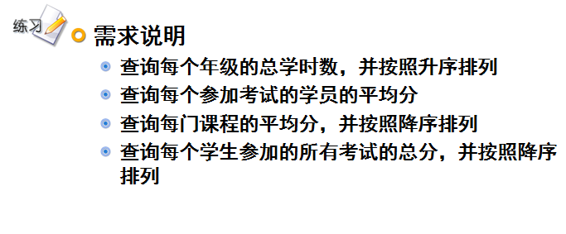
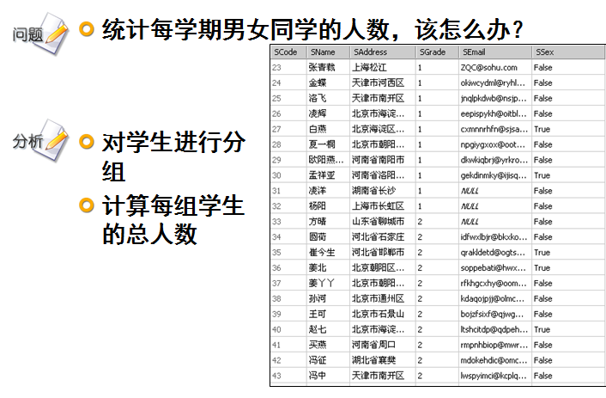
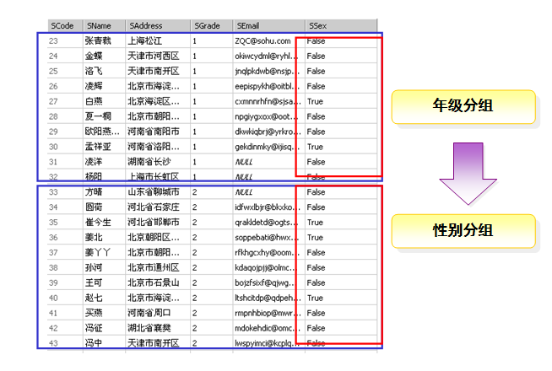
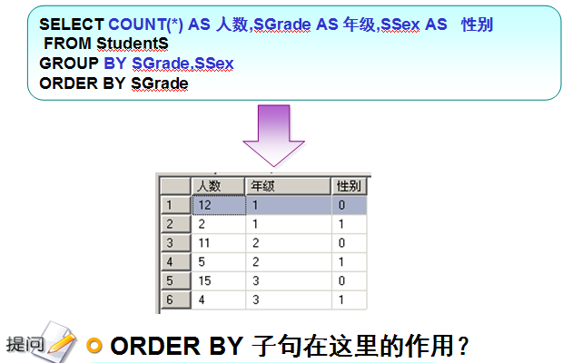

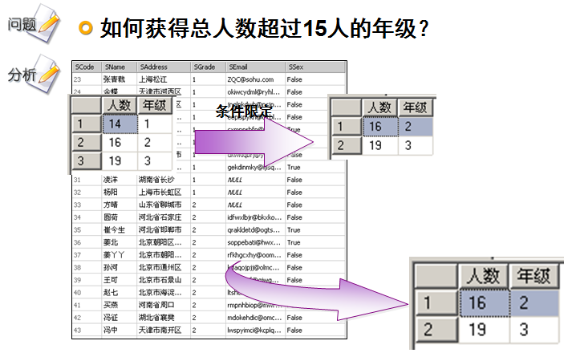

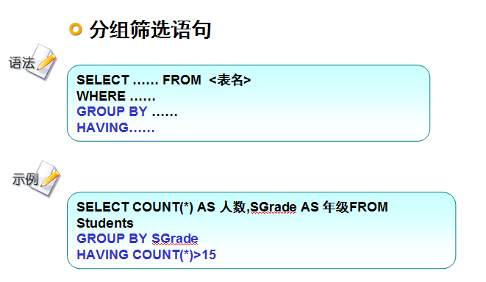

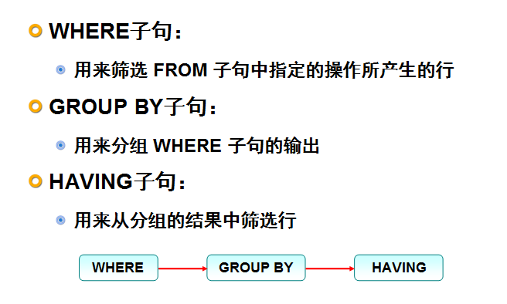
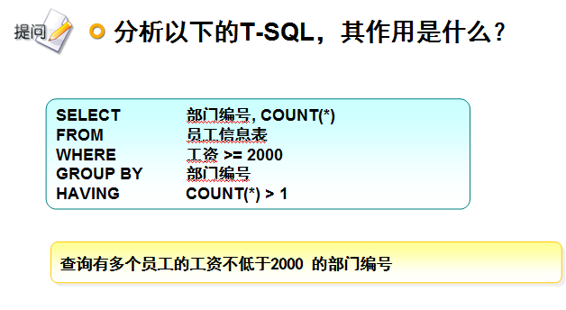
上机练习：
- 统计不同年级的超过18岁的学生人数
select count(*),g.gradeid
from student s,grade g
where ((to_days(sysdate())-to_days(s.BIRTHDATE)))/365>=25
and s.GRADEID=g.GRADEID
group by g.gradeid;

- 统计不同年级的至少一次在60-70之间的学生人数
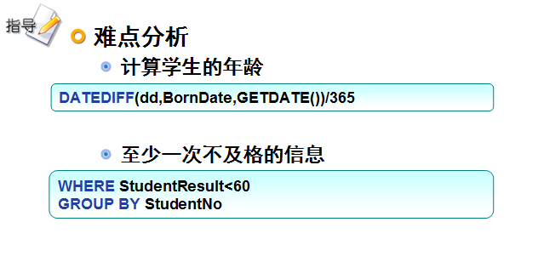

联合查询
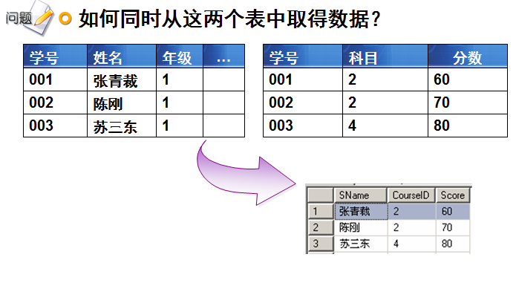
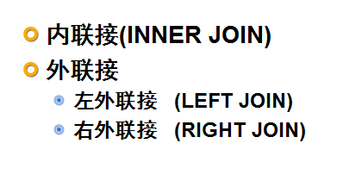
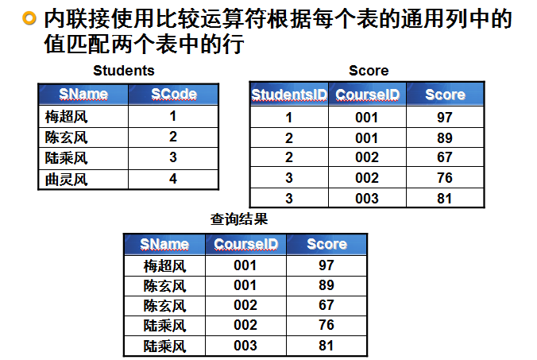
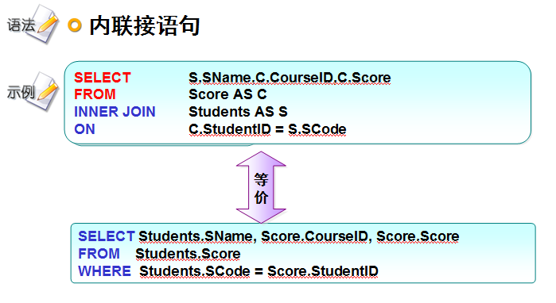
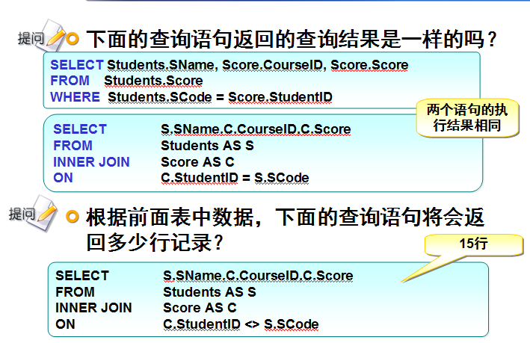
上机练习：
- 查询学生的姓名、性别、所在的年级名称，参加的考试科目和对应的分数。

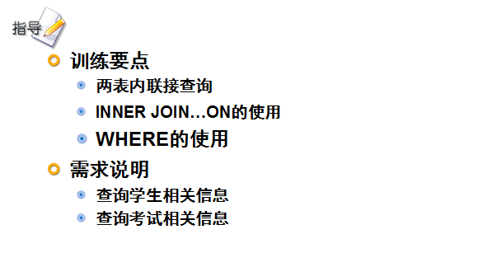
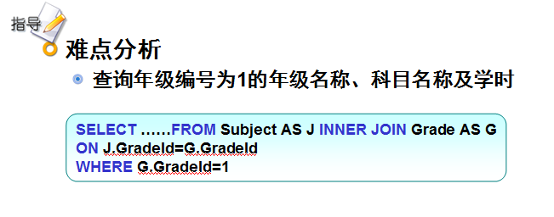
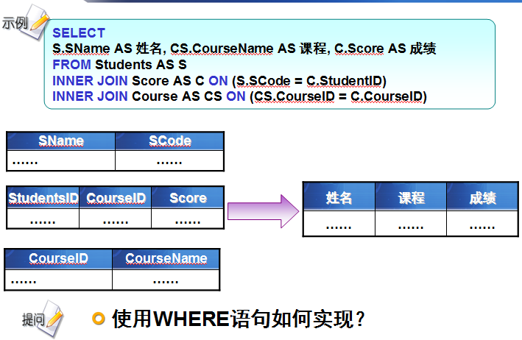
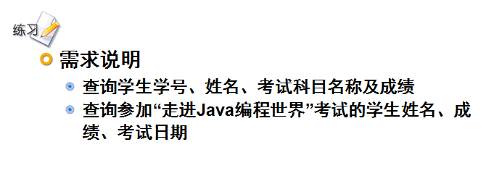
左外联接
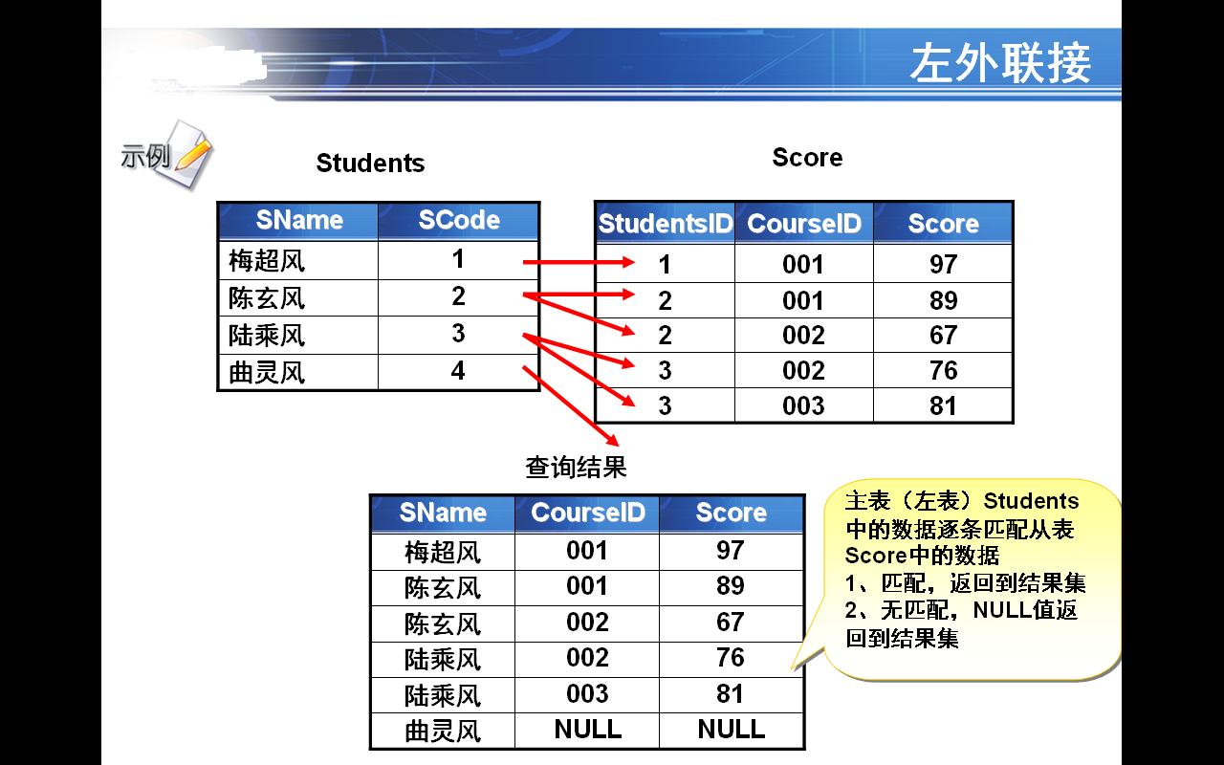

SELECT S.SName,C.CourseID,C.Score
FROM Students AS S
LEFT JOIN Score AS C
ON C.StudentID = S.SCode

右外联接
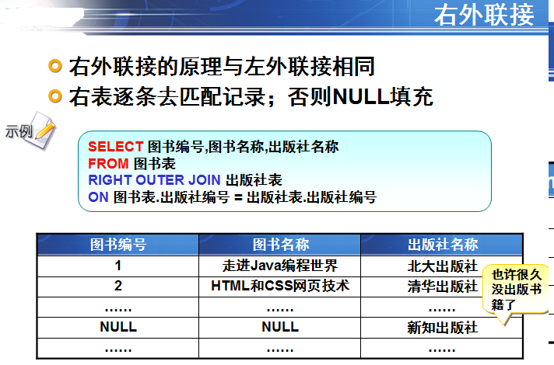

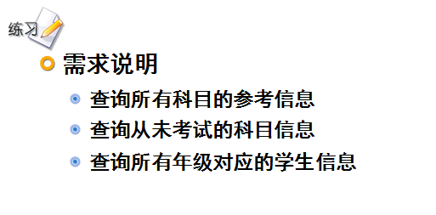
SELECT J.SubjectName AS 科目名称,R.StudentNo AS 学号,R.score AS 分数
FROM Result AS R
RIGHT OUTER JOIN Subject AS J
ON J.SubjectId=R.SubjectId;

--查询没有被考过的科目信息。

SELECT J.SubjectName AS 科目名称
FROM Result AS R
RIGHT OUTER JOIN Subject AS J
ON J.SubjectId=R.SubjectId
WHERE R.score IS NULL AND R.StudentNo IS NULL
--所有年级对应的学生信息（需要考虑某些年级可能还没有学生就读）
SELECT G.GradeName AS 年级, S.StudentNo AS 学号,S.name AS 姓名
FROM Grade AS G
LEFT OUTER JOIN Student AS S
ON G.GradeId=S.GradeId;

SELECT G.GradeName AS 年级, S.StudentNo AS 学号,S.Name AS 姓名
FROM Student AS S
RIGHT OUTER JOIN Grade AS G
ON G.GradeId=S.GradeId
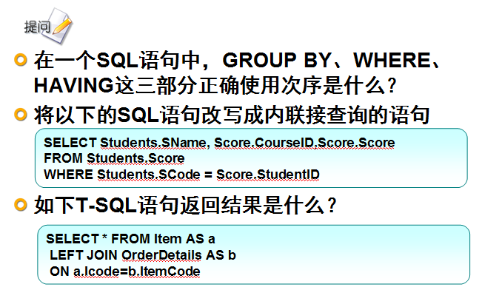
全外联接查询
--全外联接查询
select studentname,studentresult
from student
full join result
on student.studentno=result.studentno
use czf;

