第九章 高级查询
- 本章任务
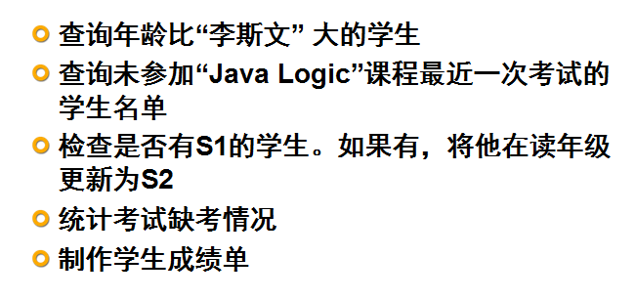
- 本章目标
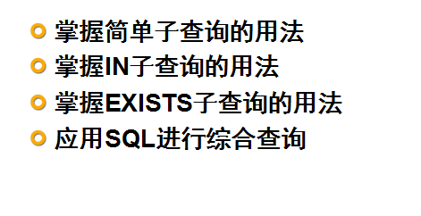
- 什么是子查询
3．1
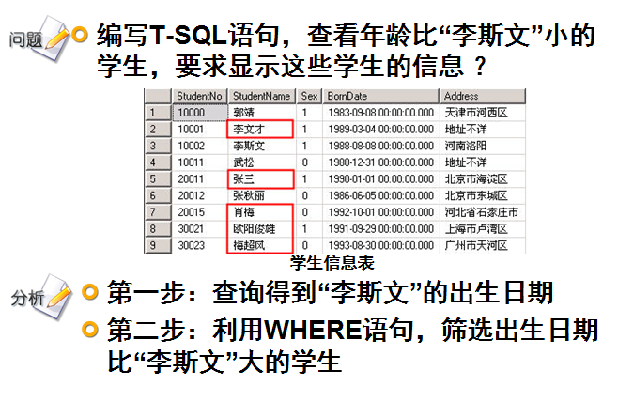
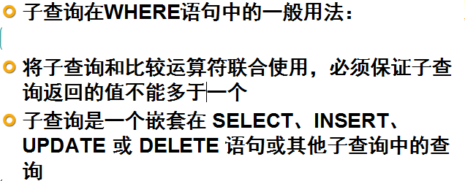
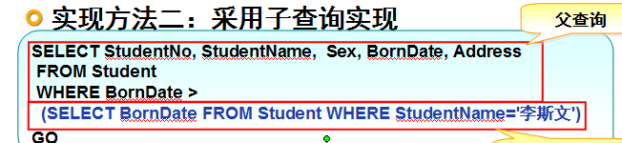
3．2 使用子查询替换表联接
- 查询“Java Logic”课程至少一次考试刚好等于60分的学生
先用表联接查询
SELECT stu.name FROM Student stu
INNER JOIN Result r ON stu.StudentNO = r.StudentNo
INNER JOIN Subject sub ON r.Subjectid = sub.Subjectid
WHERE r.score = 60 AND sub.SubjectName = 'Java Logic'
再用子查询：
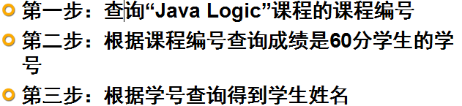
SELECT StudentName FROM Student WHERE StudentNo = (
SELECT StudentNo FROM Result
INNER JOIN Subject ON Result.SubjectNo= Subject.SubjectNo
WHERE StudentResult=60 AND SubjectName='Java Logic'
)
子查询和联合查询的区别：
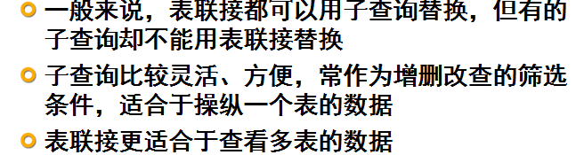
上机练习：
  - 查询参加最近一次“C# OOP”考试成绩最高分和最低分
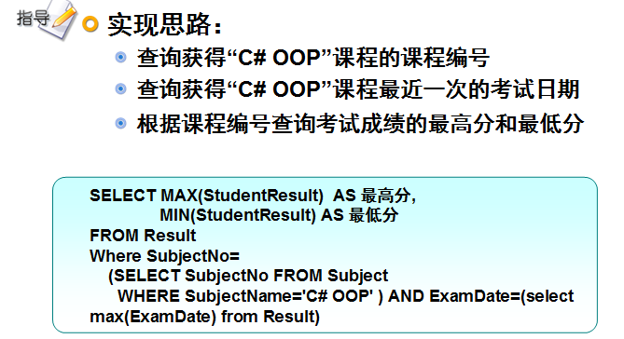
3.3 IN子查询
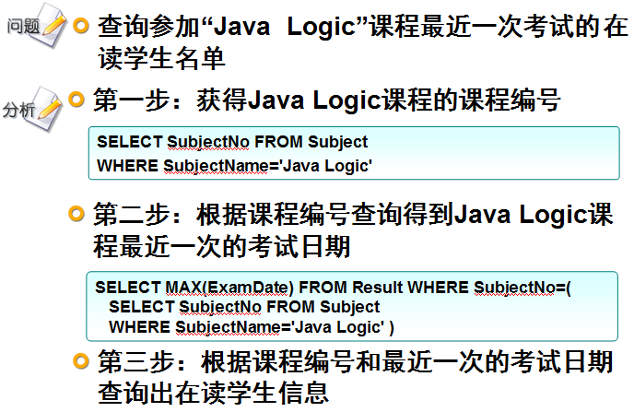
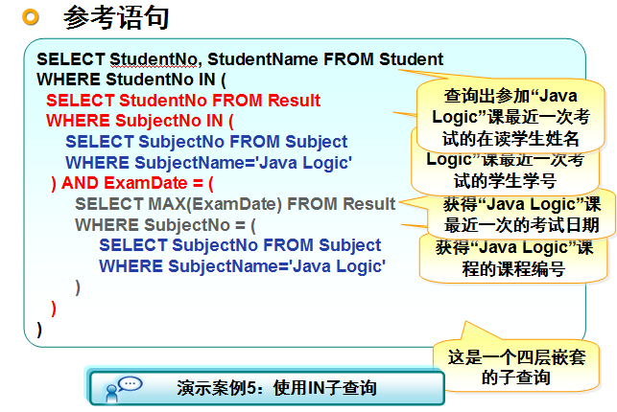
上机练习：
  - 查询S1学期开设的课程
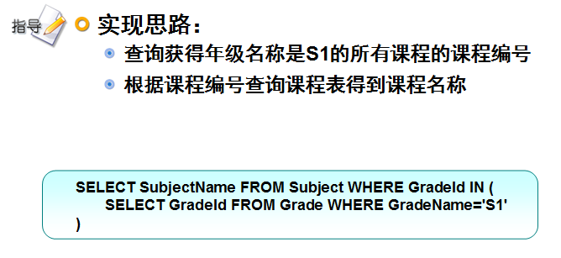
3.4 not in
- 查询未参加“Java Logic”课程最近一次考试的在读学生名单
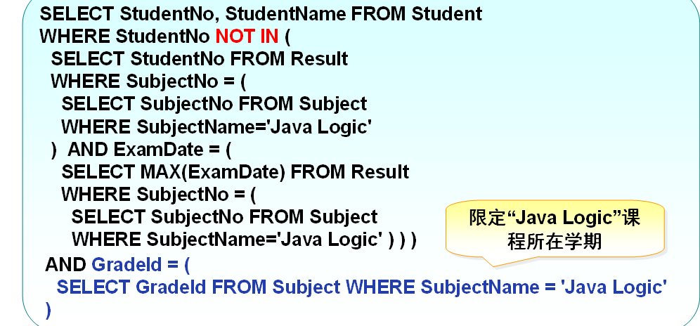
上机练习：
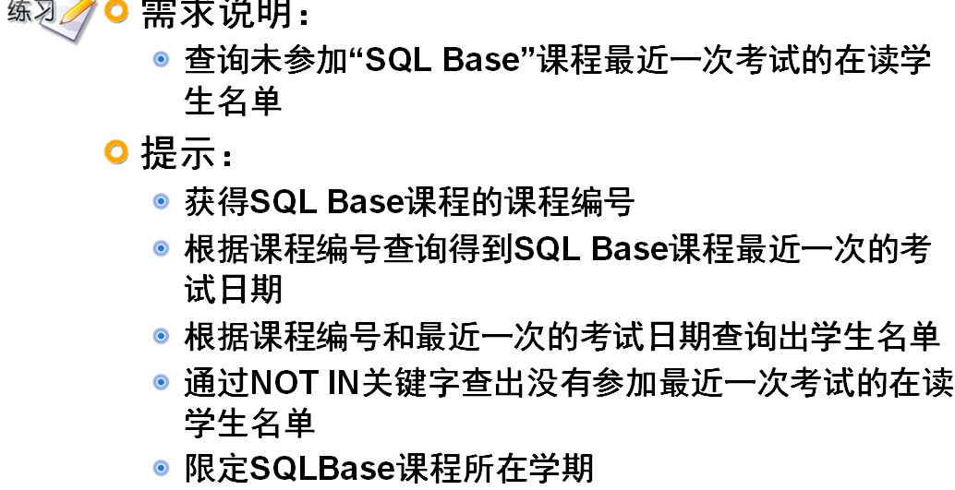

SELECT StudentName FROM Student
WHERE StudentNo NOT IN (
SELECT StudentNo FROM Result
WHERE SubjectNo = (
SELECT SubjectNo FROM Subject
WHERE SubjectName='SQL Base'
)
AND ExamDate = (
SELECT MAX(ExamDate) FROM Result
WHERE SubjectNo =(
SELECT SubjectNo FROM Subject
WHERE SubjectName='SQL Base' )
)
)
AND GradeId = (
SELECT SubjectNo FROM Subject
WHERE SubjectName='SQL Base'
)

查询综合练习：
select * from student;
-- 1 查询年龄比杜平小的学生信息
select *
from student
where birthdate>(select birthdate from student where name='杜平');
-- 2 查看和曾小胖在同一个年级的学生信息
select *
from student where gradeid=( select GRADEID from student where name='曾小胖');
-- 3、查询“Java”课程至少一次考试刚好等于83分的学生
select * from result;
-- 方法一:自然连接查询
select *
from STUDENT,result,subject
where student.studentno=result.STUDENTNO and result.subjectid=subject.SUBJECTID
and result.score=83 and subject.subjectname='java';
-- 方法二： 内连
select *
from student
inner join result
on student.studentno=result.STUDENTNO
inner join subject
on result.subjectid=subject.SUBJECTID
where result.score=83 and subject.subjectname='java';
-- 方法三:子查询
select *
from student
where STUDENTNO in (
select studentno from result
where score=83 and subjectid=(select subjectid from subject where subjectname='java')
);
select * from result;
-- 4、查询参加最近一次“java”考试成绩最高分和最低分
select max(score),min(score)
from result
where EXAMEDATE=(select max(examedate) from result where subjectid=(select subjectid from subject where subjectname='java')
) and subjectid=(select subjectid from subject where subjectname='java');

select max(score),min(score)
from result
where subjectid=(select subjectid from subject where subjectname='java')
and examedate=(select max(examedate)
from result where subjectid=(select subjectid from subject where subjectname='java'));

-- 5 查询参加最近一次“java”考试学生信息
select *
from STUDENT
where studentno in(
select studentno from result where subjectid=(select SUBJECTID from subject where subjectname='java')
and examedate=(select max(examedate) from result where subjectid=(select SUBJECTID from subject where subjectname='java'))
);
-- 6 查询S28开设的课程
select *
from subject
where gradeid =(select gradeid from grade where gradename='S28');

-- 7 查询没有参加最近一次“java”考试学生信息
select *
from STUDENT
where studentno not in(
select studentno from result where subjectid=(select SUBJECTID from subject where subjectname='java')
and examedate=(select max(examedate) from result where subjectid=(select SUBJECTID from subject where subjectname='java'))
);

