Prediction Maintance on Commercial Aircraft Engines

Predictive maintenance is increasingly vital in the aviation industry for ensuring safety, reducing downtime, and cutting costs. This report outlines the implementation of Deep Convolutional Neural Networks (DCNN) for predicting the Remaining Useful Life (RUL) of commercial aircraft engines, using time series data collected from sensors installed within the engines. The approach leverages advanced machine learning techniques to analyze sensor data, providing a reliable forecast of maintenance needs.

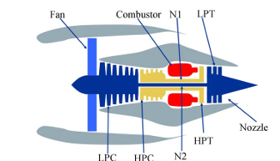

**INTRODUCTION**

Aircraft engines are complex systems with a critical need for timely and efficient maintenance. Traditional maintenance strategies, like scheduled and reactive maintenance, are often costly and inefficient. Predictive maintenance, which uses data analysis to predict when maintenance should be performed, presents a more effective alternative.

**KEY POINTS:-**

Raw sensor data conversion to CSV: This is a common initial step in data processing. Converting raw sensor data into a Comma-Separated Values (CSV) file format makes it easier to handle, visualize, and process using various data analysis and machine learning tools.

Data preprocessing: The mentioned preprocessing steps, including normalization, handling of missing values, and transformation for DCNN input, are standard and essential for preparing data for machine learning models, including Deep Convolutional Neural Networks (DCNNs).

DCNNs for time series data: DCNNs are more commonly associated with image and video processing due to their ability to extract spatial hierarchies of features. For time series data, one-dimensional convolutional neural networks (1D CNNs) or Recurrent Neural Networks (RNNs) and their variants like Long Short-Term Memory (LSTM) networks are typically more adept. However, DCNNs can be applied to time series data by treating the data as a one-dimensional image, but this isn't their most common application. DCNNs have multiple layers capable of extracting and learning features from data, including sensor data. The architecture is designed to automatically and adaptively learn spatial hierarchies of features from the data.

Random Forest :- Random Forest is generally accurate. It is a versatile machine learning algorithm used for both classification and regression tasks. Its main advantages include high accuracy, robustness to noise and outliers, capability to identify feature importance, and reducing overfitting by averaging multiple decision trees. However, the statement that Random Forest is particularly used for time series data processing or that it's the best choice for predicting Remaining Useful Life might be misleading. While Random Forest can be used for such tasks, the choice of algorithm depends on the specific characteristics of the data and the problem. Time series forecasting problems, especially those like predicting RUL, might benefit from other approaches as well, including specialized time series models or deep learning models mentioned previously.

**IMPLEMENTATION**

The model can be integrated into existing aircraft maintenance systems, providing real-time RUL predictions and alerts for necessary maintenance actions.

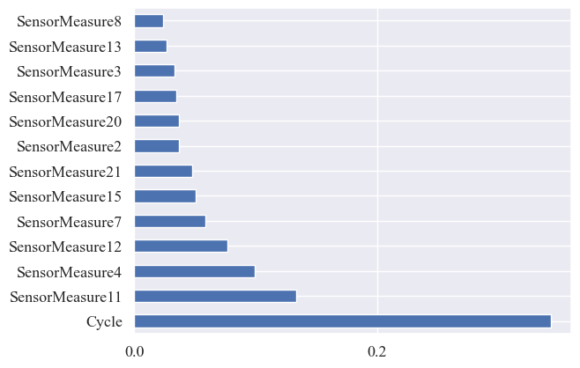

RANDOM FOREST ALGORITHM

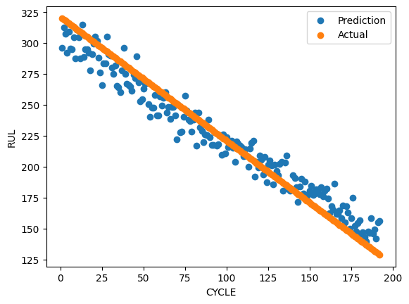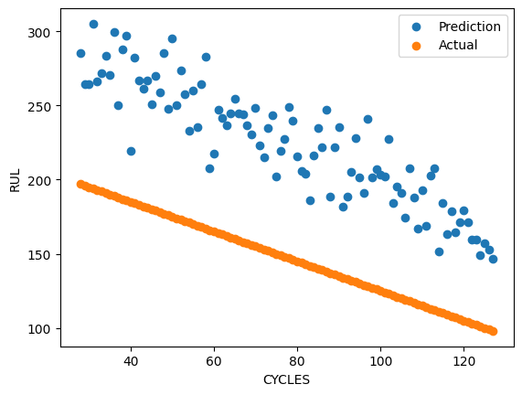

RMSE on Train set: 18.645849369830888 RMSE on Test set: 49.321371410911325

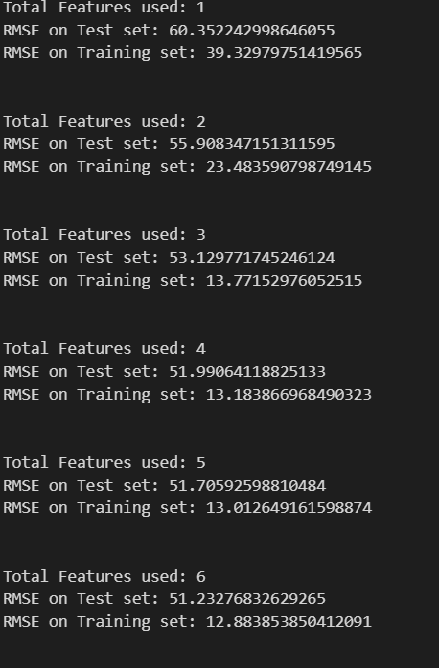 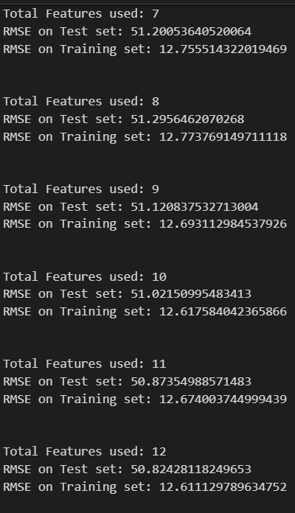

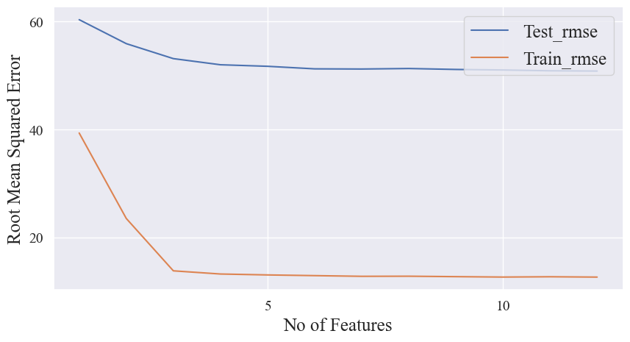

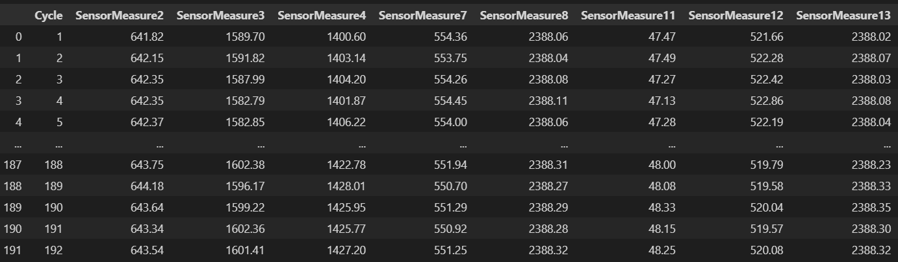

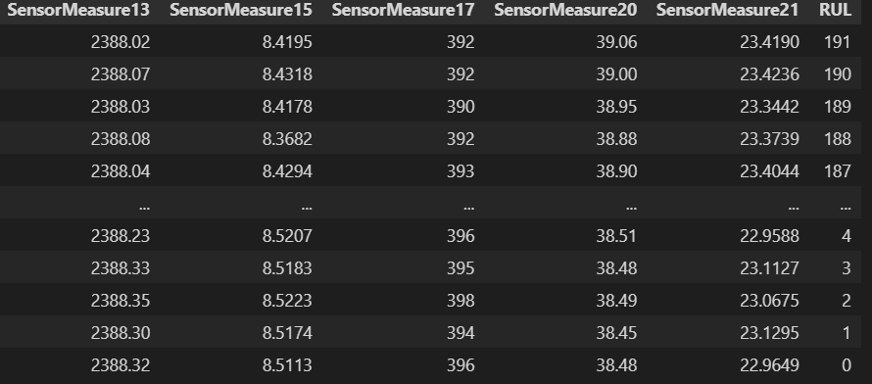

**DEEP CONVOLUTIONAL NEURAL NETWORKS(DCNNs)**  
Deep Convolutional Neural Networks (DCNNs) are used for predicting the Remaining Useful Life (RUL) of turbo engines due to their ability to automatically extract and learn the most predictive features from raw sensor data.

First Convolutional Layer:

Model .add(Conv2D(filters=64, kernel _size=3, activation=' relu', input_ shape=(win_ length, feature_ num , 1))) adds the first 2D convolutional layer to the model.

filters=64 specifies that this layer will have 64 output filters in the convolution.

kernel_ size=3 sets the height and width of the 2D convolution window to 3x3.

activation= 'relu ' uses the Rectified Linear Unit function as the activation function, introducing non-linearity to the model, allowing it to learn more complex patterns.

input_ shape=(win_ length, feature_ num, 1) defines the shape of the input data. Here, win _length = 25 and feature_ num = 13 indicate that each input sample is a 25x13 matrix with a single channel (e.g., a window of 25 time steps and 13 features per time step).

Second Convolutional Layer:

model. add(Conv2D(filters=32, kernel_ size=3, activation= 'relu')) adds another 2D convolutional layer, this time with 32 filters. The kernel size and activation function are the same as in the first convolutional layer. This layer will further process the features extracted by the first layer.

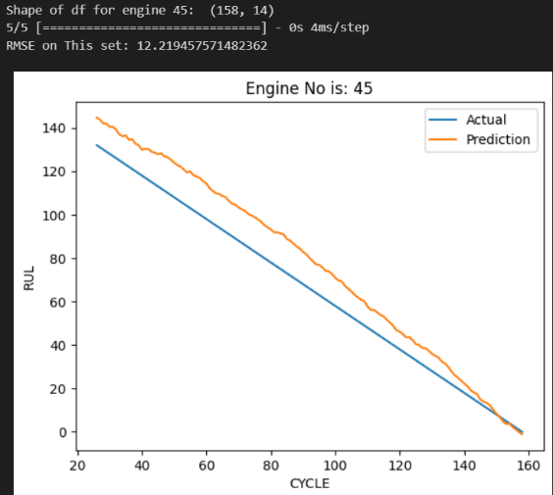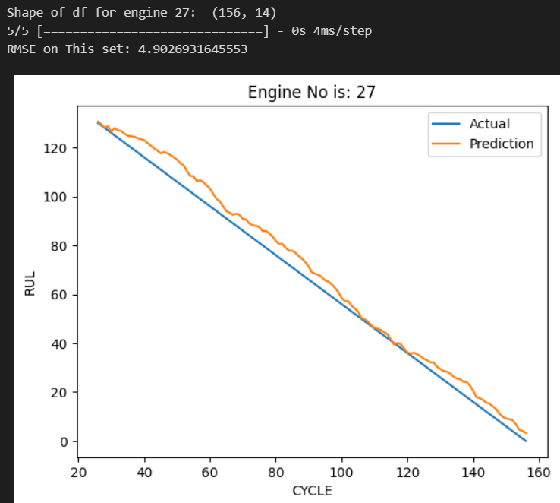

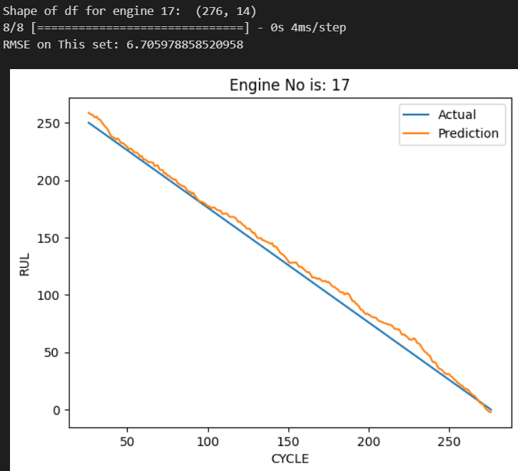 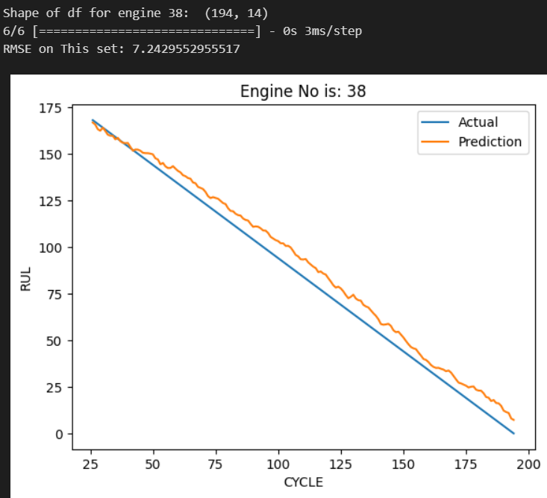

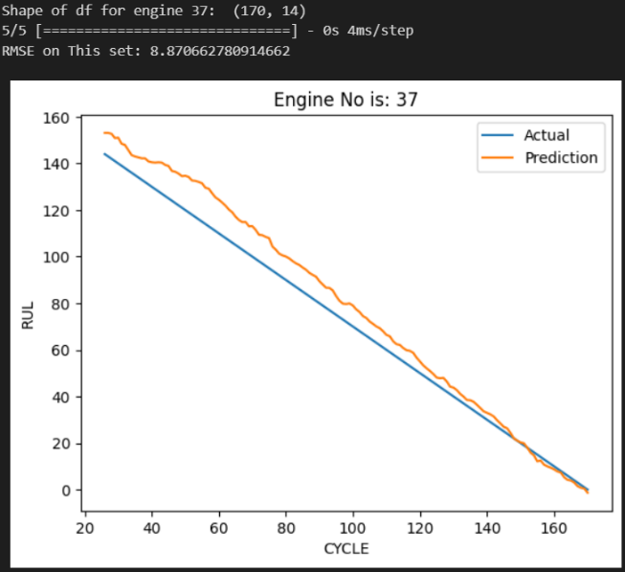 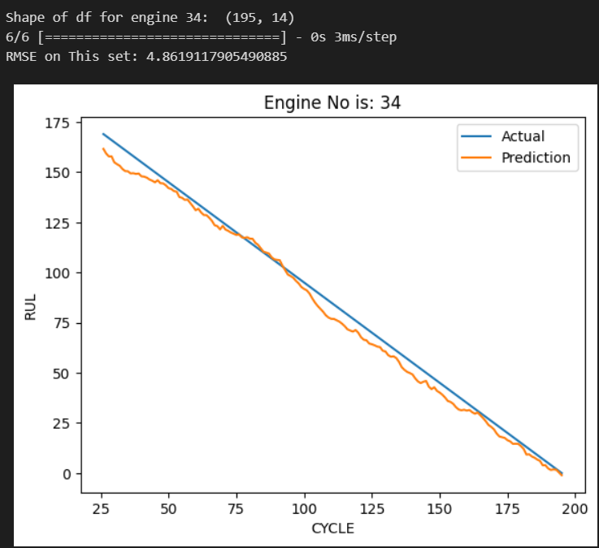

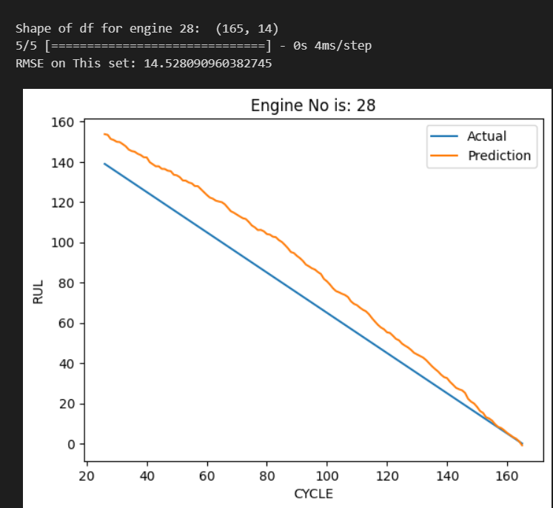 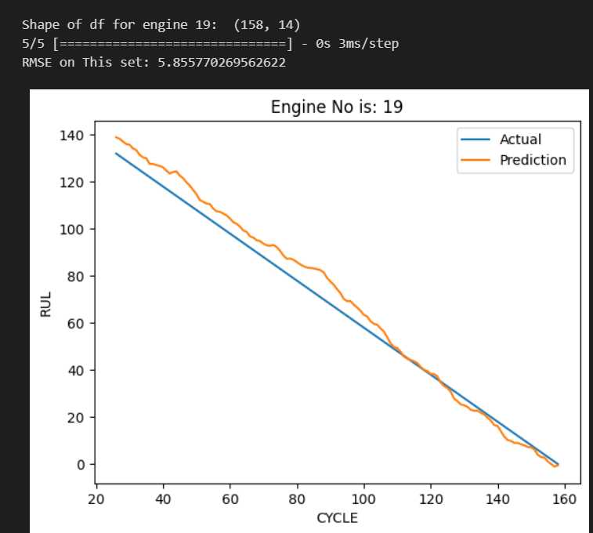

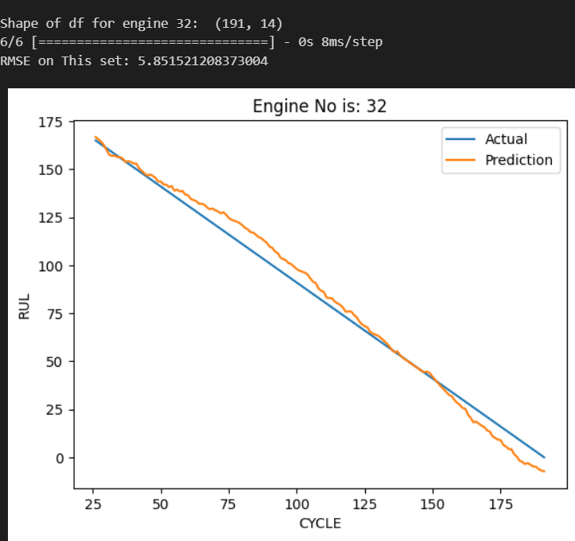 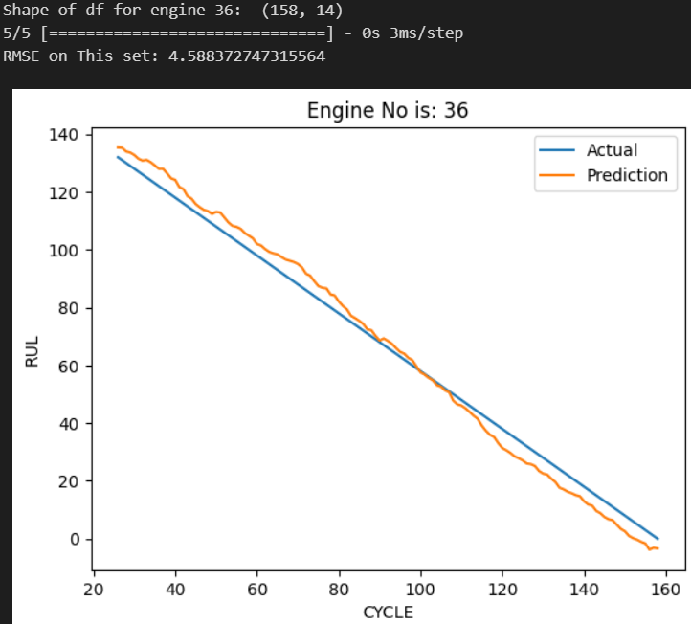

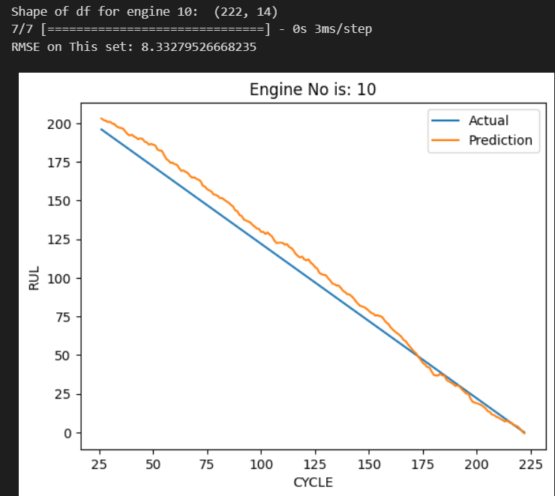 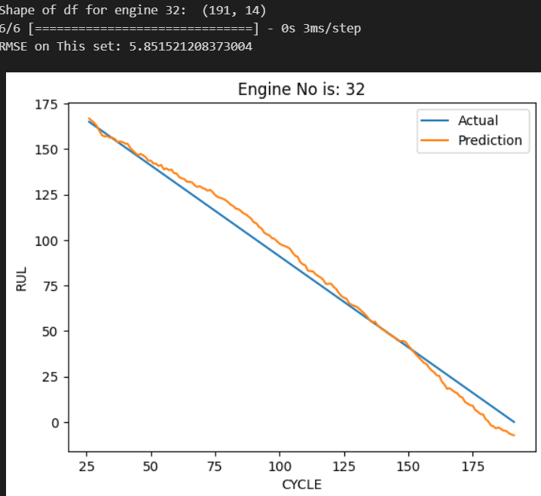

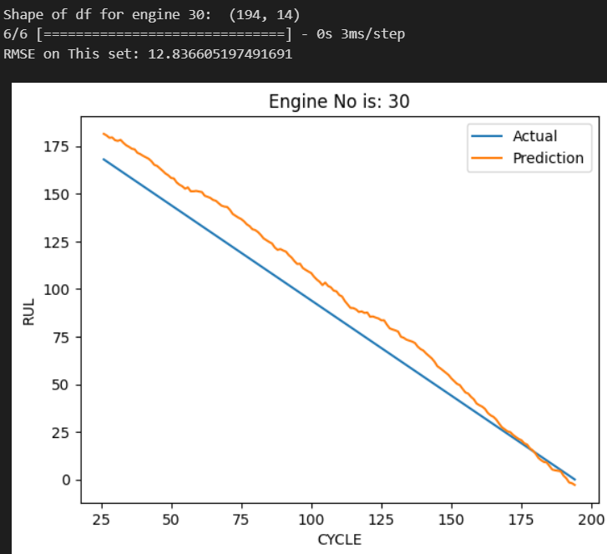 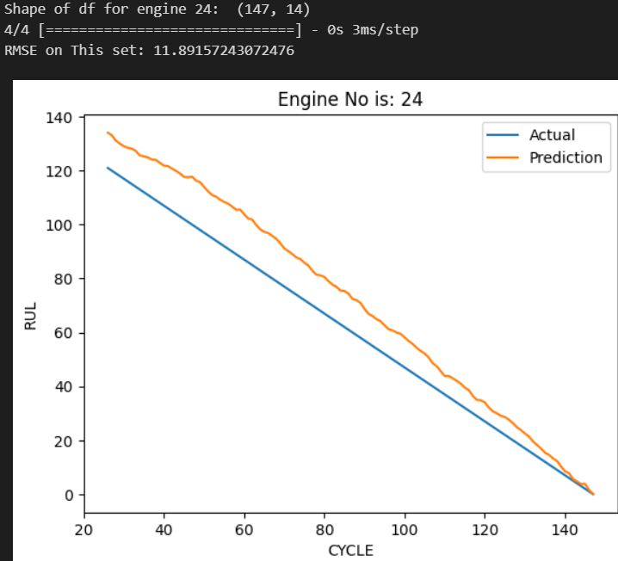

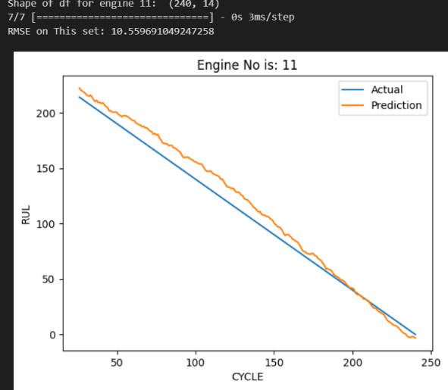 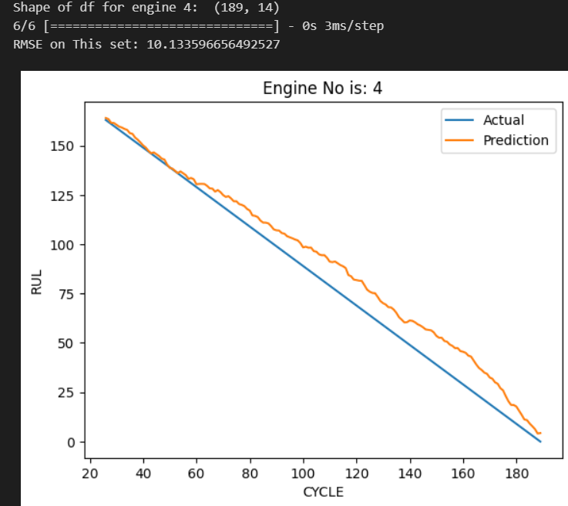

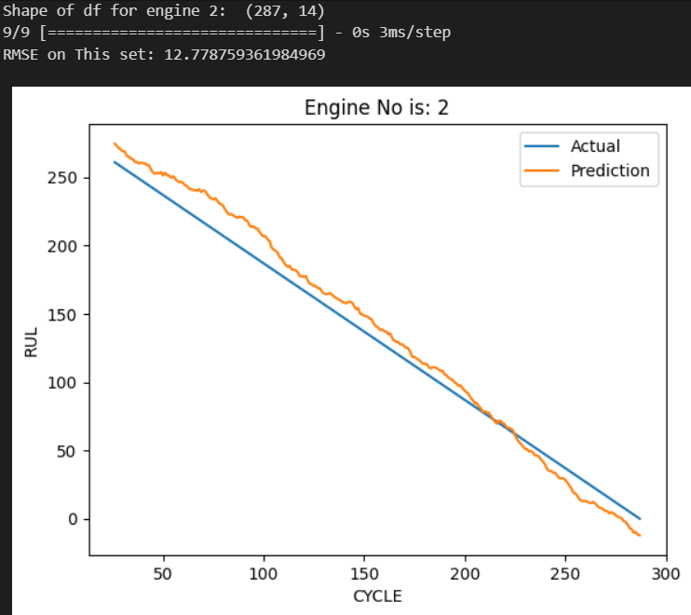 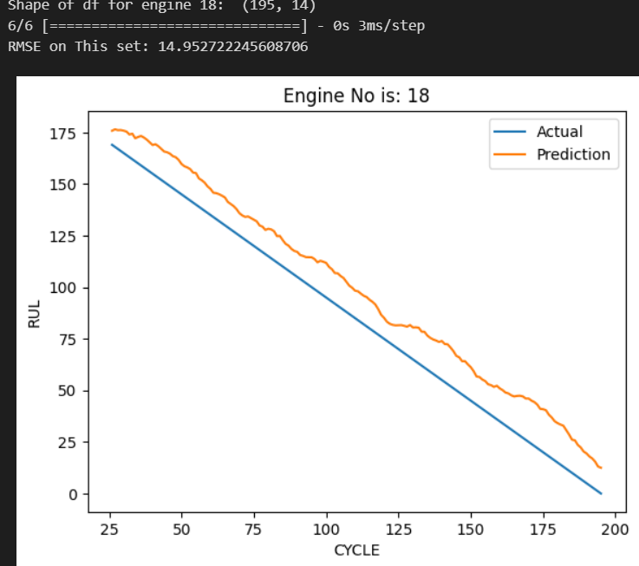

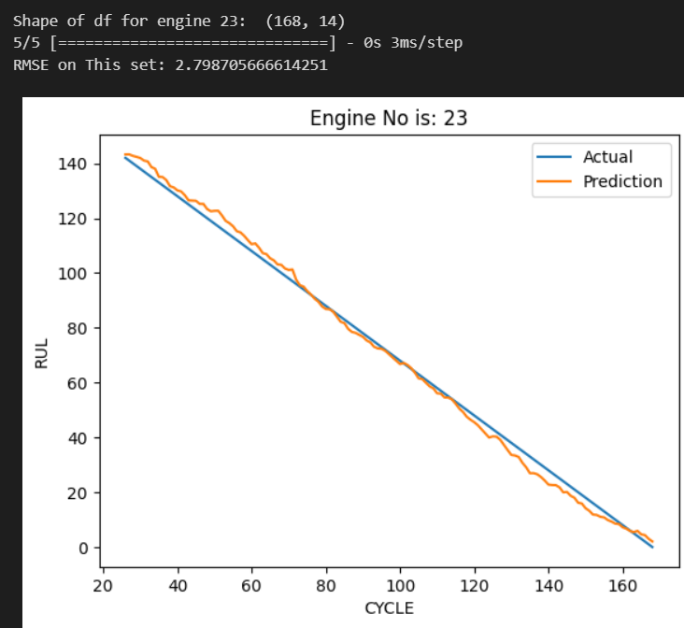 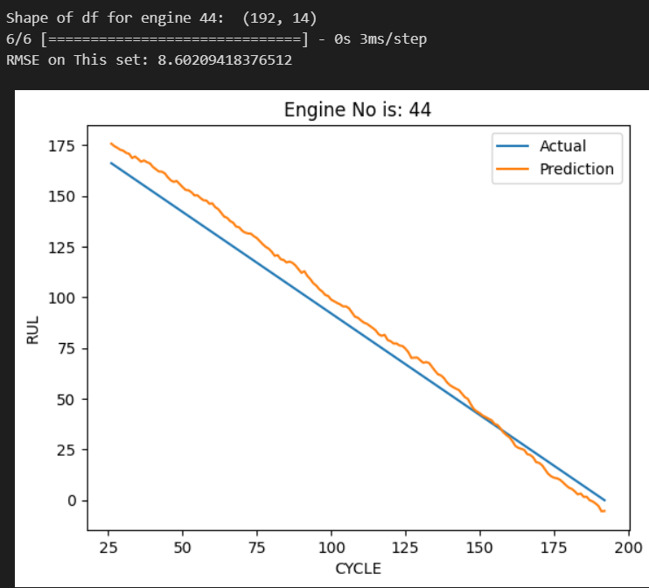

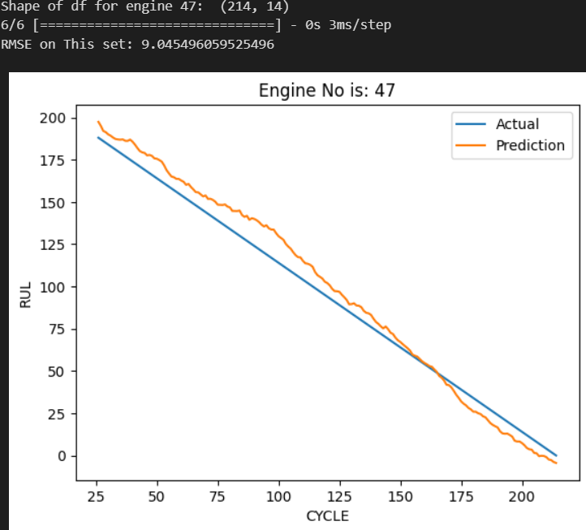 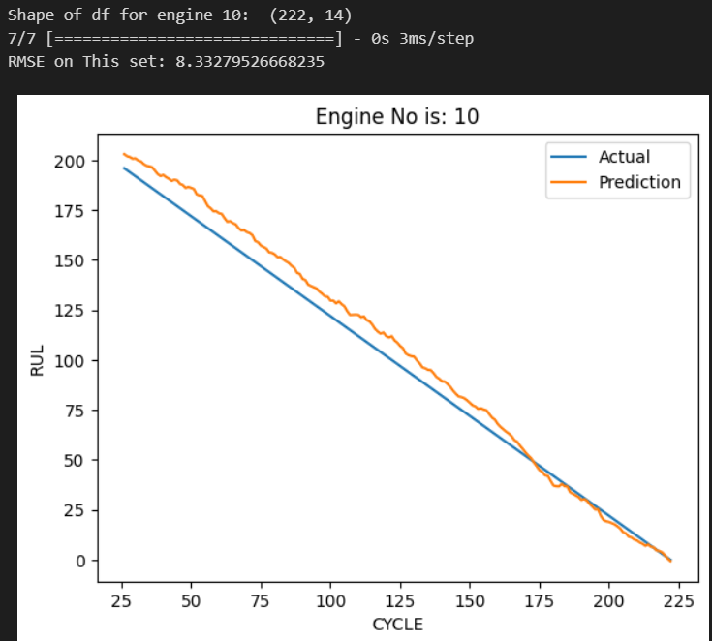

**Testing**

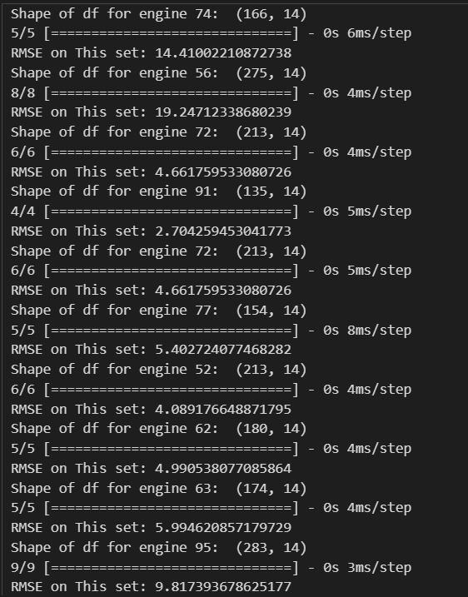

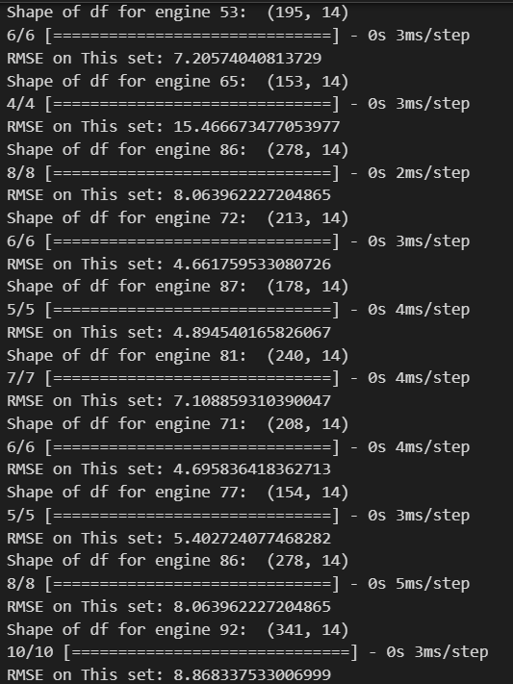

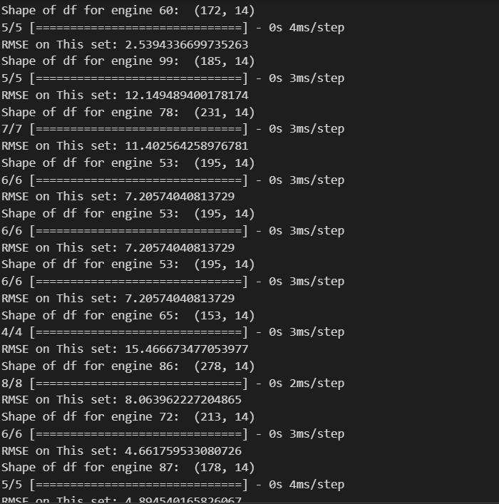

**RESULTS**

The DCNN model demonstrated high accuracy in predicting the RUL of aircraft engines. The error margins were significantly lower than traditional statistical methods, indicating a reliable prediction capability.

**BENEFITS**

Reduced Unscheduled Maintenance: Predictive maintenance helps in reducing unplanned downtime.

Cost Efficiency: Optimized maintenance schedules lead to cost savings.

Safety: Timely maintenance enhances the safety of aircraft operations.

Operational Efficiency: Improved reliability and availability of aircraft.

**CONCLUSION**

The use of DCNN for predicting the RUL of commercial aircraft engines represents a significant advancement in the field of predictive maintenance. By effectively analyzing sensor data, this approach can enhance safety, reduce costs, and improve operational efficiency in the aviation industry. However, continuous monitoring of model performance and data quality is essential for maintaining its effectiveness.