

University Institute of Computing
SUBJECT-R PROGRAMMING

PROJECT- Student Score Data Analysis

SUBMITTED BY:- SUBMITTED To:-
STUDENT NAME:- Md. Tahir TEACHER NAME:- M/s. Ambika BRANCH:- BCA(DATA SCIENCE) Designation:- Assistant Prof.
SUB CODE:- 24CAP-1 Signature:-
UID:- 24BCD10075
SECTION:-24BCD2(A)

1. Introduction
This project explores academic performance using R programming, analyzing student scores across multiple subjects through statistical summaries and visualizations.

2. Objective
- Analyze student scores using R
- Compute statistical metrics
- Create graphs to visualize performance
- Extract insights and identify patterns
- Highlight top and bottom scorers

3. Methodology
The steps include data creation, statistical computation using R functions, and plotting visualizations. Libraries used include base R and ggplot2.

4. Dataset Description
students <- data.frame(
Student_Name = c("Alice", "Bob", "Charlie", "Daisy", "Ethan"),
Maths = c(88, 76, 95, 67, 90),
Science = c(82, 89, 91, 73, 85),
English = c(78, 72, 88, 84, 80),
History = c(90, 85, 87, 70, 75)
)
print(students)

5. Data Cleaning and Preparation
# Check for NA values
sum(is.na(students))
# Summary
summary(students)

6. Statistical Analysis
summary_stats <- data.frame(
Subject = names(students)[2:5],
Mean = sapply(students[2:5], mean),
Median = sapply(students[2:5], median),
SD = sapply(students[2:5], sd)
)
print(summary_stats)
The summary table shows that Maths has the highest variation. Science is consistent across students. Median and mean values are close, indicating a symmetric distribution.

7. Data Visualization
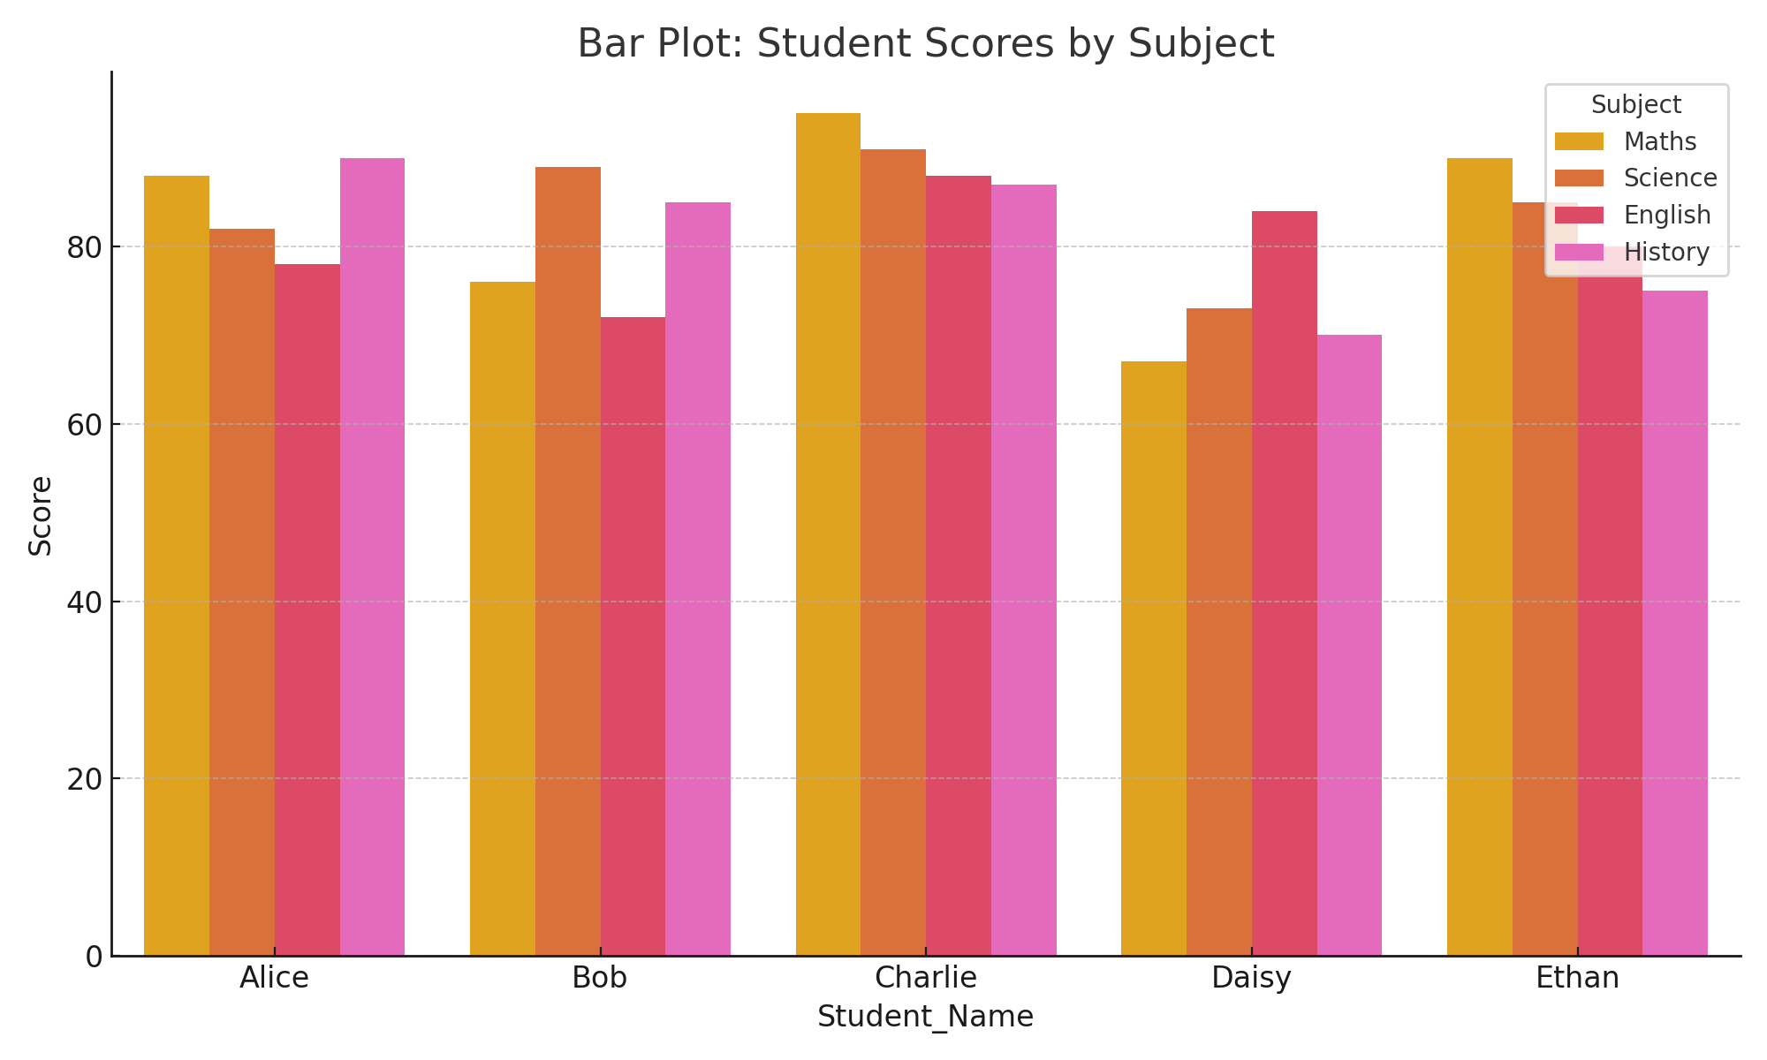
Figure 1: Bar Plot - Student Scores by Subject
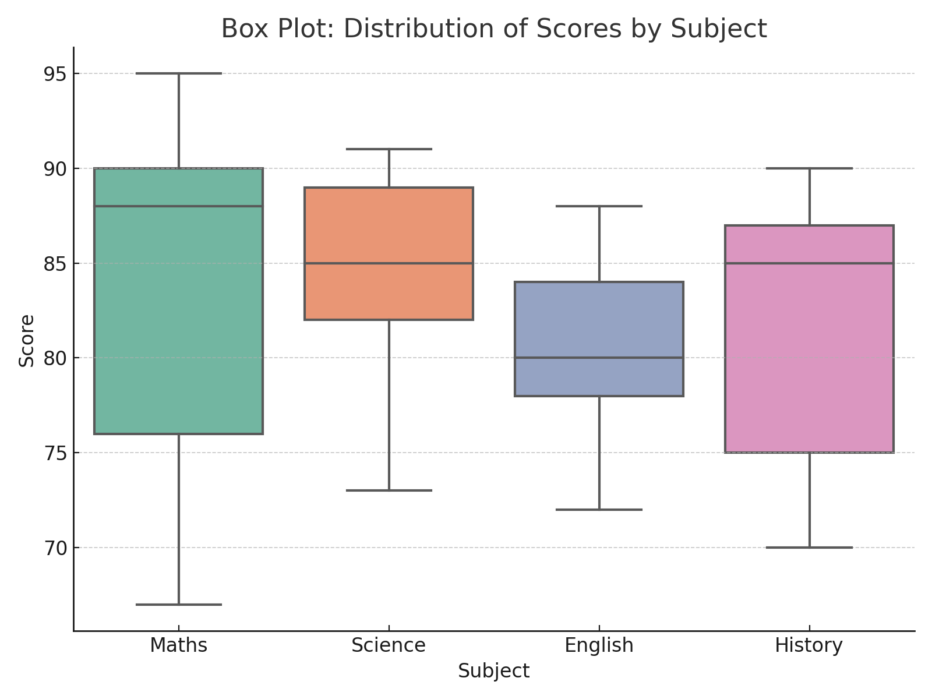
Figure 2: Box Plot - Distribution of Scores by Subject
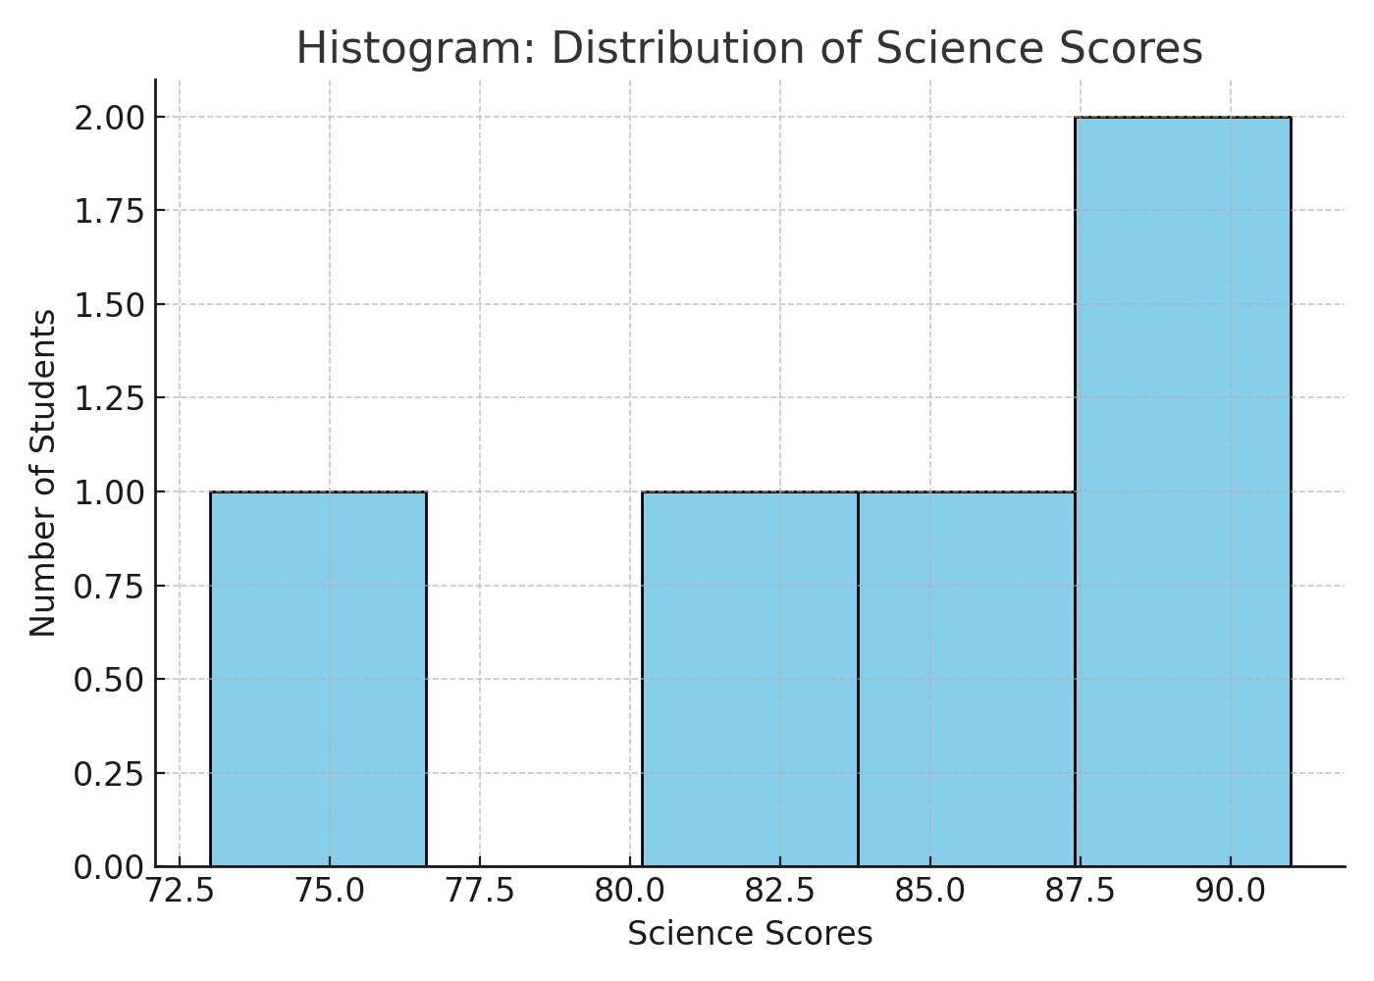
Figure 3: Histogram - Science Score Distribution
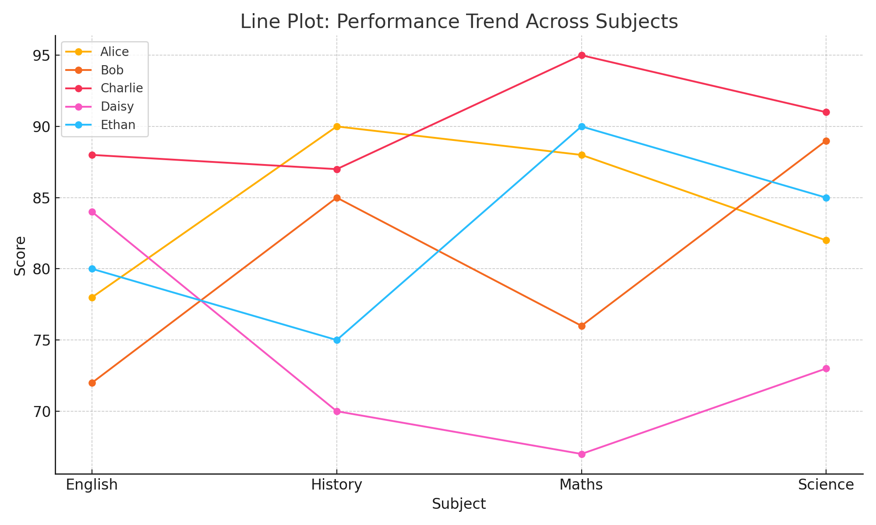
Figure 4: Line Plot - Performance Trend Across Subjects

8. Insights and Interpretation
- Maths shows widest score variability.
- Science has tight score clustering.
- Charlie is a consistent top performer.
- Daisy needs support in Maths.
- English scores are moderately spread.

9. Bonus Features
Top and Bottom Scorers Identification
top_scorers <- sapply(students[2:5], function(x) students$Student_Name[which.max(x)])
bottom_scorers <- sapply(students[2:5], function(x) students$Student_Name[which.min(x)])
print(top_scorers)
print(bottom_scorers)
Charlie topped in Maths and Science, Alice in History. Daisy needs improvement in Maths and History.

10. Code

📁 1. Creating the Dataset:
# Create dataset of student scores
students <- data.frame(
Student_Name = c("Alice", "Bob", "Charlie", "Daisy", "Ethan"),
Maths = c(88, 76, 95, 67, 90),
Science = c(82, 89, 91, 73, 85),
English = c(78, 72, 88, 84, 80),
History = c(90, 85, 87, 70, 75)
)

# Print the dataset
print(students)

📊 2. Summary Statistics:
# Compute summary statistics: mean, median, and standard deviation
summary_stats <- data.frame(
Subject = colnames(students[, 2:5]),
Mean = sapply(students[, 2:5], mean),
Median = sapply(students[, 2:5], median),
SD = sapply(students[, 2:5], sd)
)

# Print the summary statistics
print(summary_stats)

🏅 3. Top and Bottom Scorers:
# Identify top and bottom scorer in each subject
top_scorers <- sapply(students[, 2:5], function(x) students$Student_Name[which.max(x)])
bottom_scorers <- sapply(students[, 2:5], function(x) students$Student_Name[which.min(x)])

# Convert to data frame
top_scorers_df <- data.frame(Subject = names(top_scorers), Top_Scorer = top_scorers)
bottom_scorers_df <- data.frame(Subject = names(bottom_scorers), Bottom_Scorer = bottom_scorers)

# Print results
print(top_scorers_df)
print(bottom_scorers_df)

🔄 4. Reshape Data for Visualization:
# Load required library
library(reshape2)

# Reshape the dataset to long format
students_long <- melt(students, id.vars = "Student_Name",
variable.name = "Subject", value.name = "Score")

# View reshaped data
head(students_long)

📉 5. Visualization using ggplot2:-

📌 Bar Plot – Maths Scores:
library(ggplot2)

ggplot(students, aes(x = Student_Name, y = Maths, fill = Student_Name)) +
geom_bar(stat = "identity") +
ggtitle("Maths Scores by Student") +
ylab("Score") + xlab("Student Name") +
theme_minimal()

📦 Box Plot – Score Distribution by Subject:
ggplot(students_long, aes(x = Subject, y = Score, fill = Subject)) +
geom_boxplot() +
ggtitle("Distribution of Scores Across Subjects") +
theme_light()

📊 Histogram – Science Score Distribution:
hist(students$Science,
col = "lightblue",
border = "black",
main = "Science Score Distribution",
xlab = "Scores")

📈 Line Plot – Performance Trends:
ggplot(students_long, aes(x = Subject, y = Score, group = Student_Name, color = Student_Name)) +
geom_line(size = 1.2) +
geom_point(size = 2) +
ggtitle("Performance Trend Across Subjects") +
theme_minimal()

11. Conclusion
This R project offered insights into student performance through statistical and visual tools. Such analysis helps in early intervention, feedback, and academic planning.

12. References
- R Documentation: https://www.rdocumentation.org/
- ggplot2: Elegant Graphics for Data Analysis
- DataCamp and Coursera tutorials

