Flask + MongoDB Registration App

GitHub Repository: https://github.com/SillyCookies-s/flask-mongodb-registration-application

# 1. Flask /api Route

The Flask application includes a route `/api` that returns a JSON list of data.  
This data is stored in a backend file or MongoDB and is read during the request.  
When a client makes a GET request to `/api`, the Flask app fetches the data from the MongoDB collection (`form_data` inside `mongo_database`) and returns it in JSON format.  
@app.route('/api', methods=['GET'])  
def get_data():  
 data = list(collection.find({}, {'_id': 0}))  
 return jsonify(data)

# 2. Form Submission & MongoDB Integration

The frontend contains a form that collects user input and submits it to the Flask backend.  
The Flask backend handles the POST request on the `/submit` route, inserts the form data into MongoDB Atlas, and provides feedback.  
@app.route('/submit', methods=['POST'])  
def submit():  
 try:  
 form_data = dict(request.form)  
 collection.insert_one(form_data)  
 return "Data Submitted Successfully!"  
 except:  
 return "Error saving data"

# 3. Submission Handling

Upon successful submission, the user is redirected to another page with the message "Data submitted successfully".  
If an error occurs, the error message is shown on the same page without redirection.

# 4. Screenshots

Include screenshots of:

- The running Flask application

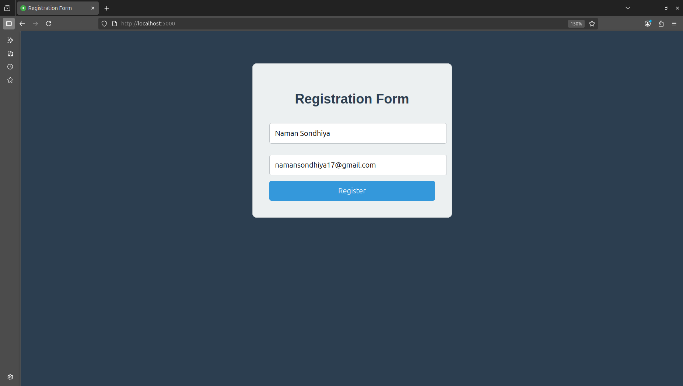

- MongoDB Atlas showing data entry

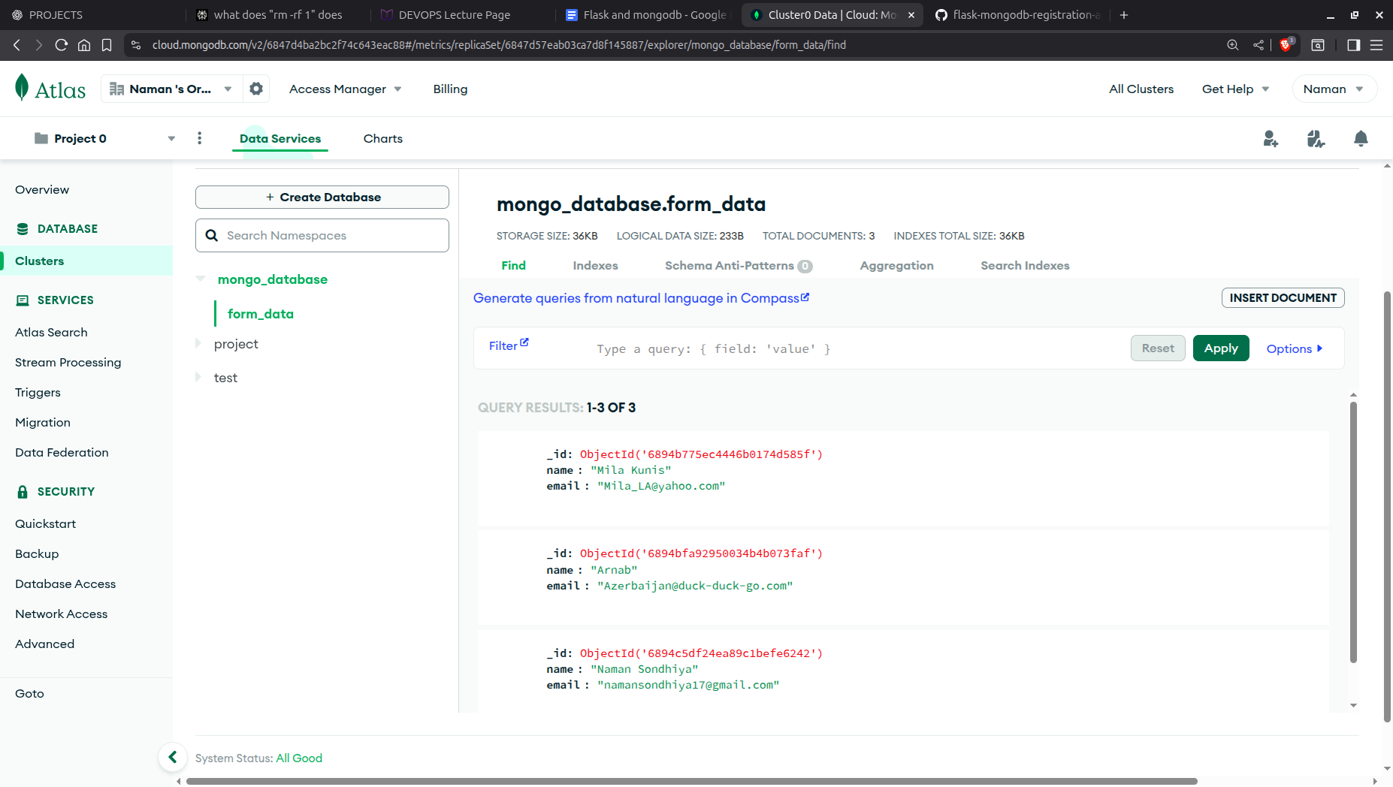

- `/api` route returning JSON

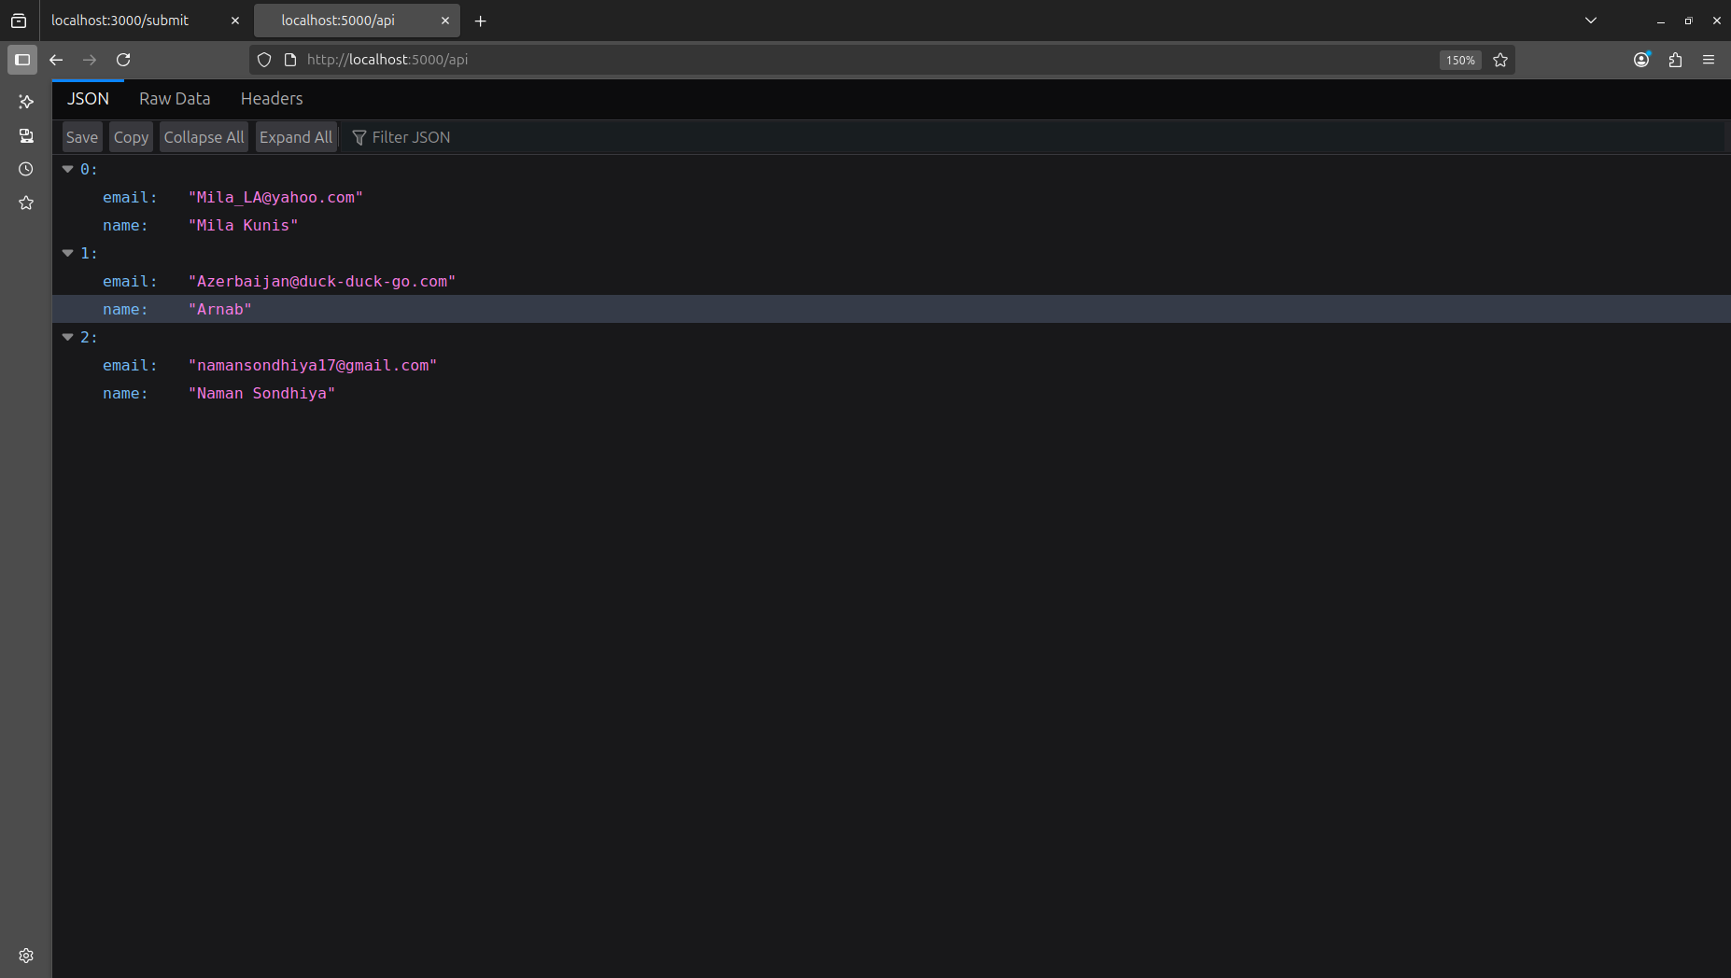- Form submission behavior (success and failure)

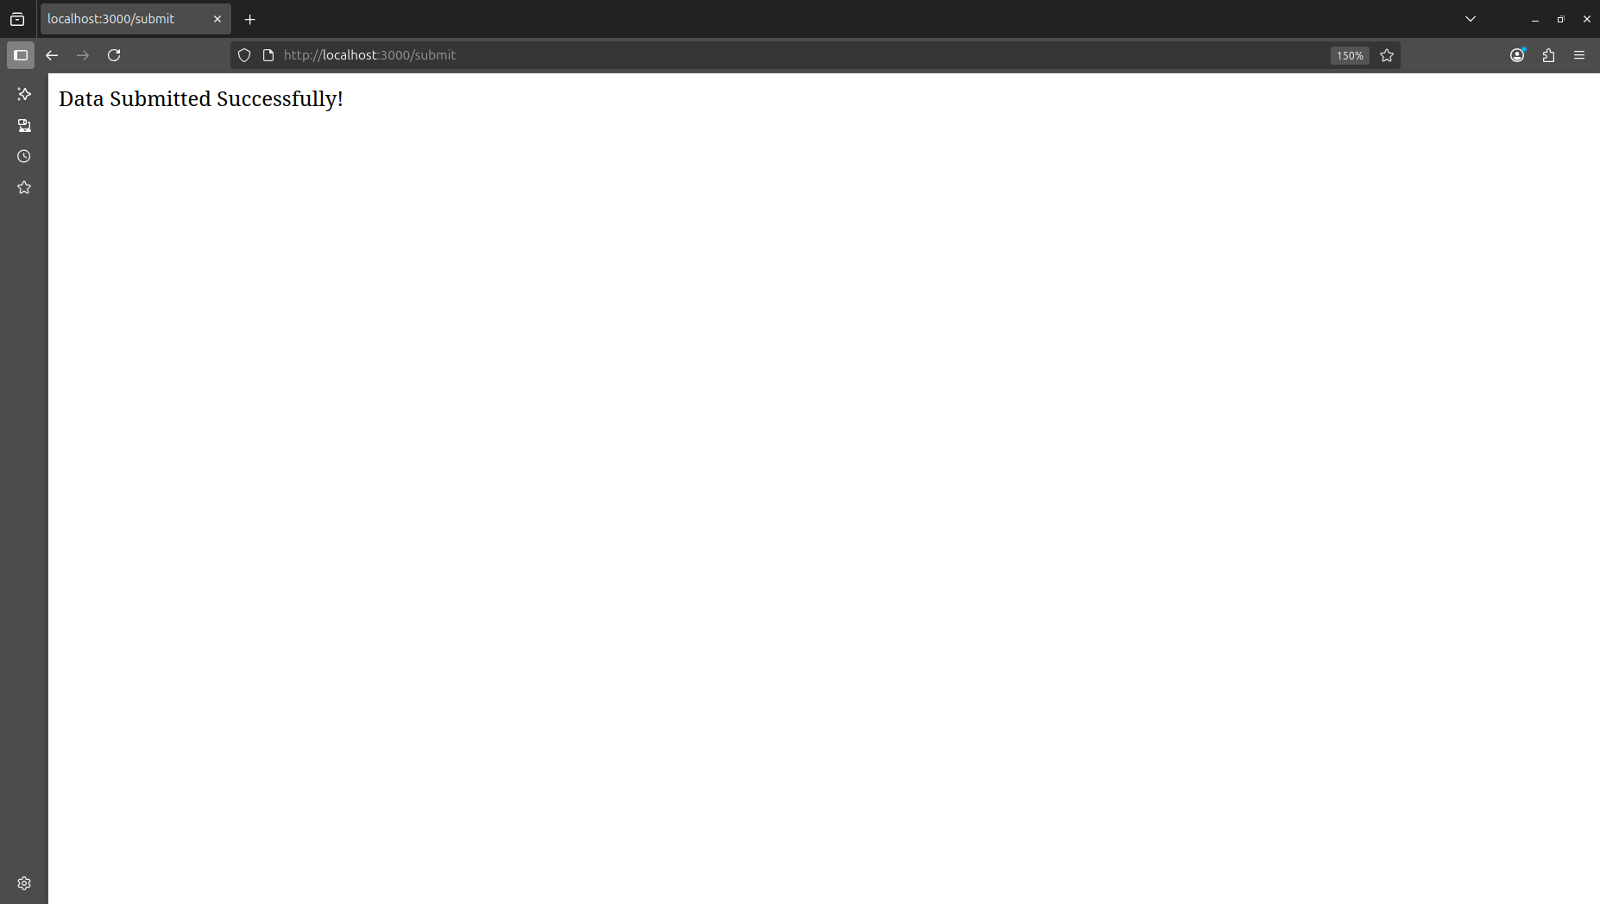Successfully submitted page response

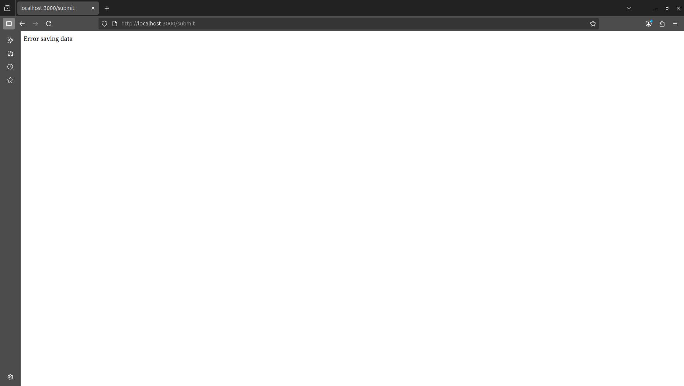Error page response