Python Programming Minor-Projects

1. Grade Checker
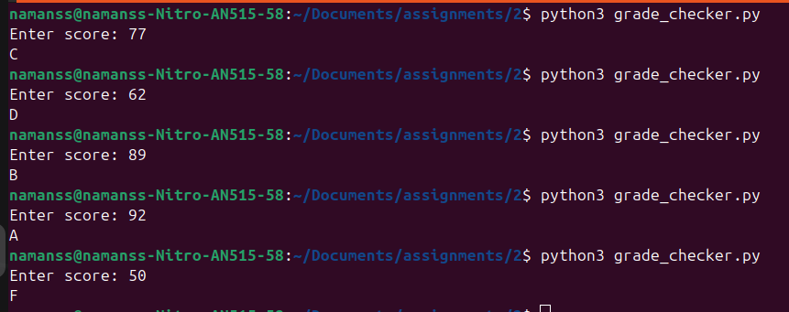
This program takes a score as input and prints the grade based on the following criteria:
90+ : 'A'
80-89 : 'B'
70-79 : 'C'
60-69 : 'D'
Below 60 : 'F'
used a basic if-else statements in “grade_checker.py” to compare the score and determine the grade.

2. Student Grades
This program uses a dictionary where keys are student names and values are their grades.
It allows the user to:
- Add a new student and grade.
- Update an existing student's grade.
- Print all student grades.
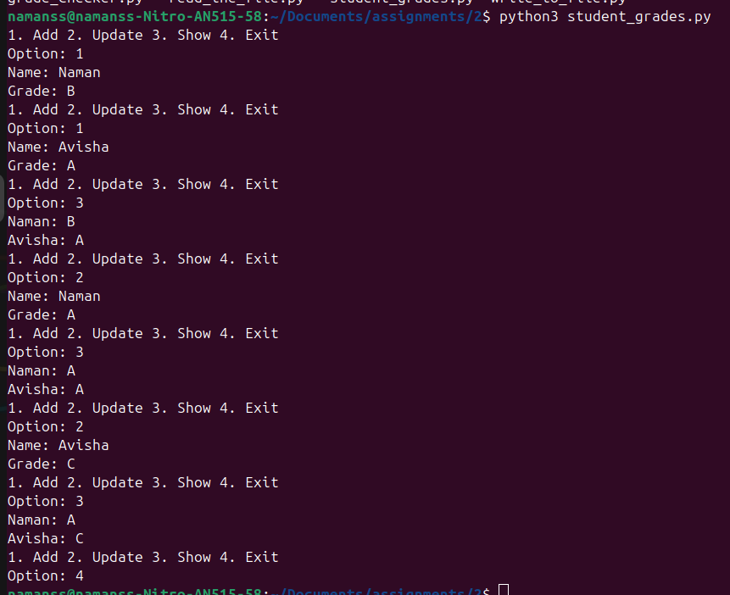
Used dictionary operations along with if-else conditions in “student_grades.py” to check whether a student exists before updating or adding.

3. Write to a File & Read from a File
This program creates a text file and writes some content to it. used file handling open() in write mode and write() to store content in the file, also another program reads from a text file and displays its contents. used open() in read mode and file.read() to read and print the file’s data.
write_to_file.py
read_the_file.py
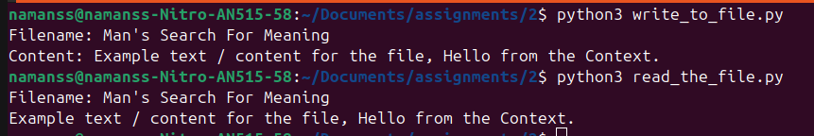
for different fuction try running the above .py, provided in the repository

