MM18 (E) –DECLARATION OF INTENTION TO USE THE MARK – UNITED STATES OF AMERICA

To be annexed to each international application or subsequent designation in which the United States of America is a designated Contracting Party.

DECLARATION OF INTENTION TO USE THE MARK: UNITED STATES OF AMERICA

By designating the United States in the international application/subsequent designation, the person signing below declares that:

(1) the applicant/holder has a bona fide intention to use the mark in commerce that the United States Congress can regulate on or in connection with the goods/services identified in the international application/subsequent designation;
(2) he/she is properly authorized to execute this declaration on behalf of the applicant/holder;
(3) he/she believes applicant/holder to be entitled to use the mark in commerce that the United States Congress can regulate on or in connection with the goods/services identified in the international application/subsequent designation; and
(4) to the best of his/her knowledge and belief no other person, firm, corporation, association, or other legal entity has the right to use the mark in commerce, either in the identical form thereof or in such near resemblance thereto as to be likely, when used on or in connection with the goods/services of such other person, to cause confusion, or to cause mistake, or to deceive;
(5) to the best of the signatory’s knowledge, information, and belief, formed after an inquiry reasonable under the circumstances, the allegations and other factual contentions made above have evidentiary support.

I declare under penalty of perjury under the laws of the United States of America that all the foregoing statements are true and correct to the best of my knowledge and belief. I understand that willful false statements and the like may jeopardize the validity of the application or document or any registration resulting therefrom, and are punishable by fine or imprisonment, or both (18 U.S.C. §1001). 35 U.S.C. §25(b).
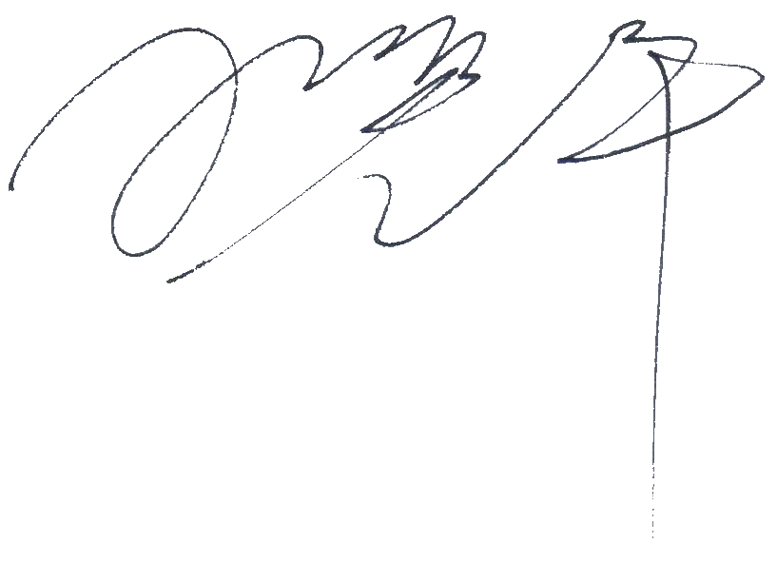 |  | 28/01/2026
Signature |  | Date of execution (dd/mm/yyyy)
Wang Huiping

Signatory’s Name (Printed)
Signatory’s Title

MM18 (E), page 2

INSTRUCTION

This declaration must be signed by:

(1) the applicant/holder or a person with legal authority to bind the applicant/holder; or

(2) a person with firsthand knowledge of the facts and actual or implied authority to act on behalf of the applicant/holder; or

(3) an attorney who is authorized to practice before the United States Patent and Trademark Office under 37 C.F.R. §10.1(c), who has an actual written or verbal power of attorney or an implied power of attorney from the applicant/holder.

INFORMATION REQUIRED BY THE INTERNATIONAL BUREAU
(a) | Where the present declaration refers to an international application based on a basic application, indicate:
 | Basic application number: | TMZCO0000089966327ZCSQ0 |  |  | Date of the basic application (dd/mm/yyyy): | 28/01/2026
(b) | Where the present declaration refers to an international application based on a basic registration, indicate:
 | Basic registration number: |  |  |  | Date of the basic registration (dd/mm/yyyy):
(c) | Where the present declaration refers to a subsequent designation of an international registration, indicate:
 | International registration number:
International Bureau’s reference (where applicable):
Name of applicant/holder: |  |  | WangHuiping

This form contains the exact wording of the declaration of intention to use the mark required by the United States of America. It should not be amended in any respect. Deletions, modifications or inclusions of text will result in the declaration being considered as irregular. The United States of America requires that the declaration of intention to use the mark be made in English, even if the international application or the subsequent designation is in French or Spanish. Therefore, this form is available in English only.

