# **Product description**

# RationalFuncCalc 2015 is a program that can tell you important qualities and data about any rational function. The rational function will then be graphed on a plane and the important information will be provided underneath the graph. This program is able to analyze rational functions in both expanded or factored form.

# **Features of RationalFuncCalc 2015**

RationalFuncCalc 2015 assists users in their grade twelve math (calculus and advanced functions) homework. The program is able to graph a function, as well as display the important features of the function that was given as input. The important features includes the x-intercepts, y-intercept, holes, asymptotes, point of inflection, increasing/decreasing intervals, concavities, local min/max.

A sample interaction page is displayed below:

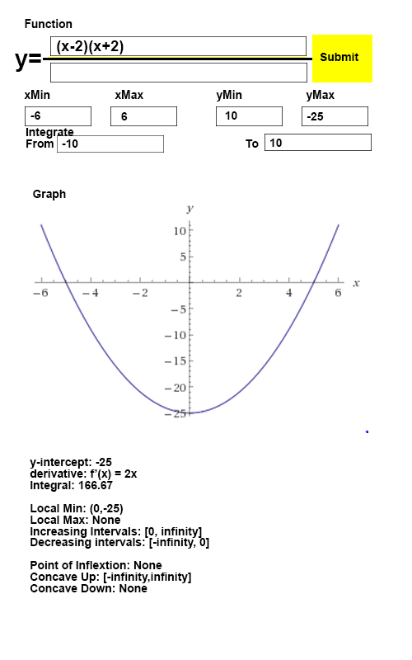

Inside the first “function” box, the user will input the numerator of the function. In the second box, the user may put the denominator if they choose. If the box is empty, the denominator is assumed to be 1. The program will be able to detect any rational function in either expanded or factored form.

After the user enters their rational function, the x and y intervals over which to graph the function as well as the integration interval, s/he will click the “submit” button.

If the inputs are valid, the program will then display the graph as well as the important features of the graph.

However, if the program detects an invalid input, an error message will be displayed instead. The user will then be given the option to change their function to a valid input.

After the user is done with their function, they will have the option of entering a new function to examine. They can delete the function currently inside the “function” box and click submit.

# **Completion plan**

**Design team**

Ian, Kevin and Arthur

|  |  |  |  |
| --- | --- | --- | --- |
| **Task** | **Team member(s) responsible** | **Target completion date** | **Status** |
| **Plan the overall design** | All | 4/20 | done |
| Define fields rationalfunction will have and how they will be formatted | All | 4/20 | done |
| Parsing input from string | Ian | 4/22 | finished (not yet handling invalid input) |
| **Code the Polynomial Class** |  |  | Done |
| **-derivatives** | Ian | 4/26 | Done |
| **-addition and subtraction** | Ian | 4/26 | Done |
| **-positive and negative intervals** | Ian | 4/26 | Done |
| **Code the RationalFunction class** |  |  | Done |
| -Constructors  -Factored form  -array of polynomials for numerator, array of polynomials for denominator  -expanded form | Arthur | 4/21 for expanded form, 4/23 for root form (requires multiplication) | done |
| -Addition/Subtraction | Kevin | 4/22 | Done |
| -Multiplication | Kevin | 4/22 | Done |
| -Division | Kevin | 4/23 | Done |
| -Derivatives | Ian | 4/24 | Done |
| -Calculate real roots | Kevin | 4/25 | Done |
| -Calculate asymptotes and holes | Ian | 4/26 | Done |
| -Calculate concavity, POIs | Ian | 4/25 | Done |
| -Calculate increasing/decreasing intervals, local maxes and mins | Ian | 4/26 | Done |
| -Format information for wolfram-style display (roots are here, derivative is x, etc) | Ian | 4/26 | Started |
| -.evaluate(x) : calculate value at x | Arthur | 4/23 | Done |
| **Code the GUI class** |  |  | Done |
| -Constructors/basic GUI  -Create text boxes for user input data (ie: function, x, y intervals) | Arthur | 4/24 | done |
| -Graph function  -optional tick mark interval | Arthur | 4/24 | Not started |
| -Displaying data nicely | Arthur | 4/26 | Started |
| -taking input from text box to call Polynomial function | Arthur | 4/23 | Done |
| **Testing** |  |  | started |
| -Taking input from text box | Ian | 4/23 | Done |
| -Invalid input | Ian | 4/23 | Started |
| -Simple polynomial | Kevin | 4/26 | Done |
| -Rational function (no asymptote) | Kevin | 4/26 | Done |
| -Rational function (asymptote) | Kevin | 4/26 | Done |
| **Submit to Edmodo** | Ian | 4/28 | not started |