**Collections**

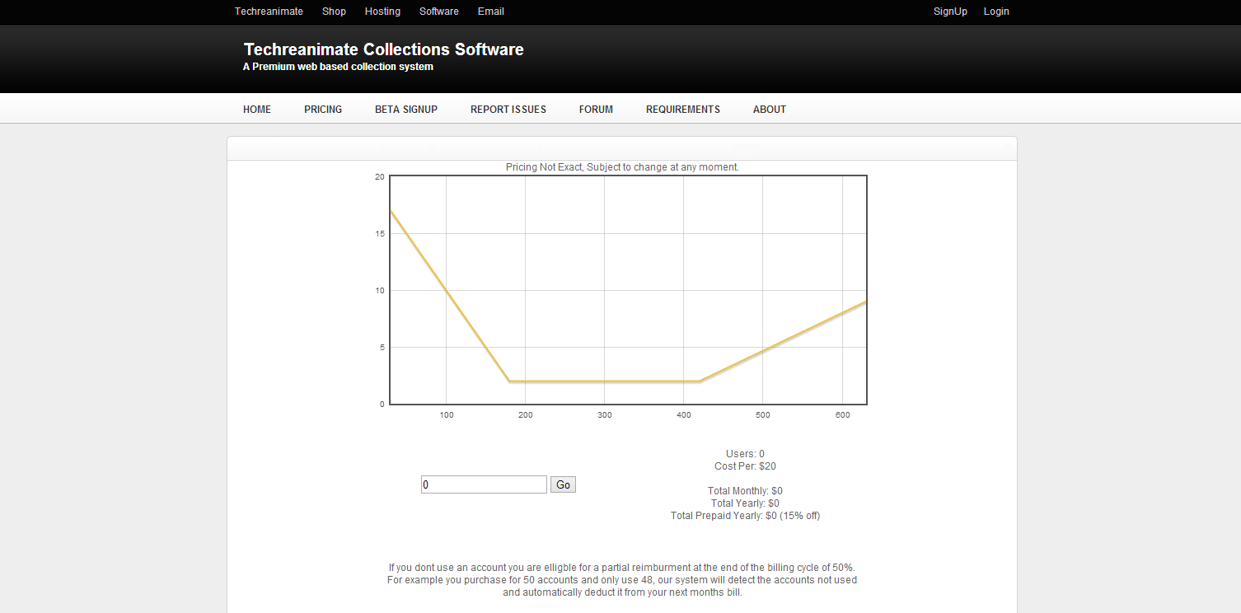

Collections is a web based collection portal for collection agencies to manage and collect on debts. They can import large 100MB+ spreadsheets of debts and categorize them by type of debts. Along with managing debts the agencies can monitor they’re monthly gross profits, revenue and more.