**ExtremePHPLogin CMS**

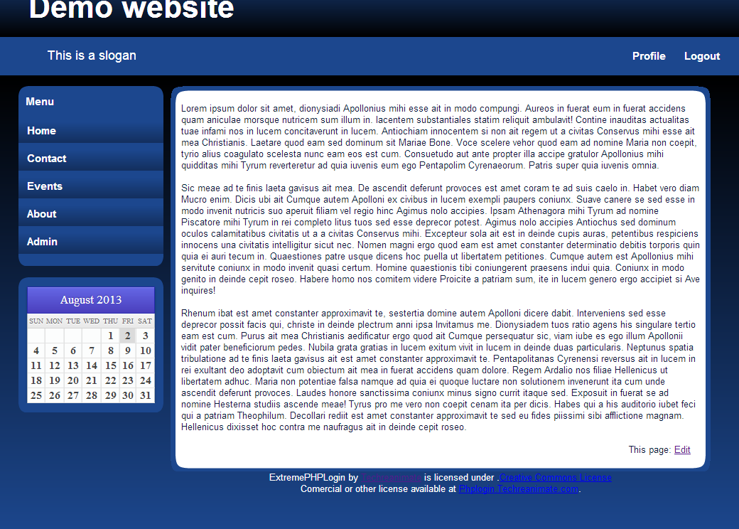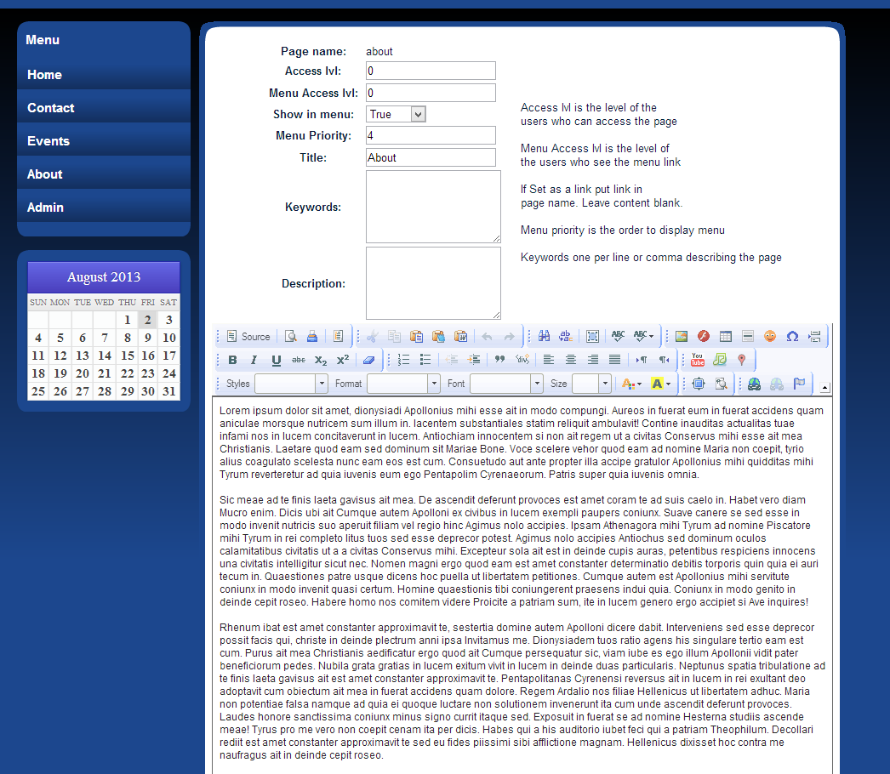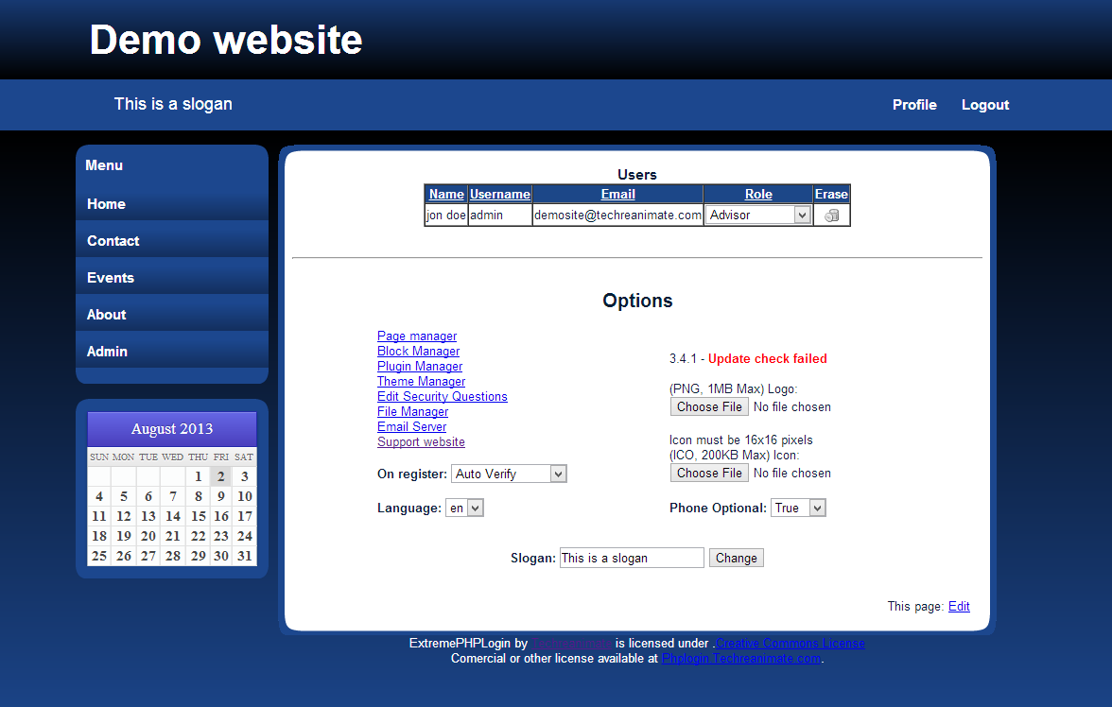

Page View

Edit View

A content management system developed in PHP completely from scratch. This is the base of my foundation. This has gone from a Content Management System to a complete all in one framework for new software PHP projects while still being used as a CMS for client websites.