**Foodorder**

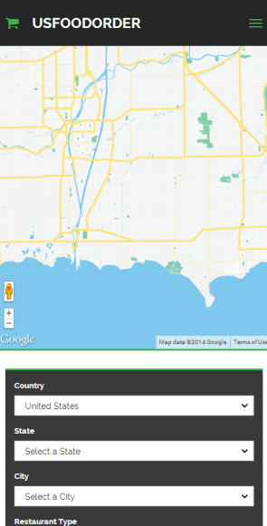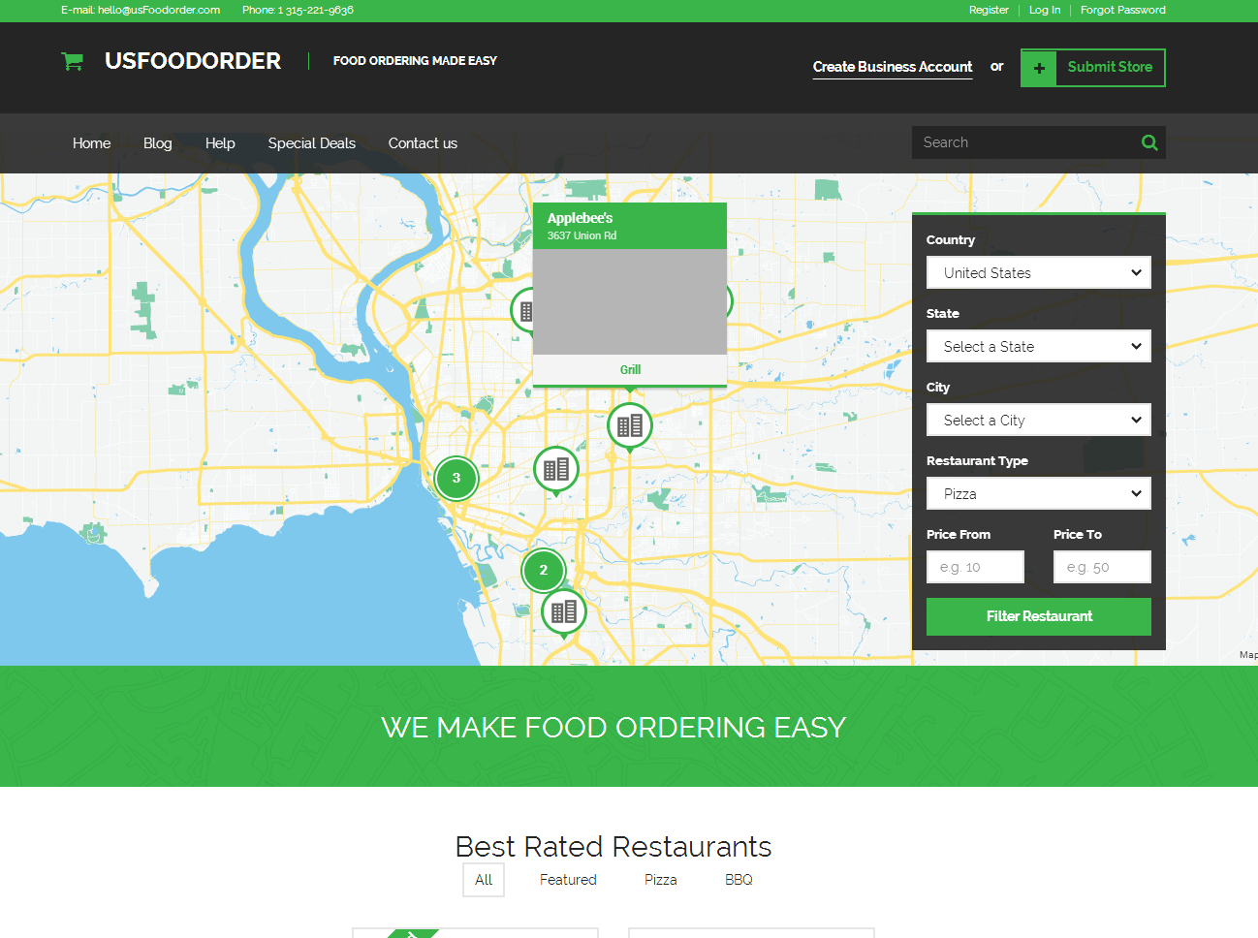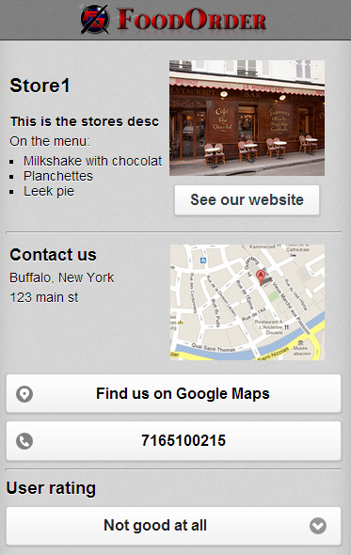

usFoodorder is a mobile ordering startup founded in 2011. We make it easy for people to order take-out food from restaurants using a mobile device such as a smartphone or tablet. Our cloud-based platform receives, processes, and delivers orders to businesses, providing targeted marketing and promotional opportunities.

I Luis Rodriguez Joined the Foodorder Team in March 2013. We then took Foodorder to a whole new level with a complete code remake and database. Foodorder Now provides each client with a website and App of their own for all mobile devices as well as Custom Print Server that works from anywhere in the world to print customer orders as they come in live!