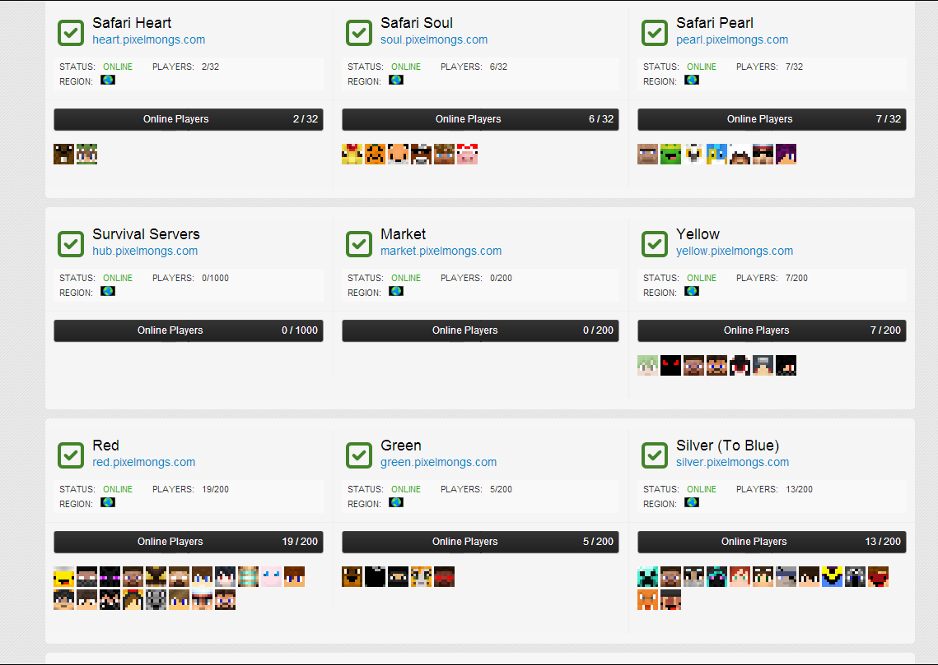**Pixelmon Gaming**

While creating the site for the pixelmon mod we met the owner of the largest servers running pixelmon. We updated code from the backend that help them communicate with their pixelmon servers. We have also helped with the fronted fixing many JavaScript issues.