**ATTO SEO Report Generator**

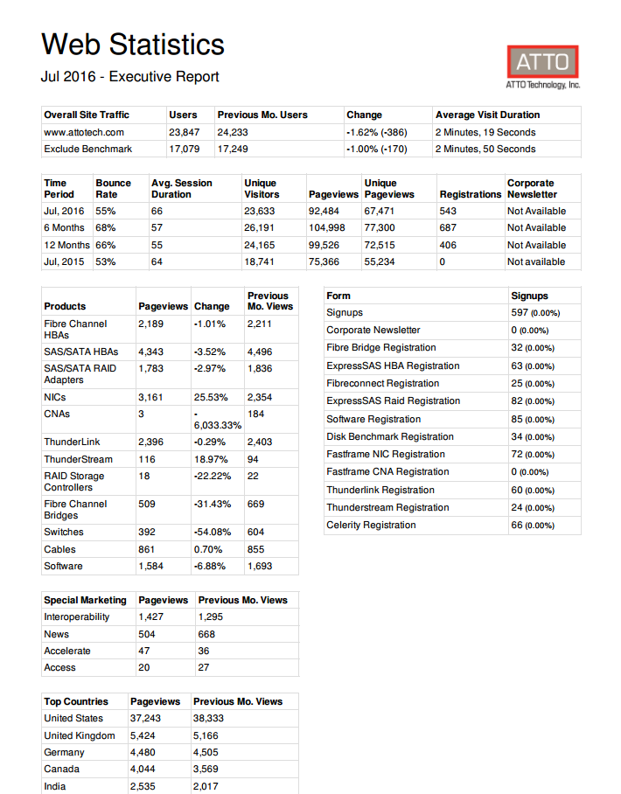

A 15 page seo report summarizing parts of the ATTO website, Scheduled to send a pdf to a list of people within the company. This was tied into the google api and pulls data right from Google Analytics. The report also has tie in’s for multiple api’s including Facebook, linkedin, and twitter.