**ATTO STORE**

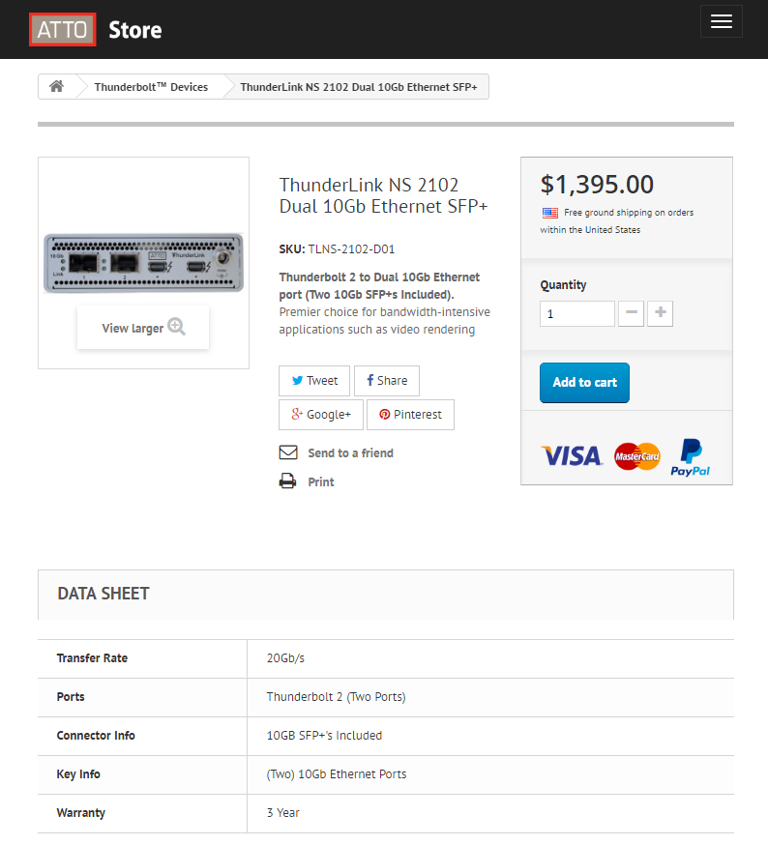

ATTO Store currently running on Prestashop shopping cart system, Designed with a custom bootstrap theme. The store features plugins such as direct credit card processing and fedex shipping calculator. The store has increased previously recorded sales at ATTO by about 2x currently. There are many more improvements that can be done for more sales that are part of prestashop and currently being investigated.