**Large Store Database in MySQL**

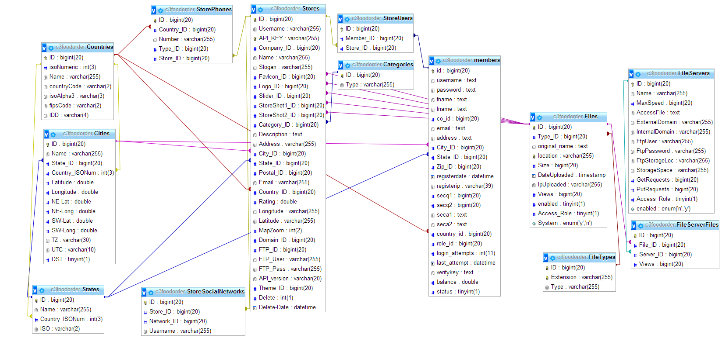

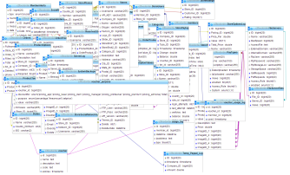

Full Mini View

This is part of a 69 Table Database with over 85000 Entries for cities, states, and zip codes. This database is used for a store management system. The image above is 13/69 tables. There are a total of 121 Relations across tables with cascades and Restricts.