**Email Backup/Firewall**

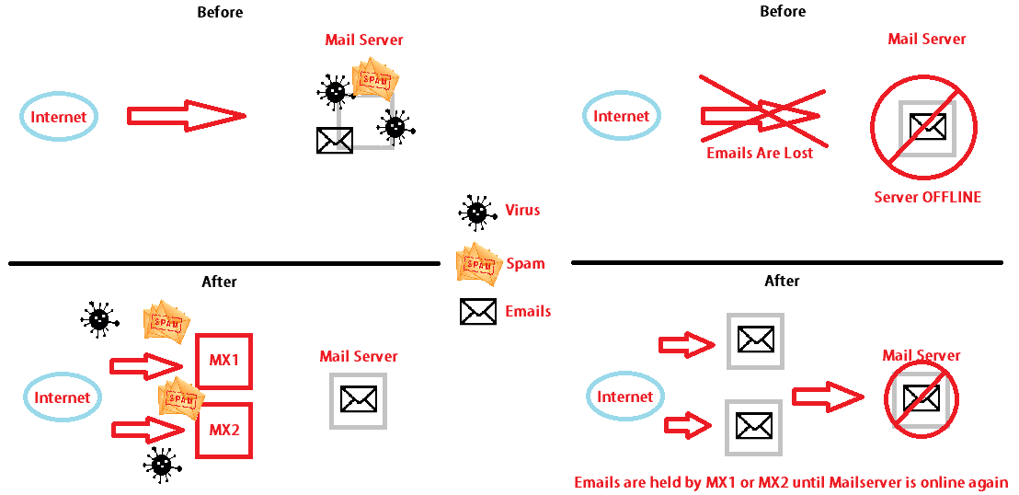

This will allow you to have a email filtering server in front of your main mail server allowing your main mail server to have reduced cpu usage. Also each MX server acts as a failover for your main server as well as each other. Thats essentially 1 backup server per mx that you setup. The odds of you loosing an email drop with every mx you add. Dont forget about the spam filtering, Youll love it!. We Toss 100% illegitable emails and possible valid emails will get marked with a subject line "***spam***" so that you can create a mail rule to send them to your junk folder.

Currently running as:

Server3.techreanimate.com + server4.techreanimate.com 🡪 server1.techreanimate.com