**Ghosts Random Class Generator**

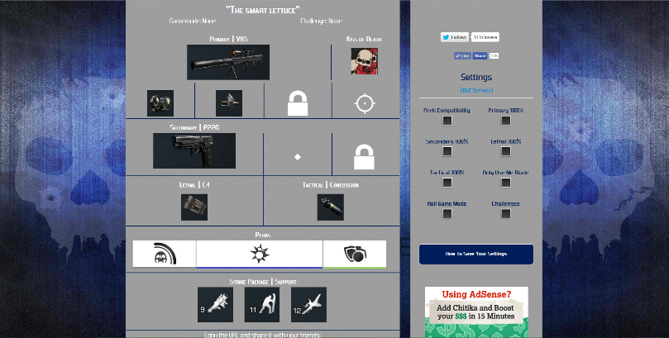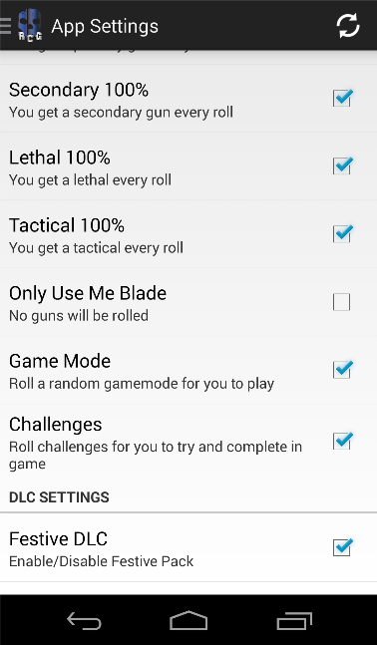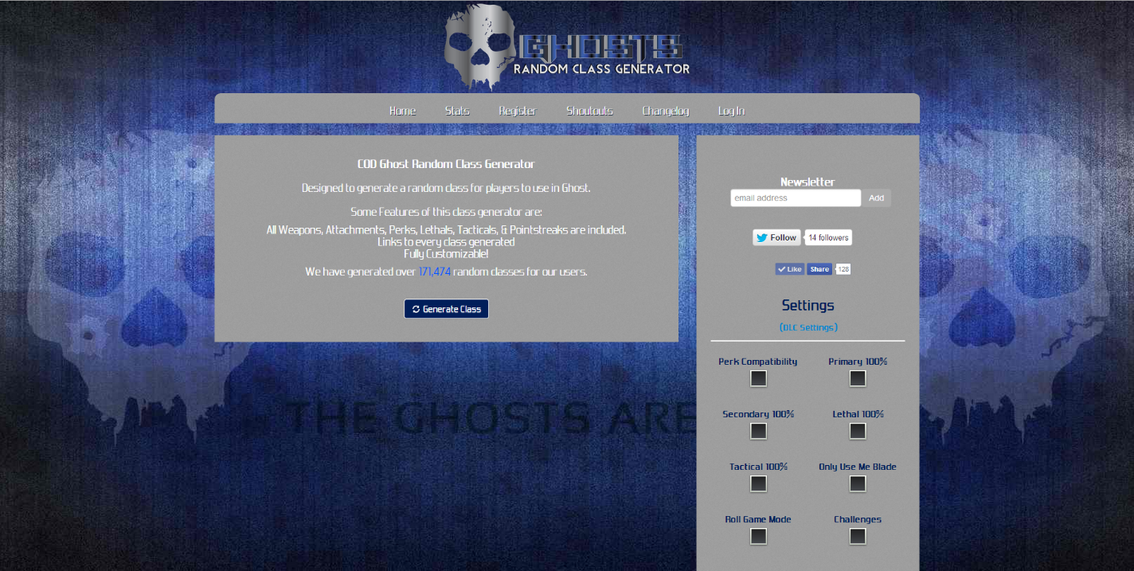

Ghosts RCG is a random class generator that random generates classes for anyone who plays call of duty ghosts to enjoy. This provides new enjoyment for the game e.g. it may choose a gun the player has never used. It also brings more challenge because you never know what you’re going to get as a class, it could be good or it could put you at a huge disadvantage, but that’s where the fun comes in trying to win and do well in the game when you’re using this crazy class that you normally would not. We launched this website less than a week after call of duty ghosts came out. I created my own algorithms to randomly create a class based on the “create a class” system used in Call of Duty Ghosts. It was a challenge because there are tons of possible class possibilities that can be created. So once I finished that I then had to go and make sure all the gun, attachment, camos, equipment, perks and score streaks were all named correctly. This site and app has been pretty popular with over 1,000,000 views and over 500,000 classes generated.