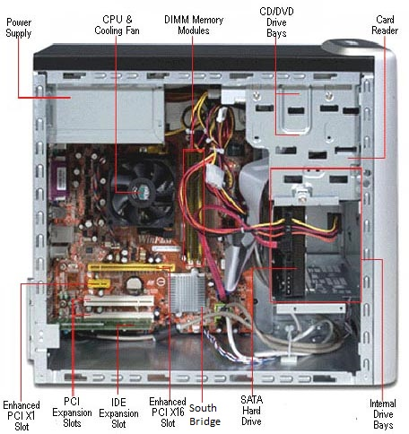

My Hardware experience goes far beyond what is labeled in the above diagram. If required, I can solder and replace damaged Capacitors, voltage regulators and other micro embedded components, as well as Laptops, Cellphones, and All-in-one computers.