**Mail Cleaner**

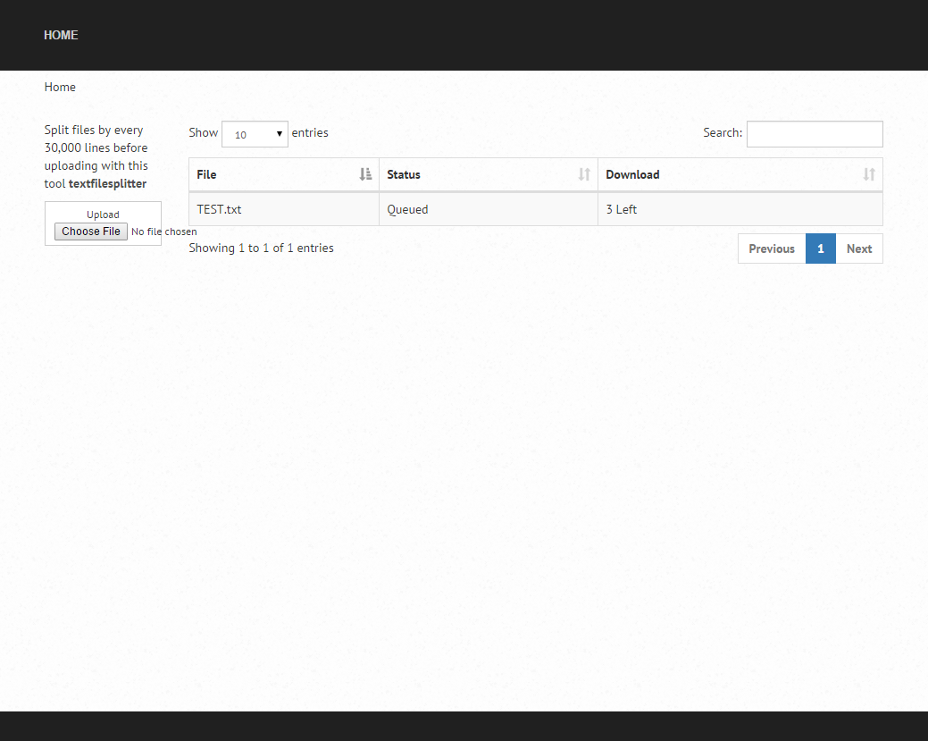

I licensed use of this mail cleaner to ATTO, The purpose of the cleaner is to run through and clean any and all emails by contacting mail servers and checking if the email exists. Used on large lists and can clean trough over 500,000 in under hours with advanced domain caching and record lookups.

Currently the system has been integrated as part of their Email Marketting system “Mautic” and is not part of their everyday process.