**Minecraft**

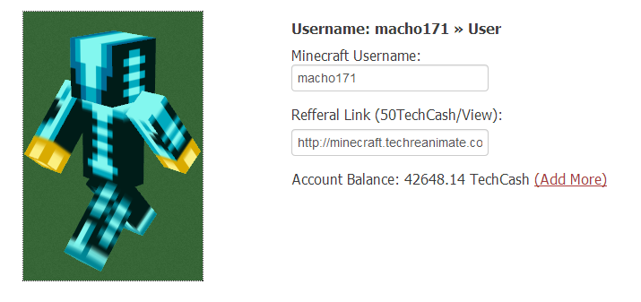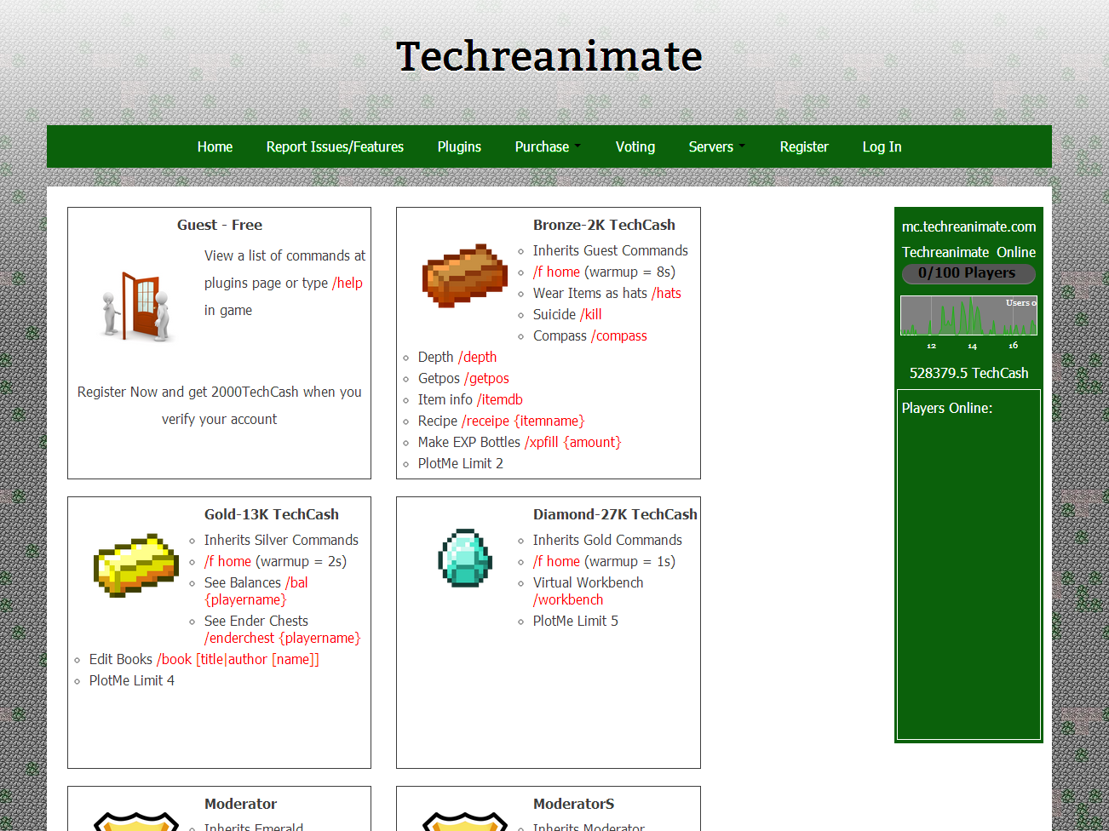

Minecraft.techreanimate.com is a web based portal for the in game endless adventure. I manage and control the server patching security threats before they are even out to the public. Although it does not make much profit it helps build my programming skills without letting me go soft.