**Cisco Packet Tracker Networks**

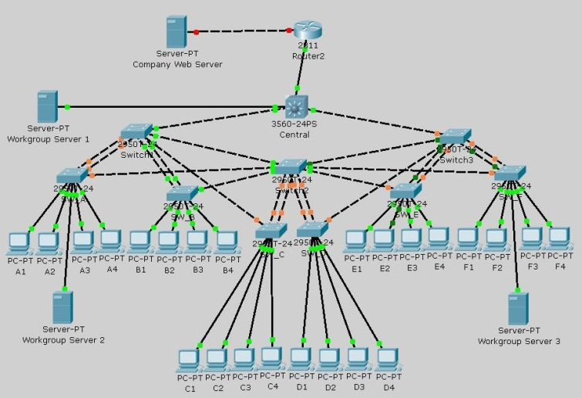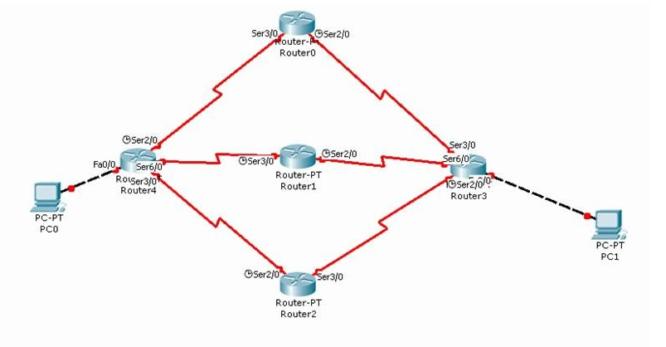

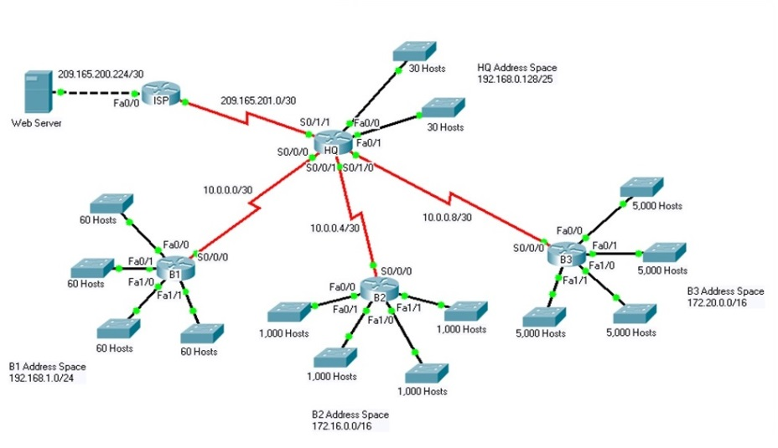Fully Connected Network Topology Mesh Network Topology.

Star Network Topology

The samples shown above are only a few samples of many network layouts I have created and tested in Cisco Packet Tracer.