**Pixelmonmod.com**

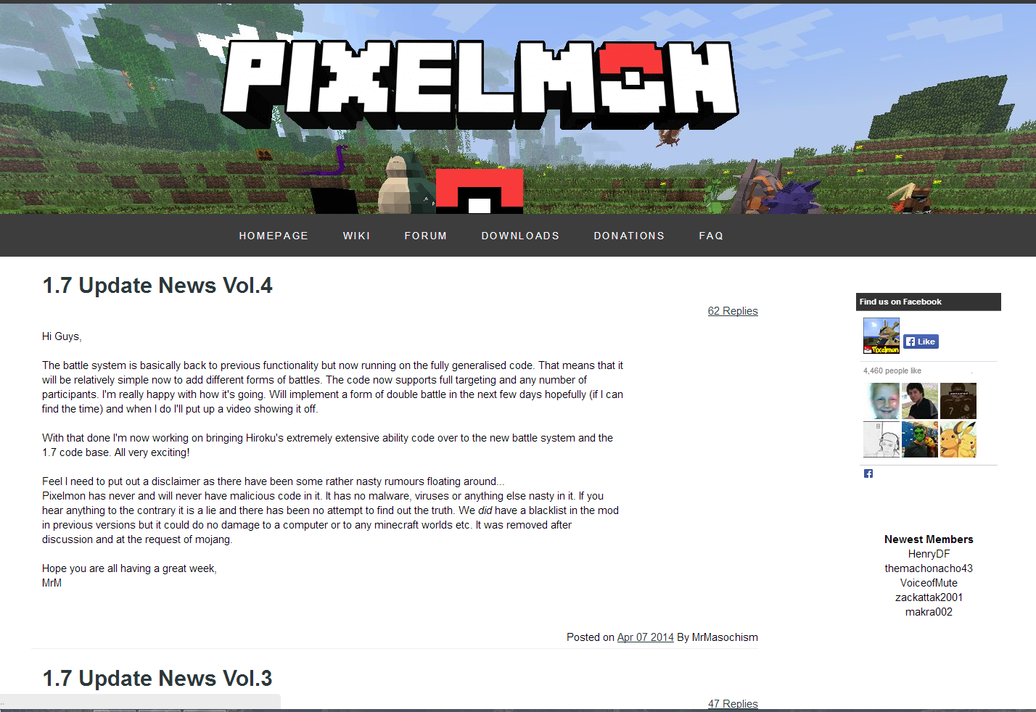

Pixelmon is a team of game developers who developed a mod for a large popular game called minecraft, I have helped them create an integrated website using our framework that integrates the game with the website using json api calls.